IEEE P802.11  
Wireless LANs

|  |  |  |  |  |
| --- | --- | --- | --- | --- |
| PDT PHY Transmit Specification | | | | |
| Date: 2025-03-27 | | | | |
| Author(s): | | | | |
| Name | Affiliation | Address | Phone | email |
| Genadiy Tsodik | Huawei |  |  | genadiy.tsodik@huawei.com |
| Yusuke Asai | NTT |  |  | yusuke.asai@ntt.com |
| Alice Chen | Qualcomm |  |  | alicel@qti.qualcomm.com |
| YuHsien Chang | Mediatek |  |  | yuhsien.chang@mediatek.com |
| Shengquan Hu | Mediatek |  |  | shengquan.hu@mediatek.com |
| Yan Zhang | Apple |  |  | yan_zhang1010@apple.com |
| Jianhan Liu | Mediatek |  |  | Jianhan.Liu@mediatek.com |
| Rui Yang | InterDigital |  |  | Rui.Yang@InterDigital.com |
| Bo Sun | Sanechips |  |  | sun.bo1@SANECHIPS.COM.CN |
| Mahmoud Kamel | InterDigital |  |  | Mahmoud.Kamel@InterDigital.com |
| Youhan Kim | Qualcomm |  |  | youhank@qti.qualcomm.com |
| Ross Jian Yu | Huawei |  |  | ross.yujian@huawei.com |
| Lisa Ward | Rohde-Schwartz |  |  | Lisa.Ward@rsa.rohde-schwarz.com |
|  |  |  |  |  |
|  |  |  |  |  |
|  |  |  |  |  |
|  |  |  |  |  |

Abstract

This document contains Proposed Draft Text (PDT) for the subclause Transmit Specification of the TGbn (UHR, Ultra High Reliability) amendment to the 802.11 standard.

# Revision information

The following is a summary of the important changes that occurred within each revision of this document:

|  |  |
| --- | --- |
| **Revision** | **Major changes** |
| 0 | Initial revision |
|  |  |
|  |  |
|  |  |
|  |  |
|  |  |

# Introduction

Interpretation of a Motion to Adopt

A motion to approve this submission means that the editing instructions and any changed or added material are actioned in the TGbn Draft. The abstract, revision information, introduction, explanation of the proposed changes, and references sections are not part of the adopted material.

***Editing instructions formatted like this are intended to be copied into the TGbn Draft (i.e. they are instructions to the 802.11 editor on how to merge the text with the baseline documents).***

## Explanation of the proposed changes:

The proposed changes to the 802.11 TGbn draft within this document are based on the following motions adopted by the TGbn task group.

### Relevant passing motions:

[Motion #313]

**Transmit Constellation Error required values for the new MCSs 17, 19, 20 and 23 (QPSK 2/3, 16QAM 2/3, 16QAM 5/6 and 256QAM 2/3) for the UHR MU PPDU will be**

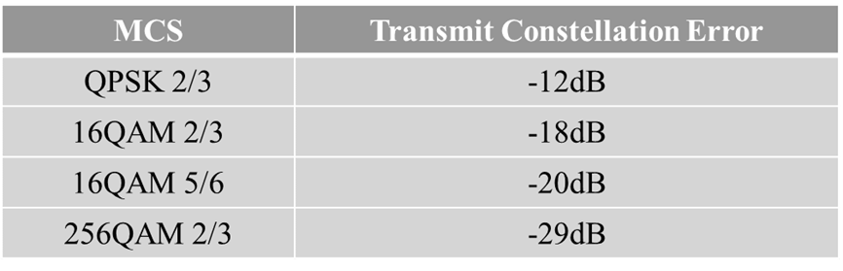

[Motion #314]

* **The testing in the transmit and receive specification in IEEE 802.11bn spec should only use EQM (i.e., not use UEQM)**
* **The testing in the transmit and receive specification in IEEE 802.11bn spec should not use 2xLDPC, if LDPC is used**

# Text to be adopted begins here:

***TGbn editor: Please add the following changes to the subclause 38.3.20 Transmit Specification to the 802.11bn draft D0.1:***

# 38 Ultra High Reliablity (UHR) PHY specification

## 38.3 UHR PHY

### 38.3.23 Transmit Specification

[placeholder for detailed text]

### 38.3.23.1 Transmitter spectral mask

[placeholder for detailed text]

### 38.3.23.2 Spectral Flatness

[placeholder for detailed text]

### 38.3.23.3 Transmit center frequency and symbol clock frequency tolerance

[placeholder for detailed text]

### 38.3.23.4 Modulation accuracy

**38.3.23.4.3 Transmitter constellation error**

The number of spatial streams under test shall be equal to the number of utilized transmitting STA physical antenna (output) ports and also equal to the number of utilized testing instrumentation input ports. In the test, no beamforming steering matrix shall be used. In the test, only EQM scheme shall be used. In the test, no LDPC coding length of 3888 shall be used.

**Table 38-XX—Allowed relative constellation error versus constellation size and coding rate**

|  |  |  |  |  |
| --- | --- | --- | --- | --- |
| Modulation | Coding rate | Relative constellation error in an UHR MU PPDU (dB) | Relative constellation error in an UHR TB PPDU when transmit power is larger than the maximum power of EHT-MCS 7 (dB) | Relative constellation error in an UHR TB PPDU when transmit power is less than or equal to the maximum power of EHTMCS 7 (dB) |
| BPSK | 1/2 | -5 | -13 | -27 |
| QPSK | 1/2 | -10 | -13 | -27 |
| QPSK | 2/3 | -12 | TBD | TBD |
| QPSK | 3/4 | -13 | -13 | -27 |
| 16-QAM | 1/2 | -16 | -16 | -27 |
| 16-QAM | 2/3 | -18 | TBD | TBD |
| 16-QAM | 3/4 | -19 | -19 | -27 |
| 16-QAM | 5/6 | -20 | TBD | TBD |
| 64-QAM | 2/3 | -22 | -22 | -27 |
| 64-QAM | 3/4 | -25 | -25 | -27 |
| 64-QAM | 5/6 | -27 | -27 | -27 |
| 256-QAM | 2/3 | -29 | TBD | TBD |
| 256-QAM | 3/4 | -30 | -30 | -30 |
| 256-QAM | 5/6 | -32 | -32 | -32 |
| 1024-QAM | 3/4 | -35 | -35 | -35 |
| 1024-QAM | 5/6 | -35 | -35 | -35 |
| 4096-QAM | 3/4 | -38 | -38 | -38 |
| 4096-QAM | 5/6 | -38 | -38 | -38 |
| BPSK-DCM(EHT-MCS 15) | 1/2 | -5 | -13 | -27 |
| BPSK-DCM(EHT-MCS 14) | 1/2 | -5 | N/A | N/A |
| NOTE 1—The maximum power of UHRMCS 7 can be measured by setting the UL Target Receive Power subfield as defined in Table 9-29j (UL Target Receive Power subfield in Trigger frame) in the Trigger frame to 127 for the RU for which the EVM test is conducted.NOTE 2—N/A = not supported by the PPDU format | | | | |

# Text to be adopted ends here.

**References:**

1. [11-24-0171r21](https://mentor.ieee.org/802.11/dcn/24/11-24-0171-21-00bn-tgbn-motions-list-part-1.pptx): 11-24-0171-21-00bn-tgbn-motions-list-part-1, Alfred Asterjadhi (Qualcomm Inc.)
2. [11-25-0014r13](https://mentor.ieee.org/802.11/dcn/25/11-25-0014-13-00bn-tgbn-motions-list-part-2.pptx): 11-25-0014-13-00bn-tgbn-motions-list-part-2, Alfred Asterjadhi (Qualcomm Inc.)