IEEE P802.11  
Wireless LANs

|  |  |  |  |  |
| --- | --- | --- | --- | --- |
| PDT PHY Enhanced Long Range (ELR) | | | | |
| Date: 2024-11-18 | | | | |
| Author(s): | | | | |
| Name | Affiliation | Address | Phone | email |
| Lin Yang | Qualcomm Inc. |  |  | linyang@qti.qualcomm.com |
| Wook Bong Lee |  |  |  |  |
| Rethna Pulikkoonattu |  |  |  |  |
| Rui Yang |  |  |  |  |
| Jiyang Bai |  |  |  |  |
| Xuwen Zhao |  |  |  |  |
| Shengquan Hu |  |  |  |  |
| Jianhan Liu |  |  |  |  |
| Juan Fang |  |  |  |  |
| Leonardo Lanante |  |  |  |  |
| Mahmoud Kamel |  |  |  |  |
| Bo Sun |  |  |  |  |
| Thomas Handte |  |  |  |  |
| Genadiy Tsodik |  |  |  |  |
| Bo Cao |  |  |  |  |
| Daniel Verenzuela |  |  |  |  |
| Rocco Di Taranto |  |  |  |  |
| Ying Wang |  |  |  |  |
| Bo Gong |  |  |  |  |
| Junghoon Suh |  |  |  |  |
| Dongguk Lim |  |  |  |  |
| Yunbo Li |  |  |  |  |
| Chenchen Liu |  |  |  |  |
| Ming Gan |  |  |  |  |
| Yapu Li |  |  |  |  |
| Toshizoh NOGAMI |  |  |  |  |
| Pelin Salem |  |  |  |  |
| Lei Zhou |  |  |  |  |
| Jeongki Kim |  |  |  |  |
| Sigurd Schelstraete |  |  |  |  |
| Tzu-Hsuan (Henry) Chou |  |  |  |  |
| Youhan Kim |  |  |  |  |
| Xiandong Dong |  |  |  |  |
| Alfred Asterjadhi |  |  |  |  |
| Nima Namvar |  |  |  |  |
| Ross Jian Yu |  |  |  |  |
| Insun Jang |  |  |  |  |
| Ke Zhong |  |  |  |  |
| Aditi Singh |  |  |  |  |
| Xiaofei Wang |  |  |  |  |
| Qinghua Li |  |  |  |  |
| Rong Zhang |  |  |  |  |
| Hari Ram Balakrishnan |  |  |  |  |
| Aniruddh Rao Kabbinale |  |  |  |  |
|  |  |  |  |  |
|  |  |  |  |  |

Abstract

This document contains Proposed Draft Text (PDT) for the Enhanced Long Range (ELR) feature of the proposed TGbn (UHR, Ultra High Reliability) amendment to the 802.11 standard.

# Revision information

The following is a summary of the important changes that occurred within each revision of this document:

|  |  |
| --- | --- |
| **Revision** | **Major changes** |
| 0 | Initial revision |
|  |  |
|  |  |
|  |  |
|  |  |
|  |  |

# Introduction

Interpretation of a Motion to Adopt

A motion to approve this submission means that the editing instructions and any changed or added material are actioned in the TGbn Draft. The abstract, revision information, introduction, explanation of the proposed changes, and references sections are not part of the adopted material.

***Editing instructions formatted like this are intended to be copied into the TGbn Draft (i.e. they are instructions to the 802.11 editor on how to merge the text with the baseline documents).***

## Explanation of the proposed changes:

The proposed changes to the 802.11 TGbn draft within this document are based on the following motions adopted by the TGbn task group.

### Relevant passing motions:

[Motion #24, [1]]

* Define Enhanced Long Range (ELR) PPDU and potentially other Range Extension mechanism.

[Motion #32, [1]]

* ELR PPDU starts with a legacy preamble in the PPDU for the ELR transmission
  + The legacy preamble contains the L-STF, L-LTF, L-SIG, RL-SIG, and U-SIG.

[Motion #33, [1]]

* In the U-SIG field of a UHR ELR PPDU, the PHY Version Identifier is set to 1. And the PPDU Type And Compression Mode is used to indicate ELR PPDU.

[Motion #36, [1]]

* ELR-SIG is located right after ELR-LTF in ELR PPDU
  + Note that ELR-LTF is the short name of UHR-LTF for ELR PPDU.

[Motion #74, [1]]

* Define an enhanced long range (ELR) PPDU in IEEE 802.11bn with the following targets
  + Downlink and Uplink in 2.4 GHz (within BSS range with 11b beacon)
  + Uplink only in 5 GHz and 6 GHz bands
  + Minimum data rate is greater than or equal to 1.5 Mbps.

[Motion #75, [1]]

* In ELR PPDU, STA boosts L-STF and L-LTF by 3 dB
  + For UL, non-AP STA corrects CFO before transmission
  + Note: Non-AP STA pre-correction CFO requirement for residual CFO is TBD.

[Motion #76, [1]]

* ELR PPDU only supports the following two modulation and coding schemes:
  + BPSK with coding rate R=1/2
  + QPSK with coding rate R=1/2.

[Motion #77, [1]]

* ELR transmission shall apply the phase rotations as below for both BPSK and QPSK modulations
  + The rotation of -1 will be applied on data subcarriers of lower half of RU3 and upper half of RU4 for 52-tone regular RU (RRU52) on 20MHz.

[Motion #78, [1]]

* ELR packet detection is done at L-STF, which has same length as legacy with 3dB power boosting
  + L-LTF also has same length as legacy with same power boosting as L-STF.

[Motion #79, [1]]

* U-SIG carries STA-ID in ELR PPDU.

[Motion #80, [1]]

* Define two ELR-Mark symbols for ELR mode classification
  + ELR-Mark symbols carry a known sequence to receiver
  + ELR-Mark symbols carry BSS color info in ELR-Mark sequence
  + No power boosting on ELR-Mark symbols
  + Two ELR-Mark symbols are both QBPSK modulated on data subcarriers
  + ELR-Mark symbols use the following tone plan
    - 4 regular pilots as EHT-SIG + 48 data tones.

[Motion #81, [1]]

* 11bn defines the following PPDU frame format for ELR
  + PE TBD.



[Motion #82, [1]]

* ELR PPDU has 3dB boosting applied on both ELR-STF and ELR-LTF
  + ELR PPDU has ELR-STF duration and sequence same as that of UHR DL SU/MU PPDU
    - 4us using EHT-STF sequence for 20MHz
  + ELR PPDU defines a fixed/single mode of LTF+GI
    - 11bn supports 2x LTF+1.6us GI only for ELR PPDU
    - 11bn uses two UHR-LTF symbols for ELR PPDU
* Note that ELR-STF/ELR-LTF are the short names of UHR-STF/UHR-LTF for ELR PPDU

[Motion #83, [1]]

* ELR PPDU defines two symbols for ELR-SIG, specifically
  + ELR PPDU defines separately encoded two symbols for ELR-SIG
    - Each symbol has separate CRC and tail bits (6 bits)
  + ELR-SIG has same tone plan and duplication scheme as ELR-data and BCC encoded with MCS0.

[Motion #91, [1]]

* The U-SIG field in ELR PPDU consists of 2 OFDM symbols and includes the same version independent fields defined in the U-SIG field of EHT PPDU
* The details for the version dependent fields are TBD.

[Motion #92, [1]]

* The BW of ELR PPDU is 20MHz and one Spatial stream is used for ELR transmission.

[Motion #93, [1]]

* In the ELR transmission, a repeating of 52-tone RRU is used in 20MHz.
  + The same data is repeated in four 52-tone RRUs in 20 MHz.
  + The subcarrier allocation of 52-tone RRU equals the 52-tone RU defined in 11be.

[Motion #94, [1]]

* ELR LDPC rate matching will reuse the existing 802.11ac LDPC rate matching with 1-bit LDPC extra OFDM symbol indication.

[Motion #95, [1]]

* ELR-SIG will use the following two OFDM symbols design.

[Motion #96, [1]]

* The contents of the U-SIG field in ELR PPDU is defined as follows.

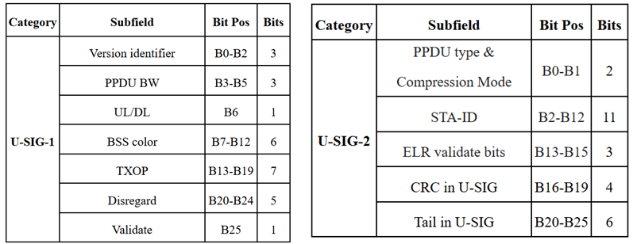

* + ELR PPDU indication: PPDU type & compression mode set to ‘11’.
  + STA-ID (11 bit): B2-B12 bit in USIG-2.
  + ELR validate bits (B13-B15 of USIG-2): Set to all ‘1’ for ELR PPDU.
  + Note: B11-B15 – in EHT MU PPDU indicates “Number of EHT-Sig symbols”, and in UHR MU PPDU indicates “Number of UHR-Sig symbols”

[Motion #104, [1]]

* ELR Mark symbols will be composed of two 1x OFDM symbols. Each symbol will have a duration of 4μS (3.2μS + GI=0.8μS).

[Motion #105, [1]]

* ELR Mark symbols will have the following tone mapping:
  + The 48 data tones are Q-BPSK mapped
  + The pilots follow BPSK mapping (polarity -1 applied to [1,1,1,-1])

[Motion #94, [1]]

* Adopt the ELR Mark sequence design as described by the matrix H in 24/1571r2. The detailed design is as described in the slides 8-9 of 24/1571r2.
  + 𝐻́  = [𝐻 𝐻𝕁; 𝐻 -𝐻𝕁], where 𝕁 is the exchange matrix of size 48x48.

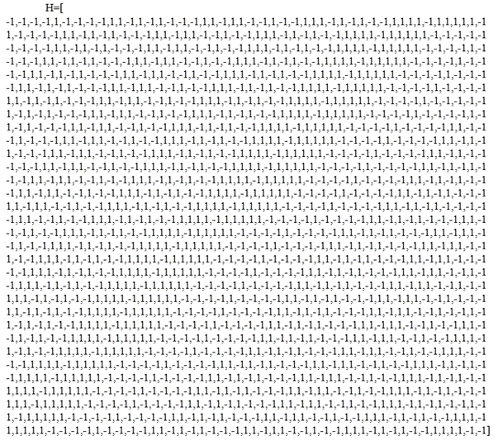

[Motion #110, [1]]

* Pilot values and mapping rules of ELR-SIG and Data symbols in ELR PPDU are the same as that of four RRU52 in DL OFDMA.

# Text to be adopted begins here:

***TGbn editor: Please add the following new subclauses for Enhanced Long Range PPDU to the 802.11bn draft D0.1:***

# 9. Frame formats

## 9.3.1 Control frames

# 10. MAC sublayer functional description

# 38.3.4 UHR PPDU format

# 38.3.5 Enhanced Long Range PPDU

# 38.3.6 Transmitter block diagram

# 38.3.7 Overview of the PPDU encoding process

## 38.3.7.1 General

## 38.3.7.2 Construction of L-STF

## 38.3.7.3 Construction of L-LTF

## 38.3.7.x Construction of UHR ELR-MARK

## 38.3.7.x Construction of UHR-STF

## 38.3.7.x Construction of UHR-LTF

## 38.3.7.x Construction of ELR-SIG

## 38.3.7.x Construction of Data field in an UHR ELR PPDU

# 38.3.8 UHR-MCSs

# 38.3.10 Timing related parameters

# 38.3.11 Mathematical description of signals

## 38.3.11.4 Transmitted signal

# 38.3.12 UHR preamble

## 38.3.12.1 Introduction

## 38.3.12.2 Cyclic shift

### 38.3.12.2.1 Cyclic shift for pre-UHR modulated fields

### 38.3.12.2.2 Cyclic shift for UHR modulated fields

## 38.3.12.3 L-STF

## 38.3.12.4 L-LTF

## 38.3.12.5 L-SIG

## 38.3.12.6 RL-SIG

## 38.3.12.7 U-SIG

### 38.3.12.7.1 General

### 38.3.12.7.2 Content

### 38.3.12.7.3 Encoding and modulation

## 38.3.12.x Enhanced Long Range (ELR) MARK field

### 38.3.12.8.1 ELR-MARK Matrix

### 38.3.12.8.2 Encoding and Modulation

## 38.3.12.9 UHR-STF

## 38.3.12.10 UHR-LTF

## 38.3.12.x ELR-SIG

### 38.3.12.x.1 General

### 38.3.12.x.2 Content

### 38.3.12.x.3 Encoding and modulation

# 38.3.13 Data field

## 38.3.13.3 Coding

### 38.3.13.3.1 general

### 38.3.13.3.2 BCC coding

### 38.3.13.3.3 LDPC coding

### 38.3.13.3.4 UHR ELR PPDU padding process

### 38.3.13.3.5 Encoding process for an UHR ELR PPDU

## 38.3.13.4 Stream parser

## 38.3.13.5 Segment parser

## 38.3.13.6 BCC interleaver

## 38.3.13.7 Constellation mapping

## 38.3.13.8 LDPC tone mapper

## 38.3.13.9 Segment deparser

## 38.3.13.10 Frequency domain duplication

## 38.3.13.11 Pilot subcarrier

## 38.3.13.12 OFDM modulation

# 38.3.X Transmit requirements for an UHR ELR PPDU

## 38.3.X.1 Introduction

## 38.3.X.2 Pre-correction accuracy requirements

# Text to be adopted ends here.

**References:**

1. [11-24-0171r21](https://mentor.ieee.org/802.11/dcn/24/11-24-0171-21-00bn-tgbn-motions-list-part-1.pptx): 11-24-0171-21-00bn-tgbn-motions-list-part-1, Alfred Asterjadhi (Qualcomm Inc.)