IEEE P802.11  
Wireless LANs

|  |  |  |  |  |
| --- | --- | --- | --- | --- |
| D5.0 CR for R1-34 and R1-35 | | | | |
| Date: 2024-10-24 | | | | |
| Author(s): | | | | |
| Name | Affiliation | Address | Phone | email |
| Shuling Julia Feng | Mediatek Inc | 2840 Junction Ave, San Jose, CA, USA |  | Julia.feng@mediatek.com |

Abstract

This submission proposes resolutions to the following comments submitted for SA110 on 11bf D5.0.

CIDs: R1-34, R1-35

Revision history:

R0: Original version

|  |  |  |  |  |  |
| --- | --- | --- | --- | --- | --- |
| **CID** | **Clause** | **Page** | **Comment** | **Proposed change** | **Proposed resolution** |
| R1-34 | 9.4.1.81.4 | 66.29 | what does this mean? Does value of 0 mean good operating point or bad operating point? | Please clarify the meaning of Rx operating point index | **REJECTED**  The meaning of Rx operating point index is included in clause 11.55.1.5.5 (Indication of receiver operating condition).  According to clause 11.55.1.5.5, value 0 of Rx_OP_Gain_Index indicates a good operating point, i.e., the impact of the sensing receiver operating point is negligible on the corresponding CSI estimate. |
| R1-35 | 9.4.1.81.4 | 66.37 | what is the resolution of RF Gain index and digital gain index? | Clarify the definition of gain index and the range of gain indices | **REJECTED**  The definition and range of RF/Analog Gain Index and Digital Gain Index is included in clause 11.55.1.5.5 (Indication of receiver operating condition).  Clause 11.55.1.5.5 explains that except the maximum and minimum values of RF/Analog Gain Index and Digital Gain Index, the mapping from analog/digital AGC gains to RF/Analog Gain Index and Digital Gain Index is implementation specific. |

**R1-34**

The text commented is as following,



The following formal text on Rx_OP_Gain_Index is included in clause 11.55.1.5.5 (Indication of receiver operating condition),

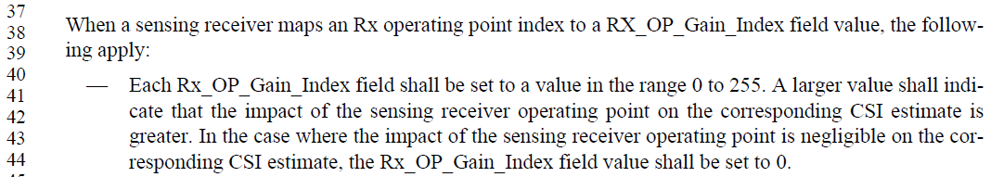

Value 0 of Rx_OP_Gain_Index in this case indicates a good operating point, i.e., the impact of the sensing receiver operating point is negligible on the corresponding CSI estimate.

**R1-35**

The text commented is as following,

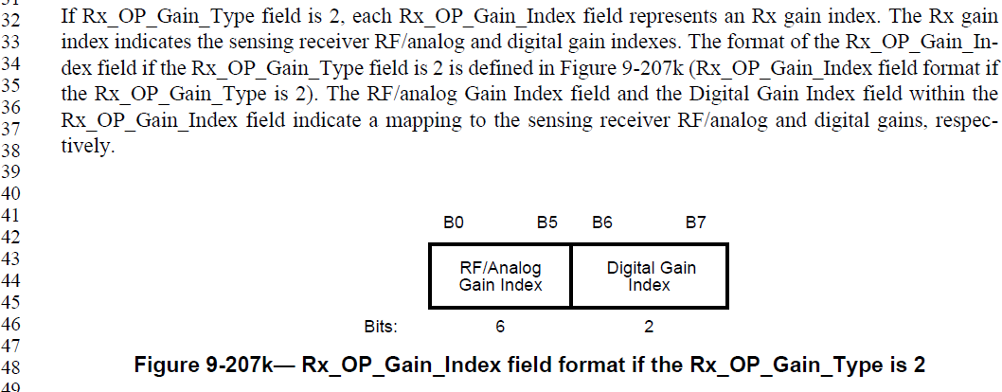

The following formal text on Rx_OP_Gain_Index in clause 11.55.1.5.5 (Indication of receiver operating condition) P163-164 defines the gain indices and range.

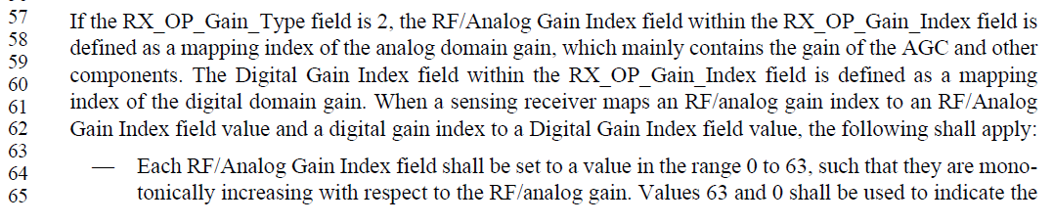

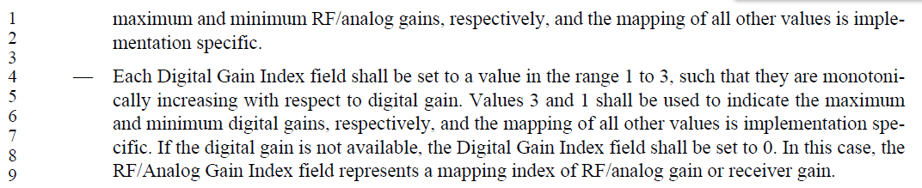

SP:

Do you agree to the resolutions provided for R1-34 and R1-35 in 802.11-24/1869r0 to be included in 11bf Draft 5.1?

Y/N/A