IEEE P802.11
Wireless LANs
IEEE 802.11 AIML TIG Technical Report use case Dynamic Spectrum Sharing via signal and protocol classification
Date: 2023-07-10
Author(s):
Name | Affiliation | Address | Phone | email
Marco Hernadez | YRP-IAI, Japan; CWC Oulu Univ. Finland, NICT, Japan |  |  | Marco.Hernandez@ieee.org
Abstract
This document contains a contribution to the technical report of the IEEE 802.11 AIML TIG.

Table of Contents

- Introduction

- AIML Use cases for IEEE 802.11
Note: use cases potentially can be organized into different categories
Note: use cases potentially can identify KPIs

  - Use case: Dynamic spectrum sharing via AIML-based signal and protocol classification
Use case description

The wireless spectrum is getting ever more crowded with an increasing number of devices and services. In the unlicensed spectrum case, the situation is more challenging with the incorporation of IoT, unlicensed cellular network, and new transmission requirements in 802.11 applications for example 802.11be. The situation requires efficient utilization of the spectrum in a shared ecosystem, where devices from different vendors and with different priority levels share a common set of spectrum bands.

AIML spectrum sensing, and signal classification infer the presence of other wireless systems sharing the same spectrum, reacting by manipulating system parameters according to a given policy (deep reinforcement learning) under a collaborative or uncollaborative scheme for interference mitigation and avoidance. The proposed use case will improve performance and coexistence of 802.11 deployments in the presence of inter-interference and intra-interference.

The motivation for AIML-based signal classification is to facilitate spectrum sharing (SS) of heterogenous wireless systems for coexistence.

Figure 1 shows an example of spectrum sharing over the 5 GHz band, illustrating the coexistence of different radio access technologies (RAT), protocols, bandwidth usage, etc. The situation is more critical in dense scenarios where interference cannot be handled with a single 802.11 specification. Moreover, there is a similar for the 6 GHz band, where future Wi-Fi standards will be sharing the spectrum with unlicensed 5G.
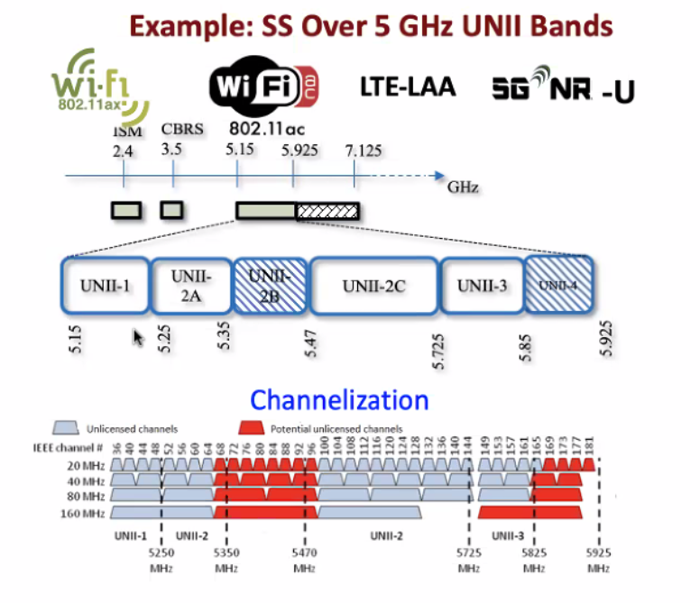
Figure 1⸺Spectrum sharing over the 5 GHz band.

Figure 2 shows examples of spectrum sharing models known as horizontal coexistence.

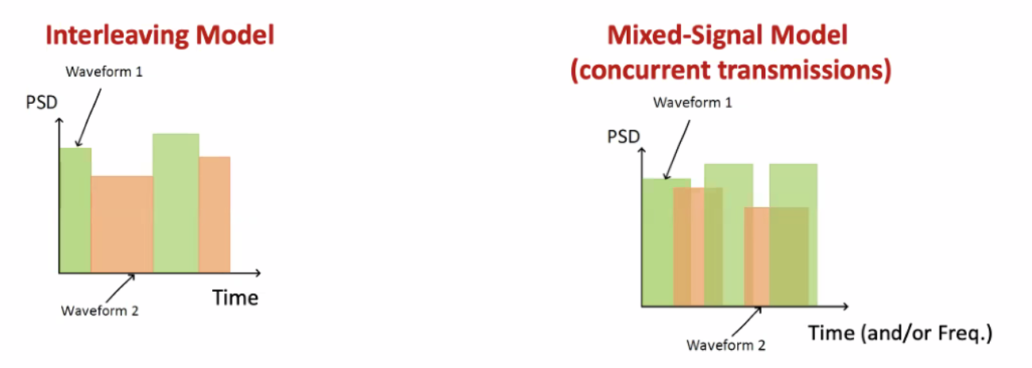
Figure 2⸺ Spectrum sharing models.

Another example is vertical or hierarchy coexistence. The best example is Citizens Broadband Radio Service (CBRS) based on a three-tiered spectrum authorization framework to accommodate a variety of commercial uses on a shared basis without requiring an exclusive spectrum license neither license-exempt.

The three tiers are: incumbent access, priority access, and general authorized access. The idea is that wireless systems subscribe to a dynamic spectrum access system (SAS), such that such wireless systems share spectrum based on access, geographic location, demand, and interference resilience, all managed by the SAS.

Signal classification is a technology that helps identify what wireless system produces the most harmful interference for a given scenario and act upon by the SAS.

Another way to see signal classification is to detect and classify adversarial (interference) transmissions and anomalies without decoding.

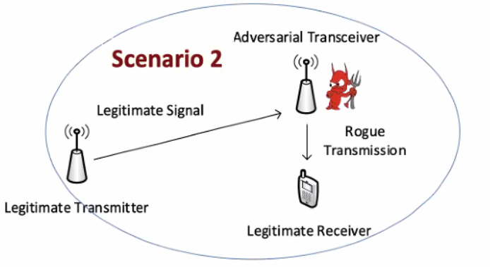
Figure 3⸺Example of coexistence with AIML.

The legitime Wi-Fi receiver does not need to have an adversarial 5G or (or other BSS) front-end. An AIML model will identify the rogue transmission protocol (or signal type) and use it in an AIML-based dynamic spectrum access system.

Example of modulation classifier using a cascade of convolutional neural networks (CNN). It can be extended to a Deep Neural Network (DNN) and consequently no need for retraining.

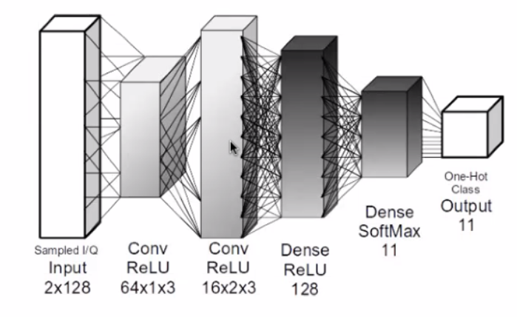
Figure 4⸺modulation classifier using CNN.

Another example using bidirectional recurrent neural network (BRNN). The training phase allow the RNN to receive information backwards (past) and forward (future), connecting hidden layers of opposite directions. Bidirectional long-short term memory (BiLSTM) RNN.

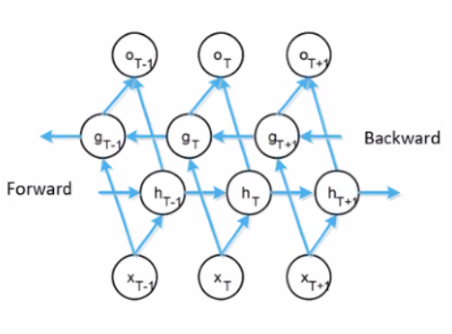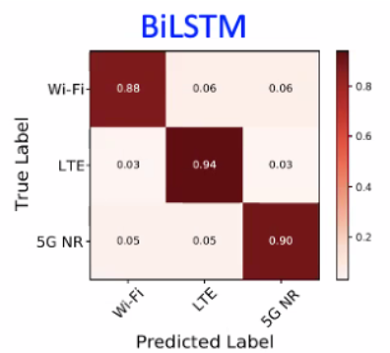

Figure 5⸺protocol classifier with BiLSTM.

Another example combined time/frequency domain classification.

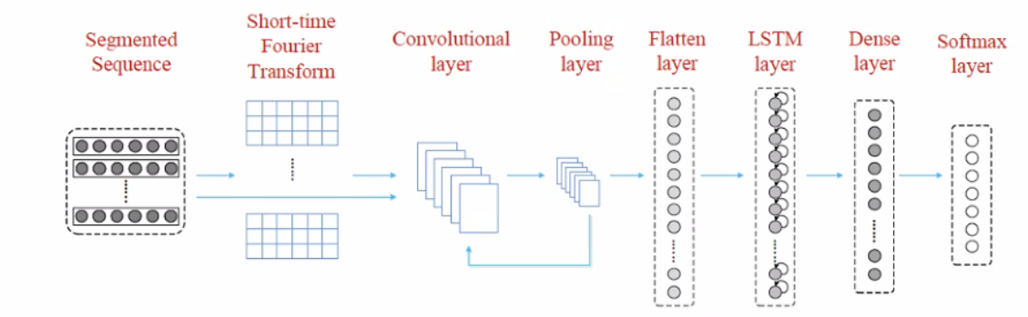

Figure 6⸺time, frequency domain classification.

Another example: automatic optimization of classifier parameters:

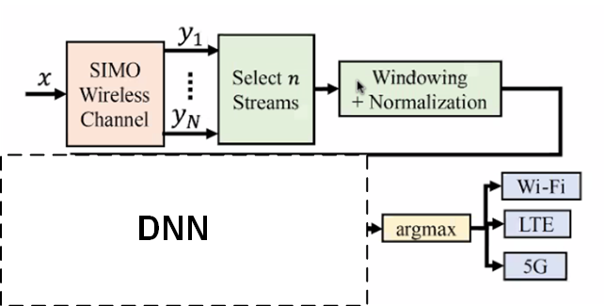

Figure 7⸺Deep learning optimizer of classifier parameters.

- Preprocessing parameters: RF chains (I/Q streams), window size.
- Learning parameters: choice of optimizer, batch size, learning rate, etc.
- Data collection parameters: filter size, etc.

- KPIs

The requirement to enable an AIML model is the availability of performance metrics (KPIs) along with historical data as inputs to the AIML model.

- Continuous throughput, low latency and jitter measured at the MAC-SAP in high density scenarios (overlapping BSSs and other wireless systems such as unlicensed 5G devices).

- Network energy efficiency (how efficiently the network converts power into data. It is calculated by dividing the data throughput by the power consumption).

- Computational complexity introduced by AIML.

- Requirements
- Backward compatibility with legacy 802.11. The use case is compatible with the different flavors of 802.11 specs.
- Performance should follow the guidance below:
  - Continuous throughput, latency and jitter measured at the MAC-SAP in the above scenarios.
  - Minimize the additional computation complexity required by AIML.

- Technical Feasibility Analysis
  - Standard Impact
The introduction of AIML requires the specification of the signaling for data collection and AIML model management.

  - Technical feasibility
The following metrics will be studied:

- Performance (as above) and energy efficiency by AIML models deployed in a STA or AP or aided cloud service (one-sided).
- Performance (as above) and energy efficiency by AIML models deployed in both STA and AP (two-sided).
- Potential additional signaling required to support AIML models management.
- Hardware requirements (cost, processing power) to support AIML processing.

Annex

Dynamic interference management

Artificial intelligence and machine learning (AIML) can be used to improve interference management in 802.11 networks in a number of ways. For example, AIML can be used to:

- Identify and classify interfering signals. This can be done by training a machine learning model on a dataset of known interfering signals. Once the model is trained, it can be used to identify and classify new interfering signals.

- Predict the impact of interference on network performance. This can be done by training a machine learning model on a dataset of historical data. The model can then be used to predict how interference will impact network performance in new situations.

- Optimize network parameters to mitigate interference. This can be done by training a machine learning model to find the optimal values of network parameters such as transmit power, channel selection, and modulation.

Example of an AIML implementation:

OBSS refers to the situation where multiple APs have overlapping coverage areas, leading to interference and degraded network performance. M-NAV, on the other hand, enables multiple APs to use the same channel by dividing the channel into several virtual sub-channels, with each sub-channel allocated to a specific AP.
These mechanisms are used in the 802.11 standards to address the issue of co-channel interference.

To combine these mechanisms, a coordinated approach is required. One approach is to use M-NAV to allocate virtual sub-channels to each AP in an OBSS. Each AP would then operate on its assigned sub-channel, reducing interference with other APs in the same OBSS.
However, this approach requires coordination among the APs in the same OBSS to ensure that they use the same M-NAV configuration. This coordination can be achieved using a centralized controller or by using a distributed protocol that enables the APs to exchange information and synchronize their M-NAV configurations.

Another approach is to use OBSS-aware MNAV, which considers the OBSS information when allocating virtual sub-channels to each AP. This approach ensures that the APs in the same OBSS are allocated sub-channels that are least likely to interfere with each other.
AIML proposed solution for either a centralized controller or distributed protocol:

- Enable OBSS and M-NAV in the network: Configure the APs to use OBSS detection and mitigation techniques, such as BSS Coloring, Spatial Reuse, Transmit Power Control, and Dynamic Frequency Selection. Configure the client devices to support M-NAV, which enables them to communicate with multiple APs using different channels.

- Collect data: Collect data on the network environment, such as the number of client devices, the traffic load, and the signal strength of each AP. As previously stated, AIML spectrum sensing, and signal classification infer the presence of other wireless systems sharing the same spectrum, reacting by manipulating system parameters according to a given policy under a collaborative or uncollaborative scheme for interference mitigation and avoidance

- Train an AI model: Use the collected data to train an AI model that can optimize channel allocation and reduce interference. The AI model can be trained using machine learning techniques such as supervised learning, unsupervised learning, or reinforcement learning.

- Deploy the AI model: Deploy the AI model on the network to optimize the channel allocation and reduce interference in real time. The AI model can communicate with the APs and client devices to allocate channels based on the current network environment.

- Continuously monitor and update the AI model: Continuously monitor the performance of the network and update the AI model as necessary to improve its accuracy and effectiveness.

By combining OBSS, MNAV, spectrum sensing, signal classification and AIML, wireless networks can achieve better performance by optimizing channel allocation and reducing interference in real time. However, it is important to note that this technique requires expertise in AI and wireless networking and may not be suitable for all network environments.

How to study the impact of AIML in 802.11 specs

AIML algorithms and models are implementation specific and out of the scope of an 802.11 specification. The requirements are on enabling AIML functionality and corresponding types of inputs and outputs, data collection, and the signaling required to support AIML solutions.

A potential standard should specify the required signaling and data format to and from the AIML Model as illustrated in Figure 8.

Figure 8⸺ Required signalling for AIML implementations.

Figure 8 shows the flows of information for AIML solutions and it is shown only to facilitate discussions. Some inference models require training, some other semi-training, while others do not require training. Data collection is required for inference, training, deployment, refreshment, and overall management. Inference functionality means the action at the PHY and MAC by supervised learning, unsupervised learning, self-supervised learning, etc.

The output of an AIML model, or Action in Figure 8, may be for example, beam steering and will be applied to the beam management. This part of the information flow of AIML solutions

The flow of information is the required signaling in a potential specification, and it should accommodate a wide class of inference models.

Data collection (DC) signaling:
- DC for Model Training
- DC for Model Inference
- DC for Model management & monitoring

Model training (MT) signaling:
- Training, validation, testing, deployment (transfer)

Model Inference (MI) signaling:
- Environment input from DC
- Model management control
- Model training deployment, update, and feedback.
- Actions from MI’s output

Model Management (MM) signaling:
- Environment input and Actor’s actions from DC
- Request and management of Model generation, update, activation, selection, monitor, fallback.

AIML technologies are continuously evolving. Hence, a specification cannot get hooked to a given way of doing training, inference, and so on. In fact, how to implement those blocks is the innovation from companies.

