IEEE P802.11
Wireless LANs
LB271 CR for 36.3.10
Date: 2023.06.20
Author(s):
Name | Company | Address | Phone | email
Ying Li | Huawei |  |  | liying246@huawei.com
Lei Huang | Huawei |  |  | lei.huang1@huawei.com
Ross Jian Yu | Huawei |  |  | ross.yujian@huawei.com
Abstract
This submission contains proposed comment resolutions to 2 comments related to clause 36.3.10 of P802.11be D3.0.
CID 17196, 17197

Revision Notes

R0 | Initial revision

#17196
CID | Commenter | Clause Number(C) | Page | Comment | Proposed Change | Resolution
17196 | Sigurd Schelstraete | 36.3.10 | 746.15 | Table 36-20, column "Description": N_SR is described as the "highest data subcarrier index". This is not correct if the punctured 20/40/80 MHz is at the high end of the bandwidth. | Correct description or add NOTE | Revised  It is very clear from (36-9) and (36-10) that the value of N_SR only depends on the channel bandwidth, and does not depend on whether the highest 20MHz subchannel is punctured or not. For clarification, we add a note here.  TGbe editor: please incorporate the changes shown in 11-23/1029r0 under tag #17196.

Background (P746 of D3.0):

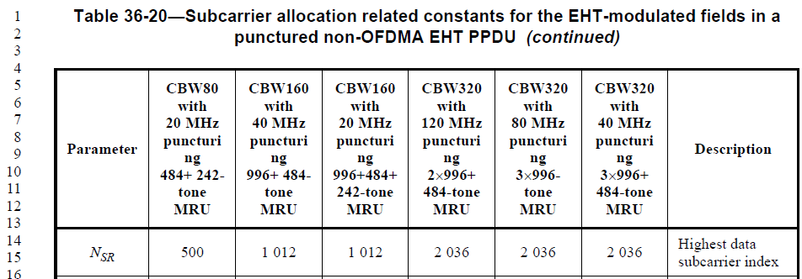
Background (P753~756 of D3.0):
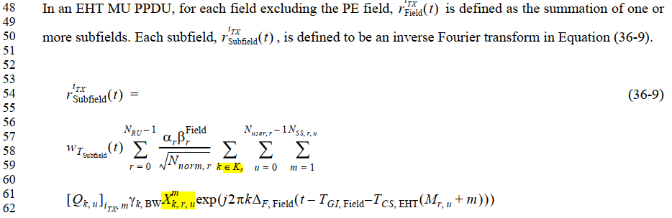
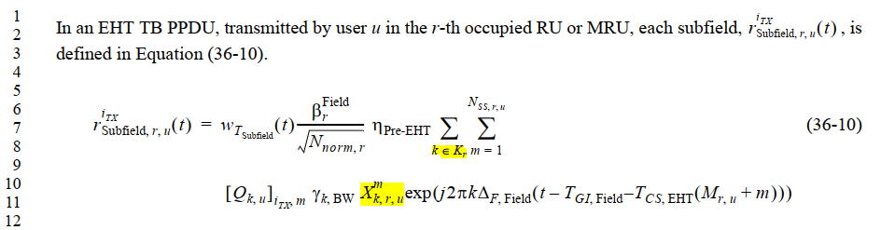

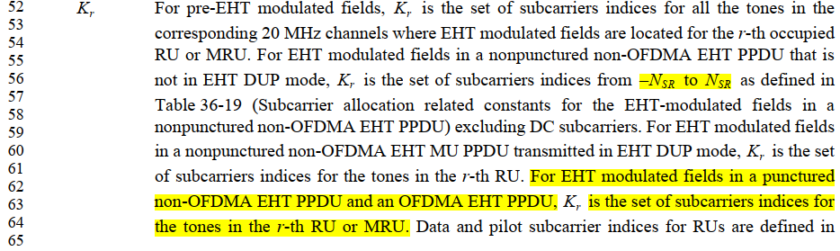

Proposed Changes:

Instruction to TGbe Editor:
Change Table 36-20 (P802.11be D3.0 P746) as follows:

Table 36-20—Subcarrier allocation related constants for the EHT-modulated fields in a punctured non-OFDMA EHT PPDU (continued)

Parameter | CBW80  with 20 MHz  puncturi ng  484+ 242-  tone MRU | CBW160  with 40 MHz  puncturi ng  996+ 484-  tone MRU | CBW160  with 20 MHz  puncturi ng 996+484+  242-tone MRU | CBW320  with 120 MHz  puncturi ng 2×996+  484-tone MRU | CBW320  with 80 MHz  puncturi ng 3×996-  tone MRU | CBW320  with 40 MHz  puncturi ng 3×996+  484-tone MRU | Description
NSR | 500 | 1 012 | 1 012 | 2 036 | 2 036 | 2 036 | Highest data subcarrier index  (#17196)NOTE-The value of N_SR only depends on the channel bandwidth, and does not depend on whether the highest 20MHz subchannel is punctured or not.
NDC | 23 | 23 | 23 | 23 | 23 | 23 | Number of null subcarriers at DC
NGuard,Left | 12 | 12 | 12 | 12 | 12 | 12 | Number of low frequency guard subcarriers
NGuard,Right | 11 | 11 | 11 | 11 | 11 | 11 | Number of high frequency guard subcarriers

#17197

CID | Commenter | Clause Number(C) | Page | Comment | Proposed Change | Resolution
17197 | Sigurd Schelstraete | 36.3.10 | 748.16 | "NOTE--For LDPC coding, this is the number of data bits per OFDM symbol based on the LDPC coding rate for the MCS.".  I have no idea what the purpose of this note is. How is this different when BCC is used? This is a table with definitions. THis is not the place to go into the derivation of N_DBPS. | Delete NOTE | Accepted

Background (P746 of D3.0):

