IEEE P802.11
Wireless LANs
Proposed IEEE 802.11 AIML TIG Technical Report Text for the CSI Compression Use Case
Date: 2023-07
Author(s):
Name | Affiliation | Address | Phone | email
Xiaofei Wang | InterDigital Inc. | 111 West 33rd Street  New York, NY 10120  USA | +1-607-592-2727 | Xiaofei.wang@interdigital.com
Ming Gan | Huawei |  |  | Ming.gan@huawei.com
Zinan Lin | InterDigital
Rui Yang | InterDigital
Aiguo Yan | Zeku
Junghoon Suh | Huawei
Ziyang Guo | Huawei
Marco Hernadez | YRP-IAI, Japan; CWC Oulu Univ. Finland, NICT, Japan
Liangxiao Xin | Zeku
Peng Liu | Huawei
Federico Lovison | Cisco
Jerome Henry | Cisco
Juan Carlos Zuniga | Cisco
Sukrit Dasgupta | Cisco
Abstract
This document contains the proposed technical report text of the IEEE 802.11 AIML TIG, especially for the CSI compression use case.

Revision history:
R0: Copied from 802.11-23/0991r0, and add VQVAE based CSI compression in Section 2.1.1, model generalization requirement in Section 2.1.4, and standard impact discussion in Section 2.1.5.
R1: Copied from 802.11-22/0987r7, and add the modifications of R0 in Section 2.1.

Table of Contents

- Introduction
  - Terminologies
AIML Artificial Intelligence/Machine Learning
CSI Channel State Information
DL Downlink
UHR Ultra High Reliability
UL Uplink

  - Background information
Artificial Intelligence/Machine Learning (AIML) algorithms have made significant progress and are being applied in many domains, including medical diagnosis, speech recognition, computer vision, and integration of vision and control for robotics. In addition, AIML algorithms are emerging as important components in many applications such as autonomous driving, language translation and human-machine interactions.

Traditional AIML techniques are based on a centralized model which requires exchanging a large amount of data between data sources and a centralized server. More recently, distributed AIML algorithms such as federated learning have been developed that will allow more analysis at the source and reduce the amount of data that need to be exchanged, though the expected amount of exchanged data remains significant. With the prevalence of wireless networks and communications, much of the exchanged data is expected to be carried through wireless networks, such as IEEE 802.11 WLAN networks.

Studies have shown that AIML algorithms can help improve the performance for wireless communication networks, by providing better resource usage, lower energy consumption, higher reliability and more robustness to a changing environment. As these algorithms become more mature and cost effective, WLAN may leverage AIML for enhanced network performance and user experience.

In May 2022, the IEEE 802.11 Working Group (WG) has approved the forming of the AIML Task Interest Group (TIG) by the following motion [1]:

Motion 5: TIG Re: AIML use in 802.11
Approve formation of a Topic Interest Group (TIG) to:
(a) describe use cases for Artificial Intelligence/Machine Learning (AIML) applicability in 802.11 systems and
(b) investigate the technical feasibility of features enabling support of AIML.
The TIG is to complete a report on this topic at or before the March 2023 session.
This technical report is the final report of the AIML TIG to the IEEE 802.11 WG detailing various AIML use cases discussed during the AIML TIG. For each use case, a number of Key Performance Indicators (KPIs) have been identified and requirements and technical feasibility analysis have been provided.

- AIML Use cases for IEEE 802.11
Note: use cases potentially can be organized into different categories
Note: use cases potentially can identify KPIs

  - Use case 1: CSI feedback compression
    - Use case description
In 802.11ax [1] and the draft of 802.11be [2], the AP initiates the sounding sequence by transmitting the NDPA frame followed by a NDP which is used for the generation of V matrix at the beamformee. Upon the receipt of the NDP from the beamformer, the beamforee applies a compression scheme (i.e., Givens rotations) on the V matrix and feeds back the angles in the beamforming report frame.

It is indicated in [4] that higher number of spatial streams has been an inevitable trend in WiFi for more than a decade. The preliminary results [4] [5] [6] show that MIMO with a large number transmitter antennas and a large number of spatial streams (e.g., 16 spatial streams) offer remarkable system performance gains on both SU-MIMO and MU-MIMO cases. Multi AP (MAP) may be one potential feature in the next 802.11 generation, e.g. UHR [7] - [10] . Large number of spatial streams combined with MAP feature may further increase the sounding feedback airtime overhead if coordination between APs (e.g., joint transmission/reception, coordinated beamforming) is applied. Large amounts of overhead or prolonged sounding procedures may negatively impact the latency and limit the system performance. Therefore, there is a need to reduce the CSI overhead especially when the number of transmitter antennas goes higher or multiple APs perform joint or coordinated transmission.

Some studies (e.g., [11] [12] [13] [14] [32]) have shown that AIML can efficiently reduce the CSI feedback and improve the system throughput. For example, motivated by the nature that the CSI may fall into different clusters due to the channel similarity of nearby STAs, iFOR algorithm [11] applies the unsupervised learning, K-mean, to the CSI compression to classify the angle vectors which are derived from V matrix. Simulation results show that for a 8x2 SU-MIMO, iFOR uses around 8% of the number of bits required by the existing feedback mechanism (802.11ax) and boosts the system throughput by up to 52%. In [12] , another unsupervised learning, Deep Neural Network Autoencoder (DNN-AE) is applied to CSI angle vectors and further compresses the derived angles (LB-SciFi) by leveraging the compression capability of DNNs. Experimental results show that LB-SciFi reduces the feedback overhead by 73% and increases the network throughput by 69% on average. In [32], a vector quantized variational autoencoder (VQVAE), which learns the compression and quantization schemes together, is applied to compress the V matrix. Simulation results show that the implementation of VQVAE can significantly increase the system throughput by up to 223%, and reduce the feedback overhead by 97%. In addition, a lightweight encoder and uniform quantization are adopted to reduce the model deployment overhead and inference complexity while maintaining the throughput improvement.

This use case proposes to apply AIML technique to CSI feedback schemes to reduce the CSI overhead with minimum loss of PER performance.
    - KPIs
KPIs considered in this use case are proposed as follows:
- Number of feedback bits per subcarrier group
- Achieved PER
  - Both SU-MIMO and MU-MIMO cases need to be considered
- Additional AIML overhead compared with compression saving
  - One example is the ratio between the number of additional bits required by AIML process (including data used for model training/inference [15] , the model parameters, the additional signaling) and the number of bits saved by the CSI feedback scheme. In this example, if the data used for model training that is performed by the AP fully relies on the legacy CSI report, then the additional AIML overhead used for model training/inference may be negligible.
  - Another aspect of the overhead is the additional storage required by AIML. For example, the K-means based schemes (e.g., [11], [30], [31]) require the codebook storage, and the autoencoder based schemes (e.g., [12], [32], [33]) require the storage of neural network models.
- Computation complexity/Latency:
  - Additional delay or computation is introduced by AIML processing.
Evaluation methodology needs to be established.
.
- Requirements
- Backward compatibility with legacy 802.11
  - Support backward compatibility and coexistence with legacy 802.11 CSI report schemes
- Performance should follow the guidance below:
  - CSI airtime reduction: achieve airtime reduction of CSI feedback over 802.11be for a given Nr x Nc MIMO, where Nr is the number of rows in the compressed beamforming feedback matrix, Nc is the number of columns in the compressed beamforming feedback matrix.
  - Additional AIML overhead: minimize the additional overhead used for AIML process. Additional AIML overhead may include the data used for AIML model training/inference [15] , the model parameters and additional signaling. The data used for AIML model training/inference [15] can reuse the legacy CSI report data.
  - Packet Error rate (PER): guarantee minimum SNR loss compared with 802.11be to achieve the target PER (e.g., 1% and/or 10%) at a given MCS in all types of channels [16] .
  - Computation complexity/Latency: minimize the additional computation complexity or latency required by AIML process
  - AIML model generalization: improve the generalization capability of AIML models. Generalization refers to the ability of an AIML model to be used in various scenarios, such as different channel models, bandwidths or number of spatial streams. For example, a single codebook can be used in different scenarios for K-means based CSI feedback schemes (e.g., [11], [30], [31]); a single neural network model (including both architecture and parameters) can be used in different scenarios for autoencoder based CSI feedback schemes (e.g., [12], [32], [33]).

- Technical Feasibility Analysis
  - Standard Impact
The standard impact may include:
- Additional signaling (e.g., between AP and non-AP STAs) required by AIML process.
For example, a signaling scheme is introduced for autoencoder based CSI compression between AP and non-AP STA, as illustrated in Fig. 1. This scheme consists of two stages: training and model sharing stage and inference stage. During training and model sharing stage, the AP receives beamforming reports from the STA, trains the AIML models, and sends the encoder with and without codebook to the STA (according to Use Case 3 Model Sharing). Then, during inference stage, STA utilizes the encoder with ang without codebook to perform CSI compression.
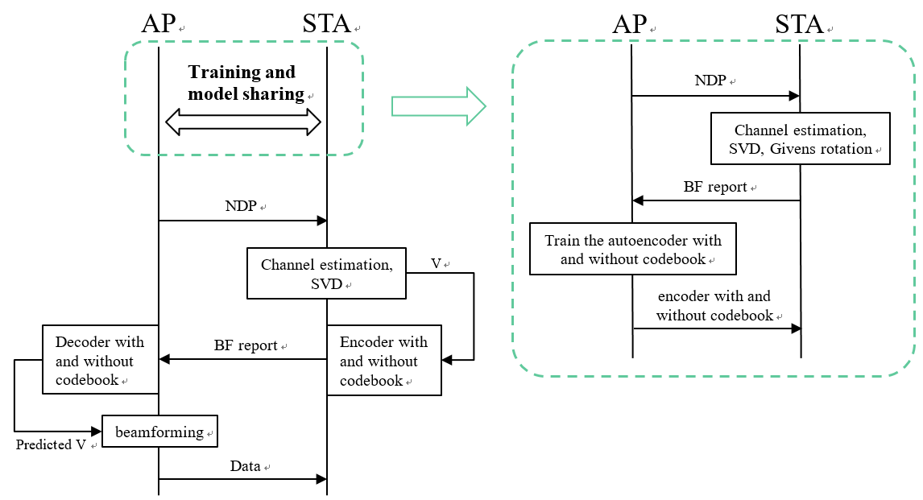
Figure 1: Illustration of signaling between AP and non-AP STA for autoencoder-based CSI compression

  - Technical feasibility
The following metrics will be studied:

- Backward compatibility: The STAs that supports AIML enabled CSI feedback compression shall support the legacy 802.11 CSI report scheme. This compatibility is expected to be supported since AIML capable STAs are expected to support legacy CSI report scheme.

- Data availability and accessibility: There are some STAs that are able to use the data to perform AIML model training and/or inference [15] . The data used for model training and/or inference shall be accessible for these STAs.
      - AP/edge computing based AIML: Data may be collected from non-AP STAs. The legacy 802.11 CSI reports may be used as training data.
      - Device computing based AIML: Data should be available at all STAs that support AIML process.

- Hardware/software capability: The STAs that use AIML to generate the AIML enabled CSI feedback compression shall have the hardware and software capability to support AIML algorithm(s).
      - AP/edge computing based AIML[17] : Extra data and model (e.g., model parameters) exchange may be required to support AP/edge computing based AIML. However, computation is not expected to be located at AP or edge computing resources for which higher computation capabilities are expected.
      - Device computing based AIML [17] : STAs that support AIML may be required to have extra computation capability. Extra data and model (e.g., model parameters) exchange between STAs may also be required to support device computing based AIML.

  - Use case 2: Distributed channel access
    - Use case description
In 802.11, the fundamental access method of the MAC used by STAs is a Distributed Coordination Function (DCF) known as carrier sense multiple access with collision avoidance (CSMA/CA). A STA is required to sense the wireless medium before transmitting. If it finds that the medium is continuously idle for a minimum specified duration, e.g., DIFS, the STA is then permitted to start transmission of a frame after waiting for an additional random backoff. The range of the generated random backoff counter is bounded by the Contention Window. The initial range is set from 0 to the minimum Contention Window size (CWmin). If the medium is occupied, the contention window is doubled until it reaches the maximum Contention Window size (CWmax) in order to further reduce collisions.

Higher throughput and lower latency have been an inevitable trend in WLAN for more than a decade as mentioned in [18] [19] [20] [21] . An efficient channel access protocol is fundamental to achieve this goal. However, the analysis in [22] shows that current contention-based access protocol suffers large performance degradation in dense deployments. The binary exponential backoff leads to short-term unfairness [23] , i.e., consecutive unsuccessful transmissions lead to worse latency performance. Therefore, more efficient channel access schemes are needed to increase throughput and to reduce latency and jitter.

Some studies [24] [25] [26] [27] have shown that AIML based channel access schemes can efficiently improve throughput/channel efficiency and reduce latency and jitter. For example, Centralized Contention window Optimization with Deep reinforcement learning (CCOD) [24] , applied Deep Q Network (DQN) or Deep Deterministic Policy Gradient (DDPG) contribute to contention window optimization. Simulation results show that the throughput improvement of CCOD over standard 802.11 ranges from 1.5% (for 5 stations) to 40% (for 50 stations). In [25] , QMIX-advanced Listen-Before-Talk (QLBT) is proposed for distributed channel access and improves the performance by leveraging the powerful learning capability of deep neural networks. Experimental results show that QLBT increases the channel efficiency by 18% and reduces the latency and jitter by 25% and 90% on average.

This use case proposes to apply AIML techniques to distributed channel access to improve throughput and reduce latency and jitter.

    - KPIs
KPIs considered in this use case include:
- Throughput
- Latency and jitter
- Fair coexistence

    - Requirements
- Fair coexistence with legacy 802.11
  - Support fair coexistence with legacy 802.11 channel access schemes. Utilization of an AIML-based channel access scheme by one or more STAs in a network shall not degrade the performance of STAs utilizing conventional channel access schemes, regardless whether these STAs are operating in the same BSS or in OBSS. Performance metrics include, but are not limited to, throughput and latency.

- Performance should follow the guidance below:
  - Throughput improvement measured at MAC data service access point (SAP): Achieve throughput improvement compared to 802.11be for different scenarios.

  - Latency and jitter reduction: Achieve latency and jitter reduction compared to 802.11be for different scenarios. Latency is the time from when a packet enters the queue to when it is successfully received. Jitter is the standard deviation of the latency.

  - Additional complexity introduced by AIML: Minimize the additional complexity, e.g., computation complexity, introduced by AIML process.

  - Performance evaluation needs to consider both the single BSS and OBSS scenarios.

    - Technical Feasibility Analysis
      - Standard Impact
The standard impacts include:
Signaling and protocols related to parameter exchange between AP and non-AP STAs, e.g., capability indication, data report to facilitate training, neural network parameters distribution, management, etc.

      - Technical feasibility

The following metrics will be studied:

- Hardware/software capability: The STAs that support AIML based channel access shall have the hardware and software capability to support AIML algorithm(s). The STAs that support model training may require higher computation capabilities.

- Data availability and accessibility: There are some STAs that are able to use data to perform AIML model training and/or inference [28] . The data used for model training and/or inference shall be accessible for these STAs. It is expected that signaling and protocols related to data accessibility will be specified.

- Model distribution: There may exist model exchange between AP and non-AP STAs during model training and/or inference [28] . It is expected that signaling and protocols related to model distribution will be specified.

  - Use case 3: AIML Model Sharing

    - Use case description

In AIML, models are mathematical algorithms replicating a decision process to enable automation and understanding. AIML models may include specific learning algorithms and parameters used in the learning algorithms, including but not limited to supervised learning, unsupervised learning and reinforcement learning, as well as parameters for these learning algorithms.

The generation and refinement of AIML models require a large amount of information exchange depending on a number of factors, such as AIML model users (such as APs and non-AP STAs) and network deployment, device computation power, and the AIML model generation schemes. Traditionally, AIML models as well as the training data required for AIML model training are exchanged as application data and may severely burden wireless networks on which such information exchange is carried, such as the IEEE 802.11 WLANs, which can cause significant descrease in QoS performance and user experience, contradictory to the ever increasing demand of higher throughput and better QoS. However, existing wireless network protocols may not be able to support some applications due to stringent latency and reliability requirements and need to rely on AIML models for performance gain.

Assuming that devices participating in AIML-based operations can be both STAs and APs, efficient AIML model distribution is essential for the success of AIML-based operations as well as for the performance and user experience of IEEE 802.11 WLANs in the centralized learning and federated learning scenarios below:

- Centralized learning or centralized AIML model generation/refinement
In this scenario, STAs provide training data to a central point, e.g., an AP, or a server, where the global AIML model is generated and refined. The central point, which may be the AP, subsequently distribute the global AIML model to all STAs, in DL.

- Distribued learning or distributed AIML model generation/refinement
In this scenario, all participating devices, such as STAs or APs, are capable of computing AIML models and share data to all participating devices so that each device can train the global model locally. This scenario, without much optimization, is considered to be especially taxing for the IEEE 802.11 networks since it requires a large amount of data to be exchanged over the air and also requires high computation power at each device.

- Federated learning or hybrid AIML model training/refinement
In this scenario, all participating devices, such as STAs or APs, are capable of computing AIML models and generating their local models and subsequently:
    - share their local models to a central point, such as the AP or a central server, likely in the UL, and the AP or central server generates a global model using the received local models as input and distributes the global model to all participating devices, likely in the DL;
    - share their local models to all participating devices, likely in UL and peer-to-peer, and all participating devices generate the global model using the received local models as input.

Additionally, IEEE 802.11 WLANs are expected to carry the traffic which distributes AIML models anyway, and these models are not limited to AIML models that are used to enhance performance and user experience for the WLANs, and can be AIML models that are used for other applications such as autonomous driving, video compression, human-machine interface, etc.

Wireless transmissions in IEEE 802.11 WLANs to distribute information are by nature broadcast and such broadcast nature should be leveraged for more efficient distribution of AIML models. IEEE 802.11bc, which has entered SA balloting process, has specified Enhanced Broadcast Services (EBCS), which includes both UL and DL broadcast services for the cases in which APs and STAs are associated and for the case in which they are not, provides a good set of baseline technology for efficient AIML model distributions.

    - KPIs

KPIs considered in this use case include:
1). AIML model distribution airtime reduction: the medium occupation time consumed using newly designed AIML model distribution protocols as compared to traditional designs that distribute AIML models through the application layer data
2) additional overhead used for AIML model distribution: the additional medium occupation time consumed which is needed to enable and manage the new AIML model distribution protocols

    - Requirements
The performance of any newly designed AIML model distribution protocols shall provide medium occupation time saving including any medium occupation time required for overhead signalings compared to traditional designs that may distribute AIML models through the application layer data.

    - Technical Feasibility Analysis
      - Standards Impact
The following standards impacts are expected:
- Architecture that enables AL/ML model sharing: architecture changes are expected to allow AIML models to be shared on the MAC Layer
- Signaling and protocols related to AIML model sharing support/capability indication
- Signaling and protocol related to AIML model sharing management

      - Technical feasibility
IEEE 802.11bc has defined UL and DL EBCS services for STAs and APs, either associated or unassociated, which provides a good set of tools for efficient AIML model sharing and distribution in IEEE 802.11 WLANs. Given the standards impact provided in the previous section, it is expected that specification for a new design of efficient AIML model distribution protocols should be accomplished with a reasonable timeline.

  - Use case 4: Roaming Enhancements
2.4.1 Use case description

Multi-AP networks commonly see a high level of roaming events. In dense AP deployments, the high number of roaming candidate APs and channels in use can cause the STA scanning process to take a long time, affecting the device battery lifetime and the user experience.

The 802.11k neighbor report, sent by the AP upon STA request, indicates neighboring APs BSSID, channel, PHY type and optional elements (see 802.11-2020 9.4.2.36) that are useful to assist STA roaming decisions, manly by providing a subset of channels and pre-scanned candidate list.

However, not all the RF neighbor APs are equally relevant for the STA to make optimal roaming decisions. Each AP can have tens of neighbors, close and far, and there are no easy mechanisms for the STA to determine early which is the likely best next AP to roam to.

The roaming enhancement use case proposes to apply AIML techniques to determine the probability of a STA to roam to a specific AP, based on the learned client roaming patterns.
In particular, the output of the AIML algorithm can be used to:
- Augment the 802.11k neighbor report, assigning a weight to each candidate, to help the STA prioritize scanning towards APs that are the most probable roaming targets.
While roaming algorithms implemented on STAs often already assign a weight to each neighbor, based for instance on QBSS load, the proposed weight represents the probability of the STA to roam to a given AP based on roaming patterns; therefore it would help STAs prioritize scanning on channels that are likely served by APs located on the STA’s direction of movement, which in some scenarios will be more relevant than the load information (e.g., if the least loaded AP is located in the opposite direction than the client’s moving direction, associating to such AP would probably require the STA to roam again within a short time).
The proposed enhancements aim at providing the STAs roaming algorithms with additional information, in order to improve the quality of roaming decisions. Likewise, the STAs can share information about the roaming decisions or its local conditions, which can then be used to further enhance future weight reports (e.g., providing a reason code in case the STA decides not to follow the recommendations received by the AP, etc.).
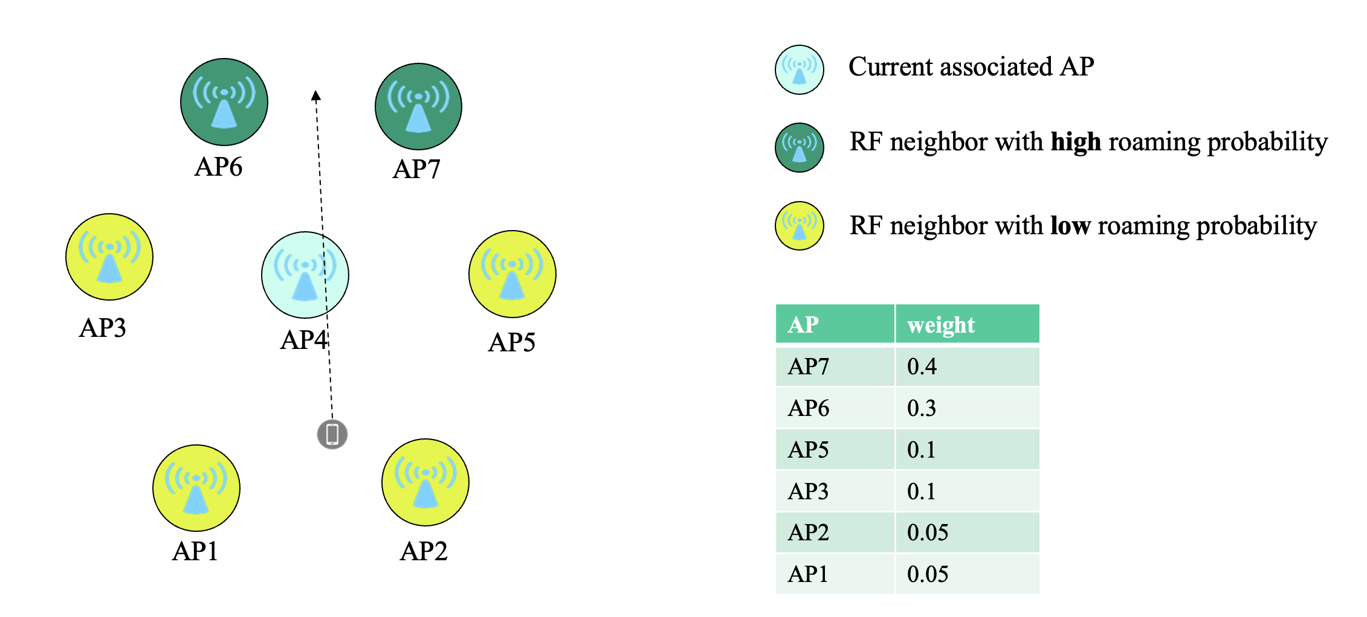
- Assist the STA to find the mid-point between APs.
The proposed solution aims at applying AIML tecniques to predict the optimal RSSI threshold for a given STA to start the scanning; the prediction can include the target RSSI value as well as the predicted time a given STA would reach such RSSI level (scanning delay), in order to help the STA know in advance when to expect the scanning to start being useful.
This allows the STA to optimize the time of scan and roam, to maintain the highest possible connection speed, without the need to wait for a usability threshold failure (e.g., increased retry/drop rate as reaching the cell edge).

The goal is to achieve overall faster roaming, with reduced latency and improved reliability.

The proposed solution supports multiple AIML implementations, from simple models to more sophisticated deep-learning techniques, allowing for distributed or centralized training and inference, adapting to different deployment scenarios. A sample implementation of the neighbor report weight calculation with an estimation of the benefits achieved as compared to a flat neighbor list is described in [29] .

How the AP determines the weights for each candidate AP or the target RSSI level can be implementation specific. The AP can use AIML techniques or non-AIML techniques to determine these values.

2.4.2 Requirements and Potential features analysis
Potential features analysis
The following potential features can be analyzed in this use case:
- Roaming neighbor list
- Roaming mean-point

    - Technical feasibility analysis

2.4.3.1 Standards impact
Notifying STAs about the weight of each roaming neighbor candidate requires the enhancement of the existing 802.11k neighbor report, using new optional elements.
Using optional elements to distribute this information would allow backwards compatibility.

Similarly, helping the STAs to trigger scanning at the mid-point between APs may require the enhancement of the 802.11v BTM request frame, for instance to include a scanning delay parameter.
The 802.11v BTM response frame can also be enhanced to let the STAs provide detailed feedback on the roaming recommendations, in order to allow the AP to improve the quality of the recommendations over time.
2.4.3.2 Technical feasibility
Depending on the specific implementation, the AIML capabilities can be either handled on each individual AP or managed on a central controller; the entity managing the model training would require sufficient computation capabilities to train and execute the implemented model.

References

- 11-22/597r3: May 2022 Working Group Motions, May 18, 2022
- IEEE 802.11-REVme D2.0, October 2022
- IEEE P802.11be D2.2, October 2022
- 802.11-18/0818r3, 16 Spatial Stream Support in Next Generation WLAN
- 802.11-20/1877r1, 16 Spatial Stream Support
- 802.11-20/1535r66, Compendium of straw polls and potential changes to the Specification Framework Document Part 2
- 802.11-22/1515, A candidate feature: Multi-AP
- 802.11-22/1394, Virtual BSS And Multi AP Transmissions
- 802.11-22/1516 Considerations on Multi-AP Coordination
- 802.11-22/1512 Multi-AP Coordination for UHR
- M. Deshmukh, Z. Lin, H. Lou, M. Kamel, R. Yang, I. Güvenç, “Intelligent Feedback Overhead Reduction (iFOR) in Wi-Fi 7 and Beyond,” in Proceedings of 2022 VTC-Spring
- P. K. Sangdeh, H. Pirayesh, A. Mobiny, H. Zeng, “LB-SciFi: Online Learning-Based Channel Feedback for MU-MIMO in Wireless LANs, ” in Proceedings of 2020 IEEE 28th ICNP
- P. K. Sangdeh and H. Zeng, “DeepMux: Deep-Learning-Based Channel Sounding and Resource Allocation for IEEE 802.11ax,” IEEE Journal on Selected Areas in Communications, Vol. 39, No. 9, Aug. 2021
- S. Szott, K. Kosek-Szott, P. Gawłoicz, J. T. Gómez, B. Bellalta, A. Zubow, F. Dressler, “WiFi Meets ML: A Survey on Improving IEEE 802.11 Performance with Machine Learning,” IEEE Communication Surveys & Tutorials, Vol.24, Issue 3, Juen 2022
- 802.11-22/0723r1, Further discussion on next generation WLAN
- 802.11-19/0719r1, IEEE 802.11be Channel Model Document
- 802.11-22/1443r0, Wi-Fi Meets ML: Re-thinking Next-generation Wi-Fi Networks
- 11-14-0165-01-0hew-802-11-hew-sg-proposed-par
- 11-18-1231-06-0eht-eht-draft-proposed-par
- 11-22-0030-01-0wng-look-ahead-to-next-generation
- 11-22-0046-01-0wng-next-generation-after-802-11be
- F. Abinader et al., “Performance evaluation of IEEE 802.11n WLAN in dense deployment scenarios”, 2014 IEEE 80th vehicular technology conference (VTC2014-Fall)
- A. Bhattacharya and A. Kumar, “Analytical Modeling of IEEE 802.11-Type CSMA/CA Networks with Short Term Unfairness”, IEEE/ACM Transactions on Networking, Vol. 25, Issue 6, Dec 2017
- W. Wydmański and S. Szott, “Contention Window Optimization in IEEE 802.11ax Networks with Deep Reinforcement Learning”, 2021 IEEE Wireless Communications and Networking Conference (WCNC)
- Z. Guo, Z. Chen, P. Liu, J. Luo, X. Yang and X. Sun, “Multi-agent reinforcement learning-based distributed channel access for next generation wireless networks”, IEEE Journal on Selected Areas in Communications, Vol. 40, Issue 5, May 2022
- Y. Ding, S. Liew and T. Wang, “Non-Uniform Time-Step Deep Q-Network for Carrier-Sense Multiple Access in Heterogeneous Wireless Networks”, IEEE Transactions on Mobile Computing, Vol. 20, Issue 9, Sept 2021
- L. Zhang, H. Yin, Z. Zhou, S. Roy and Y. Sun, “Enhancing Wi-Fi multiple access performance with federated deep reinforcement learning”, 2020 IEEE 92nd Vehicular Technology Conference (VTC2020-Fall)
- 11-22-0723-01-0wng-further-discussion-on-next-generation-wlan
- IEEE 802.11-23/0433r2 - AIML-based Roaming Enhancements Use Case
- 802.11-23/0275r2, Improved AIML Enabled Index Based Beamforming CSI Feedback Schemes
- 802.11-23/0280r0, ML aided Dual CSI Feedback for Next Generation WLANs
- 802.11-23/0290r3, Study on AI CSI Compression
- 802.11-23/0755r0, AIML Assisted Complexity Reduction For Beamforming CSI Feedback Using Autoencoder

