IEEE P802.11  
Wireless LANs

|  |  |  |  |  |
| --- | --- | --- | --- | --- |
| “Proposal for a revised Annex G containing an Introduction to Frame Exchange Sequences and their Wireless Medium” | | | | |
| Date: 2025-01 | | | | |
| Author(s): | | | | |
| Name | Affiliation | Address | Phone | email |
| Harry BIMS | Bims Laboratories, Inc. | Menlo Park, CA, USA. | 650 283 4174 | harrybims@me.com |

Abstract

This proposal seeks to introduce the reader to an alternative version of Annex G for describing frame exchange sequence examples, their temporal boundaries, and recommended practice based on frame exchange sequences that are specified in the P802.11-REVme/D5.0 document.

# A. Background

The Architecture Standing Committee has extensively debated the disposition of Annex G for many meetings. In the course of those discussions, the group has requested a proposed revision to Annex G that explains to the novice reader of the 802.11 standard, using informative text, the concept of frame exchange sequences, as the term is consistently used throughout the standard in various contexts. To this end, proposed text for Annex G is presented below for discussion. We may want to consider as part of the discussion the prospect of moving the informative text in clause O.3 (Example of RD frame exchanges) to Annex G, as it appears to be out of place in its current location.

The proposed Annex G presented below contains an informative description of frame exchange sequences, and their use in the normative text. The style of this proposed Annex G follows the style of other Annexes that provide exemplary descriptions of the normative text. In particular, consideration has been given to Annex I, Annex K.1, Annex L, Annex O.3, Annex Q, and Annex W.

**Annex G (revised)**

(informative)

# The WM context of frame exchange sequences

According to 3.1 and 4.3.5.1, there can be multiple instances of a wireless medium (WM), where each AP has a “WM for associated STAs”. As described in 8.1, data is transmitted and received between two or more STAs through a WM. This is repeated in this standard for each 802.11 PHY description. Though not described expressly in the normative text, it appears that each infrastructure BSS is a set of two or more STAs where an AP is associated with non-AP STAs. This association allows for communication across the wireless medium of the BSS.

When beamforming is used by the AP, it is temporarily creating a plurality of BSSs in parallel over which communication takes place with one or more associated STAs, where each BSS forms a WM instance. Figure 4-17 of 4.4.4 shows different the different infrastructure BSSs, which could originate from the same AP STA.



The consequence of this is that non-AP STAs that communicate with an AP that uses different beams to communicate with each, can have independent frame exchange sequences, and independent awake states or active modes that are not coordinated by a NAV value.

One example of this is Figure 10-14 of 10.3.2.13.1 in which each sequence of BAR and BA/Ack can occur over separate beams in parallel.



For example, the following are mechanisms related to frame exchange sequences:

1. TXOP error continuation.  A STA owning a TXOP that misses a response can recover by transmission after a PIFS, and can transmit to another STA.

2.       RDG.  Effectively transfers ownership of the balance of the current TXOP to another STA.  But that “balance” is constrained in that other STA can only talk to the original STA.

3.       HCCA.   This is a polled mechanism where the HC grants a sequence of TXOPs to other STAs.  The HC remains in control of who owns a TXOP,  and the duration of that TXOP.

The first two mechanisms are limited by the original TXOP boundaries and apply to both STAs and APs.  The TXOP limits are determined by the AP by signalling in the beacon.

The second two mechanisms are for APs to manage the medium and are not limited to a single TXOP limit.

# Frame Exchange Sequence Examples

A transmission of a frame by one peer STA, and the reception of that frame by one or more peer STAs across a WM is a basic form of a frame exchange sequence. One example of this is a communication between two peer STAs in an IBSS, as described in the figure from this standard shown below:



An instance of the WM is essentially identified in the normative text by three factors:

a) the frequency segment(s) within a radio frequency band used for contiguous or non-contiguous transmission of frames (see 3.1). For EDMG the frequency segment(s) occupy a bandwidth up to 2.16 GHz (see 10.38.12);

b) the type of IEEE 802.11 PHY used for frame exchanges between peer STAs (see 4.6), even if they are part of a colocated access point set, and

c) the optional set of beamforming steering matrices used for direct communication of frame exchanges between peer STAs operating as a beamformer/beamformee pair (see 3.1). See for example, the DMG PHY (see Clause 20) and EDMG PHY (see Clause 28).

As shown in the figure below, a single AP along with a subset of its associated STAs in an IBSS can form a WM.

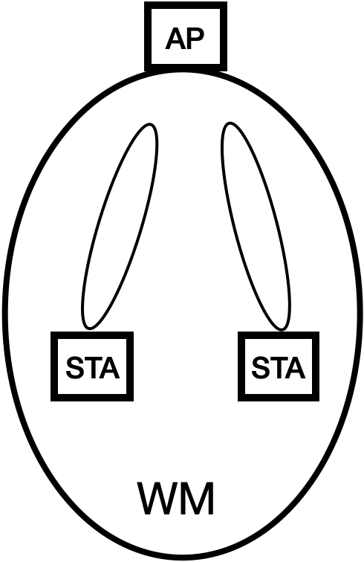

In the context of this WM, when a single MPDU is transmitted as a frame exchange, the one or more peer STAs that are addressed using a unicast or multicast address might use their own beamforming steering matrices to receive the MPDU, and the STA that transmitted the MPDU might use its own beamforming steering matrix to transmit the MPDU.

Further, when an A-MPDU is exchanged, the one or more associated STAs that are addressed by the MPDUs contained in this frame might use their own beamforming steering matrices to receive the A-MPDU, and the AP that transmitted the A-MPDU might use its own beamforming steering matrix to multicast the A-MPDU to all of the STAs in the WM. An acknowledgement frame from each STA that received at least one MPDU is then transmitted to the AP as a Block Ack.

The AP can manage multiple such WMs in parallel by sectorizing the IBSS, as shown in the figure below.

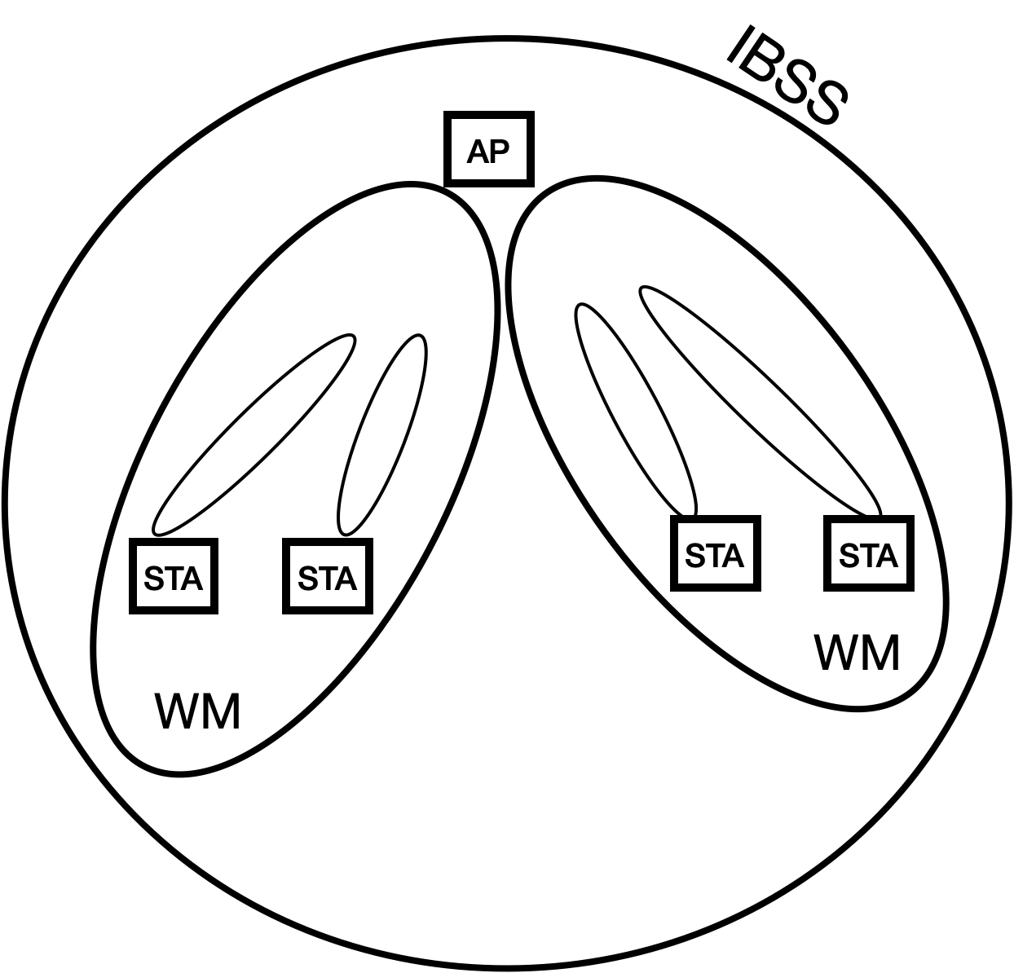

STAs that are in different WMs might rely on the DS to transport their MAC service tuples to peer STAs, as described in the definitions in 3.1, and shown in the figure below, if the different WMs are not colocated in the same AP. This applies to different WMs that use different frequency segments, and/or use different IEEE 802.11 PHYs, and/or use different optional sets of beamforming steering matrices.

In addition, the AP may use a different beamforming steering matrix for each associated STA in the WM, as described in the normative text figure below for the DMG STA:



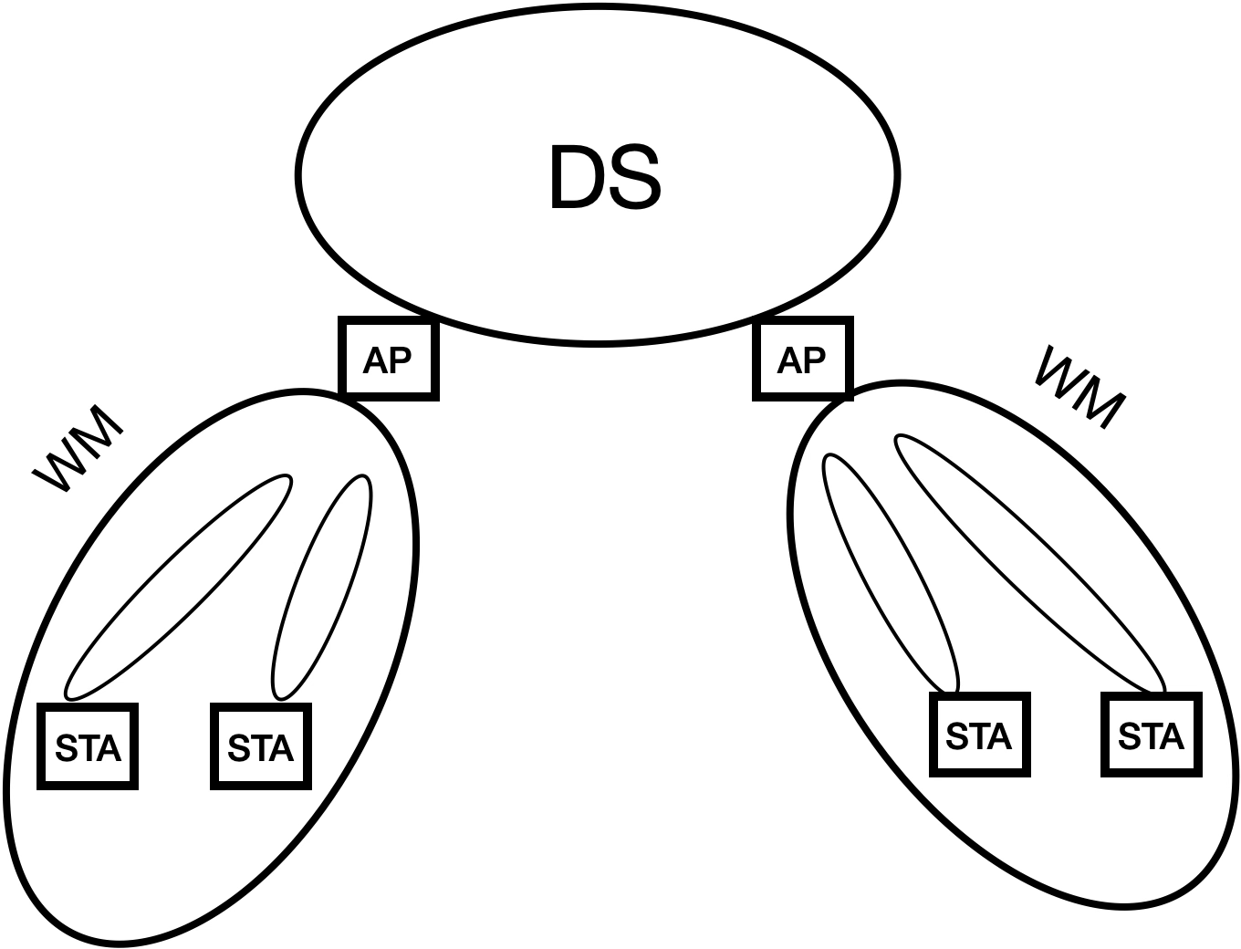

In the case of an OBSS, there can be multiple APs that participate in forming a single WM, as shown in the figure below. Within this WM, there can be multiple NAV values that control the WM.

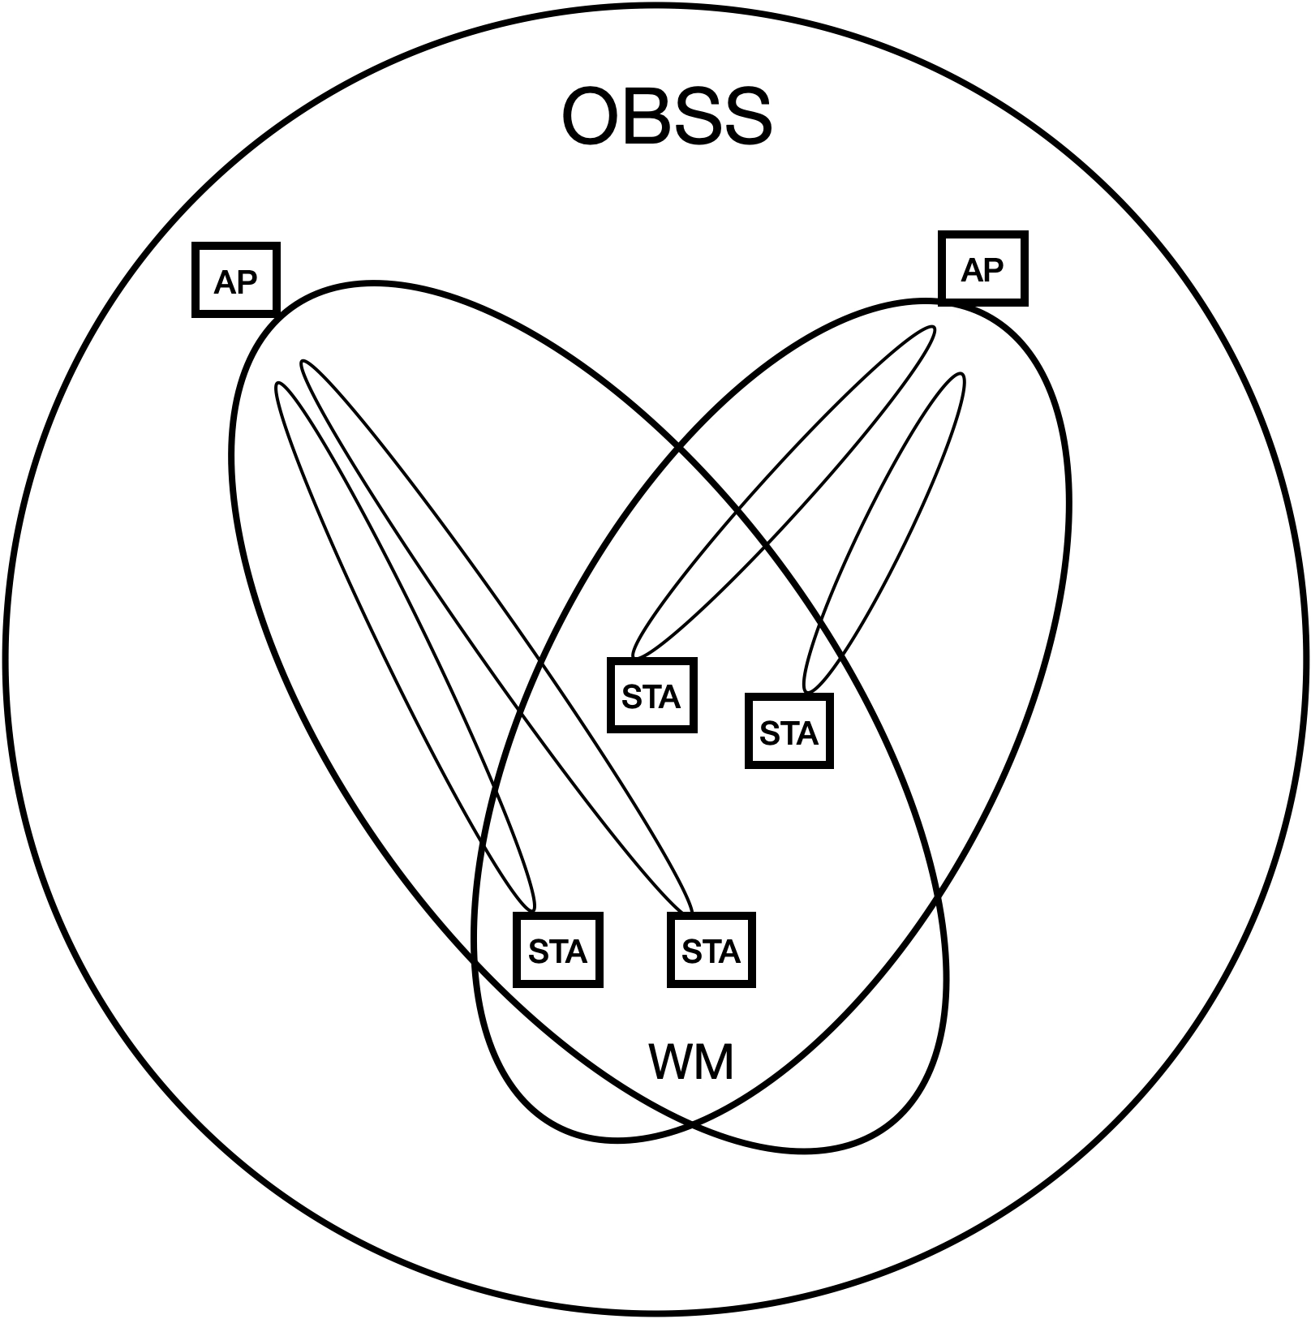

A frame exchange sequence is a series of frame exchanges communicated across a WM, that maintain control of the WM through their transport of the NAV and/or RID, and are communicated either serially and/or in parallel. Each frame transmitted during a frame exchange sequence includes a request to reserve the WM for a period of time. This reservation request is either a NAV value in the Duration/ID field, or for an S1G STA, can also include a response indication deferral (RID). Neither the NAV nor the RID are necessarily limited to any particular frame exchange sequence, or set of frame exchange sequences, however a frame exchange sequence must complete on or before the NAV or RID expires.

# Impact of NAV, Awake State, and RID on Frame Exchange Sequence Participation

According to 10.3.2.1, the NAV does not control the wireless medium, rather it merely “maintains a prediction of future traffic on the medium based on duration information that is announced in RTS/CTS frames by non-DMG STAs, in MU-RTS Trigger/CTS frames by HE STAs as defined in 26.2.6 (MU-RTS Trigger/CTS frame exchange exchange procedure, and in RTS/DMG CTS frames by DMG STAs prior to the actual exchange of data.” For any given frame exchange sequence (FES), the STAs participating in the FES use the NAV to remain in the awake state. However, there can be different understandings among the peer STAs about when they are allowed to transition from the awake state to the doze state. This can affect the timing for when certain procedures within a given STA that cannot be initiated when an ongoing awake state (or active mode) is required, can be initiated.

For example, as described in 10.3.2.1 and 9.2.5.2 for S1G STAs, there can be two virtual CS mechanisms provided by S1G MACs during a frame exchange sequence; 1) the single protection or multiple protection NAV (which is used to update the NAV under data rate selection rules, see 10.3.2.4), or 2) the response indication deferral (RID) (which is used to update the NAV after the RID is updated, see 10.3.2.4, and 10.3.2.5). The multiple protection NAV indicates to all STAs participating in the FES they are allowed to transition to the doze state only after the end of the TXOP, whereas according to 10.49.2, a non-AP STA may transition to the doze state if the More Data field in a frame sent by the AP is equal to 0 prior to the end of the TXOP.

There are several MAC layer procedures that are delayed within the awake state until the STA is no longer participating in an FES. According to 6.5.3.2.4, the scan process can be initiated only when a frame exchange sequence is completed. Similarly, according to 6.5.4.2.4, the synchronization procedure can be initiated only when a frame exchange sequence is completed, and according to 6.5.11.2.4, the BSS initialization procedure can be initiated only once the current frame exchange sequence is completed, and according to 9.2.4.1.7 and 9.2.4.5.11, the power management mode of a STA is initiated only after successful completion of a frame exchange sequence. Thus, these procedures can be initialized once a frame exchange sequence has completed during an ongoing TXOP, if a single protection NAV is used by the TXOP holder.

As described in 11.2.6, the completion of a frame exchange sequence can be determined through multiple possibilities, including a deteremination made by the CS mechanism:

“The STA can determine the end of the frame exchange sequence through any of the following:

* It receives an individually addressed frame addressed to another STA.
* It receives a frame with a TA that differs from the TA of the frame that started the TXOP.

. . .

* The CS mechanism (see 10.3.2.1 (CS mechanism) indicates that the medium is idle at the TxPIFS slot boundary (defined in 10.3.7 (DCF timing relations)).”

This nuance is not currently captured in the normative text, and should be explained to the reader in Annex G where appropriate.

# In addition, according to 10.3.2.5, the RID is updated when a S1G PPDU is received, except when a non-zero Duration/ID field is received that sets the NAV. Thus, different S1G STAs can have different perspectives on the ending of the FES depending on whether their RID counter was updated, or their NAV was reset.

ofinir

# Availability of a STA for Participation in Frame Exchanges

Each STA in a WM determines whether or not it is currently participating in an FES. This determination is necessary because there are at least four processes: a) scan procedure (see 6.5.3.2.4), synchronization procedure with a newly joined BSS (see 6.5.4.2.4), BSS initialization procedure (see 6.5.11.2.4), and the power save mechanisms (see 11.2.3.11, 11.2.3.16 (when allowed by the VHT AP during a TXOP after a BlockAck), 11.2.3.18, 11.2.4.2, 11.2.4.4, 11.2.7.1, 11.2.7.2.2, 11.2.7.2.3, 11.2.7.3.3, 11.2.7.4, and 11.2.7.5) within a STA that arerequired by the normative text to delay their execution if the STA is currently participating in an FES, see 11.2.3.1.

For example, though the normative text at 11.1.4.1 says “details of how to optimize scanning is out of scope of this standard”, if a STA that is participating in a FES initiates its scan procedure during its participation in an FES will cause the STA to become unavailable during a time period where other STAs may attempt to exchange frames with the STA across the WM. The normative text expressly requires that the BSS initialization procedure must delay until the current frame exchange sequence is complete.

By definition, any STA that does not transmit or receive a PPDU frame transmission or control frame during an FES prior to the execution of one of these four processes, does not participate in that FES for its entire duration.

When a STA transmits a PPDU or control frame in the context of an FES, it becomes a participant in the FES. When a STA receives a PPDU frame transmision or a control frame transmission that addresses the STA in its destination address field, the STA also becomes a participant in the FES. Once a STA becomes a participant in an FES, there are many reasons for a STA to terminate is participation in the FES, as described in the various clauses of the normative text.

In addition, at least the dynamic SM power save mode requires the participation of the STA in a FES to be completed before switching back from enabling multiple receive chains to single receive chain mode (see 11.2.6).

# Examples of Frame Exchange Sequences

## Introduction

Frame exchange sequences are described in a variety of contexts throughout the normative text. For example, descriptions of frame exchange sequences are generally included in the normative text of multiple clauses (i.e., 4.3.10 (describing frame exchange rules are part of the core QoS facility), 4.3.11.11 (describing link measurement a frame exchange seqeunce), Clause 10 (describing different STA Types), Clause 11 (describing a GAS frame exchange sequence), 4.3.24.5.6 and 14.6 (describing AMPE and MCCA), 4.10 (describing 802.1X frame exchange sequences), 6.3 and Clauses 26 through 28 (each describing a different peer PHY entity). Informative text descriptions of frame exchange sequences are also described in Annex O (RD frame exchanges), and Annex Y (PAD procedures). The first description of a frame exchange sequence appears in 4.10.3.3, Figure 4-34.

Often, these descriptions are tailored to the specific requirements context of the clause in which they appear. For example, some frame exchange sequences are identified by a higher layer protocol (9.4.2.123), or by a peer-to-peer application (9.4.2.254). For some PHY scenarios, there is only one wireless channel instance, for other PHY scenarios, there may be several channel instances of the wireless medium, due to sectorization, beamforming, and MU-MIMO.

At times different peer STAs involved in a frame exchange sequence may terminate their participation in the FES, even though in accordance with 9.2.5.2, 9.2.5.4 and 9.2.5.5, each STA’s estimated time duration of the NAV that controls the WM in which the FES communicates is determined by the value of the Duration/ID field in all exchanged frames. See 10.3.2.6. This is particularly true for a frame exchange sequence involving more than two STAs (such as the MU PPDU frame exchange sequence, see Figure 10-13 or Figure 10-16), where an individual STA can terminate its participation before the completion of a a group FES. This can affect the timing for when certain procedures are initiated by each STA, and can affect channel efficiency if neighboring STAs with pending transmissions are waiting for the NAV to expire, and determine that all STAs have ended their participation in the FES before the NAV has expired outside of a TXOP interval.

This Annex provides examples of frame exchange sequences that depict their usage throughout the various clauses of this standard. This Annex will not cover reference designs or recommended implementations of frame exchange sequences. The examples of frame exchange sequences that will be covered in Annex G include the following contexts:

1. DCF. This example is one in which a minimum specified duration exists between basic frame exchange sequences to gain control of a wireless medium for the duration of a contention-based access period protected by a NAV.
2. HCCA and EDCA. This example is one in which HCF frame exchange sequences are implemented as part of the channel access rules defined by the HCF. See 10.2.3.
3. MCCA. This example is one in which the efficiency of frame exchange sequences is optimized in a mesh BSS.
4. TXOP. This example is one in which frame exchange sequences may be initiated by one or more QoS STAs or an AP in an MU cascading sequence. In this case, a TXOP responder may or may not transmit its frame within the time window of the TXOP, given the estimated time required for transmission of the response frame may be inexact.
5. GCR TXOP. This example is one in which frame exchange sequences may be initiated by one or more APs and/or mesh stations to support the GCR service.
6. Multiple frame exchange sequences in an EDCA TXOP or HCCA TXOP. This example is one in which other mechanisms have overlapping control of the wireless medium with frame exchange sequences.
7. Association of a GLK STA with a GLK AP. This example is one of many in which frame exchange sequences may occur outside the context of an HCF, MCCA or TXOP. Service Period, Announcement Transmission Interval (ATI) and Data Transfer Interval (DTI) are other examples.
8. DMS Request and Response frame exchange to set up GLK-GCR service.
9. Peer-to-peer application. This example is one in which a peer-to-peer application can identify individual frame exchange sequences between HE STAs.
10. Block Ack for VHT PHYs. This example is one in which a single frame exchange sequence includes multiple block acknowledgments, each from a different STA, and each preceded by either a BAR or a MU PPDU transmitted by an AP STA.
11. Restricted Access Window (RAW). This example is one in which a frame exchange sequence shall not exceed the allocated RAW slot boundary.
12. GCR MU-BAR. This example is one in which a frame exchange sequence includes two types of Block Acks for the GCR group members.
13. RD frame exchanges. This example is shown in the informative text of clause O.3.
14. Implicit transmit beamforming. This example is one in which a transmit beamforming frame exchange sequence is initiated by an unsteered PPDU that includes a training request.
15. SU-MIMO and MU-MIMO channel access. This example is one in which frame exchange sequences use MIMO channel access to exchange frames.
16. TXOP-based sectorization operation. This example is one in which spatially orthogonal frame exchange sequences are transmitted until the expiry of the SO timer without resetting the NAV.
17. Sector training. This example is one in which an AP transmits NDP CTS frames, followed by sector ID feedback.
18. Power management in an MBSS. This example shows the unique endings of the frame exchange sequence.

Suggested categories for these frame exchange sequences that will be used for the purpose of examples in this Annex are described below:

1. contention-based access periods (including RTS/CTS) generally the DCF and contention-based HCF

the remaining categories are for protection mechanism-based access periods.

1. Frame aggregation
2. Block acknowledgment
3. Service period)
4. Reverse Direction (see 10.29.1)
5. Beamforming on single spatial stream
6. Point-to-multipoint frame exchanges between an AP STA (the point STA sending a multicast frame) and each of its multipoint STAs (that respond with unicast frames).
7. The abovementioned frame exchange sequences exchange frames within a single wireless medium. Below are for frame exchange sequences that exchange frames across multiple wireless media.

The following table depicts the STA Types that are described as part of the normative description of each FES category. Depending on its capability as described in the normative text, a STA Type that is not described as part of the normative description of a FES Group, might nonetheless support the FES Group. In addition, the FES Groups may not be mutually exclusive. For example, an RTS/CTS protection mechanism used to begin a frame exchange within an EDCA-based TXOP, while the countdown of the NAV timer for the TXOP spans more than one frame exchange sequence, and the TXOP holder determines that start and stop of individual frame exchange sequences within the TXOP (10.23.2.3, 10.23.2.8, 10.23.3.4, 10.50. 26.2.8).

| **FES Grouping** | **STA Types referenced in the FES Group normative descriptions (non-referenced STA Types might be capable of certain FES Groups)** | | | | | | | | | |
| --- | --- | --- | --- | --- | --- | --- | --- | --- | --- | --- |
| **DCF** | **DMG** | **CDMG** | **CMMG** | **GLK** | **EDMG** | **HE** | **S1G** | **VHT** | **HT** |
| Contention-based access period (NAV) | X |  |  |  |  |  |  |  |  |  |
| Protection mechanism-based access period (10.27) | X  (RTS/ CTS) | X  (DMG CTS) |  |  |  | X | X |  | X | X |
| TXOP holder-based access period within a TXOP (10.23.2.8, 10.29.2, 10.50) (EDCA/HCCA/ Reverse Direction) |  | X | X | X |  | X | X | X | X | X |
| Scheduled access period (10.39.6) |  |  |  |  |  | X |  |  |  |  |
| Block acknowledgment (10.25) |  | X | X | X |  |  | X | X |  | X |
| Service period w/ dynamic truncation (Reverse Direction) (10.39) |  | X | X | X |  |  |  |  |  | X |
| Beamforming on single spatial stream (10.33, 10.34, 10.42.1) |  | X | X | X |  | X |  |  | X | X |
| Multi-user MIMO (10.42.10.2, 26.5.3) |  |  |  |  |  | X | X |  |  |  |
| MIMO and spatial sharing across multiple wireless media (10.39.12.4, 10.42.10.2.2) |  | X | X | X |  | X |  |  |  |  |
| Simultaneous Multiband (11.31) |  | X | X |  |  |  |  |  |  |  |
| Transparent Fast Session Transfer |  | X |  | X |  |  |  |  |  |  |
| Traffic Wake Time and Quiet Time Period (10.47) |  |  |  |  |  |  | X |  |  |  |

## Example 1—HE and VHT STA Frame Exchange Sequences with MU acknowledgments

The HE STA and VHT STA are capable of frame exchange sequences that contain multi-user acknowledgments, as described in Clause 10.3.2.13.

### Termination of the frame exchange sequence time interval

For any given multi-user frame exchange sequence (FES), there can be different peer STAs can terminate their participation at different times prior to when the FES terminates. For this example, there are two perspectives:

Persepctive #1: The STA that initiates the FES (STA #1, also called the TXOP holder) identifies the end of the FES as the end of a PIFS interval following the last transmission during the FES. The timing for the end of the last transmission of the FES is either pre-determined by the particular FES (e.g., an RTS / CTS exchange) or is scheduled by STA #1 for the current FES (when it schedules BAR frames).

Perspective #2: A peer STA to STA #1 (STA #2) identifies the end of the FES as the end of a PIFS interval following the last frame transmission it is destined to receive during the FES. This understanding may differ from STA #1. For example, if STA #1 transmits PPDUs to four different STAs (STA #2 through STA #5) during a single FES, and STA #2’s CCA function indicates the medium is idle while the BlockAcks from STA #3 through #5 are transnmitted, then STA #2 may declare the end of its participation in the frame exchange sequence a PIFS interval after its BlockAck transmission. Note, however, that the NAV protection signaled by STA #1 still prevents STA #2 from initiating any transmission until STA #5 has transmitted, regardless of CCA sensing. If STA #2’s CCA function indicates the medium is busy when the BlockAcks from STA #3 through #5 are transmitted, then STA #2 will immediately terminate its FES with STA #1 if it can decode the PPDU, per the normative text. See §11.2.6:

“The STA can determine the end of the frame exchange sequence through any of the following:

* It receives an individually addressed frame addressed to another STA.
* It receives a frame with a TA that differs from the TA of the frame that started the TXOP.

. . .

* The CS mechanism (see 10.3.2.1 (CS mechanism) indicates that the medium is idle at the TxPIFS slot boundary (defined in 10.3.7 (DCF timing relations)).”

These differences in perspective allow for the possibility that a non-TXOP holder may engage scanning, power save, and/or power management mechanisms while the TXOP holder is waiting for BlockAck frames from other non-TXOP holders. This behavior may or may not impact the delivery of re-transmissions from the TXOP holder.

## Example 2—RD frame exchange sequences

***[Editor instruction to copy the text in O.3]***