IEEE P802.11  
Wireless LANs

|  |  |  |  |  |
| --- | --- | --- | --- | --- |
| LB271 CR for subclause 36.3.21 Receiver specification | | | | |
| Date: 2023-04-10 | | | | |
| Author(s): | | | | |
| Name | Affiliation | Address | Phone | email |
| Yapu Li | OPPO | 15F, Building A2, Central Park Plaza, Chao Yang, Beijing, China |  | liyapu1@oppo.com |
| Xiaogang Chen | ZEKU |  |  |  |

Abstract

This submission contains proposed comment resolutions to the following CID based on P802.11be D3.0. The changes are based on P802.11 be D3.1

CID 15745, 15746, 15747, 15748, 17629

Revisions:

- Rev 0: Initial version of the document.

-

# CID 15745, 15746

|  |  |  |  |  |  |
| --- | --- | --- | --- | --- | --- |
| **CID** | **Page.**  **Line** | **Clause** | **Comment** | **Proposed Change** | **Resolution** |
| 15745 | 889.11 | 36.3.21.1 | "Device Under Test"? Why is this term capitalized? (It is not a defined term.) Also, this term suggests that the device undergoes a test, whereas what is really being stated is a normative requirement on the device. | Change "Device Under Test" to "STA". | Revised  Agree with the commenter in principle. To consist with 11me D2.1, change "Device Under Test" to "receiving STA".  **Instructions to the editor:**  **Please make the changes to the spec as shown in 11/23-0614r0** |
| 15746 | 889.12 | 36.3.21.1 | "Device Under Test"? Why is this term capitalized? (It is not a defined term.) Also, this term suggests that the device undergoes a test, whereas what is really being stated is a normative requirement on the device. | Change "Device Under Test" to "STA". | Revised  Agree with the commenter in principle. To consist with 11me D2.1, change "Device Under Test" to "receiving STA".  **Instructions to the editor:**  **Please make the changes to the spec as shown in 11/23-0614r0** |

**Discussion**

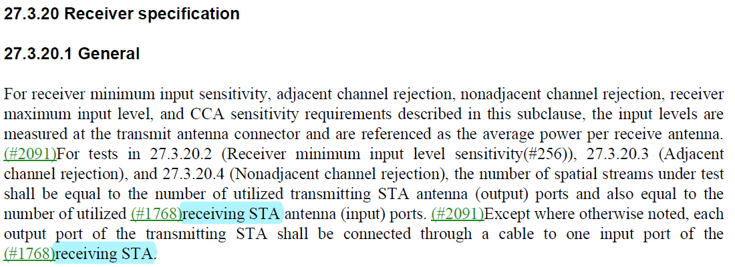

***TGbe editor:***

***Please make the following changes in Page 896 Line11-12 in D3.1:***

For receiver minimum input sensitivity, adjacent channel rejection, nonadjacent channel rejection, receiver maximum input level, and CCA sensitivity requirements described in this subclause, the input levels are measured at the antenna connector and are referenced as the average power per receive antenna. The number of spatial streams under test shall be equal to the number of utilized transmitting STA physical antenna (output) ports and also equal to the number of utilized (#15745)receiving STA antenna (input) ports. Each output port of the transmitting STA shall be connected through a cable to one input port of the (#15746)receiving STA.

# CID 15747, 15748

|  |  |  |  |  |  |
| --- | --- | --- | --- | --- | --- |
| **CID** | **Page.**  **Line** | **Clause** | **Comment** | **Proposed Change** | **Resolution** |
| 15747 | 889.45 | 36.3.21.2 | What exactly is the purpose of listing requirements for the first 11 MCSs in this list in bandwidths from 20 MHz to 160 MHz? It seems they are all identical to the requirements stated for the same MCS in the same bandwidth in HE, which are in turn the same (for applicable MCSs and bandwidths) for VHT, which are in turn the same (for applicable MCSs and bandwidths) for HT, which are in turn the same (for applicable MCSs and bandwidths) for ERP and OFDM. An EHT device is an HE device, so this is utterly duplicative. Apart from pointlessly cluttering up the standard, this adds unnecessary overhead to the task of determing whether a given deice is compliant. Can we stop the mindless copying of (already rather meaningless) requirements? | Split Table 36-67 into two, with the first 11 MCSs in one new table and the last 4 in a second table. In the first table, delete the columns corresponding to bandwidths from 20 MHz to 160 MHz inclusive. | Rejected  It’s better to list the “Receiver minimum input level sensitivity” of all EHT-MCS cases for readability and completeness of the spec. |
| 15748 | 890.43 | 36.3.21.3 | What exactly is the purpose of listing requirements for 20/4/80/160 MHz for the first 11 MCSs in this table? They appear to be the same as the values prescribed for the same case for HE (Table 27-52 in 11me D2.0). Since 320 MHz is the only new case for these MCSs, and its value is the same in each case as for 20/40/80/160 MHz, it would be simpler to replace the rows corresponding to the first 11 MCSs with an approriate sentence. | Delete the rows corresponding to the first 11 MCSs in Table 36-68, and add a new sentence after the table: "For all other MCSs, the adjacent channel rejection and nonadjacent channel rejection shall be no less than specified for HE devices for 20/40/80/160 MHz." | Rejected  It’s better to list the “Minimum required adjacent and nonadjacent channel rejection levels” of all EHT-MCS cases for readability and completeness of the spec. |

# CID 17629

|  |  |  |  |  |  |
| --- | --- | --- | --- | --- | --- |
| **CID** | **Page.**  **Line** | **Clause** | **Comment** | **Proposed Change** | **Resolution** |
| 17629 | 889.32 | 36.3.21.2 | Unlike HE, we don't have an explicit bit for DCM so "BPSK modulation with DCM" is inelegant | Try "for MCS 14 or MCS15" in place of "BPSK modulation with DCM" | Revised  Agree with the commenter in principle.  **Instructions to the editor:**  **Please make the changes to the spec as shown in 11/23-0614r0** |

***TGbe editor:***

***Please make the following changes in Page 896 Line31 in D3.1:***

**36.3.21.2 Receiver minimum input sensitivity**

The PER shall be less than 10% for a PSDU with the rate-dependent input levels listed in Table 36-67 (Receiver minimum input level sensitivity). The PSDU length shall be 2048 octets for EHT-MCS 14 or EHT-MCS 15 or 4096 octets for all other modulations.