IEEE P802.11
Wireless LANs
LB271 CR for for EHT-SIG Part 2
Date: 2023.03.25
Author(s):
Name | Company | Address | Phone | email
Ross Jian Yu | Huawei Technologies | F3 building, Huawei Base, Bantian, Longgang, Shenzhen, Guangdong, China, 518129 |  | ross.yujian@huawei.com
Ming Gan | Huawei Technologies
Abstract
This submission contains proposed comment resolutions to comments on P802.11be D3.0.

Two comments are resolved.
CID 15269 and 16643

Revision Notes

R0 | Initial revision
R1 | Modify the NOTE for CID 16643

CID 15269
Page.  Line | Clause Number | Comment | Proposed Change | Resolution
785.22 | 36.3.12.8.3 | According to the definition of unallocated RU (Page 791, Line 1), it is confusing to say unallocated 484-RU here. Suggest changing "unallocated" into "unassigned" (which can be expressed by two unassigned 242-tone RU). | As in the comment | REVISED  Agree with the commenter, reflect the detail changes. Also try to unify the wording throughout the spec.  Instructions to the editor:  Please make the changes as shown in 11/23-0533r1
Discussion
In P802.11be D3.1, there are three terminology used for an empty RU:
- Unassigned (9 times)
36.3.2.2.3.3 Location of large size MRUs, P719

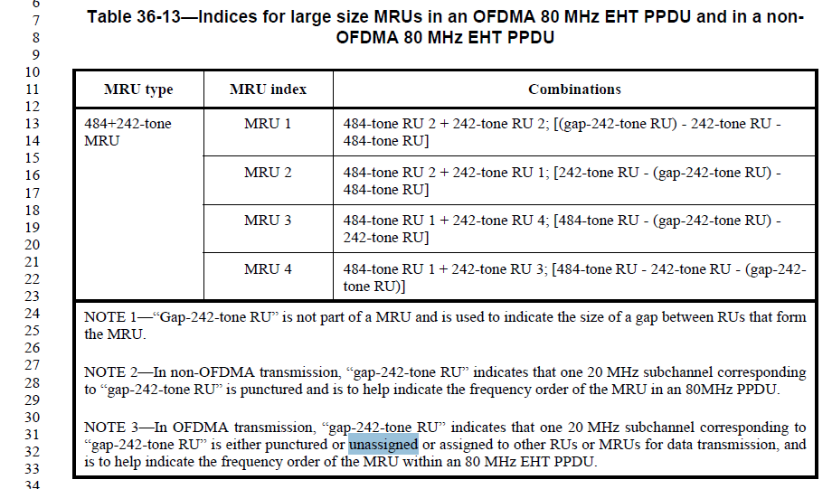
P721
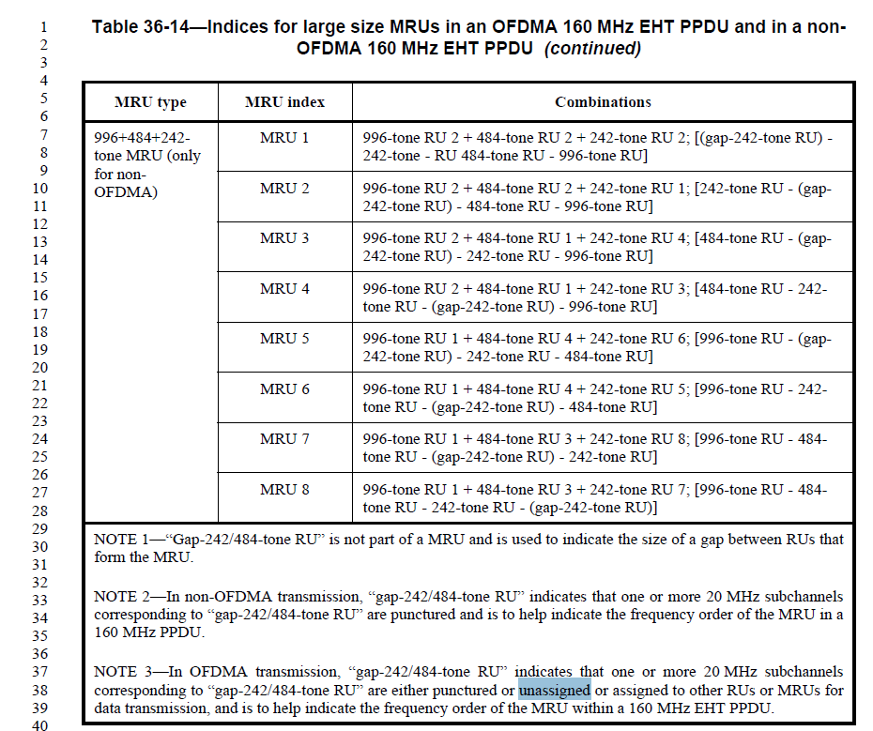
P724
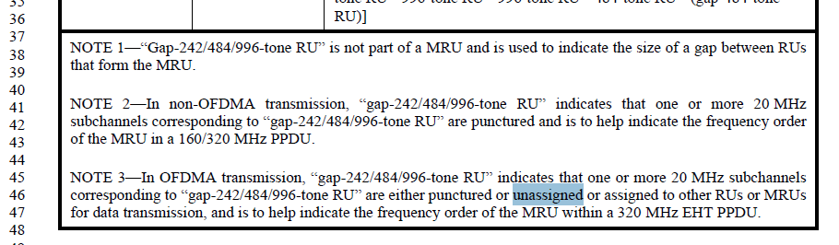
P791

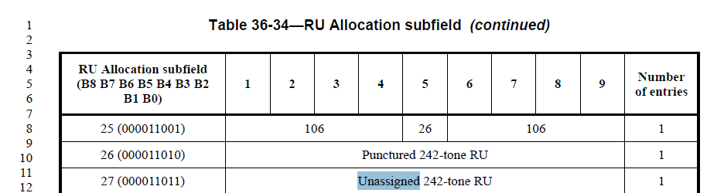
P794
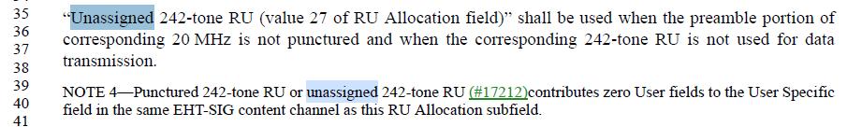
36.3.12.10 EHT-LTF, P826
36.3.12.11.4 Preamble puncturing for EHT TB PPDUs, P830
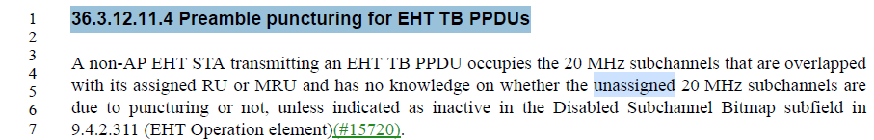
Z.12 EHT-SIG example 7, P995
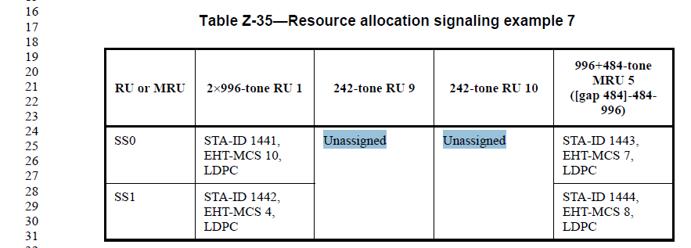

- Punctured (230 times)
- Unallocated (5 times)
9.3.1.22.4 HE variant User Info field, P181
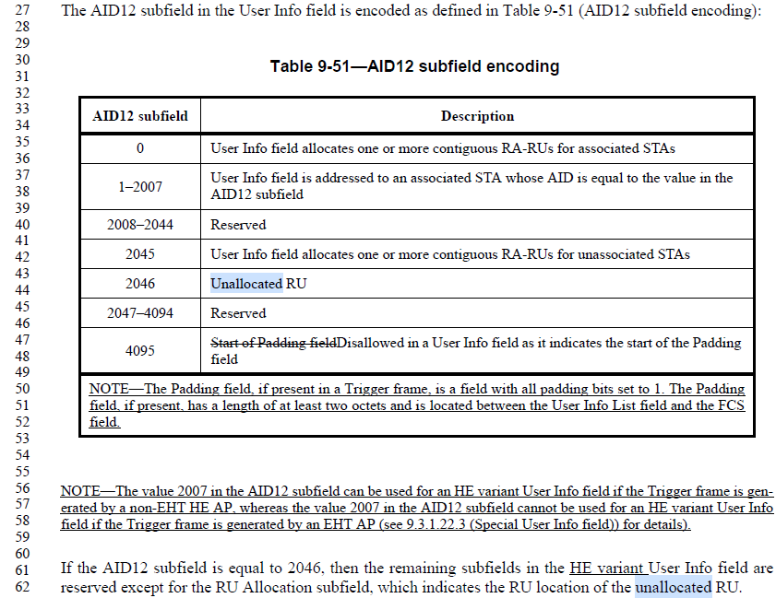
P183
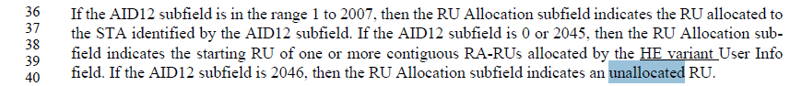
36.3.12.8.3 Common field for OFDMA transmission, P789
P795
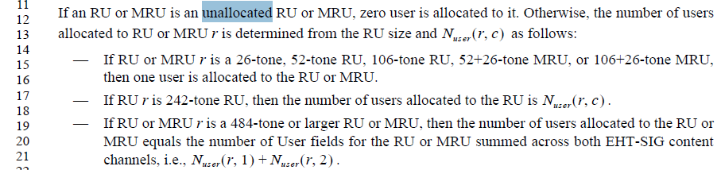

Some descriptions in the spec regarding punctured and unassinged:
“Punctured 242-tone RU (value 26 of RU Allocation field)” shall be used when the preamble portion of corresponding 20 MHz is punctured. In this case, the corresponding 242-tone RU shall not be used for data transmission.
“Unassigned 242-tone RU (value 27 of RU Allocation field)” shall be used when the preamble portion of corresponding 20 MHz is not punctured and when the corresponding 242-tone RU is not used for data transmission.

If we try to unfiy the wording of unassigned or unallocated, then below is my suggestion,
Unassigned: used when there is no preamble puncturing.
Unallocated: does differentiate puncturing or not, used for both the puncturing case and the unassigned case.

End of discussion
TGbe editor, please make the changes to P826, line 14 of P802.11be D3.1 as shown below:
For an OFDMA transmission, the values of the EHT-LTF sequence (defined in Equation (27-41) to Equation (27-52) and Equation (36-38) to Equation (36-40)) are replaced by zero, for all subcarriers that belong to unallocated (#15269) RUs as well as for DC tones or null subcarriers

TGbe editor, please make the changes to P830, line 5 of P802.11be D3.1 as shown below:
A non-AP EHT STA transmitting an EHT TB PPDU occupies the 20 MHz subchannels that are overlapped with its assigned RU or MRU and has no knowledge on whether the unallocated (#15269)20 MHz subchannels are due to puncturing or not, unless indicated as inactive in the Disabled Subchannel Bitmap subfield in 9.4.2.311 (EHT Operation element)(#15720).

TGbe editor, please make the changes to P789, line 22 of P802.11be D3.1 as shown below:
An RU Allocation subfield shall not indicate an RU or MRU which occupies all nonpunctured 20 MHz channels within the PPDU bandwidth.
NOTE 1—For example, a 4996-tone RU cannot be indicated by the RU Allocation subfield. A 996-tone RU cannot be indicated by the RU Allocation subfield in an 80 MHz EHT MU PPDU. A 3996+484-tone RU cannot be indicated in a 320 MHz EHT MU PPDU with 40 MHz puncturing indicated in the U-SIG field.
NOTE 2—For a DL OFDMA transmission to a single user, RU Allocation subfields can indicate an RU or MRU that occupies part of nonpunctured 20 MHz channels within the PPDU bandwidth. For example, a 3996+484-tone MRU can be indicated to a single user with the other 484-tone RU unassigned (#15269)in a 320 MHz EHT MU PPDU.

CID 16643
Page.  Line | Clause Number | Comment | Proposed Change | Resolution
801.15 | 36.3.12.8.5 | MU-MIMO is supported for equal or greater than 242 tones. STA-ID = 2046 is to indicate non-allocated RU for less than 242 tones. Thus, there is no case when STA-ID=2046 is used in User field format for an MU-MIMO allocation. | For MCS and Coding, please make sure STA-ID shall not be 2046 for MU-MIMO case. And delete "Set to an arbitrary value if the STA-ID subfield is equal to 2046." | REVISED  Agree with the commenter, reflect the detail changes.  Instructions to the editor:  Please make the changes as shown in 11/23-0533r1.
Discussion
The commenter’s comment is valid. See:
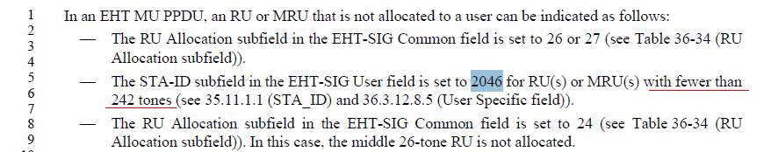
Hence STA-ID 2046 shall not be used in an RU with MU-MIMO.
End of discussion

TGbe editor, please make the changes to P806, line 21 of P802.11be D3.1 as shown below:
Table 36-41—User field format for an MU-MIMO allocation
Bit | Subfield | Number of bits | Description
B0-B10 | STA-ID | 11
  Set to a value of the TXVECTOR parameter STA-ID (see 35.11.1.1 (STA_ID)).
  NOTE - An RU/MRU using MU-MIMO has RU/MRU size greater than or equal to 242 tones. Thus, the STA ID subfield is not set to 2046 for an MU-MIMO RU allocation (see 36.3.12.8.3).(#16643)
B11–B14 | MCS | 4 | (#16643)Indicates the following modulation and coding scheme:  Set to n for EHT-MCS n, where  (#16643)  If the value of STA-ID subfield matches the user’s STA-ID, other values are Validate. If the value of STA-ID subfield does not match the user’s STA-ID, all values are Disregard.
B15 | Coding | 1 | (#16643)Indicates whether BCC or LDPC is used:  Set to 0 for BCC.  Set to 1 for LDPC.  If the RU size is larger than 242, this bit is reserved and set to 1.  (#16643)  If the value of STA-ID subfield matches the user’s STA-ID, the Reserved subfield is Validate. If the value of STA-ID subfield does not match the user’s STA-ID, the Reserved subfield is Disregard.
B16–B21 | Spatial Configuration | 6 | Indicates the number of spatial streams for a user in an MU-MIMO allocation (see Table 36-42 (Spatial Configuration subfield encoding)).  If STA-ID matches, the values that are reserved or do not exist in Table 36-42 (Spatial Configuration subfield encoding) are Validate.  If STA-ID does not match, all values are Disregard.

