IEEE P802.11
Wireless LANs
Proposed IEEE 802.11 AIML TIG Technical Report Text for the AIML-based Roaming Enhancements Use Case
Date: 2023-06-13
Author(s):
Name | Affiliation | Address | Phone | email
Federico Lovison | Cisco Systems |  |  | flovison@cisco.com
Jerome Henry | Cisco Systems |  |  | jerhenry@cisco.com
Juan Carlos Zuniga | Cisco Systems |  |  | juzuniga@cisco.com
Sukrit Dasgupta | Cisco Systems |  |  | sukdasgu@cisco.com
Abstract
This document contains the proposed text for the AIML-based Roaming Enhancements use case to be included in the IEEE 802.11 AIML TIG technical report.

Revision history:
r0: initial version
r1: extended description of the proposed use-cases
r2: added feedback received during the May 15th AM2 session in Orlando
r3: added missing section for KPIs
r4: add comments from the May 30th teleconference
Introduction
  - Terminologies
  - Background information

- AIML Use cases for IEEE 802.11
  - Use case N: Roaming Enhancements
    - Use case description
Multi-AP networks commonly see a high level of roaming events. In dense AP deployments, the high number of roaming candidate APs and channels in use can cause the STA scanning process to take a long time, affecting the device battery lifetime and the user experience.

The 802.11k neighbor report, sent by the AP upon STA request, indicates neighboring APs BSSID, channel, PHY type and optional elements (see 802.11-2020 9.4.2.36) that are useful to assist STA roaming decisions, manly by providing a subset of channels and pre-scanned candidate list.

However, not all the RF neighbor APs are equally relevant for the STA to make optimal roaming decisions. Each AP can have tens of neighbors, close and far, and there are no easy mechanisms for the STA to determine early which is the likely best next AP to roam to.

The roaming enhancement use case proposes to apply AIML techniques to determine the probability of a STA to roam to a specific AP, based on the learned client roaming patterns.
In particular, the output of the AIML algorithm can be used to:
- Augment the 802.11k neighbor report, assigning a weight to each candidate, to help the STA prioritize scanning towards APs that are the most probable roaming targets.
While roaming algorithms implemented on STAs often already assign a weight to each neighbor, based for instance on QBSS load, the proposed weight represents the probability of the STA to roam to a given AP based on roaming patterns; therefore it would help STAs prioritize scanning on channels that are likely served by APs located on the STA’s direction of movement, which in some scenarios will be more relevant than the load information (e.g., if the least loaded AP is located in the opposite direction than the client’s moving direction, associating to such AP would probably require the STA to roam again within a short time).
The proposed enhancements aim at providing the STAs roaming algorithms with additional information, in order to improve the quality of roaming decisions. Likewise, the STAs can share information about the roaming decisions or its local conditions, which can then be used to further enhance future weight reports (e.g., providing a reason code in case the STA decides not to follow the recommendations received by the AP, etc.).
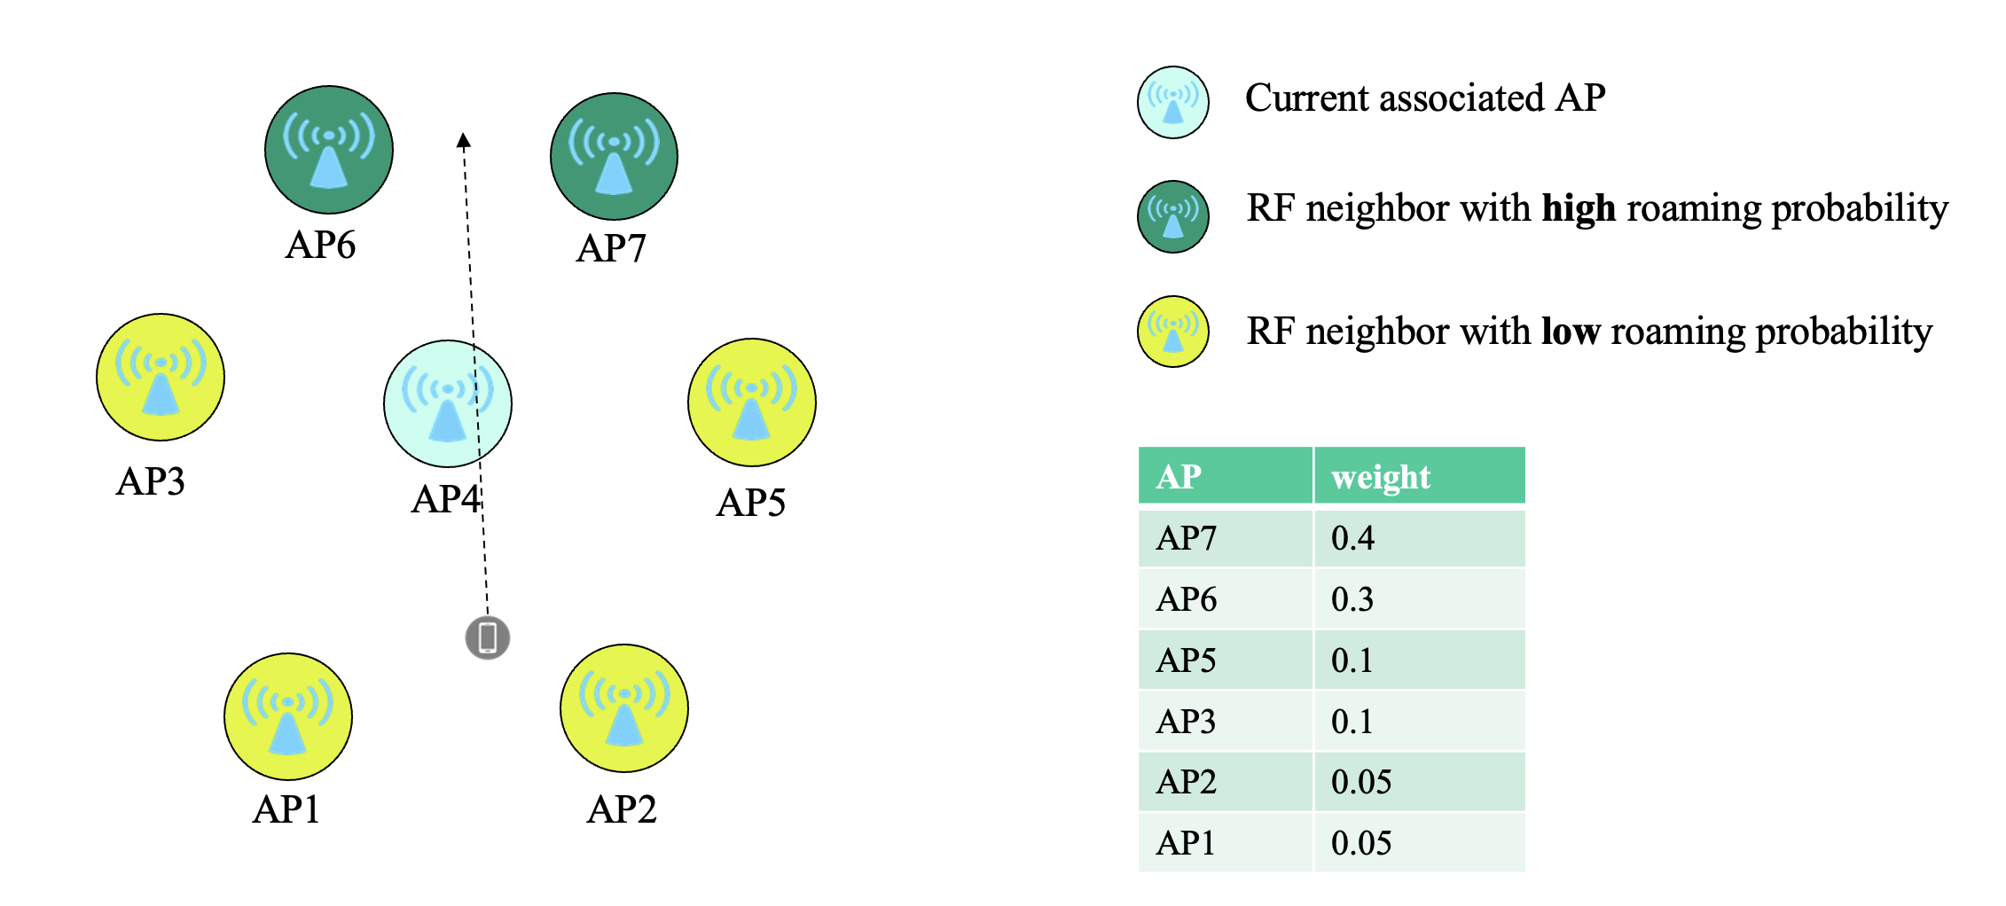
- Assist the STA to find the mid-point between APs.
The proposed solution aims at applying AIML tecniques to predict the optimal RSSI threshold for a given STA to start the scanning; the prediction can include the target RSSI value as well as the predicted time a given STA would reach such RSSI level (scanning delay), in order to help the STA know in advance when to expect the scanning to start being useful.
This allows the STA to optimize the time of scan and roam, to maintain the highest possible connection speed, without the need to wait for a usability threshold failure (e.g., increased retry/drop rate as reaching the cell edge).

The goal is to achieve overall faster roaming, with reduced latency and improved reliability.

The proposed solution supports multiple AIML implementations, from simple models to more sophisticated deep-learning techniques, allowing for distributed or centralized training and inference, adapting to different deployment scenarios. A sample implementation of the neighbor report weight calculation with an estimation of the benefits achieved as compared to a flat neighbor list is described in [1] .

How the AP determines the weights for each candidate AP or the target RSSI level can be implementation specific. The AP can use AIML techniques or non-AIML techniques to determine these values.

    - KPIs
KPIs considered in this use case are proposed as follows:
- Scanning / Roaming time:
  - Both scanning and roaming time are expected to decrease by having the STAs to follow the scanning priority suggested by the weighted neighbor reports as compared to the traditional method (flat neighbor report).
- Roaming failure rate:
  - Roaming failure rate is expected to decrease because of the recommendations about the best target neighbors, as compared to the traditional method.
- MCS distribution during a BSS transition:
  - The AP mid-point prediction is expected to allow the STAs to maintain higher MCS rates during the roaming, hence having a distribution whose mode is shifted towards higher data-rates, as compared to the traditional method.
  - The measurement is referred to MCS rates for successful transmission, for both uplink and downlink.
While data rates for retransmissions wouldn’t be relevant to this KPI, retry rate is proposed as a separate KPI.
  - The KPI would be primarily aimed at measuring the MCS rate improvement for data frames, as those would have the stronger impact on user experience; moreover, as management frames are often transmitted at basic rates, they’re less reflective of the STA conditions.
- Retry rate during a BSS transition:
  - The AP mid-point prediction is expected to result in a reduction in retransmissions, by allowing the STAs to roam before usability threshold failures are hit.
  - The retry rate reduction and the MCS rate improvement metrics are correlated and they’re both meant to measure the link quality enhancement obtained thanks to STA making use of the mid-point prediction, even though they should be measured separately due to the implementation differences for MCS selection and retry algorithms.
- RSSI at reattach time:
  - The AP mid-point prediction is expected to improve the overall roaming, and the STA RSSI at re-association time would be an indication of whether the STA followed the recommended scanning time and RSSI threshold.

- Requirements and Potential features analysis (high level)
  - Potential features analysis
The following potential features can be analysed in this use case:
- Roaming neighbor list
- Roaming mean-point

- Technical feasibility analysis
  - Standards impact
Notifying STAs about the weight of each roaming neighbor candidate requires the enhancement of the existing 802.11k neighbor report, using new optional elements.
Using optional elements to distribute this information would allow backwards compatibility.

Similarly, helping the STAs to trigger scanning at the mid-point between APs may require the enhancement of the 802.11v BTM request frame, for instance to include a scanning delay parameter.
The 802.11v BTM response frame can also be enhanced to let the STAs provide detailed feedback on the roaming recommendations, in order to allow the AP to improve the quality of the recommendations over time.
  - Technical feasibility
Depending on the specific implementation, the AIML capabilities can be either handled on each individual AP or managed on a central controller; the entity managing the model training would require sufficient computation capabilities to train and execute the implemented model.

- References

- IEEE 802.11-23/0433r2 - AIML-based Roaming Enhancements Use Case

