IEEE P802.11  
Wireless LANs

|  |  |  |  |  |
| --- | --- | --- | --- | --- |
| LB271 CR on subclause 36.3.12.2 Cyclic shift | | | | |
| Date: 2023-03-08 | | | | |
| Author(s): | | | | |
| Name | Affiliation | Address | Phone | email |
| Yapu Li | OPPO |  |  | liyapu1@oppo.com |
| Xiaogang Chen | ZEKU |  |  |  |

Abstract

This submission contains proposed comment resolutions to the following CID based on P802.11be D3.0.

CID 17931, 17932, 15262

Revisions:

- Rev 0: Initial version of the document.

-

# CID 17931, 17932

|  |  |  |  |  |  |
| --- | --- | --- | --- | --- | --- |
| **CID** | **Page.**  **Line** | **Clause** | **Comment** | **Proposed Change** | **Resolution** |
| 17931 | 759.06 | 36.3.12.2.1 | Some mentioned EHT PPDU fields are not defined in Table 21-10, i.e., the RL-SIG, U-SIG, and EHT-SIG fields of the EHT PPDU. | Changing the first sentence in the paragraph to "The cyclic shift values for the L-STF, L-LTF, and L-SIG fields of the EHT PPDU for transmit chain out of a total of are defined in Table 21-10 (Cyclic shift values for L-STF, L-LTF, L-SIG, and VHT-SIG-A fields of the PPDU). Similarly, the cyclic shift values for the RL-SIG, U-SIG, and EHT-SIG fields of the EHT PPDU refer to Table 21-10." | Rejected  The first sentence means that the values in Table 21-10 can be applied to L-STF, L-LTF, L-SIG, RL-SIG, U-SIG, and EHT-SIG fields. The proposed change is redundant. |
| 17932 | 759.21 | 36.3.12.2.2 | Table 21-11 is about VHT modulated fields, rather than EHT modulated fields. | Adding "is same as the cyclic shift values for the VHT modulated fields, that" between word "streams" and word "is". | Rejected  The sentence means that the values in Table 21-11 can be applied to EHT modulated fields. The proposed change is redundant. |

**Discussion**

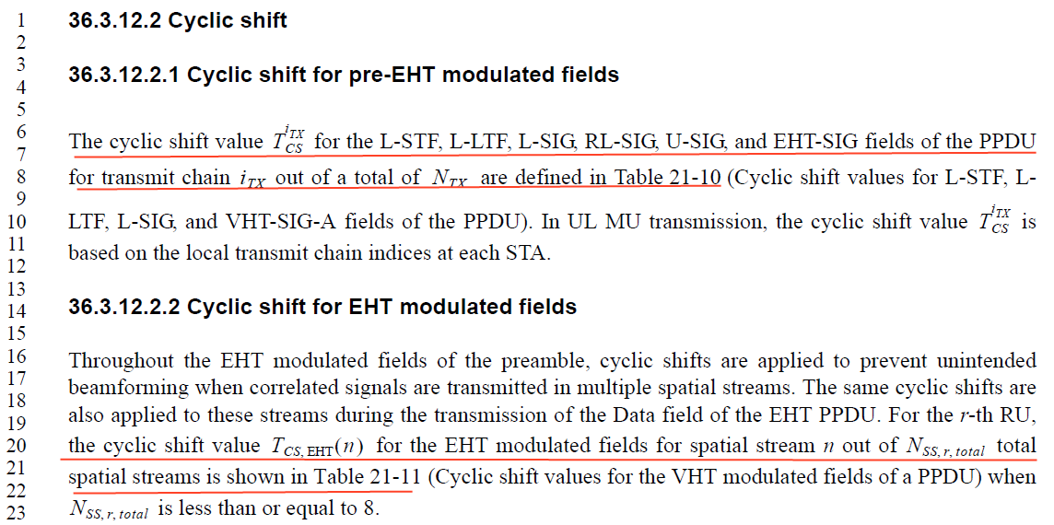

**CID 15262**

|  |  |  |  |  |  |
| --- | --- | --- | --- | --- | --- |
| **CID** | **Page.**  **Line** | **Clause** | **Comment** | **Proposed Change** | **Resolution** |
| 15262 | 759.23 | 36.3.12.2.2 | No need to mention that the number of spatial streams is less than or equal to 8. | As in the comment | Revised  Table 21-11 is used when Nss is less than or equal to 8, so it’s better to delete the sentence after the Table 21-11.  **Instructions to the editor:**  **Please make the changes to the spec as shown in 11-23/0341r0** |

***TGbe editor:***

***Please make the following changes in Page 759 Line19-23 in D3.0:***

**36.3.12.2.2 Cyclic shift for EHT modulated fields**

*Omit*

…For the *r*-th RU, the cyclic shift value $T_{CS, EHT}(n)$ for the EHT modulated fields for spatial stream *n* out of $N_{SS,r,total}$ total spatial streams is shown in Table 21-11 (Cyclic shift values for the VHT modulated fields of a PPDU).