IEEE P802.11  
Wireless LANs

|  |  |  |  |  |
| --- | --- | --- | --- | --- |
| LB271 CR on subclause 36.3.6 Transmitter block diagram | | | | |
| Date: 2023-03-08 | | | | |
| Author(s): | | | | |
| Name | Affiliation | Address | Phone | email |
| Yapu Li | OPPO |  |  | liyapu1@oppo.com |
| Xiaogang Chen | ZEKU |  |  |  |

Abstract

This submission contains proposed comment resolutions to the following CID based on P802.11be D3.0.

CID 15718, 17924, 17925, 15723

Revisions:

- Rev 0: Initial version of the document.

-

# CID 15718

|  |  |  |  |  |  |
| --- | --- | --- | --- | --- | --- |
| **CID** | **Page.**  **Line** | **Clause** | **Comment** | **Proposed Change** | **Resolution** |
| 15718 | 735.47 | 36.3.6 | In figure 36-25, the last block of IDFT arrow is not connected with the block of Spatial and Frequency Mapping. | Connect them | Revised  The original Visio diagram is correct. The figure display is incomplete, because it was not resized when merging in the draft.  **Instructions to the editor:**  **Please zoom out figure 36-25 to make sure it is complete.** |

**Discussion**

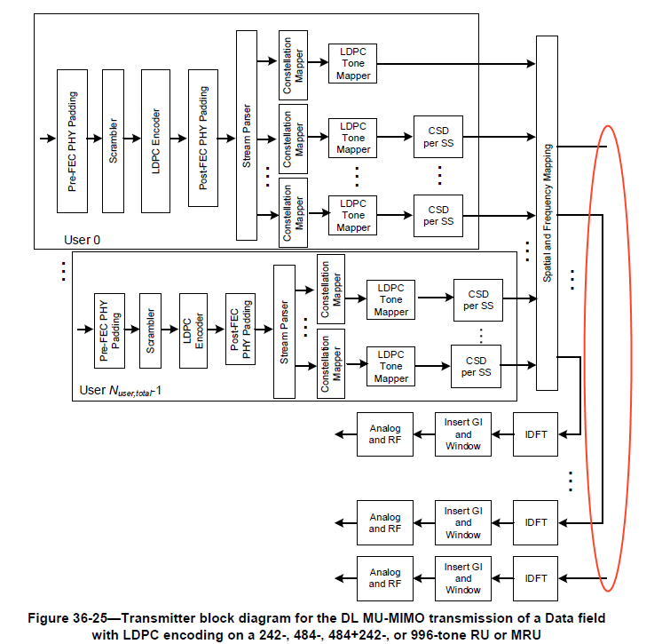

# CID 17924, 17925, 15723

|  |  |  |  |  |  |
| --- | --- | --- | --- | --- | --- |
| **CID** | **Page.**  **Line** | **Clause** | **Comment** | **Proposed Change** | **Resolution** |
| 17924 | 733.26 | 36.3.6 | Simplifying the expression "Â¡. an RU or MRU that is the same size as or smaller than a 242-tone RU" to "Â¡. an RU or MRU smaller than or equal to 242 tones" | As in the comment. | Revised  Agree in principle.  **Instructions to the editor:**  **Please make the changes to the spec as shown in 11-23/0326r0** |
| 17925 | 733.62 | 36.3.6 | Simplifying the expression "Â¡. an RU or MRU that is the same size as or smaller than a 996-tone RU" to "Â¡. an RU or MRU smaller than or equal to 996 tones" | As in the comment. | Revised  Agree in principle.  **Instructions to the editor:**  **Please make the changes to the spec as shown in 11-23/0326r0** |
| 15723 | 736.31 | 36.3.6 | "...996 tones" should be unify to "...a 996-tone RU" | As in comment | Accepted |

***TGbe editor:***

***Please make the following changes in Page 733 Line26-27 in D3.0:***

**Figure 36-22—Transmitter block diagram for the UL transmission or DL non-MU-MIMO transmission of a Data field with BCC encoding on an RU or MRU size equal to or smaller than a 242-tone RU**

***TGbe editor:***

***Please make the following changes in Page 733 Line62-63 in D3.0:***

**Figure 36-23—Transmitter block diagram for the UL transmission or DL non-MU-MIMO transmission of a Data field with LDPC encoding on an RU or MRU size equal to or smaller than a 996-tone RU**