IEEE P802.11
Wireless LANs
LB271 CR for clasue 36.6
Date: 2023.03.08
Author(s):
Name | Company | Address | Phone | email
Ross Jian Yu | Huawei Technologies | F3 building, Huawei Base, Bantian, Longgang, Shenzhen, Guangdong, China, 518129 |  | ross.yujian@huawei.com
Ming Gan | Huawei Technologies
Zhi Mao | Huawei Technologies
Abstract
This submission contains proposed comment resolutions to comments on P802.11be D3.0.

2 comments is resolved.
CID 17802 and 17803

Revision Notes

R0 | Initial revision
R1 | Change the DCN in the header, point out the correct page number of the two CIDs

CID 17802
Page.  Line | Clause Number | Comment | Proposed Change | Resolution
986.15 | 36.6 | EHT-SIG symbol time is 4us, also rate (Mb/s) for MCS 0 is 26/4 = 6.5 | Change EHT-SIG rate (Mb/s) to 6.5 | ACCEPTED
Discussion
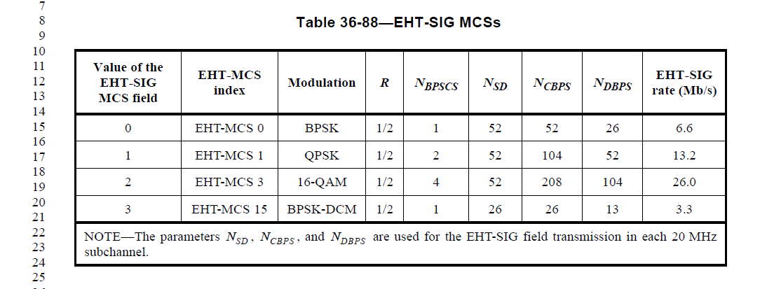

CID 17803
Page.  Line | Clause Number | Comment | Proposed Change | Resolution
986.17 | 36.6 | EHT-SIG symbol time is 4us, also rate (Mb/s) for MCS 1 is 52/4 = 13 | Change EHT-SIG rate (Mb/s) to 13 | ACCEPTED
Discussion

