IEEE P802.11
Wireless LANs
LB271 CR for EHT-SIG Part 1
Date: 2023.03.08
Author(s):
Name | Company | Address | Phone | email
Ross Jian Yu | Huawei Technologies | F3 building, Huawei Base, Bantian, Longgang, Shenzhen, Guangdong, China, 518129 |  | ross.yujian@huawei.com
Mengshi Hu | Huawei Technologies
Stephen McCann | Huawei Technologies
Ming Gan | Huawei Technologies
Abstract
This submission contains proposed comment resolutions to comments on P802.11be D3.0.

16 comments are resolved.
CID 15222, 15223, 15254, 15255, 15713, 16268, 16269, 16270, 17211, 17212, 17240, 17241, 17242, 17243, 17244, 17926

Revision Notes

R0 | Initial revision
R1 | Correct some typo

CID 15222
Page.  Line | Clause Number | Comment | Proposed Change | Resolution
781.12 | 36.3.12.8.2 | Add "subfield" at the end of "Number of Non-OFDMA Users" for Common field in Figure 36-34 and 36-36. | As in comment | REVISED  Instructions to the editor:  Please add "subfield" at the end of "Number of Non-OFDMA Users" for Common field in Figure 36-34, 36-36, 36-37, 36-38, 36-39, 36-40, and 36-41 of P802.11be D3.0.  NOTE to the editor: will provide the visio files separately when the motion is passed.
Discussion
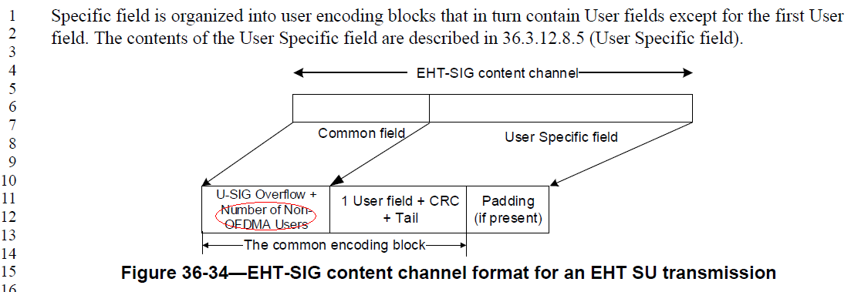
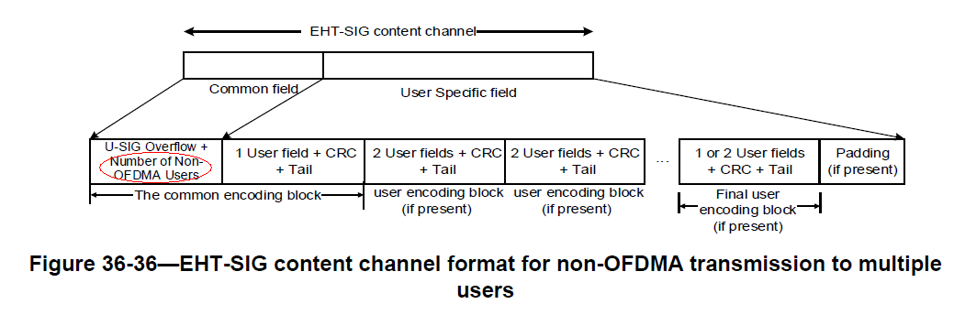
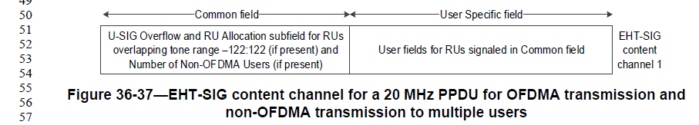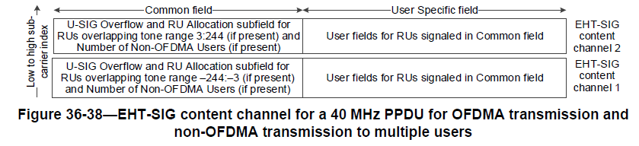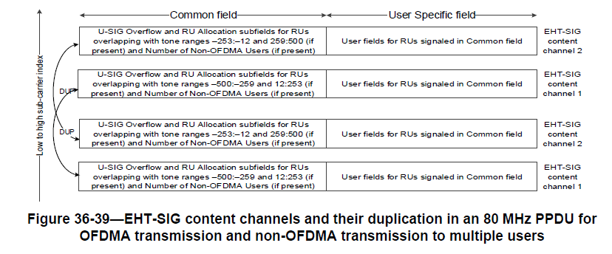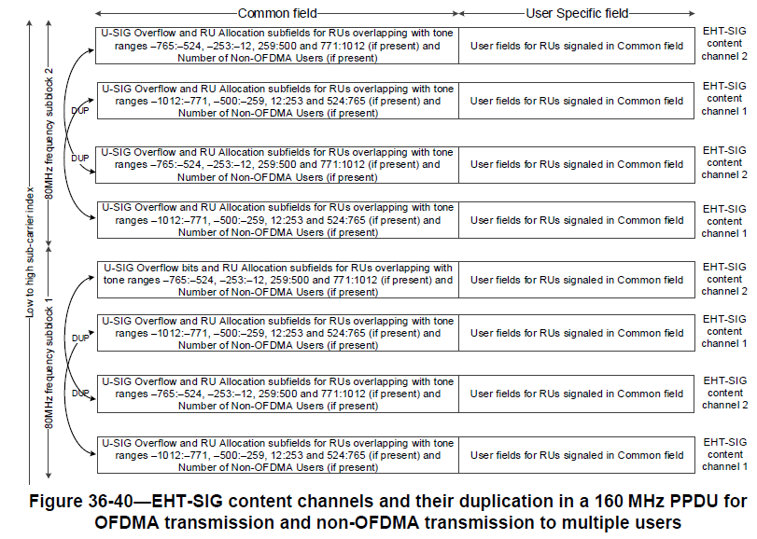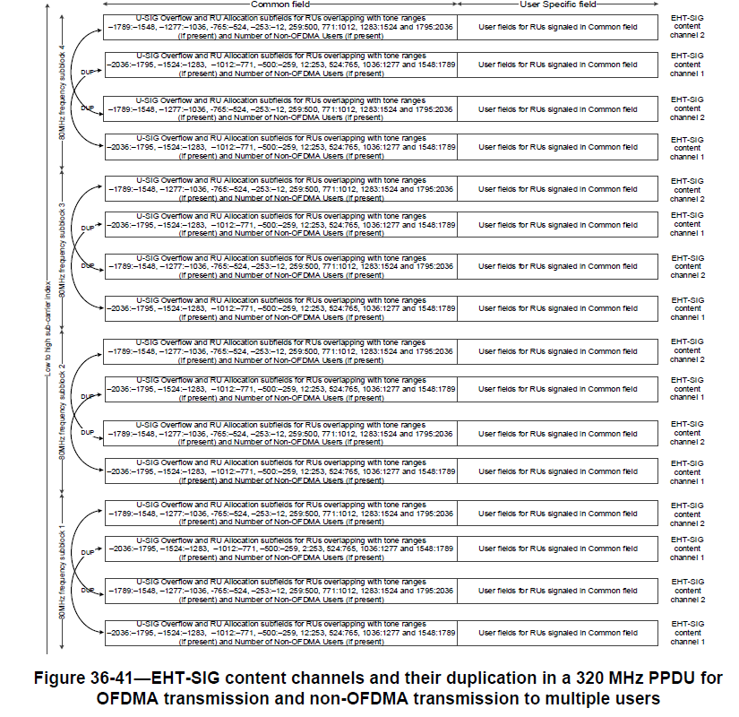

CID 15223
Page.  Line | Clause Number | Comment | Proposed Change | Resolution
810.06 | 36.3.12.8.6 | Add "subfield" at the end of "Number of Non-OFDMA Users" for Common field in Figure 36-42, 36-43, 36-44, 36-45 and 36-46. | As in comment | ACCEPTED  NOTE to the editor: will provide the visio files separately when the motion is passed.
Discussion
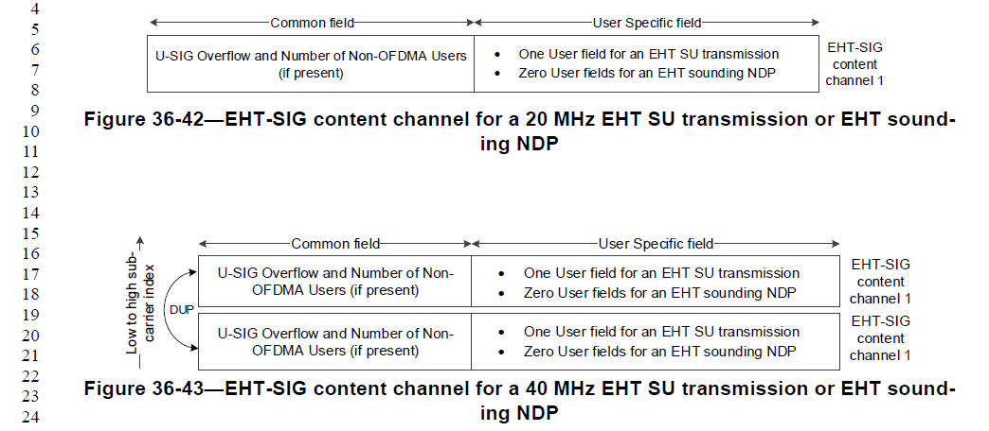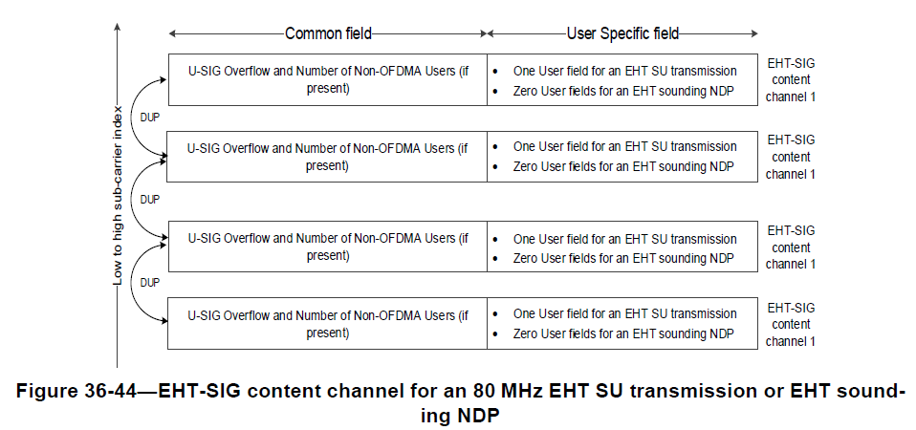
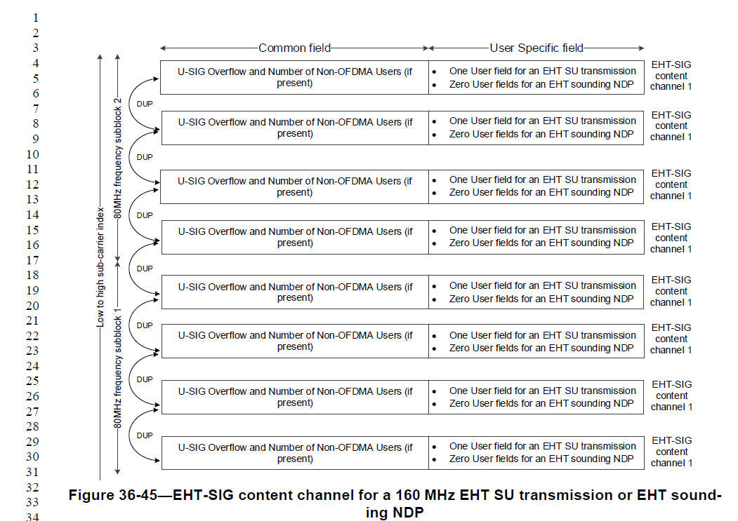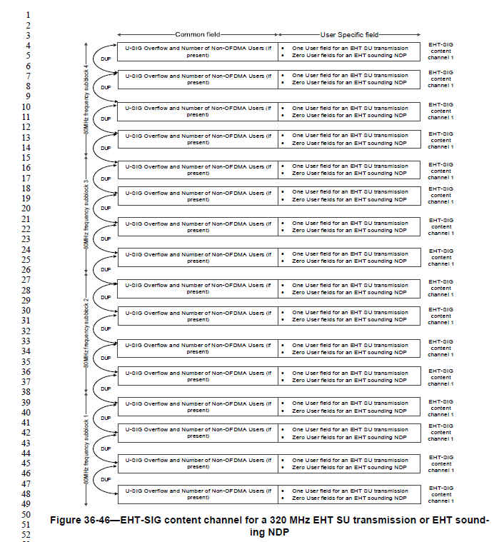

CID 15254
Page.  Line | Clause Number | Comment | Proposed Change | Resolution
787.10 | 36.3.12.8.3 | RU Allocation subfield may be used to indicate punctured 242 RU or unassigned 242-tone RU. It is confused whether the above two cases are RU or not RU. For example, if the punctured 242 tone RU is an RU, the RU definition should contain this RU. If it is not an RU, it is conflicted with the description "Each RU Allocation-A subfield in an EHTSIG content channel corresponding to a 20 MHz frequency subchannel indicates the RU or MRU assignment, including the size  of the RU(s) or MRU(s) and their placement  in the frequency domain" | Need to clarify whether the punctured RU and unassigned 242-tone RU are RUs or not. | REJECTED  Punctured 242-tone RU or unassigned 242-tone RU both refer to 242-tone RU.
Discussion
None.

CID 15255
Page.  Line | Clause Number | Comment | Proposed Change | Resolution
787.10 | 36.3.12.8.3 | Punctured 242-tone RU and Unassigned 242-tone RU use the wording "-tone RU". However, the other rows do not use this description. For example, B8-B1 (67-71) corresponds to "242". | The wording should be consistent. | REJECTED  Punctured 242-tone RU or unassigned 242-tone RU both refer to 242-tone RU.  The full naming “242-tone RU” is used for special cases where additional descriptions are needed.
Discussion
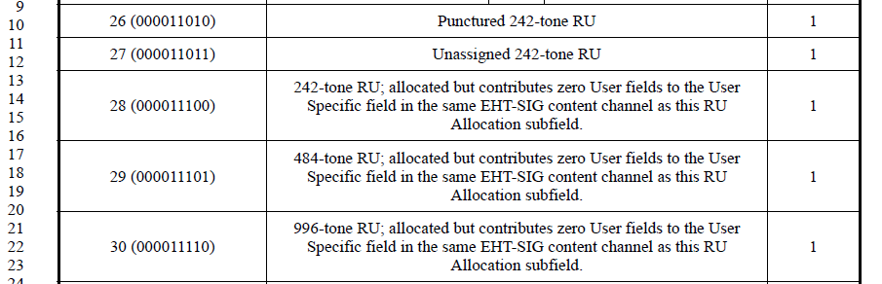
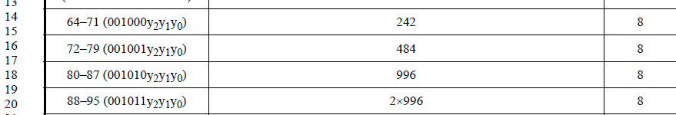

CID 15713
Page.  Line | Clause Number | Comment | Proposed Change | Resolution
802.07 | 36.3.12.8.5 | "242 subcarriers" should be unify to "242-tone".Also in P793L49, P802L15. | As in comment | REVISED  Instructions to the editor:  Please change “242 subcarriers” to “242 tones” in P802L07, P793L48 and P802L15 of P802.11be D3.0.
Discussion
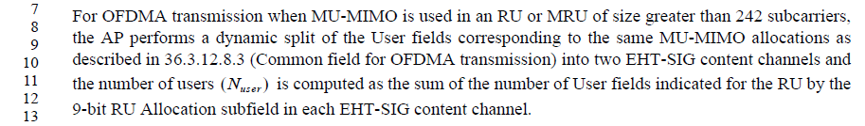

CID 16268
Page.  Line | Clause Number | Comment | Proposed Change | Resolution
779.42 | 36.3.12.8.2 | typo "is 20" in the title of Figure 36-31 | Change "is 20" to "is equal to 20" | ACCEPTED

CID 16269
Page.  Line | Clause Number | Comment | Proposed Change | Resolution
779.59 | 36.3.12.8.2 | typo "is 160" in the title of Figure 36-32 | Change "is 160" to "is equal to 160" | ACCEPTED

CID 16270
Page.  Line | Clause Number | Comment | Proposed Change | Resolution
780.14 | 36.3.12.8.2 | typo "is 320" in the title of Figure 36-33 | Change "is 320" to "is equal to 320" | ACCEPTED

CID 17211
Page.  Line | Clause Number | Comment | Proposed Change | Resolution
790.21 | 36.3.12.8.3 | "[Gap-242/484/996]" should have lowercase g for consistency with the rest of the table. | Change "[Gap-242/484/996]" to "[gap-242/484/996]" | REJECTED  Capitalized G is used because it is the intial wording of a sentence.
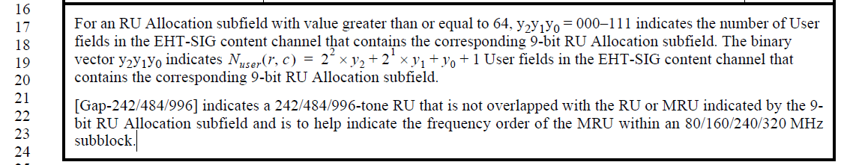

CID 17212
Page.  Line | Clause Number | Comment | Proposed Change | Resolution
790.39 | 36.3.12.8.2 | "Punctured 242-tone RU or unassigned 242-tone RU contributes to zero User fields" | Change "contributes to zero" to "contributes zero" | ACCEPTED
Discussion
None

CID 17240
Page.  Line | Clause Number | Comment | Proposed Change | Resolution
782.35 | 36.3.12.8.3 | Values 5-7 are not specified | Add "Values 5-7 are reserved" | REVISED  Instructions to the editor:  Please add the following paragraph on P782L40 of P802.11be D3.0:  Values 5-7 are Validate.
Discussion
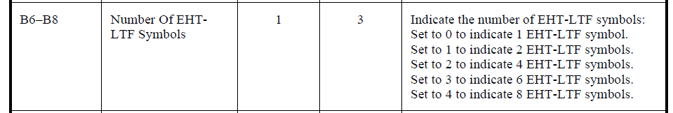

CID 17241
Page.  Line | Clause Number | Comment | Proposed Change | Resolution
794.35 | 36.3.12.8.4 | Values 5-7 are not specified | Add "Values 5-7 are reserved" | REVISED  Instructions to the editor:  Please add the following paragraph on P794L40 of P802.11be D3.0:  Values 5-7 are Validate.
Discussion
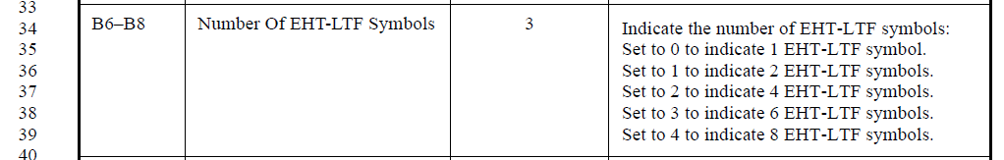

CID 17242
Page.  Line | Clause Number | Comment | Proposed Change | Resolution
796.24 | 36.3.12.8.4 | Value 2 is not specified | Add "Value 2 is reserved" | REVISED  Instructions to the editor:  Please add the following paragraph on P796L28 of P802.11be D3.0:  Value 2 is Validate.
Discussion:
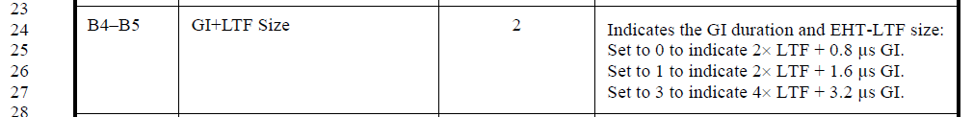

CID 17243
Page.  Line | Clause Number | Comment | Proposed Change | Resolution
796.29 | 36.3.12.8.4 | Values 5-7 are not specified | Add "Values 5-7 are reserved" | REVISED  Instructions to the editor:  Please add the following paragraph on P796L35 of P802.11be D3.0:  Values 5-7 are Validate.
Discussion:
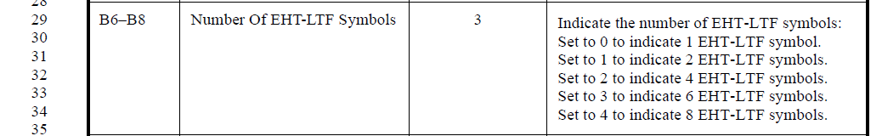

CID 17244
Page.  Line | Clause Number | Comment | Proposed Change | Resolution
796.37 | 36.3.12.8.4 | Values 8-15 are not specified | Add "Values 8-15 are reserved" | REVISED  Instructions to the editor:  Please add the following paragraph on P796L40 of P802.11be D3.0:  Values 8-15 are Validate.
Discussion:
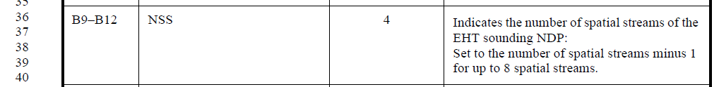

CID 17926
Page.  Line | Clause Number | Comment | Proposed Change | Resolution
797.39 | 36.3.12.8.5 | "Â¡. non-OFDMA transmission" should be " a non-OFDMA transmission" | As in the comment. | REVISED  Instructions to the editor:  Please add “a” between “and” and “non-OFDMA” on P797L40 of P802.11be D3.0.
Discussion:

