IEEE P802.11
Wireless LANs
LB270 Miscellaneous Comments
Date: 2023-1-17
Author(s):
Name | Affiliation | Address | Phone | email
Youhan Kim | Qualcomm Technologies, Inc. |  |  | youhank@qti.qualcomm.com

Abstract
This submission proposes resolutions for the following comments from comment collection on P802.11-REVme D2.0:

3291, 3299, 3739, 3818

NOTE – Set the Track Changes Viewing Option in the MS Word to “All Markup” to clearly see the proposed text edits.

Revision History:

R0: Initial version.

CID 3291

CID  Clause  Page.Line | Comment | Proposed Change
3291  21.1  3387.4 | L_DATARATE is missing in Table 21-1--TXVECTOR and RXVECTOR parameters (cf. CID 1057) | As it says in the comment

Discussion
TXVECTOR/RXVECTOR parameters which are not directly used by a particular PHY generation P1 but used in a previous PHY generation P2 were removed from the PHY generation P1 to avoid standard text bloating in https://mentor.ieee.org/802.11/dcn/21/11-21-1136-01-000m-cc35-txvector-rxvector.docx. For example, SMOOTHING was removed from the VHT TXVECTOR/RXVECTOR as it is not used by VHT PPDUs but used by HT PPDUs.

L_DATARATE and L_LENGTH were removed from VHT TX/RXVECTORs as part of that change as they are used for transmitting NON-HT (duplicate) PPDUs, not VHT PPDUs. However, upon re-reviewing, L_DATARATE and L_LENGTH are referenced at the following location in REVme D2.0 P3429:
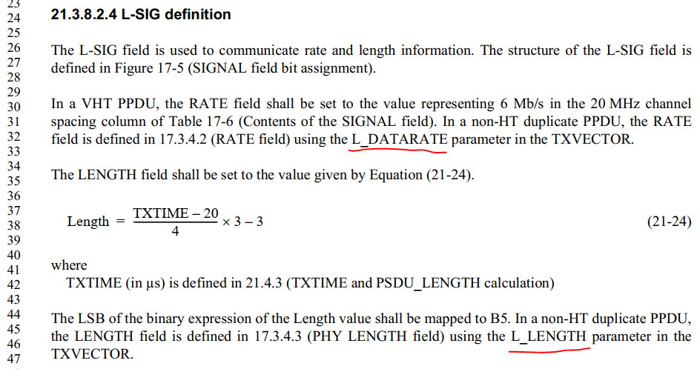

Hence the proposed resolution adds back both L_DATARATE and L_LENGTH.

Proposed Resolution: CID 3291
REVISED

Instruction to TGme Editor:
Implement the proposed text updates for CID 3291 in https://mentor.ieee.org/802.11/dcn/23/11-23-0099-00-000m-lb270-misc-comments.docx

Note to commenter:
The proposed text updates add L_DATARATE and L_LENGTH to the VHT TXVECTOR/RXVECTOR.

Proposed Text Update: CID 3291
Instruction to TGme Editor: Update REVme D2.0 P3387L34 as shown below.
21.2.2 TXVECTOR and RXVECTOR parameters
Table 21-1 – TXVECTOR and RXVECTOR parameters
Parameter | Condition | Value | TXVECTOR | RXVECTOR
FORMAT |  | Determines the format of the PPDU.  Enumerated type:  NON_HT indicates OFDM  or non-HT duplicate PPDU format. In this case, the modulation is determined by the NON_HT_MODULATION parameter.  HT_MF indicates HT-mixed format.  HT_GF indicates HT-greenfield format.  VHT indicates VHT format. | Y | Y
NON_HT_MODULATION | FORMAT is NON_HT | In TXVECTOR, indicates the format type of the transmitted  non-HT PPDU.  In RXVECTOR, indicates the estimated format type of the received non-HT PPDU.  Enumerated type:  OFDM indicates OFDM format. NON_HT_DUP_OFDM indicates non-HT duplicate format | Y | Y
 | Otherwise | Not present | N | N
L_LENGTH | FORMAT is VHT | Not present  NOTE—The Length field of the L-SIG in VHT PPDUs is defined in Equation (21-24) using the TXTIME value defined by Equation (21-109) and Equation (21-110), which in turn depend on other parameters including the TXVECTOR parameter APEP_LENGTH. | N | N
 | Otherwise | See corresponding entry in Table 19-1 (TXVECTOR and RXVECTOR parameters)
L_DATARATE | FORMAT is VHT | Not present  NOTE—The RATE field in the L-SIG field in a VHT PPDU is set to the value representing 6 Mb/s in the 20 MHz channel spacing column of Table 17-6 (Contents of the SIGNAL field). | N | N
 | Otherwise | See corresponding entry in Table 19-1 (TXVECTOR and RXVECTOR parameters)
N_TX | FORMAT is VHT | Indicates the number of transmit chains. | Y | N
 | Otherwise | See corresponding entry in Table 19-1 (TXVECTOR and RXVECTOR parameters)

CID 3299

CID  Clause  Page.Line | Comment | Proposed Change
3299  17.3.10.6.1  3201.53 | 17.3.10.6.1's NOTE should be in .2 as in all the other PHYs | Move NOTE 2 to the end of 17.3.10.6.2

Discussion

Commenter suggests moving the NOTE 2 in 17.3.10.6.1 to 17.3.10.6.2.

REVme D2.0 P3201-3202
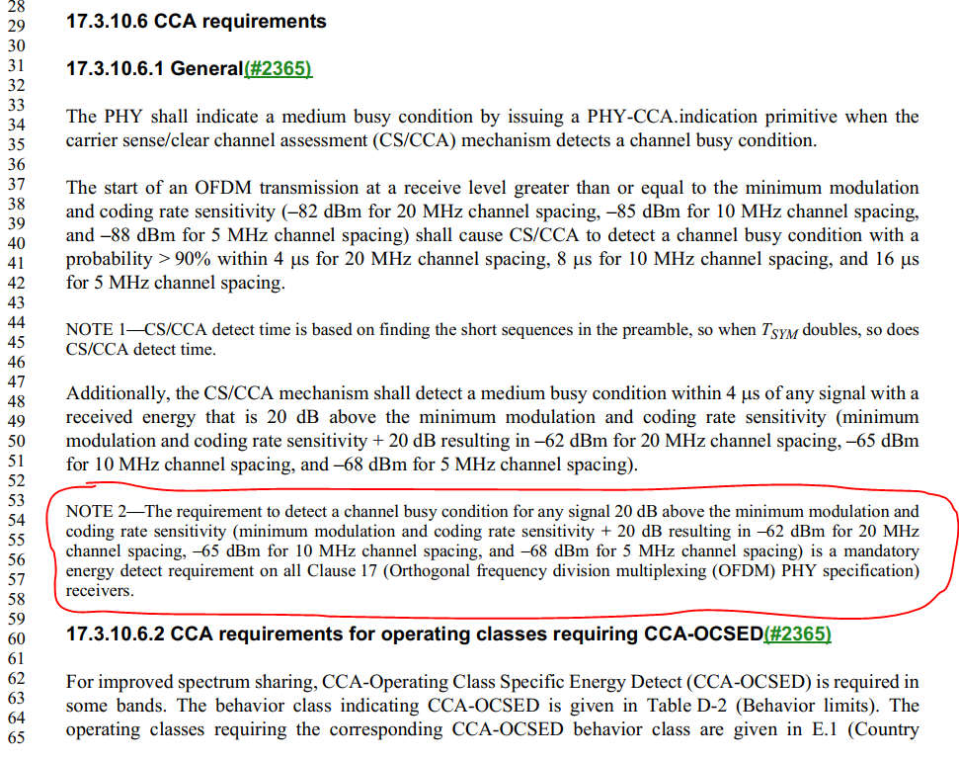
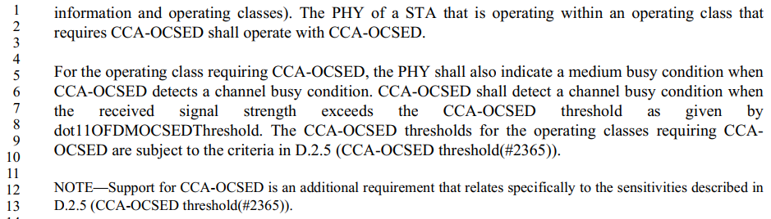

Note that HT (Clause 19), VHT (21) and HE (27) PHY clauses have the CCA-OCSED section before the mandatory energy detect CCA section, and the corresponding note is in the CCA-OCSED section.
For example:

REVme D2.0 P3308-3309
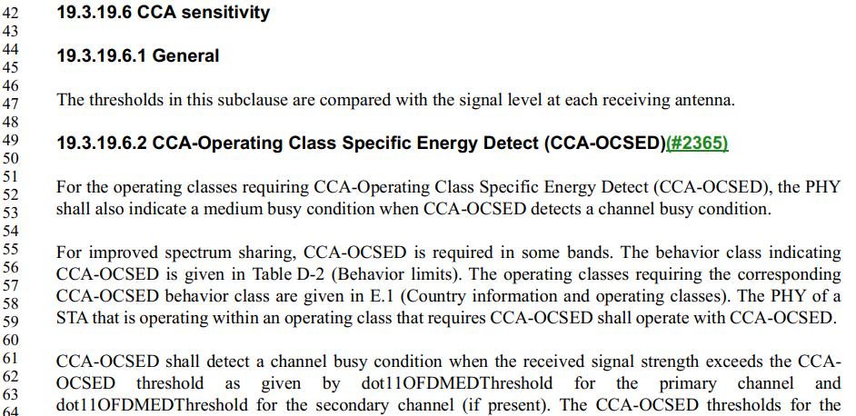
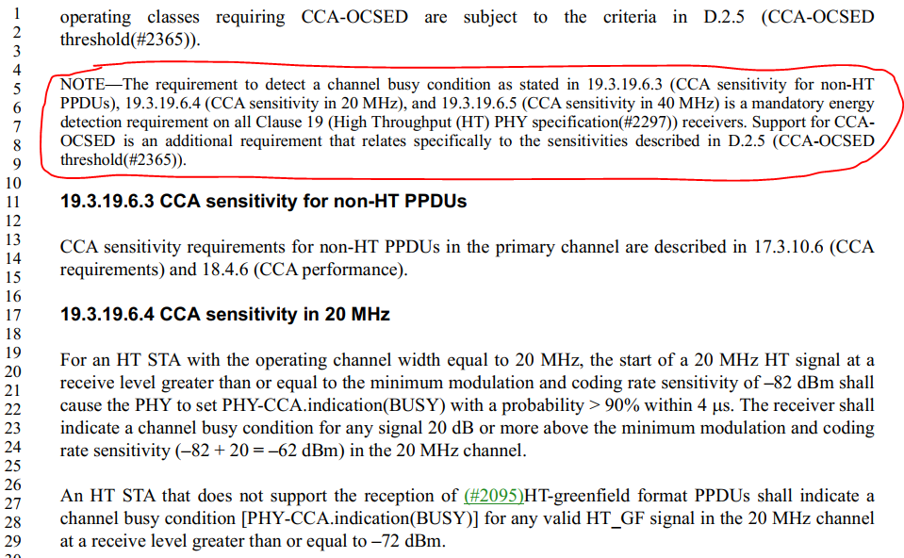

Propose to move the NOTE as suggested by the commenter.

Proposed Resolution: CID 3299
REVISED

Instruction to TGme Editor:
Implement the proposed text updates for CID 3299 in https://mentor.ieee.org/802.11/dcn/23/11-23-0099-00-000m-lb270-misc-comments.docx

Note to Commenter:
Proposed text updates move the NOTE from 17.3.10.6.1 to 17.3.10.6.2 with some editorial updates.

Proposed Text Update: CID 3299

Instruction to TGme Editor: Update REVme D2.0 P3201-3202 as shown below.
17.3.10.6 CCA requirements
17.3.10.6.1 General
The PHY shall indicate a medium busy condition by issuing a PHY-CCA.indication primitive when the carrier sense/clear channel assessment (CS/CCA) mechanism detects a channel busy condition.
The start of an OFDM transmission at a receive level greater than or equal to the minimum modulation and coding rate sensitivity (–82 dBm for 20 MHz channel spacing, –85 dBm for 10 MHz channel spacing, and –88 dBm for 5 MHz channel spacing) shall cause CS/CCA to detect a channel busy condition with a probability > 90% within 4 μs for 20 MHz channel spacing, 8 μs for 10 MHz channel spacing, and 16 μs for 5 MHz channel spacing.
NOTE —CS/CCA detect time is based on finding the short sequences in the preamble, so when T_{SYM} doubles, so does CS/CCA detect time.
Additionally, the CS/CCA mechanism shall detect a medium busy condition within 4 μs of any signal with a received energy that is 20 dB above the minimum modulation and coding rate sensitivity (minimum modulation and coding rate sensitivity + 20 dB resulting in –62 dBm for 20 MHz channel spacing, –65 dBm for 10 MHz channel spacing, and –68 dBm for 5 MHz channel spacing).

17.3.10.6.2 CCA requirements for operating classes requiring CCA-OCSED
For improved spectrum sharing, CCA-Operating Class Specific Energy Detect (CCA-OCSED) is required in some bands. The behavior class indicating CCA-OCSED is given in Table D-2 (Behavior limits). The operating classes requiring the corresponding CCA-OCSED behavior class are given in E.1 (Country information and operating classes). The PHY of a STA that is operating within an operating class that requires CCA-OCSED shall operate with CCA-OCSED.
For the operating class requiring CCA-OCSED, the PHY shall also indicate a medium busy condition when CCA-OCSED detects a channel busy condition. CCA-OCSED shall detect a channel busy condition when the received signal strength exceeds the CCA-OCSED threshold as given by dot11OFDMOCSEDThreshold. The CCA-OCSED thresholds for the operating classes requiring CCA-OCSED are subject to the criteria in D.2.5 (CCA-OCSED threshold(#2365)).
NOTE— The requirement to detect a channel busy condition as stated in 17.3.10.6.1 is a mandatory energy detect requirement on all Clause 17 receivers. Support for CCA-OCSED is an additional requirement that relates specifically to the sensitivities described in D.2.5 (CCA-OCSED threshold).

CID 3739

CID  Clause  Page.Line | Comment | Proposed Change
3739  27.1.1  3987.1 | "1x HE-LTF + 1.6 usec GI" from Table 9-48 is not listed as a required or optional combination. | Please confirm either the missing text, or modify the Table 9-48.  a Note could be useful to explain the impossibility cases, if any.

Discussion
Commenter is asking why 1x HE-LTF with 1.6 usec GI is not listed at P3987L1:
REVme D2.0 P3986-3987
…
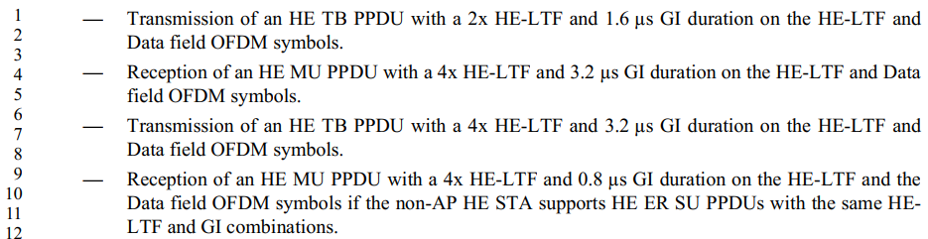

This is because support for 1x HE-LTF with 1.6 usec GI is common for both AP and non-AP STAs, and hence listed earlier on P3984.

REVme D2.0 P3984
…

Proposed Resolution: CID 3739
REJECTED

REVme D2.0 P3987L1 lists requirements specific for non-AP HE STAs only.

Support for 1x HE-LTF and 1.6 us GI duration is common for both AP and non-AP HE STAs, and hence is listed at REVme D2.0 P3984L57: an HE STA shall support “full bandwidth UL MU-MIMO with a 1x HE-LTF and 1.6 us GI duration … if the STA supports UL MU-MIMO.”

CID 3818

CID  Clause  Page.Line | Comment | Proposed Change
3818  26.17.1  3968.10 | P3968L1-10 essentially specifies that if an HE STA supports MCS X, where MCS X is a defined MCS as well in HT, then the HE STA shall support the MCS X in HT as well.  However, there is no such requirement for VHT MCS.  I.e., there is no requirement specified that if an HE STA supports MCS X, where MCS X is a defined MCS as well in VHT, then the HE STA shall support MCS X in VHT as well. | Add requirement that if an HE STA supports MCS X, where MCS X is a defined MCS as well in VHT, then the HE STA shall support MCS X in VHT as well.

Discussion
At REVme D2.0 P3968L1-10, there are normative requirements on the relationship between the supported HE-MCSs and HT-MCSs.

REVme D2.0 P3968
26.17.1 Basic HE BSS operation
…
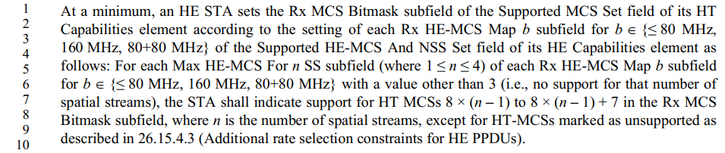

The commenter is suggesting to add similar normative requirement on the relationship between the supported HE-MCSs and VHT-MCSs. However, such normative requirement is already specified at REVme D2.0 P3970.

REVme D2.0 P3970
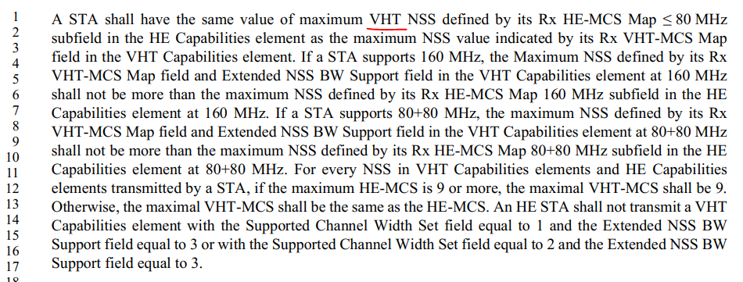

Note that the “VHT NSS” at P3970L1 is a typo and should be “HE NSS”.

Proposed Resolution: CID 3818
REVISED

Instruction to TGme Editor:
At REVme D2.0 P3970L1, change “maximum VHT NSS” to “maximum HE NSS”.

Note to Commenter:
REVme D2.0 P3970L1-17 specifies the normative relationship between the supported HE-MCSs and VHT-MCSs, which addresses the concern raised by the commenter.

There is a typo found on P3970L1, however, which is fixed in the above instruction to editor.

[End of File]

