IEEE P802.11  
Wireless LANs

|  |  |  |  |  |
| --- | --- | --- | --- | --- |
| Resolutions for Open Technical Comments | | | | |
| Date: 2022-12-19 | | | | |
| Author(s): | | | | |
| Name | Affiliation | Address | Phone | email |
| Claudio da Silva | Meta Platforms |  |  | claudiodasilva@meta.com |
|  |  |  |  |  |
|  |  |  |  |  |
|  |  |  |  |  |

Abstract

This submission proposes resolutions to technical comments submitted in CC40.

CIDs: 385, 663

|  |  |  |  |  |
| --- | --- | --- | --- | --- |
| **CID** | **Clause** | **Page** | **Comment** | **Proposed change** |
| 663 |  | 14.32 | the paragraph starting with "WLAN Sensing enables..." seems repetitive. More meaningful description of the WLAN sensing is needed perhaps with brief mentioning of use cases and adding Figure whenever possible. | As in comment |

**Proposed resolution**: Revised

**Discussion**: The text referred to by the commenter is (note: wrong page number):

has been heavily modified by the resolution of multiple comments,

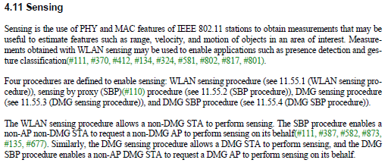

The next version of the text addresses some of the concerns raised by the commenter, such as the original text being repetitive and including use cases. Suggest maintaining the current (D0.5) version of the text.

**Modifications**: This comment has been resolved in D0.5. No further modifications are required.

|  |  |  |  |  |
| --- | --- | --- | --- | --- |
| **CID** | **Clause** | **Page** | **Comment** | **Proposed change** |
| 385 |  |  | In different places of the draft, the term 'sensing measurement' can be simply changed to 'measurement', e.g., 'sensing measurements of the channel' in the definition of WLAN sensing in Subclause 4.3.21.25. | Change 'sensing measurement' to 'measurement' in various locations in the draft, e.g., in Subclauses 4.3.21.25 and 4.3.21.26 |

**Proposed resolution**: Revised

**Discussion**: The text referred to by the commenter is (note: no clause nor page number is provided):

has been heavily modified by the resolution of multiple comments,

'Sensing measurements of the channel' is no longer used in the D0.5 (including in Clause 4).

**Modifications**: This comment has been resolved in D0.5. No further modifications are required.