IEEE P802.11
Wireless LANs
LB266 CR for 36.3.10
Date: 2022.10.12
Author(s):
Name | Company | Address | Phone | email
Lei Huang | Huawei |  |  | lei.huang1@huawei.com
Abstract
This submission contains proposed comment resolutions to 11 comments related to clause 36.3.10 of P802.11be D2.0.

CID 11218, 11282, 11283, 10376, 10179, 11207, 11352, 11353, 12846, 10827, 10828

Revision Notes

R0 | Initial revision

#11218
CID | Commenter | Clause Number(C) | Page | Comment | Proposed Change | Resolution
11218 | ron porat | 36.3.10 | 622.62 | Table 36-18 incorrect formula for T_L-LTF | Change "T_GI,LTF" to "T_GI,L-LTF" | Accepted

Background (P638 of D2.1.1):

#11282, 11283

CID | Commenter | Clause Number(C) | Page | Comment | Proposed Change | Resolution
11282 | Sigurd Schelstraete | 36.3.10 | 623.34 | "N_service" does not belong in a table with "Timing-related Constants" | Move from Table 36-18 to Table 36-23 | Rejected  Since Table 36-23 includes frequently used parameters whose values are configurable, it is not a suitable place to accommodate the constant “N_service”. In addition, it should be noted that in 11ax, “N_service” is also included in the table with “Timing- related constants”. As a result, it is better to keep “N_service” in Table 36-18.
11283 | Sigurd Schelstraete | 36.3.10 | 623.36 | "N_tail" does not belong in a table with "Timing-related Constants" | Move from Table 36-18 to Table 36-23 | Rejected  Since Table 36-23 includes frequently used parameters whose values are configurable, it is not a suitable place to accommodate the constant “N_tail, N_tail,u”. In addition, it should be noted that in 11ax, “N_tail, N_tail,u” is also included in the table with “Timing-related constants”. As a result, it is better to keep “N_tail, N_tail,u” in Table 36-18.

#10376
CID | Commenter | Clause Number(C) | Page | Comment | Proposed Change | Resolution
10376 | Mengshi Hu | 36.3.10 | 624.12 | CBW320 seems not that accurate because CBW320-1 and CBW320-2 should also be considered. If this only indicates CBW320, what about the case CBW320-1 and CBW320-2? If this indicates 320MHz BW, then CBW320 should not be used because it is a little bit confusing. The next two tables in the same page and next page also have the same problem. | Add CBW320-1 and CBW320-2. | Rejected  In Table 36-3, there is a note saying “The CH_BANDWIDTH of CBW320-1 and CBW320-2 is interpreted as CBW320 for the transmission of an EHT PPDU of 320  MHz bandwidth.” As a result, it is unnecessaty to add CBW320-1 and CBW320-2 in these tables.

Background (P640 of D2.1.1):

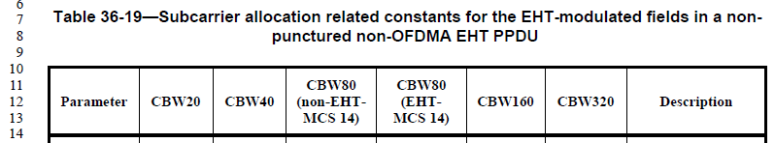
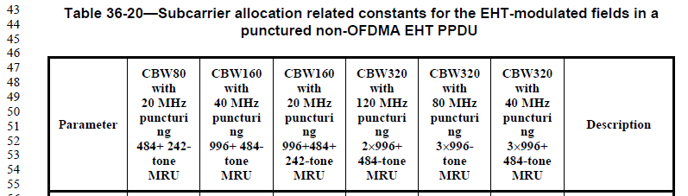

P579 of D2.1.1:
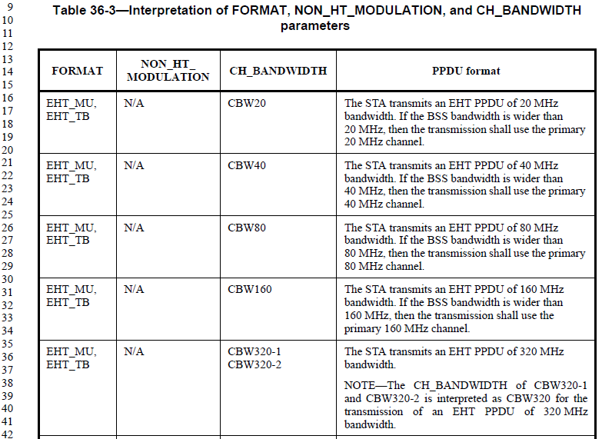

#10179, 11207, 11352, 11353, 12846
CID | Commenter | Clause Number(C) | Page | Comment | Proposed Change | Resolution
10179 | Xiaogang Chen | 36.3.10 | 626.58 | The "effective number of" may need to clarify. For instance, the note of Nsd need to cover MCS14. also the "unique" in N_sd,total may confused bystandard. | suggest to change the note to include MCS14 in the defintion of N_SD. Maybe the same note need to be added for Nsd_total. | Rejected  80 MHz, 160 MHz and 320 MHz EHT DUP transmission are actually based on 484-tone RU, 996-tone RU and 2x996-tone RU, respectively.  For each 484-tone RU, 996-tone RU and 2x996-tone RU, the N_SD value with DCM is half of the N_SD value without DCM, and this is true for all EHT-MCSs. As a result, the N_SD note need not to be clarified especially for EHT-MCS 14.
11207 | ron porat | 36.3.10 | 626.62 | Table 36-23: parameter being defined should be N_SD,u instead of N_SD,total (see original text in 11-21/1893r2) | Replace "N_SD,total" with "N_SD,u" | Revised  Agreed with the comment in principle. The proposed changes define N_SD,u and N_SD,total separately.  TGbe editor: please incorporate the changes shown in 11-22/1716r0 under tag #11207.
11352 | Bin Tian | 36.3.10 | 626.61 | Based on explanation, NSD,total should be NSD,u. Add another row for NSD,total | as in the comment | Revised  Agreed with the comment in principle. The proposed changes define N_SD,u and N_SD,total separately.  TGbe editor: please incorporate the changes shown in 11-22/1716r0 tag #11352.
11353 | Bin Tian | 36.3.10 | 626.61 | The denifition of NSD,total is wrong. It should be the total number of data subcarriers in a RU or MRU | as in the comment | Revised  Agreed with the comment in principle. The proposed changes define N_SD,u and N_SD,total separately.  TGbe editor: please incorporate the changes shown in 11-22/1716r0 tag #11353.
12846 | Yan Xin | 36.3.10 | 626.61 | Based on the explanation, it should be "N_(SD,u)" rather than "N_(SD,total)". | Replace "N_(SD,total)" with "N_(SD,u)" | Revised  Agreed with the comment in principle. The proposed changes define N_SD,u and N_SD,total separately.  TGbe editor: please incorporate the changes shown in 11-22/1716r0 tag #12846.

Background (P642 of D2.1.1):

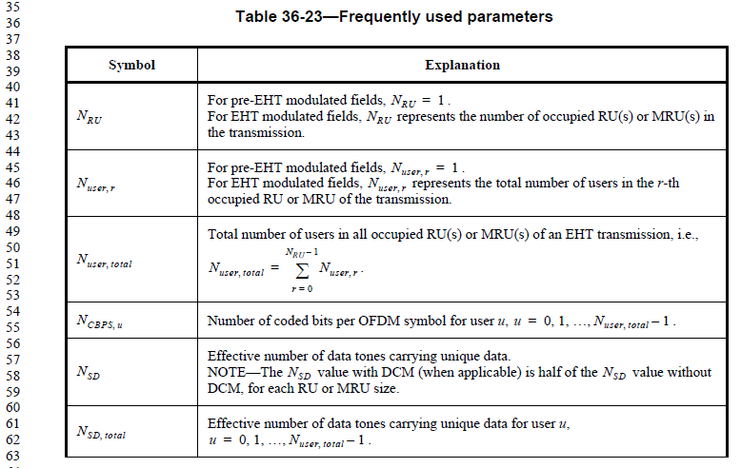

Proposed Changes:

Instruction to TGbe Editor:
Change Table 36-23 (P802.11be D2.1.1 P642) as follows:

Table 36-23—Frequently used parameters

Symbol | Explanation
NRU | For pre-EHT modulated fields, NRU = 1 .  For EHT modulated fields, NRU represents the number of occupied RU(s) or MRU(s) in the transmission.
Nuser, r | For pre-EHT modulated fields, Nuser, r = 1 .  For EHT modulated fields, Nuser, r represents the total number of users in the r-th occupied RU or MRU of the transmission.
Nuser, total | Total number of users in all occupied RU(s) or MRU(s) of an EHT transmission, i.e.,  NRU – 1  Nuser, total = ∑ Nuser, r .  r = 0
NCBPS, u | Number of coded bits per OFDM symbol for user u, u = 0, 1, …, Nuser, total – 1 .
NSD | Effective number of data tones carrying unique data.  NOTE—The NSD value with DCM (when applicable) is half of the NSD value without DCM, for each RU or MRU size.
NSD, u | Effective number of data tones carrying unique data for user u, u = 0, 1, …, Nuser, total – 1 .
NSD, total | Effective number of data tones in a RU or MRU.

#10827, 10828

CID | Commenter | Clause Number(C) | Page | Comment | Proposed Change | Resolution
10827 | Dong Guk Lim | 36.3.10 | 627.10 | NCBPSS,l,u is not the same as NCBPSS,u. To clarify it, the explanation should be modified. | Change " Number of coded bits per OFDM symbol per spatial stream for user u" with "Number of coded bits per OFDM symbol per spatial stream for user u in the l-th 80 MHz frequency block " and delete "in the l-th 80 MHz frequency block " in the second sentence. | Accepted
10828 | Dong Guk Lim | 36.3.10 | 627.23 | NBPSCS,l,u is not the same as NBPSCS,u. To clarify it, the explanation should be modified. | Change " Number of coded bits per subcarrier per spatial stream for user u" with "Number of coded bits per subcarrier per spatial stream for user u in the l-th 80 MHz frequency block " and delete "in the l-th 80 MHz frequency block " in the second sentence. | Accepted

Background (P643 of D2.1.1):
