IEEE P802.11  
Wireless LANs

|  |  |  |  |  |
| --- | --- | --- | --- | --- |
| LB266 CR on subclause 36.3.19.1 Transmit spectral mask | | | | |
| Date: 2022-09-01 | | | | |
| Author(s): | | | | |
| Name | Affiliation | Address | Phone | email |
| Yapu Li | OPPO |  |  | liyapu1@oppo.com |
| Xiaogang Chen | ZEKU |  |  |  |

Abstract

This submission contains proposed comment resolutions to the following CID based on P802.11be D2.1.1.

CID 11299,11302, 12029, 12030, 13846

Revisions:

- Rev 0: Initial version of the document.

-

# CID 11299

|  |  |  |  |  |  |
| --- | --- | --- | --- | --- | --- |
| **CID** | **Page.**  **Line** | **Clause** | **Comment** | **Proposed Change** | **Resolution** |
| 11299 | 747.9 | 36.3.19.1.2 | "When the lowest and/or the highest subchannel(s) are/is punctured in a PPDU, the subchannel edge mask as defined in Figure 36-65 ...". The mask shown in Figure 36-65 only applies at the "high" edge. For the "low" edge, the mirror image is needed. | Show both high and low band edge mask correctly | Revised  Agree in principle.  For clarity, it need be added a puncture mask for lower edge of the lowest occupied subchannel in Figure 36-65.  **Instructions to the editor:**  **Please make the changes to the spec as shown in 11/22-1514r0 under CID 11299** |

**Discussion**

In Figure 36-65, this puncture mask is only used for higher edge of the highest occupied subchannel. For clarity, it need be added a puncture mask for lower edge of the lowest occupied subchannel.

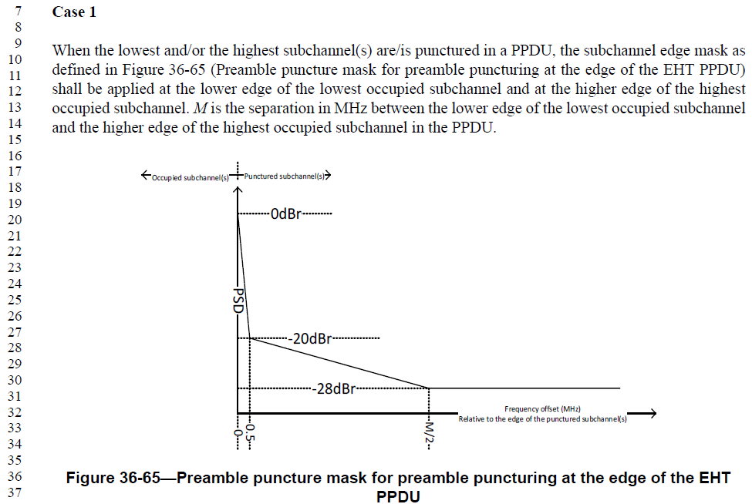

***TGbe editor:***

***Please replace Figure 36-65 (in Page 763 Line 17 in D2.1.1) with the following figure:***

Figure 36-65—Preamble puncture mask for preamble puncturing at the edge of the EHT PPDU

# CID 11302

|  |  |  |  |  |  |
| --- | --- | --- | --- | --- | --- |
| **CID** | **Page.**  **Line** | **Clause** | **Comment** | **Proposed Change** | **Resolution** |
| 11302 | 748.42 | 36.3.19.1.2 | "... shall be applied at the lower edge of the lowest punctured subchannel(s) and at the higher edge of the highest punctured subchannel(s).". The mask as shown in Figure 36-67 can only be applied at the lower edge of the punctured subchannel. For the higher edge, the mirror image of Figure 36-67 is needed. | Show both high and low band edge mask correctly | Revised  Agree in principle.  For clarity, it need be added a puncture mask for higher edge of the highest punctured subchannel in Figure 36-67.  **Instructions to the editor:**  **Please make the changes to the spec as shown in 11/22-1514r0 under CID 11302** |

**Discussion**

In Figure 36-67, this puncture mask is only used for the lower edge of lowest punctured subchannel. For clarity, it need be added a puncture mask for higher edge of the highest punctured subchannel.

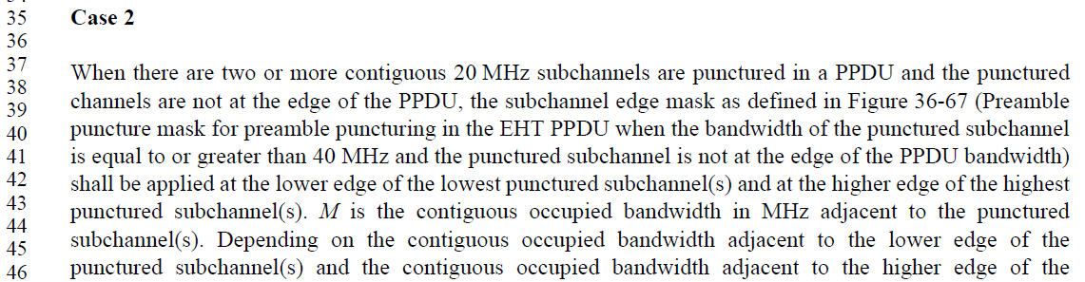

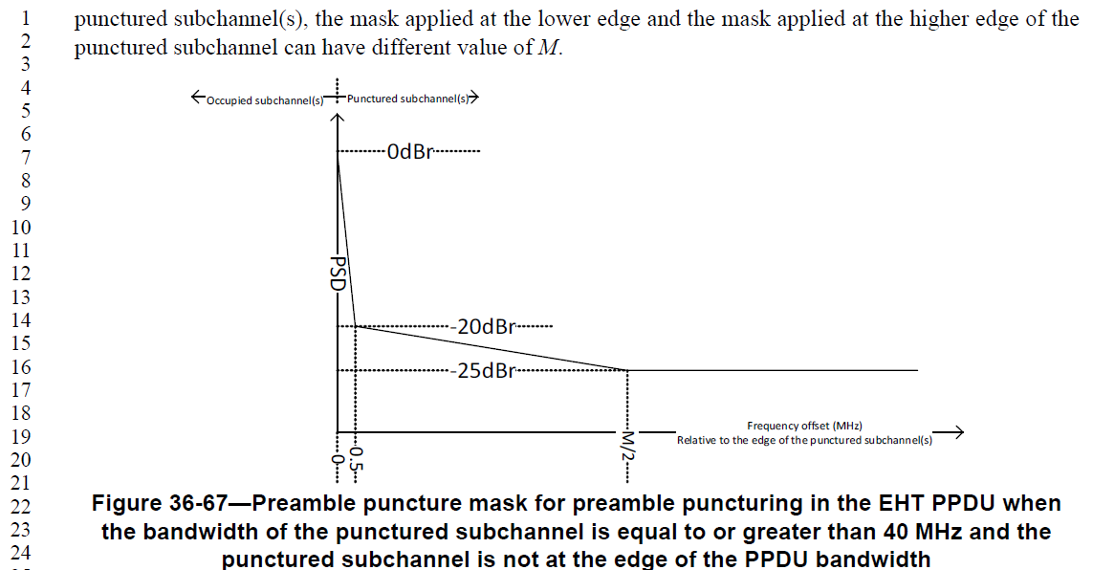

***TGbe editor:***

***Please replace Figure 36-67 (in Page 765 Line 4 in D2.1.1) with the following figure:***



Figure 36-67—Preamble puncture mask for preamble puncturing in the EHT PPDU when

the bandwidth of the punctured subchannel is equal to or greater than 40 MHz and the

punctured subchannel is not at the edge of the PPDU bandwidth

# CID 12029

|  |  |  |  |  |  |
| --- | --- | --- | --- | --- | --- |
| **CID** | **Page.**  **Line** | **Clause** | **Comment** | **Proposed Change** | **Resolution** |
| 12029 | 747.17 | 36.3.19.1.2 | In Figure 36-65, there is a term "Punctured subchannel(s)" at the top. It seems that this puncture mask is applied only to the edge where puncturing is applied. However, as shown in Figure 36-66 this puncture mask is applied to both edges although the lower side is only punctured. | Delete "Punctured subchannel(s)" in Figure 36-65 or modify Figure 36-66 by applying the puncture mask only to the lower side. | Revised  Agree to delete "Punctured subchannel(s)" in Figure 36-65.  **Instructions to the editor:**  The resolution is same as CID11299 |

**Discussion**

**36.3.19.1.2 Additional restrictions for puncturing in EHT PPDU**

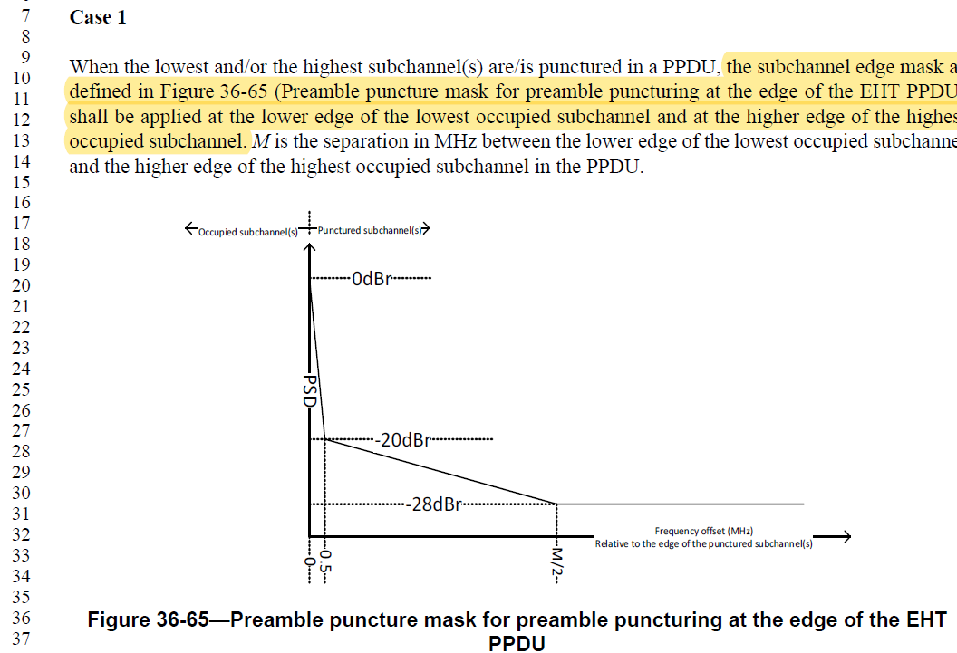

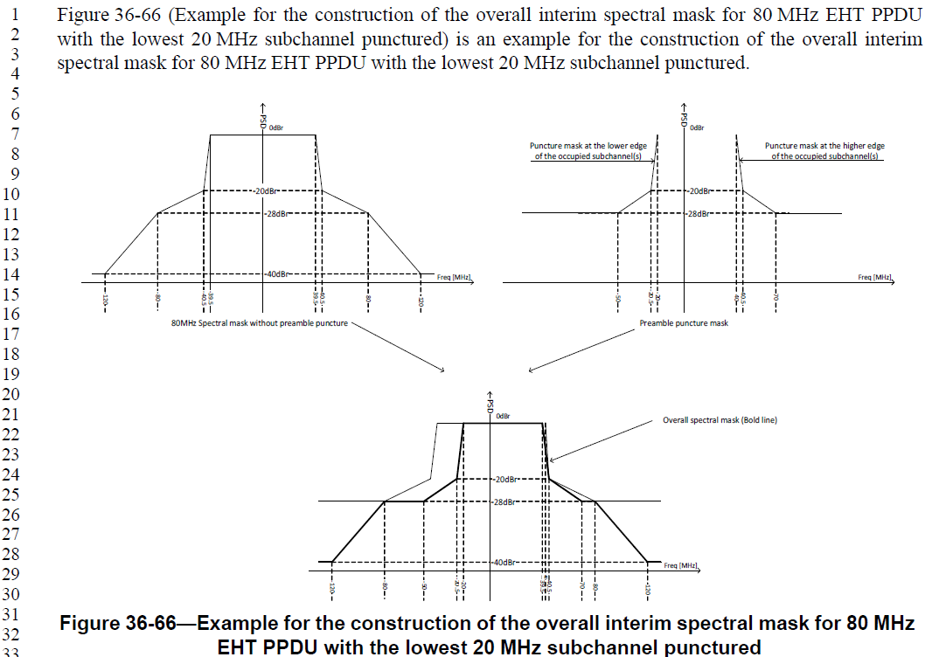

# CID 12030

|  |  |  |  |  |  |
| --- | --- | --- | --- | --- | --- |
| **CID** | **Page.**  **Line** | **Clause** | **Comment** | **Proposed Change** | **Resolution** |
| 12030 | 753.4 | 36.3.19.1.3 | In Figure 36-71, there is a term "Punctured subchannel(s)" at the top. It seems that this puncture mask is applied only to the edge where puncturing is applied. However, as shown in Figure 36-74 this puncture mask is applied to both edges although the lower side is only punctured. | Delete "Punctured subchannel(s)" in Figure 36-71 or modify Figure 36-74 by applying the puncture mask only to the lower side. | Revised  Agree to delete "Punctured subchannel(s)" in Figure 36-71. Besides, it need be added a puncture mask for lower edge of the lowest occupied subchannel.  **Instructions to the editor:**  **Please make the changes to the spec as shown in 11/22-1514r0 under CID 12030** |

**Discussion**

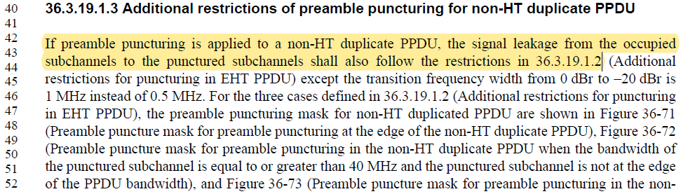

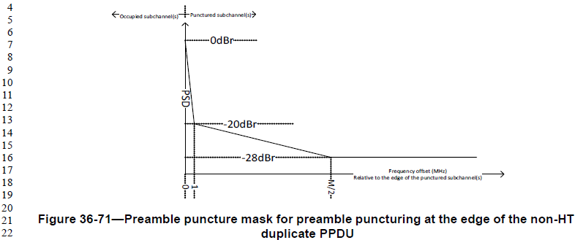

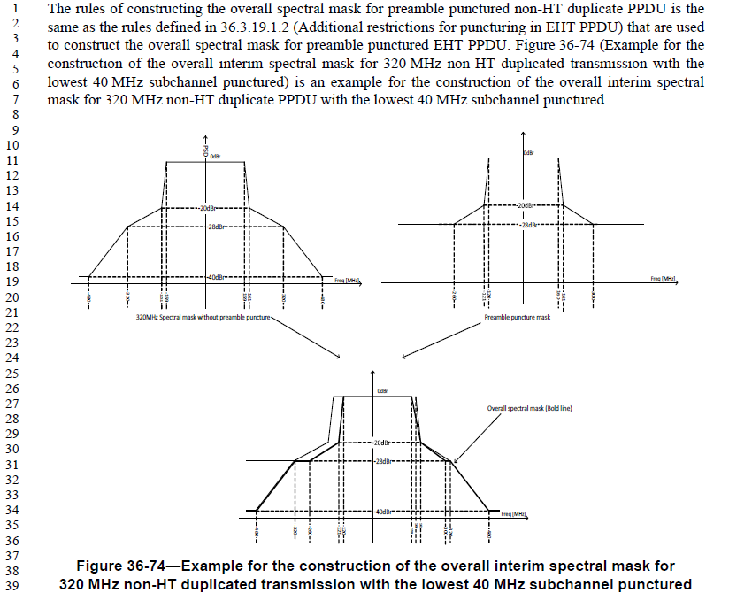

***TGbe editor:***

***Please replace Figure 36-71 (in Page 769 Line 4 in D2.1.1) with the following figure:***



Figure 36-71—Preamble puncture mask for preamble puncturing at the edge of the non-HT duplicate PPDU

# CID 13846

|  |  |  |  |  |  |
| --- | --- | --- | --- | --- | --- |
| **CID** | **Page.**  **Line** | **Clause** | **Comment** | **Proposed Change** | **Resolution** |
| 13846 | 750.19 | 36.3.191.2 | Typo: caption of the figure should be 160 MHz Spectral mask without preamble puncture | Please replace '80 MHz ' with '160 MHz' | Accepted  Note to the Editor: The corresponding sentence is on P766L19 of D2.1.1 |

**Discussion**

