IEEE P802.11
Wireless LANs
LB266-Caluse3.2-CIDs-part-2
Date: 2022.08.17
Author(s):
Name | Company | Address | Phone | email
Ross Jian Yu | Huawei Technologies | H3 building, Huawei Base, Bantian, Longgang, Shenzhen, Guangdong, China, 518129 |  | ross.yujian@huawei.com
Ming Gan | Huawei Technologies
Edward Au | Huawei Technologies
Abstract
This submission contains proposed comment resolution to a comment on P802.11be D2.0. The changes are based on P802.11be D2.1.1.

1 comment is resolved.
CID 11812

Revision Notes

R0 | Initial revision

CID 11812
Page.  Line | Clause Number | Comment | Proposed Change | Resolution
51.34 | 3.2 | Why are 20, 80, and 160 MHz operating STAs special? Please clarify, expand or remove as needed. | As in comment. | Rejected  Definitions for 20 MHz, 80 MHz, and 160 MHz operating STAs are required to support the discussion in the corresponding subclause in 36.3.2.5/7/8 of P802.11be D2.1.1 respectively.  Regarding “40 MHz operating”, there are 40 MHz operating channel/device/beamformee, but there is no corresponding description about 40 MHz operating STA in the draft and therefore, no specific definition in subclause 3.2 is required
Discussion
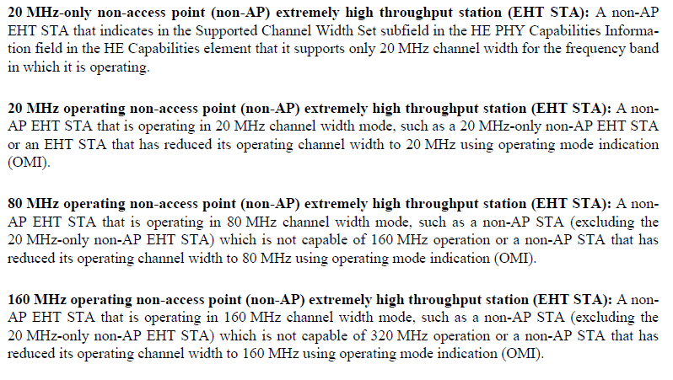
In 11ax, there are also definitions shown as below:
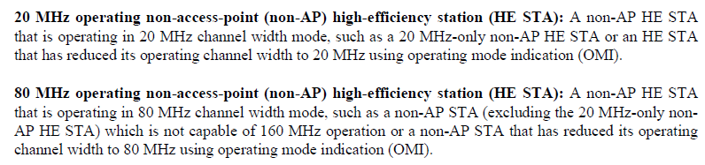
Corresponding subclause in P802.11be D2.1.1:
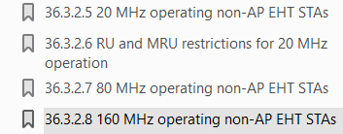
Discussion ends

