IEEE P802.11
Wireless LANs
LB266 CR in 36.3.12.8.3 – part 2
Date: 2022.08.24
Author(s):
Name | Company | Address | Phone | email
Ross Jian Yu | Huawei Technologies | H3 building, Huawei Base, Bantian, Longgang, Shenzhen, Guangdong, China, 518129 |  | ross.yujian@huawei.com
Ming Gan | Huawei Technologies
Edward Au | Huawei Technologies
Abstract
This submission contains proposed comment resolutions to comments on P802.11be D2.0. The changes are based on P802.11be D2.1.1.

3 comments are resolved.
11286, 11362

Revision Notes

R0 | Initial revision
R1 | Add “-” after “gap”
R2 | Add pattern, remove CID 13581 for now

CID 11286, 11362
CID | Page.  Line | Clause Number | Comment | Proposed Change | Resolution
11286 | 667.27 | 36.3.12.8.3 | "MRU of []-242-484" is awkward notation/description. | Change to e.g. "242+484 tone MRU with pattern []-242-484". Similarly in other places. | Revised  Reflect the detail changes.  Instructions to the editor:  Please make the changes as shown in 11/22-1349r2, under CID 11362
11362 | 668.63 | 36.3.12.8.3 | Notaton "[]" and its definition need to be updated to be more clear. Can use the same notation as in the MRU definition table in 36.3.2.2.3 | as in the comment | Revised  Reflect the detail changes.  Instructions to the editor:  Please make the changes as shown in 11/22-1349r2, under CID 11362
Discussion
Example in 36.3.2.2.3
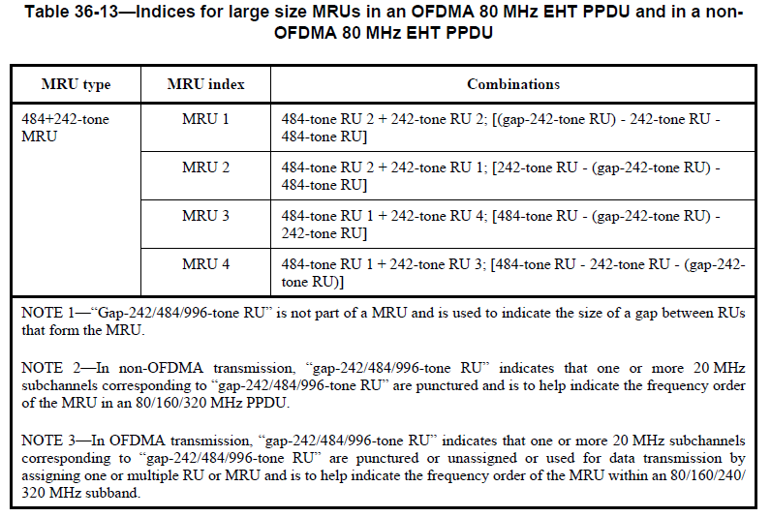
Discussion end
Instructions to the editor, please make the following changes to P683, L27 of P802.11be D2.1.1:
96–103 (001100y2y1y0) | MRU of pattern [gap-242]-242-484, specifically 484+242-tone MRU-1, 5, 9, and 13 within the first, second, third, and fourth 80 MHz subblock in increasing frequency order, respectively | 8
104–111 (001101y2y1y0) | MRU of pattern 242-[gap-242]-484, specifically 484+242-tone MRU-2, 6, 10, and 14 within the first, second, third, and fourth 80 MHz subblock in increasing frequency order, respectively | 8
112–119 (001110y2y1y0) | MRU of pattern 484-[gap-242]-242, specifically 484+242-tone MRU-3, 7, 11, and 15 within the first, second, third, and fourth 80 MHz subblock in increasing frequency order, respectively | 8
120–127 (001111y2y1y0) | MRU of pattern 484-242-[gap-242], specifically 484+242-tone MRU-4, 8, 12, and 16 within the first, second, third, and fourth 80 MHz subblock in increasing frequency order, respectively | 8
128–135 (010000y2y1y0) | MRU of pattern [gap-484]-484-996, specifically 996+484-tone MRU-1 and 5 within the first and second 160 MHz subblock in increasing frequency order, respectively | 8
136–143 (010001y2y1y0) | MRU of pattern 484-[gap-484]-996, specifically 996+484-tone MRU-2 and 6 within the first and second 160 MHz subblock in increasing frequency order, respectively | 8
144–151 (010010y2y1y0) | MRU of pattern 996-[gap-484]-484, specifically 996+484-tone MRU-3 and 7 within the first and second 160 MHz subblock in increasing frequency order, respectively | 8
152–159 (010011y2y1y0) | MRU of pattern 996-484-[gap-484], specifically 996+484-tone MRU-4 and 8 within the first and second 160 MHz subblock in increasing frequency order, respectively | 8
160–167 (010100y2y1y0) | MRU of pattern [gap-996]-996-996-996, specifically 3×996-tone MRU-1 | 8
168–175 (010101y2y1y0) | MRU of pattern 996-[gap-996]-996-996, specifically 3×996-tone MRU-2 | 8
176–183 (010110y2y1y0) | MRU of pattern 996-996-[gap-996]-996, specifically 3×996-tone MRU-3 | 8
184–191 (010111y2y1y0) | MRU of pattern 996-996-996-[gap-996], specifically 3×996-tone MRU-4 | 8
192–199 (011000y2y1y0) | MRU of pattern [gap-484]-484-996-996-996, specifically 3×996+484-tone MRU-1 | 8
200–207 (011001y2y1y0) | MRU of pattern 484-[gap-484]-996-996-996, specifically 3×996+484-tone MRU-2 | 8
208–215 (011010y2y1y0) | MRU of pattern 996-[gap-484]-484-996-996, specifically 3×996+484-tone MRU-3 | 8
216–223 (011011y2y1y0) | MRU of pattern 996-484-[gap-484]-996-996, specifically 3×996+484-tone MRU-4 | 8
224–231 (011100y2y1y0) | MRU of pattern 996-996-[gap-484]-484-996, specifically 3×996+484-tone MRU-5 | 8
232–239 (011101y2y1y0) | MRU of pattern 996-996-484-[gap-484]-996, specifically 3×996+484-tone MRU-6 | 8
240–247 (011110y2y1y0) | MRU of pattern 996-996-996-[gap-484]-484, specifically 3×996+484-tone MRU-7 | 8
248–255 (011111y2y1y0) | MRU of pattern 996-996-996-484-[gap-484], specifically 3×996+484-tone MRU-8 | 8
256–263 (100000y2y1y0) | MRU of pattern [gap-484]-484-996-996, specifically 2×996+484-tone MRU-1 and 7 within the 240 MHz subblock composed of the first, second, and third 80 MHz subblock and the 240 MHz subblock composed of the second, third, and fourth 80 MHz subblock in increasing frequency order, respectively | 8
264–271 (100001y2y1y0) | MRU of pattern 484-[gap-484]-996-996, specifically 2×996+484-tone MRU-2 and 8 within the 240 MHz subblock composed of the first, second, and third 80 MHz subblock and the 240 MHz subblock composed of the second, third, and fourth 80 MHz subblock in increasing frequency order, respectively | 8
272–279 (100010y2y1y0) | MRU of pattern 996-[gap-484]-484-996, specifically 2×996+484-tone MRU-3 and 9 within the 240 MHz subblock composed of the first, second, and third 80 MHz subblock and the 240 MHz subblock composed of the second, third, and fourth 80 MHz subblock in increasing frequency order, respectively | 8
280–287 (100011y2y1y0) | MRU of pattern 996-484-[gap-484]-996, specifically 2×996+484-tone MRU-4 and 10 within the 240 MHz subblock composed of the first, second, and third 80 MHz subblock and the 240 MHz subblock composed of the second, third, and fourth 80 MHz subblock in increasing frequency order, respectively | 8
288–295 (100100y2y1y0) | MRU of pattern 996-996-[gap-484]-484, specifically 2×996+484-tone MRU-5 and 11 within the 240 MHz subblock composed of the first, second, and third 80 MHz subblock and the 240 MHz subblock composed of the second, third, and fourth 80 MHz subblock in increasing frequency order, respectively | 8
296–303 (100101y2y1y0) | MRU of pattern 996-996-484-[gap-484], specifically 2×996+484-tone MRU-6 and 12 within the 240 MHz subblock composed of the first, second, and third 80 MHz subblock and the 240 MHz subblock composed of the second, third, and fourth 80 MHz subblock in increasing frequency order, respectively | 8
304–511 (100110y2y1y0–  111111y2y1y0) | Disregard | 26×8
For an RU Allocation subfield with value greater than or equal to 64, y₂y₁y₀ = 000–111 indicates the number of User fields in the EHT-SIG content channel that contains the corresponding 9-bit RU Allocation subfield. The binary vector y2y1y0 indicates N (r, c) = 2² × y + 2¹ × y + y + 1 User fields in the EHT-SIG content channel that
user 2 1 0
contains the corresponding 9-bit RU Allocation subfield.
[Gap-242/484/996] indicates a 242/484/996-tone RU that is not overlapped with the RU or MRU indicated by the 9-bit RU Allocation subfield and is to help indicate the frequency order of the MRU within an 80/160/240/320 MHz subband.

