IEEE P802.11
Wireless LANs
LB266 CR in 36.3.12.8.3 – part 2
Date: 2022.07.14
Author(s):
Name | Company | Address | Phone | email
Ross Jian Yu | Huawei Technologies | H3 building, Huawei Base, Bantian, Longgang, Shenzhen, Guangdong, China, 518129 |  | ross.yujian@huawei.com
Ming Gan | Huawei Technologies
Edward Au | Huawei Technologies
Abstract
This submission contains proposed comment resolutions to comments on P802.11be D2.0. The changes are based on P802.11be D2.1.1.

3 comments are resolved.
11286, 11362, 13581

Revision Notes

R0 | Initial revision

CID 11286, 11362
CID | Page.  Line | Clause Number | Comment | Proposed Change | Resolution
11286 | 667.27 | 36.3.12.8.3 | "MRU of []-242-484" is awkward notation/description. | Change to e.g. "242+484 tone MRU with pattern []-242-484". Similarly in other places. | Revised  Reflect the detail changes.  Instructions to the editor:  Please make the changes as shown in 11/22-1349r0, under CID 11362
11362 | 668.63 | 36.3.12.8.3 | Notaton "[]" and its definition need to be updated to be more clear. Can use the same notation as in the MRU definition table in 36.3.2.2.3 | as in the comment | Revised  Reflect the detail changes.  Instructions to the editor:  Please make the changes as shown in 11/22-1349r0, under CID 11362
Discussion
Example in 36.3.2.2.3
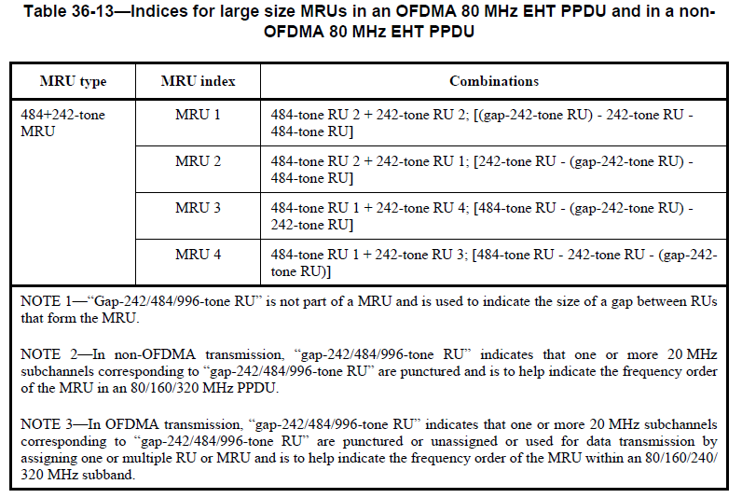
Discussion end
Instructions to the editor, please make the following changes to P683, L27 of P802.11be D2.1.1:
96–103 (001100y2y1y0) | MRU of [gap 242]-242-484, specifically 484+242-tone MRU-1, 5, 9, and 13 within the first, second, third, and fourth 80 MHz subblock in increasing frequency order, respectively | 8
104–111 (001101y2y1y0) | MRU of 242-[gap 242]-484, specifically 484+242-tone MRU-2, 6, 10, and 14 within the first, second, third, and fourth 80 MHz subblock in increasing frequency order, respectively | 8
112–119 (001110y2y1y0) | MRU of 484-[gap 242]-242, specifically 484+242-tone MRU-3, 7, 11, and 15 within the first, second, third, and fourth 80 MHz subblock in increasing frequency order, respectively | 8
120–127 (001111y2y1y0) | MRU of 484-242-[gap 242], specifically 484+242-tone MRU-4, 8, 12, and 16 within the first, second, third, and fourth 80 MHz subblock in increasing frequency order, respectively | 8
128–135 (010000y2y1y0) | MRU of [gap 484]-484-996, specifically 996+484-tone MRU-1 and 5 within the first and second 160 MHz subblock in increasing frequency order, respectively | 8
136–143 (010001y2y1y0) | MRU of 484-[gap 484]-996, specifically 996+484-tone MRU-2 and 6 within the first and second 160 MHz subblock in increasing frequency order, respectively | 8
144–151 (010010y2y1y0) | MRU of 996-[gap 484]-484, specifically 996+484-tone MRU-3 and 7 within the first and second 160 MHz subblock in increasing frequency order, respectively | 8
152–159 (010011y2y1y0) | MRU of 996-484-[gap 484], specifically 996+484-tone MRU-4 and 8 within the first and second 160 MHz subblock in increasing frequency order, respectively | 8
160–167 (010100y2y1y0) | MRU of [gap 996]-996-996-996, specifically 3×996-tone MRU-1 | 8
168–175 (010101y2y1y0) | MRU of 996-[gap 996]-996-996, specifically 3×996-tone MRU-2 | 8
176–183 (010110y2y1y0) | MRU of 996-996-[gap 996]-996, specifically 3×996-tone MRU-3 | 8
184–191 (010111y2y1y0) | MRU of 996-996-996-[gap 996], specifically 3×996-tone MRU-4 | 8
192–199 (011000y2y1y0) | MRU of [gap 484]-484-996-996-996, specifically 3×996+484-tone MRU-1 | 8
200–207 (011001y2y1y0) | MRU of 484-[gap 484]-996-996-996, specifically 3×996+484-tone MRU-2 | 8
208–215 (011010y2y1y0) | MRU of 996-[gap 484]-484-996-996, specifically 3×996+484-tone MRU-3 | 8
216–223 (011011y2y1y0) | MRU of 996-484-[gap 484]-996-996, specifically 3×996+484-tone MRU-4 | 8
224–231 (011100y2y1y0) | MRU of 996-996-[gap 484]-484-996, specifically 3×996+484-tone MRU-5 | 8
232–239 (011101y2y1y0) | MRU of 996-996-484-[gap 484]-996, specifically 3×996+484-tone MRU-6 | 8
240–247 (011110y2y1y0) | MRU of 996-996-996-[gap 484]-484, specifically 3×996+484-tone MRU-7 | 8
248–255 (011111y2y1y0) | MRU of 996-996-996-484-[gap 484], specifically 3×996+484-tone MRU-8 | 8
256–263 (100000y2y1y0) | MRU of [gap 484]-484-996-996, specifically 2×996+484-tone MRU-1 and 7 within the 240 MHz subblock composed of the first, second, and third 80 MHz subblock and the 240 MHz subblock composed of the second, third, and fourth 80 MHz subblock in increasing frequency order, respectively | 8
264–271 (100001y2y1y0) | MRU of 484-[gap 484]-996-996, specifically 2×996+484-tone MRU-2 and 8 within the 240 MHz subblock composed of the first, second, and third 80 MHz subblock and the 240 MHz subblock composed of the second, third, and fourth 80 MHz subblock in increasing frequency order, respectively | 8
272–279 (100010y2y1y0) | MRU of 996-[gap 484]-484-996, specifically 2×996+484-tone MRU-3 and 9 within the 240 MHz subblock composed of the first, second, and third 80 MHz subblock and the 240 MHz subblock composed of the second, third, and fourth 80 MHz subblock in increasing frequency order, respectively | 8
280–287 (100011y2y1y0) | MRU of 996-484-[gap 484]-996, specifically 2×996+484-tone MRU-4 and 10 within the 240 MHz subblock composed of the first, second, and third 80 MHz subblock and the 240 MHz subblock composed of the second, third, and fourth 80 MHz subblock in increasing frequency order, respectively | 8
288–295 (100100y2y1y0) | MRU of 996-996-[gap 484]-484, specifically 2×996+484-tone MRU-5 and 11 within the 240 MHz subblock composed of the first, second, and third 80 MHz subblock and the 240 MHz subblock composed of the second, third, and fourth 80 MHz subblock in increasing frequency order, respectively | 8
296–303 (100101y2y1y0) | MRU of 996-996-484-[gap 484], specifically 2×996+484-tone MRU-6 and 12 within the 240 MHz subblock composed of the first, second, and third 80 MHz subblock and the 240 MHz subblock composed of the second, third, and fourth 80 MHz subblock in increasing frequency order, respectively | 8
304–511 (100110y2y1y0–  111111y2y1y0) | Disregard | 26×8
For an RU Allocation subfield with value greater than or equal to 64, y₂y₁y₀ = 000–111 indicates the number of User fields in the EHT-SIG content channel that contains the corresponding 9-bit RU Allocation subfield. The binary vector y2y1y0 indicates N (r, c) = 2² × y + 2¹ × y + y + 1 User fields in the EHT-SIG content channel that
user 2 1 0
contains the corresponding 9-bit RU Allocation subfield.
[Gap 242/484/996] indicates a 242/484/996-tone RU that is not overlapped with the RU or MRU indicated by the 9-bit RU Allocation subfield and is to help indicate the frequency order of the MRU within an 80/160/240/320 MHz subband.

CID 13581
Page.  Line | Clause Number | Comment | Proposed Change | Resolution
661.01 | 36.3.12.8.3 | Define 1 bit of Disregard bit in EHT-SIG as vendor specific field | Will bring a detailed proposal. | Revised  Reflect the detail changes  Instructions to the editor:  Please make the changes as shown in 11/22-1349r0, under CID 13581
Discussion:
- Vendors may make use of some reserved fields/entries in preamble for proprietary/vendor specific designs.
  - For example, implementation of 1K QAM for 11ac; implementation of 4KQAM for 11ax.
  - This will make reserved entries difficult for further use because of the proprietary/vendor specific designs.
- In 11be, the spec defines Validate and Disregard. There are:
  - 5 Disregard bits (B20-B24) and 1 Validate bit (B25) for U-SIG-1
  - 1 Validate bit (B2) for potential modes extension, 1 Validate bit (B8) for potential puncture mode extension in U-SIG-2
  - 4 Disregard bits (B13-B16) in U-SIG overflow of EHT-SIG common for OFDMA/non-OFDMA transmission to single user/multiple users, 2 Disregard bits (B14-B15) in U-SIG overflow of EHT-SIG common for EHT sounding NDP.
  - 1 Reserved bit for User field format for a non-MU-MIMO allocation
- If different vendor takes use of different reserved values, it may make the reserved values difficult for future use or make some interoperability issues.
- Propose to choose one Disregard bit (B15 of EHT-SIG common field) as vendor specific subfield.
Discussion end
Instructions to the editor, please make the following changes to P683, L27 of P802.11be D2.1.1:
Table 36-33—Common field for OFDMA transmission (continued)

Bit | Subfield | Number of subfields | Number of bits per subfield | Description
B13–B14 | Disregard | 1 | 2 | Set to all 1s. Disregard if dot11EHTBaseLineFeaturesImplementedOn ly equals true.
B15 | Vendor specific | 1 | 1 | Vendor specific
B16 | Disregard | 1 | 1 | Set to 1. Disregard if dot11EHTBaseLineFeaturesImplementedOn ly equals true.

Table 36-36—Common field for non-OFDMA transmission to a single user and non-OFDMA transmission to multiple users (continued)

Bit | Subfield | Number of bits | Description
B12 | PE Disambiguity | 1 | Indicates PE disambiguity as defined in  36.3.14 (Packet extension).
B13–B14 | Disregard | 2 | Set to all 1s. Disregard if dot11EHTBaseLineFeaturesImplementedOnly equals true.
B15 | Vendor specific | 1 | Vendor specific
B16 | Disregard | 1 | Set to 1. Disregard if dot11EHTBaseLineFeaturesImplementedOn ly equals true.

Table 36-37—Common field for EHT sounding NDP (continued)

Bit | Subfield | Number of bits per subfield | Description
B14 | Disregard | 1 | Set to 1. Disregard if dot11EHTBaseLineFeaturesImplementedOn ly equals true.
B15 | Vendor specific | 1 | Vendor specific

