IEEE P802.11
Wireless LANs
LB266 CR in 36.3.12.8.6
Date: 2022.08.04
Author(s):
Name | Company | Address | Phone | email
Ross Jian Yu | Huawei Technologies | H3 building, Huawei Base, Bantian, Longgang, Shenzhen, Guangdong, China, 518129 |  | ross.yujian@huawei.com
Ming Gan | Huawei Technologies
Stephen McCann | Huawei Technologies
Edward Au | Huawei Technologies
Abstract
This submission contains proposed comment resolutions to comments on P802.11be D2.0. The changes are based on P802.11be D2.1 for a revised resolution. For an accepted resolution, the page and line in D2.1 are also added as a note to the editor.

2 comments are resolved.
CID 12021, 12354

Revision Notes

R0 | Initial revision

CID 12021
Page.  Line | Clause Number | Comment | Proposed Change | Resolution
689.36 | 36.3.12.8.6 | Change "~ contains on EHT-SIG ~" to "~ contains one EHT-SIG ~". | As in comment. | Accepted  NOTE to the editor: page 689 line 36 of D2.0 is page 701 line 36 of D2.1

CID 12354
Page.  Line | Clause Number | Comment | Proposed Change | Resolution
683.54 | 36.3.12.8.6 | In the sentence: "For EHT-SIG for OFDMA transmission and non-OFDMA transmission to multiple users, each user encoding block OFDMA transmission, if the number of User fields in an EHT-SIG content channel is odd, there is a single User field in the final user encoding block." It is unclear the intent of "each user encoding block OFDMA transmission, " | Suggest removing "each user encoding block OFDMA transmission, " | Revised  Regarding this part, the proposed change in 11/21-1387r4 is correct, whilst not correctly reflected in the draft. Now change the current text back to what was proposed in 11/21-1387r4.  Instructions to the editor:  Please make the changes as shown in 11/22-1207r0, under CID 12354.

Discussion:
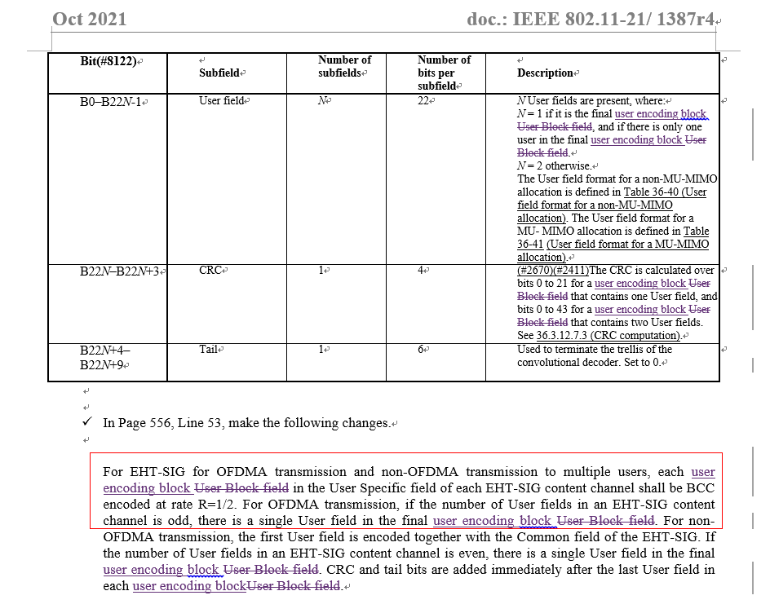
Discussion ended.

Instructions to the editor, please make the following changes to P695, L54 of P802.11be D2.1:
For EHT-SIG for OFDMA transmission and non-OFDMA transmission to multiple users, each user encoding block in the User Specific field of EHT-SIG content channel shall be BCC encoded at rate R=1/2. For (#12354)OFDMA transmission, if the number of User fields in an EHT-SIG content channel is odd, there is a single User field in the final user encoding block. For non-OFDMA transmission, the first User field is encoded together with the Common field of the EHT-SIG. If the number of User fields in an EHT-SIG content channel is even, there is a single User field in the final user encoding block. CRC and tail bits are added immediately after the last User field in each user encoding block.

