IEEE P802.11
Wireless LANs
LB266 CR in 36.3.12.8.5
Date: 2022.07.26
Author(s):
Name | Company | Address | Phone | email
Ross Jian Yu | Huawei Technologies | H3 building, Huawei Base, Bantian, Longgang, Shenzhen, Guangdong, China, 518129 |  | ross.yujian@huawei.com
Ming Gan | Huawei Technologies
Stephen McCann | Huawei Technologies
Edward Au | Huawei Technologies
Abstract
This submission contains proposed comment resolutions to comments on P802.11be D2.0. The changes are based on P802.11be D2.1 for a revised resolution. For an accepted resolution, the page and line in D2.1 are also added as a note to the editor.

12 comments are resolved.
CID 10751, 10752, 10753, 11192, 11193, 11194, 11195, 11219, 11363, 12568, 13575, 13576

Revision Notes

R0 | Initial revision

CID 10751
Page.  Line | Clause Number | Comment | Proposed Change | Resolution
676.21 | 36.3.12.8.5 | Table 36-38 is for non-OFDMA transmission that is MU-MIMO. It seems odd to include the non-MU-MIMO option in the description. | Please clarify it or remove the non-MU-MIMO option from the description. | Rejected  Table 36-38 is for both single user (non-MU-MIMO allocation) and multiple users (MU-MIMO allocation).

CID 10752
Page.  Line | Clause Number | Comment | Proposed Change | Resolution
681.18 | 36.3.12.8.5 | Size greater than 242 subcarriers should include MRU. | Please add "or MRU" following "an RU." | Accepted  Note to the editor: page 681 line 18 of D2.0 is page 693 line 18 of D2.1

CID 11363
Page.  Line | Clause Number | Comment | Proposed Change | Resolution
681.18 | 36.3.12.8.5 | "For OFDMA transmission when MU-MIMO is used in an RU of size greater than 242 subcarriers", add " or MRU" after RU. Make the same change to the sentence in P681L26 | as in the comment | Revised  Agree with the commenter for the first place at page 681 line 18 of D2.0. For Page 681 line 26, it should be an RU of size equal to 242 subcarriers, but not an MRU.  Instructions to the editor:  Please add "or MRU" following "an RU."  Note to editor: This is the same change as the proposed resolution for CID 10752.

CID 10753
Page.  Line | Clause Number | Comment | Proposed Change | Resolution
681.45 | 36.3.12.8.5 | For consistency, need to specify the reserved fields in this table to either Validate or Disregard. | As in comment | Rejected  It has been specified in the description of Spatial Configuration subfield of Table 36-41—User field format for an MU-MIMO allocation.
Discussion:
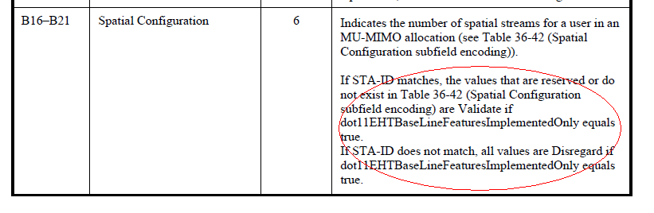

CID 11192
Page.  Line | Clause Number | Comment | Proposed Change | Resolution
678.22 | 36.3.12.8.5 | MCS validate check in Table 36-40 should be re-worded to account for the fact that STA-ID check is not applicable for UL single-user transmission, since STA-ID is set equal to the transmitter's (non-AP STA) AID. | Replace current text at lines 22-30 with the following:  "  If dot11EHTBaseLineFeaturesImplementedOnly equals true and the UL/DL sub-field of the U-SIG field is set to 0:  - If the value of STA-ID subfield matches the user's STA-ID, the value of EHT-MCS 14 or EHT-MCS 15 is Validate if the condition described in 36.1.1 (Introduction to the EHT PHY) is not met.  - If the value of STA-ID subfield does not match the user's STA-ID , all values are Disregard.  If dot11EHTBaseLineFeaturesImplementedOnly equals true and the UL/DL sub-field of the U-SIG field is set to 1, the value of EHT-MCS 14 or EHT-MCS 15 is Validate if the condition described in 36.1.1 (Introduction to the EHT PHY) is not met.  " | Accepted  Note to the editor:  Page 678, line 22-30 of D2.0 is page 690 , line 22-30 of D2.1
Discussion
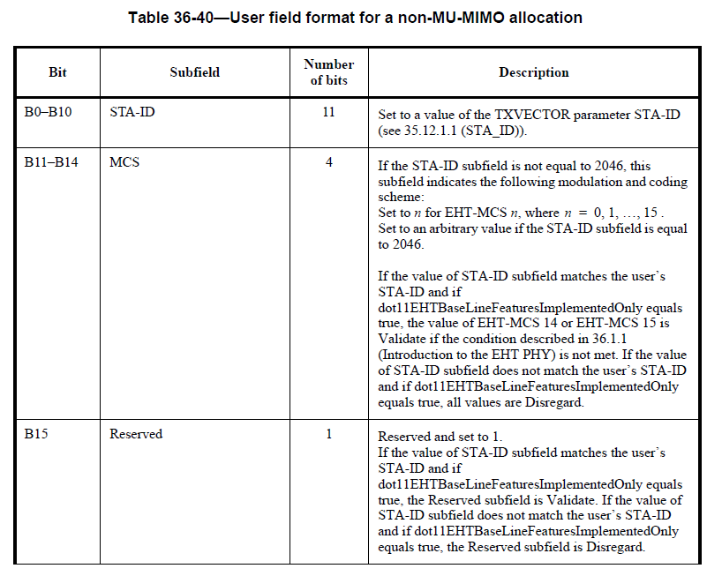

CID 11193
Page.  Line | Clause Number | Comment | Proposed Change | Resolution
678.33 | 36.3.12.8.5 | Reserved bit validate check in Table 36-40 should be re-worded to account for the fact that STA-ID check is not applicable for UL single-user transmission, since STA-ID is set equal to the transmitter's (non-AP STA) AID. | Replace current text at lines 32-39 with the following:  "  Reserved and set to 1.  If dot11EHTBaseLineFeaturesImplementedOnly equals true and the UL/DL sub-field of the U-SIG field is set to 0:  - If the value of STA-ID subfield matches the user's STA-ID, the Reserved subfield is Validate.  - If the value of STA-ID subfield does not match the user's STA-ID, the Reserved subfield is Disregard.  If dot11EHTBaseLineFeaturesImplementedOnly equals true and the UL/DL sub-field of the U-SIG field is set to 1, the Reserved subfield is Validate.  " | Accepted  Note to the editor:  Page 678, line 32-39 of D2.0 is page 690, line 32-39 of D2.1

CID 11194
Page.  Line | Clause Number | Comment | Proposed Change | Resolution
679.16 | 36.3.12.8.5 | Nss validate check in Table 36-40 should be re-worded to account for the fact that STA-ID check is not applicable for UL single-user transmission, since STA-ID is set equal to the transmitter's (non-AP STA) AID. | Replace current text at lines 16-23 with the following:  "  If dot11EHTBaseLineFeaturesImplementedOnly equals true and the UL/DL sub-field of the U-SIG field is set to 0:  - If the value of STA-ID subfield matches the user's STA-ID, values indicating more than eight spatial streams are Validate.  - If the value of STA-ID subfield does not match the user's STA-ID, all values are Disregard.  If dot11EHTBaseLineFeaturesImplementedOnly equals true and the UL/DL sub-field of the U-SIG field is set to 1, values indicating more than eight spatial streams are Validate.  "" | Accepted  Note to the editor:  Page 679, line 16-23 of D2.0 is page 691, line 16-23 of D2.1
Discussion
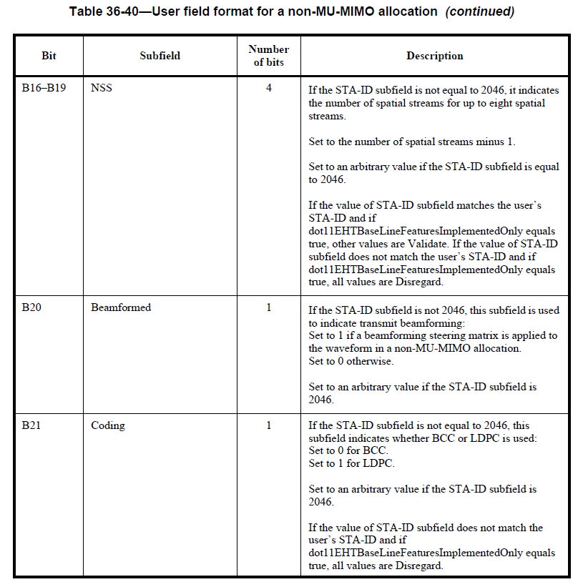

CID 11195
Page.  Line | Clause Number | Comment | Proposed Change | Resolution
679.41 | 36.3.12.8.5 | Coding bit validate check in Table 36-40 should be re-worded to account for the fact that STA-ID check is not applicable for UL single-user transmission, since STA-ID is set equal to the transmitter's (non-AP STA) AID. | Replace current text at lines 41-45 with the following:  "  If the UL/DL sub-field of the U-SIG field is set to 0 and if the value of STA-ID subfield does not match the user's STA-ID and if dot11EHTBaseLineFeaturesImplementedOnly equals true, all values are Disregard.  " | Accepted  Note to the editor:  Page 679, line 41-45 of D2.0 is page 691, line 41-45 of D2.1

CID 13576
Page.  Line | Clause Number | Comment | Proposed Change | Resolution
678.08 | 36.3.12.8.5 | The Disregard and Validate don't consider the AP STA case, need to cover that part | Divide the description to two cases, AP STA case and non-AP STA case. | Revised  The issue raised by the commenter has been resolved with the resolution of CID 11192,  11193, 11194, and 11195  Note to the editor:  No further changes are needed.

CID 11219
Page.  Line | Clause Number | Comment | Proposed Change | Resolution
678.34 | 36.3.12.8.5 | Wrong reference to eqn 36-82 | Replace reference to eqn 36-82 to the appropriate one (36-87?)" | Revised  Reflect the detailed changes  Instructions to the editor:  Please change “(36-82)” at page 695, line 34 of P802.11be D2.1 to “(36-87)”

CID 12568
Page.  Line | Clause Number | Comment | Proposed Change | Resolution
680.19 | 36.3.12.8.5 | Extra space after 13 in Table 36-41 Subfield MCS description | Remove the extra space | Accepted  Note to the editor:  Page 680, line 19 of D2.0 is page 692, line 19 of D2.1

CID 13575
Page.  Line | Clause Number | Comment | Proposed Change | Resolution
675.47 | 36.3.12.8.5 | depending on the number of user fields | Adding fields between user and s, and capatilize U | Accepted  Note to the editor:  Page 675, line 47 of D2.0 is page 687, line 47 of D2.1
Discussion:
