IEEE P802.11
Wireless LANs
LB266 CR in 36.3.12.8.3
Date: 2022.07.26
Author(s):
Name | Company | Address | Phone | email
Ross Jian Yu | Huawei Technologies | H3 building, Huawei Base, Bantian, Longgang, Shenzhen, Guangdong, China, 518129 |  | ross.yujian@huawei.com
Ming Gan | Huawei Technologies
Edward Au | Huawei Technologies
Abstract
This submission contains proposed comment resolutions to comments on P802.11be D2.0. The changes are based on P802.11be D2.1 for a revised resolution. For an accepted resolution, the page and line in D2.1 are also added as a note to the editor.

22 comments are resolved.
10000, 10177, 10180, 10749, 10831, 10939, 11287, 11359, 11360, 11361, 11695, 11969, 11970, 12189, 12190, 12191, 12203, 12868, 13570, 13571, 13572, 13573

Revision Notes

R0 | Initial revision
R1 | Add CID column for the case of a group of CIDs..
R2 | Changes during presentation

CID 10000, 11969, 11970, 12189, 12868
CID | Page.  Line | Clause Number | Comment | Proposed Change | Resolution
10000 | 669.01 | 36.3.12.8.3 | Spec doesn't specify the userinfo field of punctured 242 RU | Add a sentence saying userinfo field of punctured 242 RU should be treated similar to zero-user field | Revised  Unallocated and punctured 242-tone RU can imply that no user can be allocated and hence no corresponding User field.  Whilst a NOTE can be added to help people understand better.  Instructions to the editor:  Please add the following in page 681 line10 of P802.11be D2.1:  “NOTE—punctured 242-tone RU or unassigned 242-tone RU contributes to zero User fields to the User Sepcific field in the same EHT-SIG content channel as this RU Allocation subfield.”
11969 | 669.01 | 36.3.12.8.3 | It should be clarified that 'Punctured 242-tone RU' contributes zero user-field to the user specific field | add the following text at the end of the paragraph in line 3: "Punctured 242-tone RU contributes zero user-field to the user specific field." | Revised  Relfect the detail changes.  Instructions to the editor:  Please make the changes as the proposed resolution for CID 10000.
11970 | 669.06 | 36.3.12.8.3 | It should be clarified that 'Unassigned 242-tone RU' contributes zero user-field to the user specific field | add the following text at the end of the paragraph in line 3: "Unassigned 242-tone RU contributes zero user-field to the user specific field." | Revised  Relfect the detail changes.  Instructions to the editor:  Please make the changes as the proposed resolution for CID 10000.
12189 | 669.01 | 36.3.12.8.3 | There is no text clearly stating that "Punctured 242-tone RU (value of 26)" and "Unassigned 242-tone RU (value of 27)" contributes zero User fields to the User Specific field in the same EHT-SIG content channel. Suggest to add the corresponding text for each value, or add the text in the correponding entries in Table 36-34. | as in the comment. | Revised  Relfect the detail changes.  Instructions to the editor:  Please make the changes as the proposed resolution for CID 10000.
12868 | 669.01 | 36.3.12.8.3 | Clarify "Punctured 242-tone RU (value of 26)" and "Unassigned 242-tone RU (value of 27)" contributes zero User fields to the User Specific field in the same EHT-SIG content channel. | add the corresponding text for each value | Revised  Relfect the detail changes.  Instructions to the editor:  Please make the changes as the proposed resolution for CID 10000.
Discussion:
Within the RU allocation table:
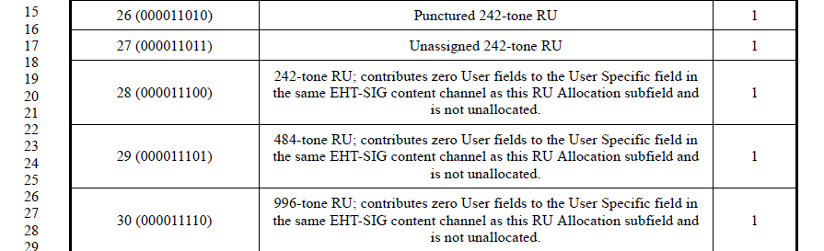

The corresponding description:
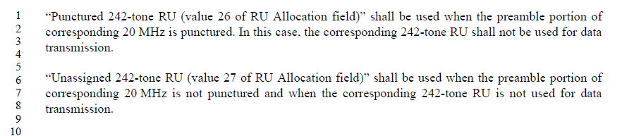

CID 10177
Page.  Line | Clause Number | Comment | Proposed Change | Resolution
669.15 | 36.3.12.8.3 | "In Table 36-34 (RU Allocation subfield), the Number of entries column refers to the number of RU  Allocation subfield values that refer to the same RU assignment to be used in the frequency domain but  differ in the number of User fields indicated by this EHT-SIG content channel per RU." Really had hard time to understand this long sentence, especially after "but" | Please consider split to two sentences | Revised  Reflect the detail changes.  Instructions to the editor:  Please make the changes as shown in 11/22-1130r2, under CID 10177
Instructions to the editor, please make the following paragraph to P681, L15 of P802.11be D2.1:
In Table 36-34 (RU Allocation subfield), the Number of entries column refers to the number of RU Allocation subfield values that refer to the same RU assignment to be used in the frequency domain, but the different RU Allocation subfield values contribute to different number of User fields to the User Specific field in the same EHT-SIG content channel as this RU allocation subfield.

CID 10180
Page.  Line | Clause Number | Comment | Proposed Change | Resolution
664.26 | 36.3.12.8.3 | "An RU Allocation subfield shall not indicate an RU or MRU which  )  occupies all nonpunctured 20  An RU Allocation subfield shall not indicate an RU or MRU which  )  occupies all nonpunctured 20 MHz channels within the PPDU bandwidth" | better to add a note e.g.: if only one non-AP STA is included in a DL OFDMA transmission, RU allocation subfield can be used to indicate the resource allocation. | Revised  Reflect the changes with slightly modification.  Instructions to the editor:  Please make the changes as shown in 11/22-1130r2, under CID 10180.
Instructions to the editor, please make the following changes to P676, L28 of P802.11be D2.1:
An RU Allocation subfield shall not indicate an RU or MRU which occupies all nonpunctured 20 MHz channels within the PPDU bandwidth.
NOTE—For example, a 4x996-tone RU cannot be indicated by the RU Allocation subfield. A 996-tone RU cannot be indicated by the RU Allocation subfield in an 80 MHz EHT MU PPDU. A 3x996+484-tone RU cannot be indicated in a 320 MHz EHT MU PPDU with 40 MHz puncturing indicated in the U-SIG field.
NOTE—For a DL OFDMA transmission to a single user, RU allocation subfields can indicate an RU or MRU which occupies part of nonpunctured 20 MHz channels within the PPDU bandwidth. For example, a 3x996+484-tone MRU can be indicated to a single user with the other 484-tone RU unallocated in a 320 MHz EHT MU PPDU.

CID 10749
Page.  Line | Clause Number | Comment | Proposed Change | Resolution
669.44 | 36.3.12.8.3 | Change "no users are allocated to it" to "no user is allocated to it." | As in comment | Revised  It is “zero users” in current spec.  Instructions to the editor:  Please change “zero users are” to “zero user is” in page 681 line 44 of P802.11be D2.1.
Discussion:
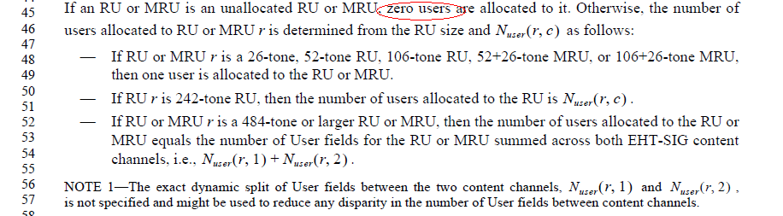

CID 10831, 10939, 11360, 12203
CID | Page.  Line | Clause Number | Comment | Proposed Change | Resolution
10831 | 664.23 | 36.3.12.8.3 | Typo, Delete ")" | As in the comment. | Accepted  NOTE: page 664 line 23 of D2.0 is page 676 line 23 of D2.1
10939 | 664.23 | 36.3.12.8.3 | There is a green ) too much just before the "occupies" | Please delete | Accepted  NOTE: page 664 line 23 of D2.0 is page 676 line 23 of D2.1
11360 | 664.23 | 36.3.12.8.3 | Remove ) before "occupies" | as in the comment | Accepted  NOTE: page 664 line 23 of D2.0 is page 676 line 23 of D2.1
12203 | 664.23 | 36.3.12.8.3 | Extra (green?) parentheses that should be removed | Remove the extra parentheses | Accepted  NOTE: page 664 line 23 of D2.0 is page 676 line 23 of D2.1

CID 11287, 11695
CID | Page.  Line | Clause Number | Comment | Proposed Change | Resolution
11287 | 669.11 | 36.3.12.8.3 | "An EHT STA shall skip N_user(r, c) User fields indicated by the field value and continue to process the EHT-SIG if the RU Allocation subfield has a value designated to be Disregard.". Put condition first to clarify the requirement. | If the RU Allocation subfield has a value designated to be Disregard, the EHT STA shall skip N_user(r, c) User fields indicated by the subfield value and continue processing the EHT-SIG. | Revised.  Reflect the detail changes.  Instructions to the editor:  Please change  "An EHT STA shall skip N_user(r, c) User fields indicated by the field value and continue to process the EHT-SIG if the RU Allocation subfield has a value designated to be Disregard." to  “If the RU Allocation subfield has a value designated to be Disregard, the EHT STA shall skip N_user(r, c) User fields indicated by the subfield value and continue processing the EHT-SIG.”  and move the parargraph to page 681, line 27 of P802.11be D2.1.  NOTE to the editor: the proposed resolution for CID 11287 and CID 11695 are the same.
11695 | 669.25 | 36.3.12.8.3 | The definition of N_user(r,c) is given here after it's been used. It should be introduced and explained earlier. | Please refer to the comment. | Revised.  Reflect the detail changes.  Instructions to the editor:  Please make the changes as the proposed resolution for CID 11287.
Discussion:
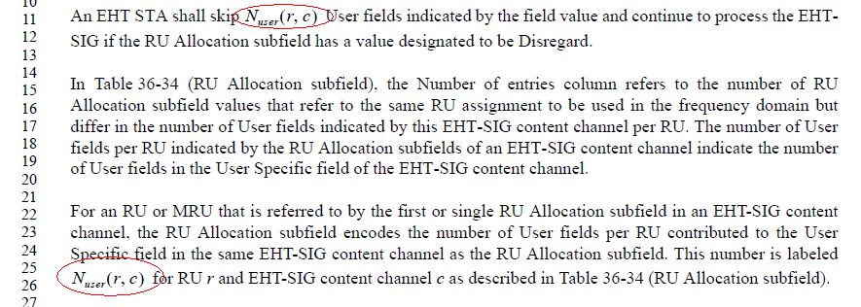
Would be good if we move the first paragraph after the third paragraph

CID 11359
Page.  Line | Clause Number | Comment | Proposed Change | Resolution
664.04 | 36.3.12.8.3 | Is it simpler to change "overlaps more than one of the subcarrier ranges [-500: -259],[-253: -12], [12: 253], or [259: 500]" to "overlaps more than one 20MHz subchannel". Make the similar changes to the 160 and 320MHz PPDU | As in comment | Revised  Reflect the detailed changes  Instructions to the editor:  Please make the changes as shown in 11/22-1130r2, under CID 11359.

Instructions to the editor, please insert the following paragraph to P676, L04 of P802.11be D2.1:
If a single RU or MRU in an 80 MHz, 160 MHz or 320 MHz PPDU overlaps more than one 20 MHz subchannel, the corresponding RU Allocation subfields in the respective content channels shall all refer to the same RU or MRU.

CID 11361
Page.  Line | Clause Number | Comment | Proposed Change | Resolution
666.19 | 36.3.12.8.3 | In description "contributes zero User fields to the User Specific field in the same EHT-SIG content channel as this RU Allocation subfield and is not unallocated.", "is not unallocated" means allocated or assigned. Change the sentence to "assigned but contributes zero User fields to the User Specific field in the corresponding EHT-SIG content channel of this RU Allocation subfield." Make the similar changes to the entry of values 29 and 30 | As in the comment | Revised  Reflect the detail changes.  Instructions to the editor:  Please make the changes as shown in 11/22-1130r2, under CID 11361

Instructions to the editor, please make the following changes to P678, L19 of P802.11be D2.1:
242-tone RU; allocated but contributes zero User fields to the User Specific field in the same EHT-SIG content channel as this RU Allocation subfield.
484-tone RU; allocated but contributes zero User fields to the User Specific field in the same EHT-SIG content channel as this RU Allocation subfield.
996-tone RU; allocated but contributes zero User fields to the User Specific field in the same EHT-SIG content channel as this RU Allocation subfield.

CID 12190
Page.  Line | Clause Number | Comment | Proposed Change | Resolution
661.34 | 36.3.12.8.3 | Clarify if extra EHT-LTF is supported in OFDMA case. | As in comment | Rejected  There already exists Maximum Number Of Supported EHT-LTFs Subfield in EHT PHY Capabilities Information field. It describes the capability regarding support of extra-LTF in OFDMA case.

CID 12191
Page.  Line | Clause Number | Comment | Proposed Change | Resolution
661.35 | 36.3.12.8.3 | If extra EHT-LTF is supported in OFDMA case, clarify that value of "Number Of EHT- LTF Symbols" in EHT-SIG field indicates the initial number of EHT-LTF symbols or the total number of EHT-LTF symbols including the extra EHT-LTF symbols. | Add a clarification statement. | Rejected  It is clear that the number of EHT-LTF symbols include all kinds of EHT-LTF symbols.

CID 13570
Page.  Line | Clause Number | Comment | Proposed Change | Resolution
662.27 | 36.3.12.8.3 | MRU is missing | Adding or MRU after RU | Accepted  NOTE to the editor:  Page 662 line 27 of D2.0 is page 674 line 27 of D2.1
Discussion
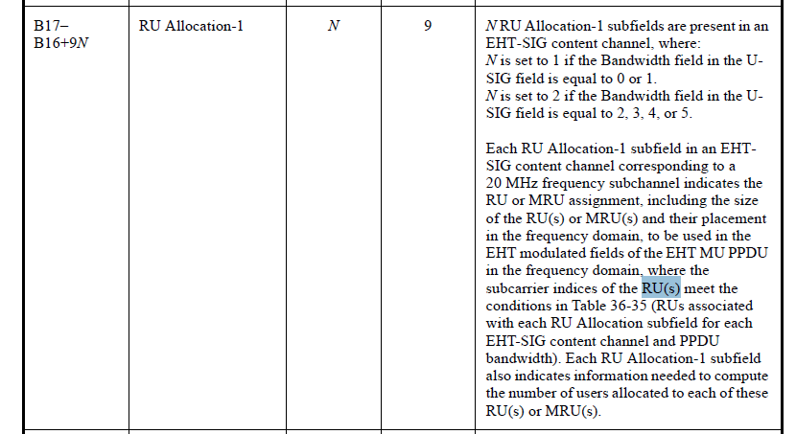

CID 13571
Page.  Line | Clause Number | Comment | Proposed Change | Resolution
663.28 | 36.3.12.8.3 | MRU is missing | Adding or MRU after RU | Accepted  NOTE to the editor:  Page 663 line 28 of D2.0 is page 675 line 28 of D2.1

CID 13572
Page.  Line | Clause Number | Comment | Proposed Change | Resolution
668.65 | 36.3.12.8.3 | Subband here is not consistent with subblock used above | Change subband to subblock | Accepted  NOTE to the editor:  Page 668 line 65 of D2.0 is page 680 line 65 of D2.1
Discussion
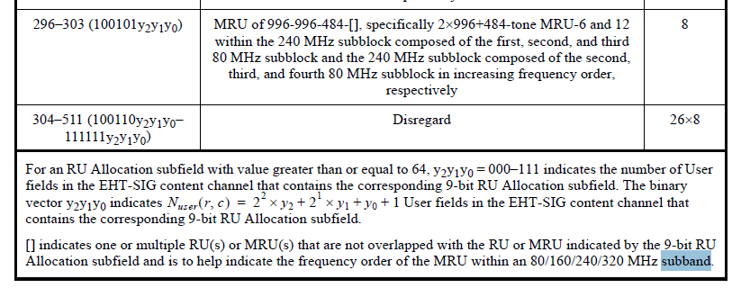

CID 13573
Page.  Line | Clause Number | Comment | Proposed Change | Resolution
670.21 | 36.3.12.8.3 | RUs should be changed to RU or MRUs | Adding MRU between RU and s | Revise  Reflect the detail changes  Instructions to the editor:  Add “or MRU” between “RU” and “s” in page 682 line 21, page 682 line 26. Add “or MRU” after “RU” in page 682 line 28 of P802.11be D2.1.
