IEEE P802.11  
Wireless LANs

|  |  |  |  |  |
| --- | --- | --- | --- | --- |
| Resolutions to NGV PPDU format and Transmiter block diagram | | | | |
| Date: 2022-05-24 | | | | |
| Author(s): | | | | |
| Name | Affiliation | Address | Phone | email |
| Yujin Noh | Senscomm |  |  | yujin.noh at senscomm.com |
|  |  |  |  |  |

Abstract

This submission shows

* Comments from TGbd draft 4.0.
* Resolutions applied to TGbd draft 4.0.
* 3 CIDs:   
  5071, 5068, 5067

Revisions:

* Rev 0: Initial version of the document.

|  |  |  |  |  |
| --- | --- | --- | --- | --- |
| **CID** | **P.L** | **Comment** | **Proposed Change** | **Resolution** |
| 5071 | 75.47 | Change "PSDU_LENGTH" to "APEP_LENGTH" because PDSU_LENGTH (shown on P74L33) is not a TXVECTOR parameter. | As in comment | Acepted. |

***Discussion***

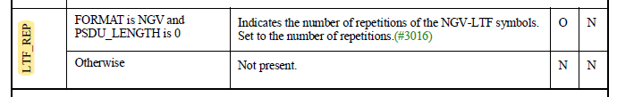

|  |  |  |  |  |
| --- | --- | --- | --- | --- |
| **CID** | **P.L** | **Comment** | **Proposed Change** | **Resolution** |
| 5068 | 83.02 | Please add "CSD per chain is included in the Spatial Mapping block" to the end of the paragraph to account for item l) on P81L61. | As in comment | Rejected.  First of all, there is no paragraph corresponding to the l) CSD per chain insertion in the current specification. It is the the transmitter block diagram for the Data field. |
| 5067 | 83.12 | Please remove the dotted vertical line on the left. NUM_SS is either 1 or 2 only for an NGV STA. The dotted vertical line on the right can be kept. | As in comment | Accepted.  To TGbd editor: location of the title of Figure 32-7 should be centered. |

***Discussion***

