IEEE P802.11  
Wireless LANs

|  |  |  |  |  |
| --- | --- | --- | --- | --- |
| Clause 6 – Investigation | | | | |
| Date: 2022-02 | | | | |
| Author(s): | | | | |
| Name | Affiliation | Address | Phone | email |
| Graham SMITH | SR Technology | Sunrise, FL, USA. | 916 799 9563 | gsmith@srtrl.com |

Abstract

Look in depth at Clause 6

**Background:**

Contribution 21/1822 noticed that Clause 6 consumes 434 pages MORE THAN Clause 11 (398 pages) and questioned if it was really worth it.

Contribution 21/1822 also looked at refeerrences in text to Clause 6 and proposed an approach along the lines of

**ACTION.request primitives are detailed in this clause when they do not directly correspond to frame described in “Clause 9” or Clause 11 (note some might be elsewhere), or where the primitive parameters significantly differ.**

**Hence, first short list might be:**

6.3.2 MLME-POWERMGT

6.3.3 MLME SCAN

6.3.4 MLME JOIN (synchronization)

6.3.5 MLME AUTHENTICATE

6.3.6 MLME DEAUTHENICATE

6.3.7 MLME ASSOCIATE

6.3.8 MLME REASSOCIATE

6.3.9 MLME DISASSOCIATE

6.3.10 MLME RESET

6.3.11 MLME START

6.3.12 MLME STOP

6.3.19 MLME-SETKEYS

At Feb 24 telecon meeting:

Consensus on worthwhile work.

Noted diagrams in 6.3.13 and TDLS and Timing. As these are “abstract” not sure these figures are needed here. Should fit the standard model.

Possible Way ahead is to expand the Introduction to 6.3. Add diagrams showing the two different models, internal command, and request/response.

Possibly a list of all “standard” promitives meeting one or other model. Maybe with reference to Clause 9 or 11 where the respective packet is defined.

First some acronyms:

SME – Station management entity

MLME – MAC sublayer management entity

PLME – PHY layer management entity

SAP – Service Access Point

**6.3 MLME SAP interface**

The services provided by the MLME to the SME are specified in this subclause. These services are

described in an abstract way (following the model described in ITU-T Recommendation X.210 [B55]) and

do not imply any particular implementation or exposed interface. **MLME SAP primitives are of the general**

**form ACTION.request primitive followed by ACTION.confirm primitive (for an exchange initiated by the**

**SAP client) and ACTION.indication primitive followed by ACTION.response primitive (for an exchange**

**initiated by the MLME)**. The SME uses the services provided by the MLME through the MLME SAP

NOTE: “These services are described in an abstract way…and do not imply any particular implementation…”

Let’s list this out clearer:

**MLME SAP primitives are of the general form**

For an exchange initiated by the SAP client

* ACTION.request primitive,
* ACTION.confirm primitive

For an exchange initiated by the MLME

* ACTION.indication primitive
* ACTION.response primitive

Now most exchanges are of the form “Request / Response”

BTW I coud not find any similar drawing or indeed anything useful in the ITU document.

Based on this “General Form” I interpret this as following diagram:

**FIGURE 1 – General form of MLME SAP Primitives for Request/Response**



**FIGURE 2 – General form of MLME SAP Primitives for SME requests MLME to** something that does not initiate a packet to a peer STA, e.g. START



AND there is a third

**FIGURE 3 – General form of MLME SAP Primitives for request to perform a requested Action and report on it.**



Soo…let’s look at an example that we should all understand. ASSOCIATE.

**MLME-ASSOCIATE.request**

This primitive requests association with a specified peer MAC entity that is within an AP.

When generated:

This primitive is generated by the SME when a STA wishes to establish association with an AP or PCP.

Effect of receipt

This primitive initiates an association procedure. In the case that a response is received from the responder STA, the MLME subsequently issues an MLME-ASSOCIATE.confirm primitive that reflects the results.



**MLME-ASSOCIATE.confirm**

This primitive reports the results of an association attempt with a specified peer MAC entity that is in an AP or PCP.

When generated:

This primitive is generated by the MLME as a result of an MLME-ASSOCIATE.request primitive **or** receipt of an Association Response frame from the peer MAC entity to associate with a specified peer MAC entity that is in an AP or PCP.

*NOTE: This seems to indicate that the MLME sends a ‘confirmation’ of receipt back to the SME, and then later on, the confirmation that the Associaation Response frame has been received. Maybe this should have been “on” receipt.*

Effect of receipt

The SME is notified of the results of the association procedure.

*NOTE: This does not align if really is “or”*

**MLME-ASSOCIATE.indication**

This primitive indicates that a specific peer MAC entity is requesting association with the local MAC entity, which is in an AP or PCP

When generated:

This primitive is generated by the MLME as a result of the receipt of an association request from a specific peer MAC entity

Effect of receipt

The SME is notified of the receipt of the association request

**MLME-ASSOCIATE.response**

This primitive is used to send a response to a specific peer MAC entity that requested an association with the

STA that issued this primitive, which is in an AP or PCP.

When generated:

This primitive is generated by the SME of a STA that is in an AP or PCP as a response to an MLMEASSOCIATE.indication primitive

Effect of receipt

This primitive initiates transmission of an AssociationResponse to the specific peer MAC entity that requested association.



Is this right? It fits exactly with the description. Does SME need a confirm?

Note

**MLME-REASSOCIATE.confirm**

This primitive is generated by the MLME as a result of an MLME-REASSOCIATE.request primitive to reassociate with a specified peer MAC entity that is in an AP or PCP.

*NOTE: REASSOCIATE not include the “immediate” confirm. Neither does the DISASSOCIATE.*

**FIRST PROPOSED CHANGE**

I suggest the “or” should be changed to “on”.

Then ASSOCIATE meets the genral form FIG. 1.

Let’s look at another diagram that was inserted. TDLS direct link establishment. How many problems here?



This is scary. I suspect it has never been looked at since it was written.

Do we need a primitive if no response happens?

Also look at Figure 6.8.

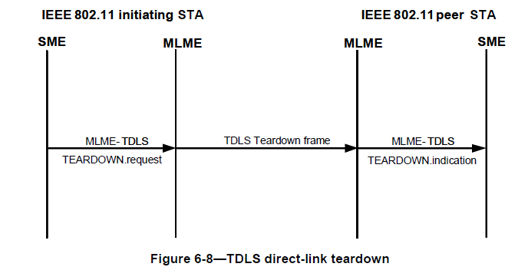

With no response at all, should this even be here?

**Let’s discuss**.

There are 24 Figures in Clause 6.3. How many are really needed? If they meet one of the “General Cases” they need not be there?

Let’s now look at FIG. 6.3

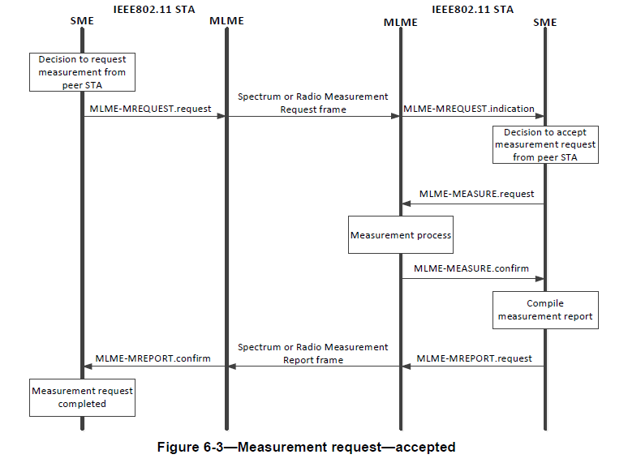

This is classic case of General Form #3. The action is pretty clear from the text, i.e. get a request, do it, then send the response.

**NEXT STEPS**

Go through all figures in 6.3. Look at text to see if they meet one of the “General Forms” and how they are actually referred to.

Are they needed? Is description in Clause 9 or 11 sufficiently clear. What about the boxes?

We could in text refer to which “Form” of MLME SAP primitive is used.

Make decision if any do not fit the three “General Forms”. Is there another?

**OBJECTIVE**

Write Introduction with descriptions of the 3 General Forms and see if these adequately cover all the 125 cases minus the 12 listed earlier.

Proposed new 6.3 Introduction

**6.3 MLME SAP interface**

**6.3.1 Introduction**

The services provided by the MLME to the SME are specified in this subclause. These services are described in an abstract way (following the model described in ITU-T Recommendation X.210 [B55]) and do not imply any particular implementation or exposed interface. MLME SAP primitives are of the general form ACTION.request primitive followed by ACTION.confirm primitive (for an exchange initiated by the SAP client) and ACTION.indication primitive followed by ACTION.response primitive (for an exchange initiated by the MLME). The SME uses the services provided by the MLME through the MLME SAP.

**6.3.1.1 Types of MLME-SAP interface primitive forms**

There are three forms of MLME-SAP interface primitives.

Figure 6.x depicts Type 1. The Type 1 form is used for the exchange of request/response frames between an initiating STA and a peer STA.

**FIGURE 6.x – Type 1 form of MLME SAP primitives for request/response process**



Figure 6.xx depicts Type 2. The Type 2 form is used for the SME requesting a process to be initiated by the MLME. The MLME-ACTION.confirm primitive may be omitted.

**FIGURE 6.xx – Type 2 form of MLME SAP primitives for SME requesting MLME to perform a process**



Figure 6.xxx depicts Type 3. The Type 3 form is used for the exchange of request/response frames between an initiating STA and a peer STA where the peer STA is requested to perform an action before responding.

**FIGURE 6.xxx – Type 3 form of MLME SAP primitives for request to peer STA to perform an action before responding.**



**6.3.1.2 MLME-SAP Primitives**

MLME-SAP primitives of type 1 and 3 are generally associated with Request and Response Action frame exchanges that are defined in Clause 9 and/or clause 11. Only if the primitive parameters differ significantly from the fields in the Request and Response Action frames, are the MLME-SAP primitives specified in this Clause.

MLME-SAP primitives of type 1 and 3 are detailed in this clause only when they do not directly correspond to frame exchanges described in “Clause 9” or Clause 11 (note some might be elsewhere), or where the primitive parameters significantly differ significantly from the fields in the respective Request and Response Action frames.

MLME-SAP primitives of type 2 are generally used for processes such as change of STA state and instructions to the STA to perform an action, e.g., send a frame.

MLME-SAP primitives of type 2 are detailed in this Clause when the primitive parameters specify an action that is not completely specified in Clauses 9 an/or 11.

**Include the following:**

6.3.2 MLME-POWERMGT

6.3.3 MLME SCAN

6.3.4 MLME JOIN (synchronization)

6.3.5 MLME AUTHENTICATE

6.3.6 MLME DEAUTHENICATE

6.3.7 MLME ASSOCIATE

6.3.8 MLME REASSOCIATE

6.3.9 MLME DISASSOCIATE

6.3.10 MLME RESET

6.3.11 MLME START

6.3.12 MLME STOP

6.3.13 Protocol layer model for spectrum management and radio measurement

6.3.19 MLME-SETKEYS

**Look through the rest, one by one to see if a case for keeping them or if adequately decibed in the relate text.**

**Look at recommendations in 21/1822 for text changes related to 6.3 references in text.**