IEEE P802.11
Wireless LANs
Proposed Draft Text for 35.7.2.1 Latency sensitive traffic differentiation
Date: 2021.11.15
Author(s):
Name | Company | Address | Phone | email
Guogang Huang | Huawei Technologies | F3-6-A124, Huawei Base, Bantian, Longgang, Shenzhen, Guangdong, China, 518129 |  | huangguogang1@huawei.com
Michael Montemurro | Huawei Technologies
Stephen McCann | Huawei Technologies
Ming Gan | Huawei Technologies
Yuchen Guo | Huawei Technologies
Yunbo Li | Huawei Technologies
Yiqing Li | Huawei Technologies
Zhenguo Du | Huawei Technologies
Rob Sun | Huawei Technologies
Mengyao Ma | Huawei Technologies
Abstract
This submission contains proposed comment resolutions to comments on P802.11be D1.0. The changes are based on P802.11be D1.3.

Revisions:
- Rev 0: Initial version of the document.

Discussion:
11be group has agreed not to expand the TID space from 0-7 to 0-15. In this case, the TID value is always set to the same value as the user priority (UP) value (0-7). Then we need to define a TID-based low latency traffic differentiation mechanism.

The proposed text in this document has two main points:
- The AP should separate the UP/TID set into two subsets, one is dedicated for the traffic belong to some SCS stream, the other one is dedicated for the traffic which doesn’t belong to any SCS stream.
[Comments] This is used for resolving the fairness issue mentioned in DCN-21-1686. Specifically, the fairness issue is described as follows:

“There could have several LL streams on a STA, but also non-LL streams that share same TID/AC as LL streams. Non-LL streams shall not take advantage of medium access offered to LL streams., otherwise unfair !”

- The AP has the final decision on which UP/TID is used for the reported SCS stream
[Comments] This is used for addressing another fairness issue I mentioned ago. For example, STA 1 and STA 2 respectively report a SCS stream with the same QoS Requirements (e.g. delay bound, packet delivery ratio and so on). STA 1 may want to use UP 5 which corresponds to AC_VI. And STA 2 may want to use UP 7 which corresponds to AC_VO. It’s not fair when the EDCA assess policy is used. The reason for this case is STA 2 has no way to know which TID and AC picked by STA 1. That’s why I propose it should be AP to decide which TID is assigned.

Example
In order to divided the current UP space (0-7) into two UP subsets, the AP can limit the UP mapping based on DSCP to a UP subset by carrying a QoS Map element in the (Re)Association Response. For example, UP 0, 1, 2, and 3 are used for the DSCP-based mapping. And the remaining UP 4, 5, 6, and 7 are used for the TCLAS-based mapping. Specifically, the AP shall set both the DSCP Low Value and DSCP High Value corresponding to each of UP 4, 5, 6, 7 to 255.

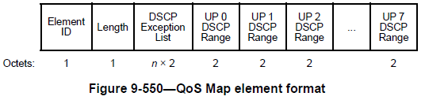

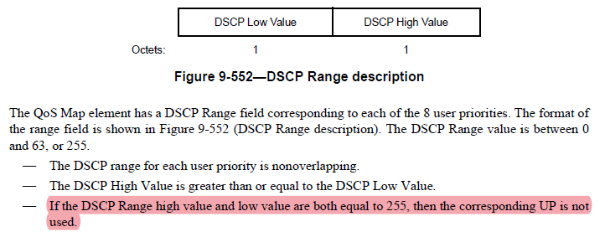

Q. How many TIDs which are used to identify latency sensitive SCS streams are needed?
A. In my opinion, maybe several TIDs are enough. Because the following reasons
- It is not likely that a STA simultaneously report many latency sensitive SCS streams.
- Since the TID usage is decided by the AP, the AP may assign the same TID to SCS streams with the same or similar QoS requirements.
- Even if there is no available TID for a new latency sensitive SCS stream, the AP can reject this latency sensitive SCS stream.

TGbe editor: Modify the subclause as follows:

35.7.2.1 Latency sensitive traffic differentiation

An EHT STA with dot11LowLatencyOperationActivated equal to true shall set the SCS Traffic Description Support field in the EHT MAC Capabilities Information field in the EHT Capability element and the QoS Map field in the Extended Capabilities element of the corresponding (Re)Association Request frame to 1.

The non-AP EHT STA might use the incorrect value for UP in QoS Characteristics element. To provide proper QoS over-the-air in the IEEE 802.11 infrastructure, an EHT AP with dot11LowLatencyOperationActivated equal to true shall include a QoS Map element in a (Re)Association Response frame if the QoS Map field in the Extended Capabilities element of the corresponding (Re)Association Request frame is 1.

An EHT STA only uses the TID value from 0 to 7 and the values 8–15 are reserved. The TID value is set to the same value as the User Priority (UP) value. To differentiate the traffic belonging to some SCS stream from the traffic which doesn’t belong to any SCS stream, the AP may assign a dedicated UP value which is not used within the QoS Map element to an admitted SCS stream.

For frames belonging to an admitted SCS stream, the UP obtained from the QoS Characteristics element shall be used instead of the UP derived from the QoS Map element. For frames which doesn’t belong to any admitted SCS stream, the UP shall be derived from the QoS Map element.

