IEEE P802.11
Wireless LANs
Proposed Draft Text for 35.7.2.1 Latency sensitive traffic differentiation
Date: 2021.11.15
Author(s):
Name | Company | Address | Phone | email
Guogang Huang | Huawei Technologies | F3-6-A124, Huawei Base, Bantian, Longgang, Shenzhen, Guangdong, China, 518129 |  | huangguogang1@huawei.com
Michael Montemurro | Huawei Technologies
Stephen McCann | Huawei Technologies
Ming Gan | Huawei Technologies
Yuchen Guo | Huawei Technologies
Yunbo Li | Huawei Technologies
Yiqing Li | Huawei Technologies
Zhenguo Du | Huawei Technologies
Rob Sun | Huawei Technologies
Mengyao Ma | Huawei Technologies
Abstract
This submission contains proposed comment resolutions to comments on P802.11be D1.0. The changes are based on P802.11be D1.3.

Revisions:
- Rev 0: Initial version of the document.

Discussion:
11be group has agreed not to expand the TID space from 0-7 to 0-15. In this case, the TID value is always set to the same value as the user priority (UP) value (0-7). Then we need to define a TID-based low latency traffic differentiation mechanism.
In order to divided the current UP space (0-7) into two UP subsets, the AP can limit the UP mapping based on DSCP to a UP subset by carrying a QoS Map element in the (Re)Association Response. For example, UP 0, 1, 2, and 3 are used for the DSCP-based mapping. And the remaining UP 4, 5, 6, and 7 are used for the TCLAS-based mapping. Specifically, the AP shall set both the DSCP Low Value and DSCP High Value corresponding to each of UP 4, 5, 6, 7 to 255.

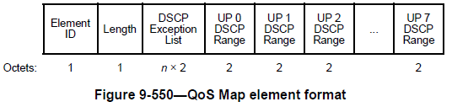

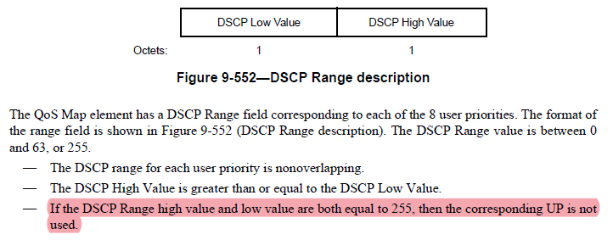

Q. How many TIDs which are used to identify latency sensitive SCS streams are needed?
A. In my opinion, maybe several TIDs are enough. Because the following reasons
- It is not likely that a STA simultaneously report many latency sensitive SCS streams.
- Since the TID usage is decided by the AP, the AP may assign the same TID to SCS streams with the same or similar QoS requirements.
- Even if there is no available TID for a new latency sensitive SCS stream, the AP can reject this latency sensitive SCS stream.

TGbe editor: Modify the subclause as follows:

35.7.2.1 Latency sensitive traffic differentiation

The AP that supports the latency sensitive operation shall set the SCS Traffic Description Support field in the EHT MAC Capabilities Information field in the EHT Capability element to 1.

For the latency sensitive operation, the TID value is always set to the same value as the user priority (UP) value (0-7). The TID values 8–15 are reserved.

To provide proper QoS over-the-air in the IEEE 802.11 infrastructure, the EHT AP that supports the latency sensitive operation shall advertise the mapping from DSCP to UP through the QoS Map element. To differentiate the traffic belonging to the latency sensitive SCS stream from the traffic belonging to the non-latency sensitive SCS stream, the AP can separate the UP space into two subsets through the QoS Map element, i.e. UP subset 1 and UP subset 2. The UP subset 1 is used to identify the traffic belonging to the non-latency sensitive SCS stream and the UP subset 2 in which both the DSCP Low Value and DSCP High Value fields corresponding each UP is set to 255 is used to identify the traffic belonging to the latency sensitive SCS stream.

The non-AP STA might use the incorrect value for UP in QoS Characteristics element. The AP shall assign a proper UP value within the UP subset 2 to an admitted latency sensitive SCS stream.

For frames transmitted by a sender belonging to an admitted SCS stream, the UP obtained from the QoS Characteristics element shall be used instead of the UP derived from the QoS Map element. For frames transmitted by a sender which doesn’t belong to any admitted SCS stream, the UP shall be derived from the QoS Map element.

