IEEE P802.11  
Wireless LANs

|  |  |  |  |  |
| --- | --- | --- | --- | --- |
| CIDs 4558 and 4562 | | | | |
| Date: 2021-11-19 | | | | |
| Author(s): | | | | |
| Name | Affiliation | Address | Phone | email |
| Sigurd Schelstraete | MaxLinear |  |  | sschelstraete@maxlinear.com |
|  |  |  |  |  |

Abstract

11-21/1520r3 resolved most of the CIDs on B.4.36a.2.

Following discussion of 11-21/1520r3, CIDs 4558 and 4562 were deferred and need revision. This submission proposes an updated resolution for those CIDs 4558 and 4562.

# Introduction

This submission proposes resolutions for CIDs 4558 and 4562

Proposed changes are relative to 802.11be D1.1.

# Proposed resolutions

**CID 4558**

|  |  |  |  |  |  |
| --- | --- | --- | --- | --- | --- |
| 4558 | B.4.36a.2 | 581.12 | Recive of UL MU-MIMO should be M for CFEHT AND EHTP7.22 | as in the comment. | REVISED.  Make changes as shown in IEEE 802.11-21/1903r0 under “CID 4558” |

Discussion

The comment is on EHTP2.12:

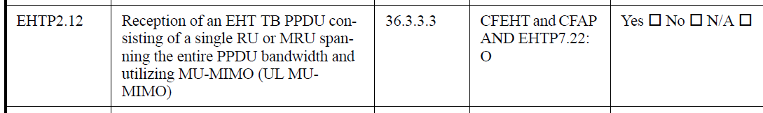

The requested change is to change “O” to “M” in the Status column.

PICS item EHTP7.22 is used to indicate the condition that the device supports (at least) four spatial streams.



During discussion of 11-21/1520r3, it was noted that EHTP7.22 does not indicate whether support is linked to transmitter or receiver. For UL MU-MIMO, the condition to support is linked to the AP being capable of *receiving* four or more spatial streams.



Conversely, for DL MU-MIMO, the condition to support is linked to the AP being capable of *transmitting* four or more spatial streams.



As such, it may be worthwhile to distinguish between those capabilities, rather than relying on EHTP7.22. We can introduce two new PICS entries for this.

Editor’s instruction:

* Add EHTP7.68 and EHTP7.69 as shown below

|  |  |  |  |  |
| --- | --- | --- | --- | --- |
|  |  |  |  |  |
| EHTP7.66 | EHT-MCS 15 with NSS=1 and RU 3x996 | 36.1.1 | EHTP3.5: O | Yes ☐ No ☐ N/A ☐ |
| EHTP7.67 | EHT-MCS 14 with NSS=1 | 36.1.1 | CFEHT6G: O | Yes ☐ No ☐ N/A ☐ |
| EHTP7.68 | Supports transmission of four or more spatial streams | 36.1.1 | CFEHT: O | Yes ☐ No ☐ N/A ☐ |
| EHTP7.69 | Supports reception of four or more spatial streams | 36.1.1 | CFEHT: O | Yes ☐ No ☐ N/A ☐ |

* Modify EHTP2.12 as follows:

|  |  |  |  |  |
| --- | --- | --- | --- | --- |
| EHTP2.12 | Reception of an EHT TB PPDU consisting of a single RU or MRU spanning the entire PPDU bandwidth and utilizing MU-MIMO (UL MU-MIMO) | ~~36.3.3.3~~36.3.3.2 | CFEHT and CFAP AND NOT EHTP7.69: O  CFEHT and CFAP AND EHTP7.~~22~~69: ~~O~~M | Yes ☐ No ☐ N/A ☐ |

* Modify EHTP2.14 as follows

|  |  |  |  |  |
| --- | --- | --- | --- | --- |
| EHTP2.14 | Reception of an EHT TB PPDU where RU/MRU allocated to a non-AP STA are utilizing MU-MIMO (UL MU-MIMO within OFDMA). | ~~TBD~~36.3.3.2 | CFEHT and CFAP ~~AND EHTP7.22~~: O | Yes ☐ No ☐ N/A ☐ |

* Modify EHTP2.5 as follows

|  |  |  |  |  |
| --- | --- | --- | --- | --- |
| EHTP2.5 | Transmission of an EHT MU PPDU consisting of a single RU or MRU spanning the entire PPDU bandwidth and utilizing MU-MIMO (DL MU-MIMO) | 36.3.3.1.2 | CFEHT and CFAP AND EHTP7.68~~EHTP7.22~~: M | Yes ☐ No ☐ N/A ☐ |

**CID 4562**

|  |  |  |  |  |  |
| --- | --- | --- | --- | --- | --- |
| 4562 | B.4.36a.2 | 585.14 | Remove EHTP6.3 since 1) it is not accurate since 1kQAM and above still mandate LDPC 2) it is already covered in EHT6.2 | as in the comment. | REVISED  Make changes as shown in IEEE 802.11-21/1903r0 under “CID 4558” |

EHTP3.6 is highlighted below:

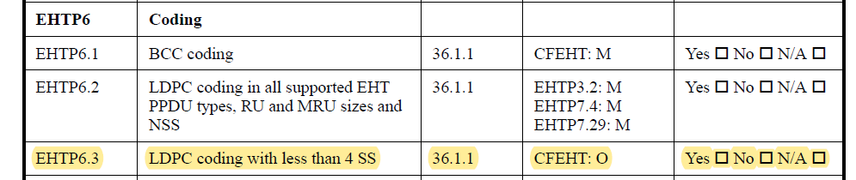

Discussion

As currently written, EHTP3.6 directly corresponds to one of the optional features listed under “An EHT STA may support the following features”:

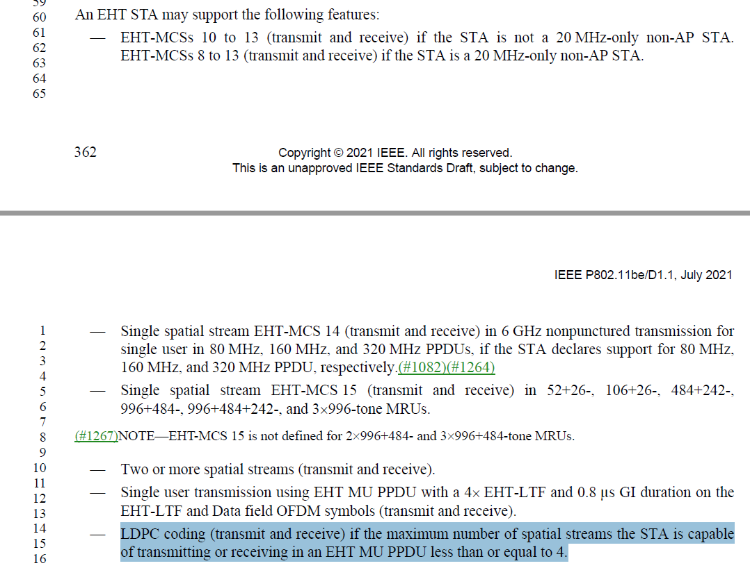

However, there is an issue with this requirement.

LDPC is mandatory if any of the following if true:

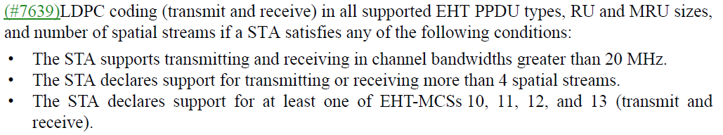

Probably, what the optional requirement is trying to say is that if none of the conditions above are true, LDPC is still available as an optional coding scheme. However, only maximum number of spatial streams is mentioned, not support of MCS or bandwidth.

It would be correct to state that LPDC is optional if “the maximum number of spatial streams the STA is capable of transmitting or receiving in an EHT MU PPDU less than or equal to 4, the maximum supported bandwidth is 20 MHz and the STA does not support EHT MCS 10, 11, 12 or 13.”.

We further observe that, since the BW needs to be 20 MHz, this limits applicability to 20 MHz non-AP STAs (APs support at least 80 MHz). In that case, we can move the statement form the generic STA to the 20 MHz only non-AP STA.

Editor’s instructions:

Remove LDPC from the bullet list under “An EHT STA may support the following features:” (starting on page 412, line 55 of D1.2)

* (…)
* Two or more spatial streams (transmit and receive).
* Single user transmission using EHT MU PPDU with a 4xEHT-LTF and 0.8μs GI duration on the EHT-LTF and Data field OFDM symbols (transmit and receive).
* ~~LDPC coding (transmit and receive) if the maximum number of spatial streams the STA is capable of transmitting or receiving in an EHT MU PPDU less than or equal to 4.~~
* (#4520) 40 MHz channel width RU and MRU size larger than 242 tones in the 2.4 GHz band (transmit and receive).
* (…)

Add LDPC coding to the bullet list “A 20MHz-only non-AP EHT STA may support the following:” (starting on page 415, line 48 of D1.2)

* (…)
* 26-, 52-, 106-, and 242-tone RU sizes and 52+26-tone MRU size on locations allowed in 36.3.2.6 (RU and MRU restrictions for 20 MHz operation(#3276)) in any 20 MHz channel within 40 MHz, 80 MHz, and 160 MHz PPDU (#1272) widths in the 5 GHz band if the 20 MHz-only non-AP EHT STA supports the EHT subchannel selective transmission operation described in 35.6.1 (EHT subchannel selective transmission).
* LDPC coding if the maximum number of spatial streams the STA is capable of transmitting or receiving in an EHT MU PPDU less than or equal to 4, and the STA does not support any of EHT-MCS 10, 11, 12 or 13.

Change EHTP6.3 as follows:

|  |  |  |  |  |
| --- | --- | --- | --- | --- |
| EHTP6.3 | LDPC coding ~~with~~ when STA supports less than or equal to 4 SS and doesn’t support EHT-MCS 10, 11, 12 or 13 | 36.1.1 | CFEHT20: O | Yes ☐ No ☐ N/A ☐ |