IEEE P802.11
Wireless LANs
EHT-SIG CR for 36.3.12.8.2 on P802.11be D1.0_follow up
Date: 2021.10.20
Author(s):
Name | Company | Address | Phone | email
Bo Gong | Huawei Technologies |  |  | gongbo8@huawei.com
Ross Jian Yu | Huawei Technologies |  |  | ross.yujian@huawei.com
Abstract

This submission shows
- resolution for a comment received from TGbe comment collection (TGbe Draft D1.0)
- the proposed changes based on TGbe D1.2.

The submission provides resolutions to CIDs 7214 and 7216.

Revision Notes

R0 | Initial revision

CID 7216
Page.  Line | Clause Number | Comment | Proposed Change | Resolution
438.19 | 36.3.12.8.2 | Should value 31 be Validate or Reserved? Validate means there is an expected value for a field that will be verified, i.e. Validate applies to a field, not a value. Doesn't look like that applies in this case. Unless Validate means something different in this case. | See comment. | REVISED  Reflect the detailed explanation.  Instructions to the editor: Please make the changes as shown in 11/21-1728r0

Discussion:

Both the reserved fields and reserved values can be divided into two categories: Validate and Disregard. If a value is identified as Validate for the STA, the STA shall terminate the reception of the PPDU. If a value is identified as Disregard for the STA, the STA shall ignore the value and continue the reception. The value 31 should be Validate since the value 31 doesn't convey the information of the number of User fields. The clarification can be referred to in Line 1, Page 510 of TGbe Draft D1.2.

Similarly, value 304~511 are Disregard. There is no definition about the RUs or MRUs size corresponding to value 304~511. Thus, the following description is not accurate.

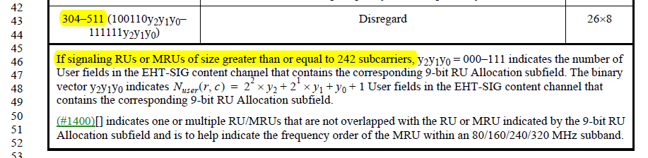

Instructions to the editor:

Please make the following changes in Line 46, Page 540 in TGbe Draft D1.2.

304–511 (100110y2y1y0–  111111y2y1y0) | Disregard | 268
For an RU Allocation subfield with value greater than or equal to 64, y₂y₁y₀ = 000–111 indicates the number of User fields in the EHT-SIG content channel that contains the corresponding 9-bit RU Allocation subfield. The binary vector y2y1y0 indicates N r c = 2²  y + 2¹  y + y + 1 User fields in the EHT-SIG content channel that
user 2 1 0
contains the corresponding 9-bit RU Allocation subfield.
(#1400)[] indicates one or multiple RU/MRUs that are not overlapped with the RU or MRU indicated by the 9-bit RU Allocation subfield and is to help indicate the frequency order of the MRU within an 80/160/240/320 MHz subband.

CID 7214
Page.  Line | Clause Number | Comment | Proposed Change | Resolution
433.47 | 36.3.12.8.2 | Numbering of the RU allocation subfields for MRU needs additional clarification, e.g.: from lowest to highest, without increasing the value for "missing" 20 MHz. | See comment. Applies to various MRU sizes (having seven, six, five, ... RU allocation fields) | REJECTED  The expression ‘in an increasing frequency order’ indicates that the RU allocation subfields are numbered ‘from lowest to highest’.  The expression ‘The seven RU allocation subfields are labeled from the first to the seventh’ indicates ‘without increasing the value for "missing" 20 MHz’.

Discussion:

