IEEE P802.11
Wireless LANs
11be D1.0 CR for CID 4924, 5186, 5190, 6041, 6042

Date: 2021-09-28
Author(s):
Name | Affiliation | Address | Phone | email
Po-Kai Huang | Intel |  |  | po-kai.huang@intel.com
Abstract
This submission proposes resolutions for the following CIDs:

4924, 5186, 5190, 6041, 6042

Revisions:

- Rev 0: Initial version of the document.

Interpretation of a Motion to Adopt

A motion to approve this submission means that the editing instructions and any changed or added material are actioned in the TGbe D1.0 Draft. This introduction is not part of the adopted material.

Editing instructions formatted like this are intended to be copied into the TGbe D1.0 Draft (i.e. they are instructions to the 802.11 editor on how to merge the text with the baseline documents).

TGbe Editor: Editing instructions preceded by “TGbe Editor” are instructions to the TGbe editor to modify existing material in the TGbe draft. As a result of adopting the changes, the TGbe editor will execute the instructions rather than copy them to the TGbe Draft.

CID | Commenter | Clause | P.L | Comment | Proposed Change | Resolution
4924 | Duncan Ho | 12.5.3.3.3 | 216.55 | Main "If" of bullet 4 not exhaustive for A3:  "Otherwise/else" case is not | Add the following line at the end of bullet 4:  "Otherwise, A3 is set to MPDU Address 3 field." | Revised –  In the AAD construction today, not all BSSID is swapped to MLD MAC address of AP MLD. This is the case when To DS is 1 and From DS is 1.  In principle, we should just have all BSSID swapped to MLD MAC address of AP MLD in AAD construction of data frame rather than condition on MLD MAC address of transmitting MLD or MLD MAC address of receiving MLD. This will align with the existing implementation method with the tweak to swap out with MLD MAC address.  “Otherwise” is also added.  TGbe editor to make the changes shown in 11-21/1609r0 under all headings that include CID 4924.
5186 | Guogang Huang | 12.5.3.3.3 | 216.60 | For this sentence "else if To DS subfield is set to 1 in the MAC header of the MPDU, set A3 to the MLD MAC address of the receiving MLD.", it should be modified as "else if To DS subfield is set to 1 and From DS subfield is set to 0 in the MAC header of the MPDU, set A3 to the MLD MAC address of the receiving MLD." | Modify this subbullet as:  else if To DS subfield is set to 1 and From DS subfield is set to 0 in the MAC header of the MPDU, set A3 to the MLD MAC address of the receiving MLD. | Revised –  In the AAD construction today, not all BSSID is swapped to MLD MAC address of AP MLD. This is the case when To DS is 1 and From DS is 1.  In principle, we should just have all BSSID swapped to MLD MAC address of AP MLD in AAD construction of data frame rather than condition on MLD MAC address of transmitting MLD or MLD MAC address of receiving MLD. This will align with the existing implementation method with the tweak to swap out with MLD MAC address.  TGbe editor to make the changes shown in 11-21/1609r0 under all headings that include CID 4924.
5190 | Guogang Huang | 12.5.3.3.3 | 216.63 | modify this subbullet as:  otherwise, A3 is set to the MPDU Address 3 field | Add ''the" before "MPDU Address 3 field" | Revised –  “The” is already there. We just modify the sentence to say “otherwise”.  TGbe editor to make the changes shown in 11-21/1609r0 under all headings that include CID 4924.
6041 | Liwen Chu | 12.5.3.3.3 | 216.41 | the condition that the recipient is ffliated with MLD should be added (part of if sentence) | AS in comment | Revised –  We have added the condition that AAD swap is only between AP MLD and non-AP MLD.  TGbe editor to make the changes shown in 11-21/1609r0 under all headings that include CID 4924.
6042 | Liwen Chu | 12.5.3.3.3 | 216.48 | the condition that the recipient is ffliated with MLD should be added (part of if sentence) | AS in comment | Revised –  We have added the condition that AAD swap is only between AP MLD and non-AP MLD.  TGbe editor to make the changes shown in 11-21/1609r0 under all headings that include CID 4924.

Discussion:

In the AAD construction today, not all BSSID is swapped to MLD MAC address of AP MLD. This is the case when To DS is 1 and From DS is 1 as summarize below.
In principle, we should just have all BSSID swapped to MLD MAC address of AP MLD in AAD construction of data frame rather than condition on MLD MAC address of transmitting MLD or MLD MAC address of receiving MLD. This will align with the existing implementation method with the tweak to swap out with MLD MAC address.

Table 9-30.
Today’s AAD texts in the spec.
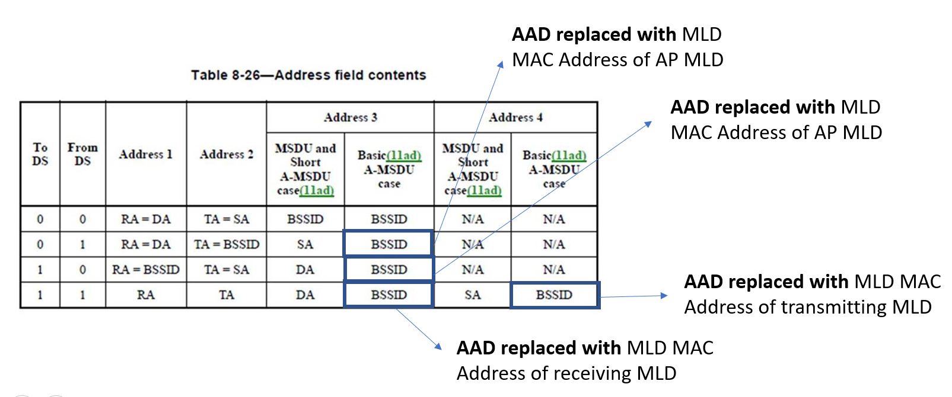
Suggested change for AAD swap:
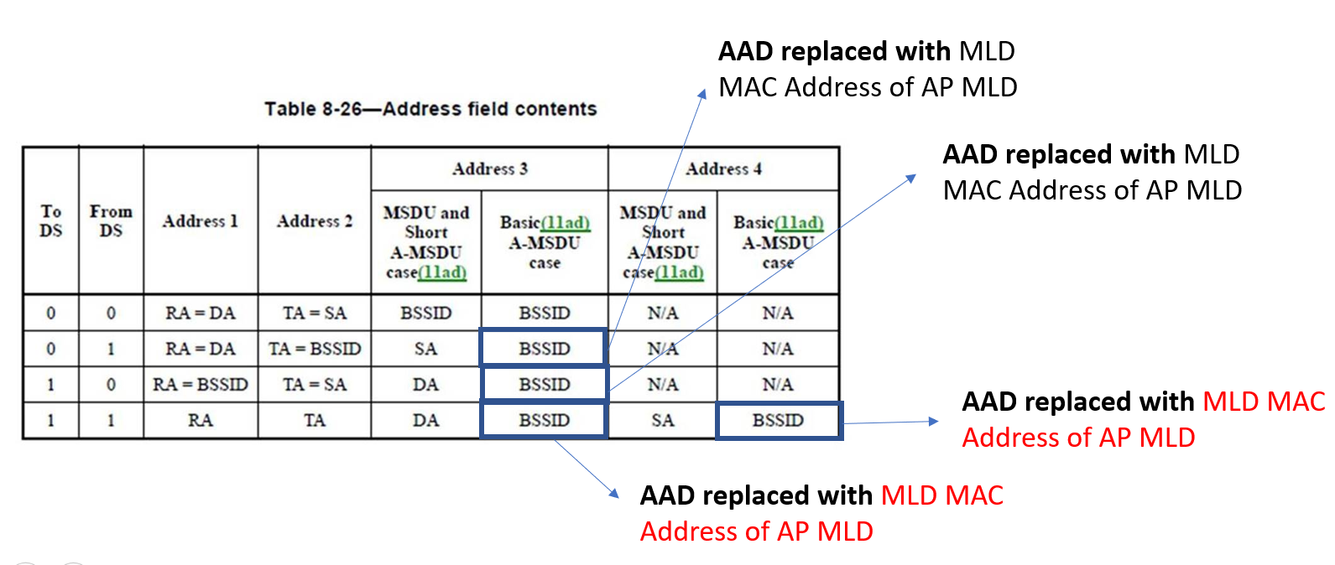

Also, since baseline mentions several cases on the setting, and IBSS, OCB, MBSS, PBSS are outside the scope of MLD R1, we propose to clarify the condition in AAD swap.

The BSSID field of the Data frame is set as follows:
- a) If the STA is contained within an AP or is associated with an AP, the BSSID is the address currently in use by the STA contained in the AP.
- b) If the STA is an IBSS STA, the BSSID is that selected by the STA that started the IBSS.
- c) If the STA is transmitting a Data frame when dot11OCBActivated is true, the BSSID is the wildcard BSSID.
- d) If the STA is a member of an MBSS, the BSSID is the address of the transmitter and is equal to the
Data frame’s TA.
- e) If the STA participates in a PBSS, the BSSID is the address of the STA contained in the PCP.

Proposed text:

TGbe editor: Change 12.5.3.3.3 Construct AAD as follows (track change on): (#4924)

12.5.3.3.3 Construct AAD

Change the first paragraph as follows:
          - For PV0 MPDUs, the format of the AAD is shown in Figure 12-19 (AAD construction for PV0 MPDUs). The length of the AAD for PV0 varies depending on the presence or absence of the QC and A4 fields and is shown in Table 12-3 (AAD length for PV0 MPDUs).
The AAD is constructed from the MPDU header. The AAD includes neither the Duration/ID field nor the HT Control field because the contents of these fields might change during normal operation (e.g., due to a rate change preceding retransmission). The HT Control field might also be inserted or removed during normal operation (e.g., retransmission of an A-MPDU where the original A-MPDU included an MRQ that has already generated a response). For similar reasons, several subfields in the Frame Control field are masked to 0. For PV0 MPDUs, AAD construction is performed as fol- lows:
            - FC – MPDU Frame Control field, with
              - Subtype subfield (bits 4 5 6) in a Data frame masked to 0
              - Retry subfield (bit 11) masked to 0
              - Power Management subfield (bit 12) masked to 0
              - More Data subfield (bit 13) masked to 0
              - Protected Frame subfield (bit 14) always set to 1
vi) +HTC subfield (bit 15) as follows:
                - Masked to 0 in all Data frames containing a QoS Control field
                - Unmasked otherwise
vii) Other subfields are not modified
            - A1 – MPDU Address 1 field.If dot11MultiLinkActivated is true, for both the transmitter and intended receiver of the MPDU, either of To DS or From DS subfields in the MAC header of the MPDU is set to 1, and the MPDU is an individually addressed Data frame between an AP MLD and a non-AP MLD associated with the AP MLD, then A1 is set to:
- the MLD MAC address of the intended receiver MLD of the MPDU.
- otherwise, Al is set to MPDU Address 1 field.
            - A2 – MPDU Address 2 field.If dot11MultiLinkActivated is true, for both the transmitter and intended receiver of the MPDU, either of To DS or From DS subfields in the MAC header of the MPDU is set to 1, and the MPDU is an individually addressed Data frame between an AP MLD and a non-AP MLD associated with the AP MLD, then A2 is set to:
- the MLD MAC address of the transmitting MLD of the MPDU.
- otherwise, A2 is set to MPDU Address 2 field.
            - A3 – MPDU Address 3 field.If dot11MultiLinkActivated is true, MPDU Address 3 field is BSSID, and the MPDU is an individually addressed Data frame between an AP MLD and a non-AP MLD associated with the AP MLD, then :
- A3 is set to the MLD MAC address of the AP MLD, where the corresponding AP with the BSSID is affiliated with the AP MLD

- Otherwise, A3 is set to the MPDU Address 3 field.
            - SC – MPDU Sequence Control field, with the Sequence Number subfield (bits 4–15 of the Sequence Control field) masked to 0. The Fragment Number subfield is not modified.
            - A4 – MPDU Address field, if present.A4, if present, is set as follows:
- if dot11MultiLinkActivated is true, MPDU Address 4 field is a BSSID, and the MPDU is an individually addressed Data frame between an AP MLD and a non-AP MLD associated with the AP MLD, then A4 is set to the MLD MAC address of the AP MLD, where the corresponding AP with the BSSID is affiliated with the AP MLD.
- otherwise A4, if present, is set to the MPDU Address 4 field.
            - QC – QoS Control field contains the MSDU priority, if present. The QC TID is used in the construction of the AAD. When in a non-DMG BSS and both the STA and its peer have their SPP A-MSDU Capable fields equal to 1, bit 7 (the A-MSDU Present field) is used in the construction of the AAD. The remaining QC fields are masked to 0 for the AAD calculation (bits 4 to 6, bits 8 to 15, and bit 7 when either the STA or its peer has the SPP A-MSDU Capable field equal to 0). When in a DMG BSS, the A-MSDU Present bit 7 and A-MSDU Type bit 8 are used in the construction of the AAD, and the remaining QC fields are masked to 0 for the AAD calculation (bits 4 to 6, bits 9 to 15).

