IEEE P802.11
Wireless LANs
Segment Deparser CR on P802.11be D1.0
Date: 2021.11.1
Author(s):
Name | Company | Address | Phone | email
Bo Gong | Huawei Technologies |  |  | gongbo8@huawei.com
Jianhan Liu | Mediatek |  |  | Jianhan.Liu@mediatek.com
Ross Jian Yu | Huawei Technologies |  |  | ross.yujian@huawei.com
Abstract

This submission shows
- resolution for a comment received from TGbe comment collection (based on TGbe Draft D1.0)
- the proposed changes based on TGbe Draft D1.2.

The submission provides resolutions to CIDs 4646, 4647, 5096, 7479, and 8139.

Revision Notes

R0 | Initial revision

CID 4646
Page.  Line | Clause Number | Comment | Proposed Change | Resolution
485.31 | 36.3.13.5 | The name "Segment Parser" has created much confusion in 11ax and 11be | Insert "NOTE - The output of the operation described in this subclause is named a frequency subblock rather than a segment because the output is one or more frequency subblocks yet one frequency segment. A more precise name for this operation would be frequency subblock parser." | Revised  Instructions to the editor  Please make the changes as shown in 11/21-1515r4

CID 4647
Page.  Line | Clause Number | Comment | Proposed Change | Resolution
494.32 | 36.3.13.9 | The name "Segment De/parser" has created much confusion in 11ax and 11be | Insert "NOTE - The input of the operation described in this subclause is named a frequency subblock rather than a segment because the input is one or more frequency subblocks yet one frequency segment. A more precise name for this operation would be frequency subblock deparser." | Revised  Instructions to the editor  Please make the changes as shown in 11/21-1515r4

Discussion:

For details about the difference between ‘segment’ and ‘frequency subblock’, see document 11-21-0489-03-00be-cr-on-cid-1279.

Instructions to the editor:

Insert the following sentence as the first paragraph of Section 36.3.13.5

The segment parser operation is applied to each 80MHz frequency subblock.

Insert the following sentence as the first paragraph of Section 36.3.13.9

The Segment deparser combines 80MHz frequency sublocks from the output of the LDPC tone mapper into a single frequency segment.

CID 5096
Page.  Line | Clause Number | Comment | Proposed Change | Resolution
494.52 | 36.3.13.9 | Name of frequency subblock is not consisent in the text | Change block to subblock | ACCEPTED

Background:

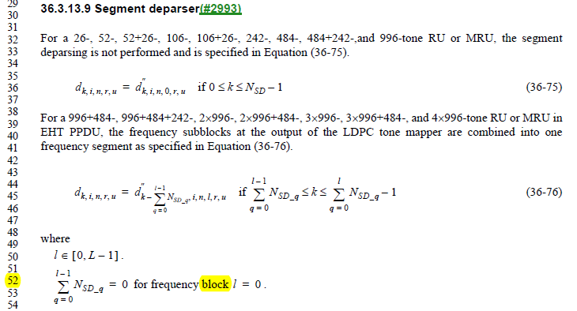

CID 7479
Page.  Line | Clause Number | Comment | Proposed Change | Resolution
494.52 | 36.3.13.9 | What is the definition of "N_{SD_q}" ? Add a definition for this variable. | As in comment. | REJECTED  The notations N_{SD_q} and N_{SD_l} have the same defination, which indicate the number of data tones in the q-th and l-th frequency subblocks. The definition has been pointed out in Line 18 and 55, Page 493 of D1.0.  As to their usage, the difference lies in the ranges of q and l, where l ∈[0, L-1] denotes one of all the frequency subblocks and q∈[0, l] denotes one of the first to the l+1-th frequency subblocks.

CID 8139
Page.  Line | Clause Number | Comment | Proposed Change | Resolution
494.32 | 36.3.13.9 | make space between "242-," and "484-" | as in comment | REVISED  Instructions to the editor  Please make the changes as shown in 11/21-1515r4
Instructions to the editor:

Please insert a space between ‘484+242-,’ and ‘and’ in Line 32 Page 593 of TGbe Draft D1.2.

