IEEE P802.11
Wireless LANs
Segment Deparser CR on P802.11be D1.0
Date: 2021.11.1
Author(s):
Name | Company | Address | Phone | email
Bo Gong | Huawei Technologies |  |  | gongbo8@huawei.com
Jianhan Liu | Mediatek |  |  | Jianhan.Liu@mediatek.com
Ross Jian Yu | Huawei Technologies |  |  | ross.yujian@huawei.com
Abstract

This submission shows
- resolution for a comment received from TGbe comment collection (based on TGbe Draft D1.0)
- the proposed changes based on TGbe Draft D1.2.

The submission provides resolutions to CIDs 4646, 4647, 5096, 7479, and 8139.

Revision Notes

R0 | Initial revision

CID 4646
Page.  Line | Clause Number | Comment | Proposed Change | Resolution
485.31 | 36.3.13.5 | The name "Segment Parser" has created much confusion in 11ax and 11be | Insert "NOTE - The output of the operation described in this subclause is named a frequency subblock rather than a segment because the output is one or more frequency subblocks yet one frequency segment. A more precise name for this operation would be frequency subblock parser." | ACCEPTED

CID 4647
Page.  Line | Clause Number | Comment | Proposed Change | Resolution
494.32 | 36.3.13.9 | The name "Segment De/parser" has created much confusion in 11ax and 11be | Insert "NOTE - The input of the operation described in this subclause is named a frequency subblock rather than a segment because the input is one or more frequency subblocks yet one frequency segment. A more precise name for this operation would be frequency subblock deparser." | ACCEPTED

Discussion:

For details about the difference between ‘segment’ and ‘frequency subblock’, see document 11-21-0489-03-00be-cr-on-cid-1279.

CID 5096
Page.  Line | Clause Number | Comment | Proposed Change | Resolution
494.52 | 36.3.13.9 | Name of frequency subblock is not consisent in the text | Change block to subblock | ACCEPTED

Background:

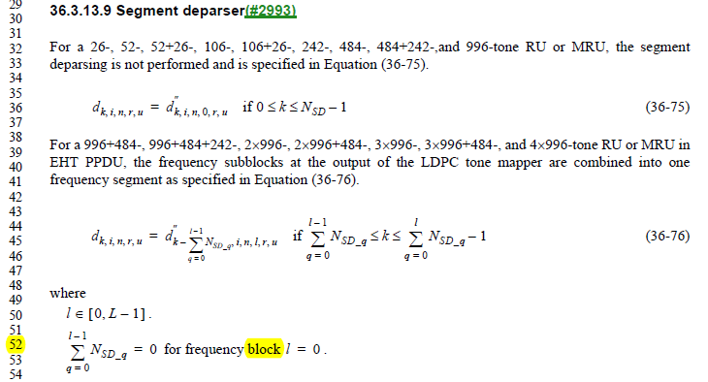

CID 7479
Page.  Line | Clause Number | Comment | Proposed Change | Resolution
494.52 | 36.3.13.9 | What is the definition of "N_{SD_q}" ? Add a definition for this variable. | As in comment. | REJECTED  The notations N_{SD_q} and N_{SD_l} have the same defination, which indicate the number of data tones in the q-th and l-th frequency subblocks. The definition has been pointed out in Line 18 and 55, Page 493 of D1.0.  As to their usage, the difference lies in the ranges of q and l, where l ∈[0, L-1] denotes one of all the frequency subblocks and q∈[0, l] denotes one of the first to the l+1-th frequency subblocks.

CID 8139
Page.  Line | Clause Number | Comment | Proposed Change | Resolution
494.32 | 36.3.13.9 | make space between "242-," and "484-" | as in comment | REVISED  Instructions to the editor  Please make the changes as shown in 11/21-1515r3
Instructions to the editor:

Please insert a space between ‘484+242-,’ and ‘and’ in Line 32 Page 593 of TGbe Draft D1.2.

