IEEE P802.11
Wireless LANs
Resolution for CID 5421
Date: 2021.09.14
Author(s):
Name | Company | Address | Phone | email
Ross Jian Yu | Huawei Technologies | F3-6-A120, Huawei Base, Bantian, Longgang, Shenzhen, Guangdong, China, 518129 |  | ross.yujian@huawei.com
Ming Gan | Huawei Technologies
Abstract
This submission contains proposed comment resolutions to comments on P802.11be D1.0. The changes are based on P802.11be D1.2.

1 comment is resolved.
CID 5421

Revision Notes

R0 | Initial revision
R1 | Change reference from D1.1 to D1.2

CID 5421
Page.  Line | Clause Number | Comment | Proposed Change | Resolution
441.54 | 36.3.12.8.3 | This paragraph has nothing to do with EHT-SIG and should be removed. Alternatively, may consider to combine this paragraph with the paragraph explaining "Punctured 242-tone RU" (P441L26) for reader's information. | Please refer to my comment. | Revised  Agreed with the commenter.  Instructions to the editor:  Please move the following paragraph:  “The pre-EHT modulated fields (see Figure 36-34 (Timing boundaries for EHT PPDU fields(#1968))) are not transmitted in 20 MHz subchannels in which the preamble is punctured.”  to Page 505, L8 of P802.11be D1.2 i.e., the end of subclause  36.3.12.1 Introduction under subclause 36.3.12 EHT preamble

Discussion begins
The paragraph which is moved:
The target position of the paragraph:
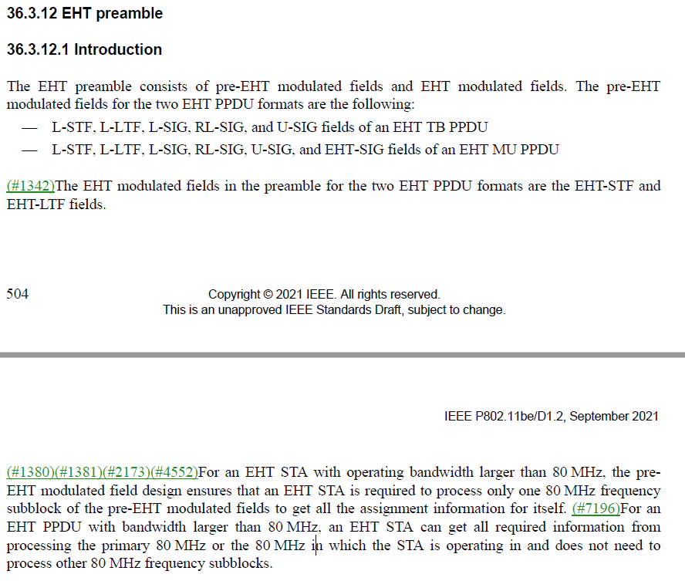
[Move to here]

End of discussion

