IEEE P802.11  
Wireless LANs

|  |
| --- |
| **TGbe CC36 Comment Resolutions for CID 8061 and 6483** |
| **Date:** 2021-09-14 |
| **Author(s):** |

|  |  |  |  |  |
| --- | --- | --- | --- | --- |
| **Name** | **Affiliation** | **Address** | **Phone** | **Email** |
| Jinyoung Chun | LG Electronics | 19, Yangjae-daero 11gil, Seocho-gu, Seoul 137-130, Korea |  | jiny.chun@lge.com |
| Dongguk Lim |  | dongguk.lim@lge.com |
| Eunsung Park |  | esung.park@lge.com |
| Insun Jang |  | insun.jang@lge.com |
| Jinsoo Choi |  | js.choi@lge.com |
| Alfred Asterjadhi | Qualcomm |  |  |  |

Abstract

This submission proposes a resolution for 2 CIDs: CID 8061 and 6483

Revisions:

* Rev 0: Initial version of the document.
* Rev 1: Modify the resolution by email discussion

#### CID *8061 and 6483*

|  |  |  |  |  |  |
| --- | --- | --- | --- | --- | --- |
| **CID** | **Clause** | **PP.LL** | **Comment** | **Proposed Change** | **Resolution** |
| 8061 | 9.2.4.6.3a | 71.40 | The number of reserved Control ID is becoming less and less. Consider adding a Control ID Extension subfield to extend more control types | as in comment | Rejected  There are 5 Control ID values remained. So it’s better to consider the extension of Control ID later if it’s needed. |
| 6483 | 9.2.4.6.3a | 71.45 | I may have missed this discussion - what is ONES? | Clarify | Revised  There’s some description in 10.8 (HT Control field operation) but it seems still not clear. So modify the text as follows.  ***Instructions to the editor:***  Please editor to make the changes shown in 11-21/1512r1. |

Discussion:

There are some text related to ONES control subfield in 10.8 (HT Control field operation) of 11ax Draft as follow:

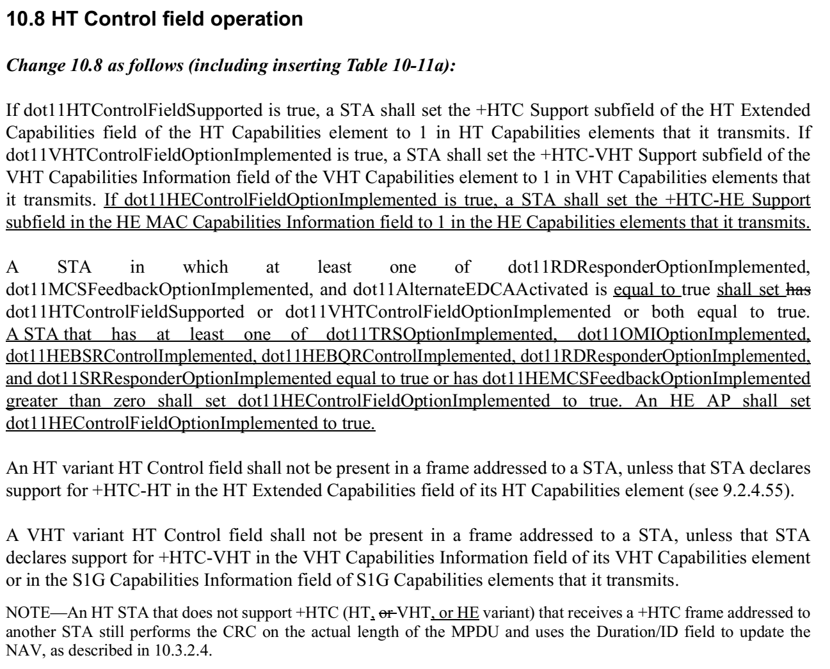

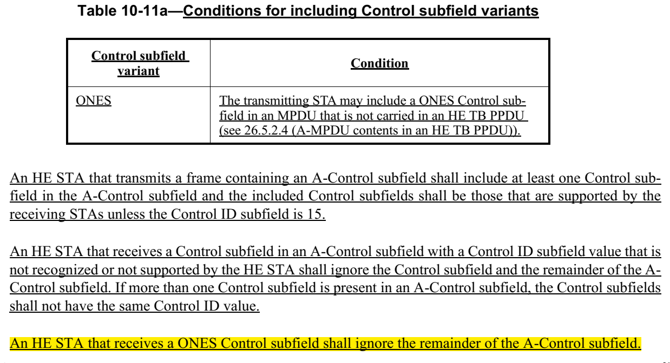

**26.5.2.4 A-MPDU contents in an HE TB PPDU**

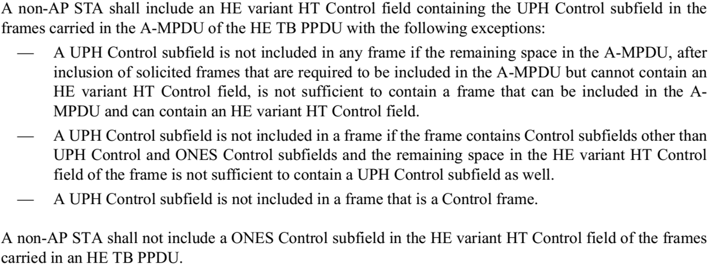

Based on that,

STA is required to include the A-Control in HE TB PPDU. For the STA to have the same MAC header size for HE PPDUs which is not HE TB PPDUs would need to always add the A-Control as well. So the STA may include an ONES Control subfield in an MDPU that is not carried in an HE TB PPDU when there’s nothing to report in A-Control subfield.

Discussion end

Proposed texts:

***Instructions to the editor, please newly add the text in P201L4 of P802.11be D1.1 as follows:***

**10.8 HT Control field operation**

***Change Table 10-11a*** ***(Conditions for including Control subfield variants) as follows (only relevant rows shown):***

**Table 10-11a (Conditions for including Control subfield variants)**

|  |  |
| --- | --- |
| **Control subfield variant** | **Condition** |
| ONES | The transmitting STA may include a ONES Control subfield in an MPDU that is not carried in an HE TB PPDU (see 26.5.2.4 (A-MPDU contents in an HE TB PPDU)) or an EHT TB PPDU when there’s nothing to report in A-Control subfield. |