IEEE P802.11
Wireless LANs
EHT-SIG CR for CID5485 on P802.11be D1.0
Date: 2021.10.22
Author(s):
Name | Company | Address | Phone | email
Bo Gong | Huawei Technologies |  |  | gongbo8@huawei.com
Ross Jian Yu | Huawei Technologies |  |  | ross.yujian@huawei.com
Abstract

This submission shows
- resolution for a comment received from TGbe comment collection (TGbe Draft D1.0)
- the proposed changes based on 11be D1.1.

The submission provides resolutions to CID5485.

Revision Notes

R0 | Initial revision

CID 5485
Page.  Line | Clause Number | Comment | Proposed Change | Resolution
457.42 | 36.3.12.8.6 | Unify encoding block and coded block | as in comment | REVISED  Agreed in principle. Reflect the detailed explanation.  Instructions to the editor: Please make the changes as shown in 11/21-1387r2

Discussion:

- From the spec, we can see that the field and encoding block have a different meanings. The common field is labeled as yellow, the user field is labeled as blue, the Encoding block is labeled as red and the User Block field is labeled as green in the following figure.

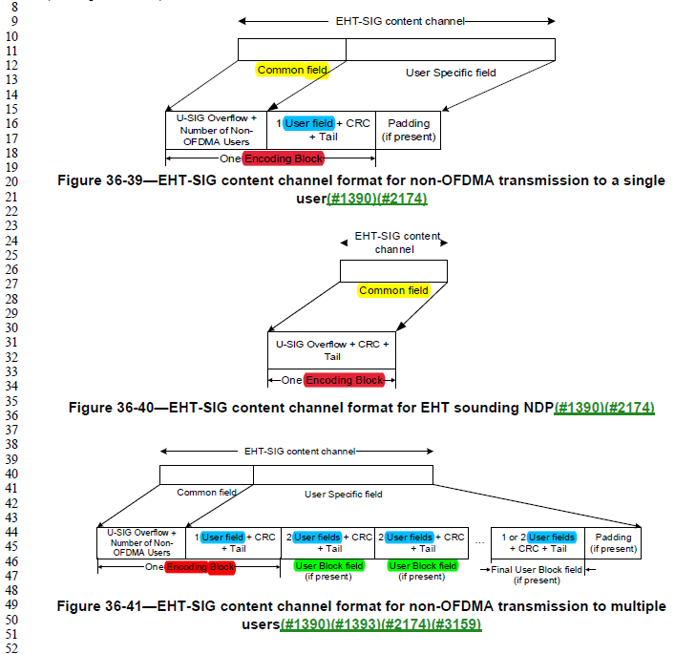
- The fields mean that it consists of regular information bits and an encoding block is a unit of the processing block. Thus, we want to change User Block field as user encoding block since User Block field is a unit of the processing block and consists of User fields, CRC and Tails bits. Correspondingly, we want to change the Encoding Block as common encoding block. Note that for non-OFDMA transmission to a single user or multiple users, the common encoding block includes the Common field of each content channel and the only User field or the first User field.

The details of the common encoding block has been clarified in the spec: (#3066) For OFDMA transmission, the Common field of each EHT-SIG content channel is included into one or two coded blocks. For EHT sounding NDP, the Common field of each EHT-SIG content channel is included in a single coded block. Each coded block shall be BCC encoded at rate R = 1/2. For EHT-SIG for non-OFDMA transmission to a single user or non-OFDMA transmission to multiple users, the Common field of each EHT-SIG content channel, together with the only User field or the first User field of the User Specific field, is included into a single coded block, which shall be BCC encoded at rate R = 1/2. (36.3.12.8.6 Encoding and modulation)

- Thus, what we need to do can be summarized as follows,
- Encoding Block/coded block should be unified and renamed as common encoding block.
- User Block field/User block should be unified and renamed as user encoding block.
- Adaptation should be conducted based on the context.

- The usage of ‘Common field’ in several places is inaccurate.

- In P508 L4.5 of TGbe Draft D1.1, ‘Common field’ should be ‘Encoding block’ according the the context.

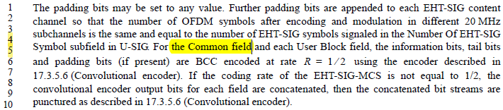
- In Page 599 Line 56 of TGbe Draft D1.1, ‘Common field’ should be ‘Encoding block’ according the the context.

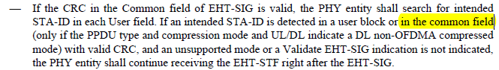

- For the 5 bullets in Page 599 Line 43, Page 599 Line 56, Page 599 Line 62, Page 600 Line 1, and Page 600 Line 6, it is not accurate for ‘If the CRC in the Common field of EHT-SIG is/is not valid’ since for non-OFDMA transmission to a single user or multiple users, the CRC is not in the common field, which should be revised as ‘If the CRCs protecting the Common field of the EHT-SIG are/are not valid’.

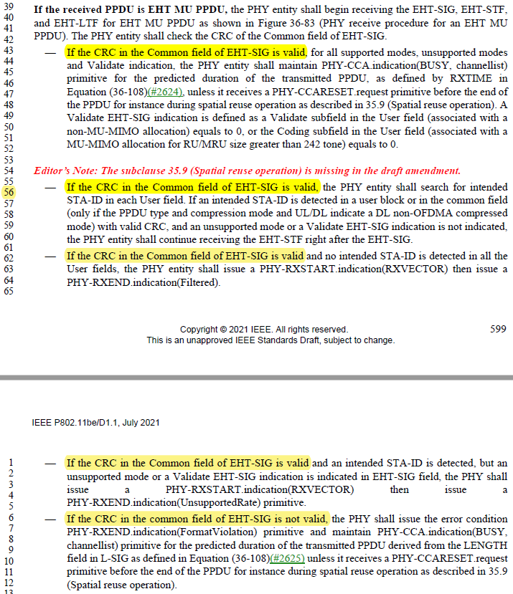

Instructions to the editor:

- Please make the following changes in TGbe Draft D1.1(Unified as common encoding block).

- In Page 31, Line 47, change ‘first Encoding Block’ to ‘common encoding block’.

Table 36-38—The common encoding block in an EHT-SIG field for non-OFDMA transmission to a single user and multiple users(#8018)(#1390)............................................................. 496

- In Page 478, Line 32, please make the following changes.
For OFDMA transmission, the Common field of an EHT-SIG content channel contains information regarding the resource unit allocation such as the RU assignment to be used in the EHT modulated fields of the PPDU, the RUs allocated for MU-MIMO and the number of users in MU-MIMO allocations. (#3186)The Common field for OFDMA transmission is defined in 36.3.12.8.3 (Common field for OFDMA transmission). The common field is organized into 1 or 2 common encoding blocks.
(#1391)(#2808)In non-OFDMA transmission, the Common field of the EHT-SIG content channel does not contain the RU allocation subfield. For non-OFDMA transmission except for EHT sounding NDP, the Common field of the EHT-SIG content channel is encoded together with the first User field and this (#1390) encoding block contains a CRC and Tail, referred to as a common encoding block.
.

(#1391)For EHT sounding NDP, the Common field of the EHT-SIG content channel consists of U-SIG overflow information, CRC, and Tail. The Common field for non-OFDMA transmission is defined in 36.3.12.8.4 (Common field for non-OFDMA transmission). The common field is also a common encoding block.

- In Page 477, Line 32, change ‘One Encoding Block’ to ‘The common encoding block’.

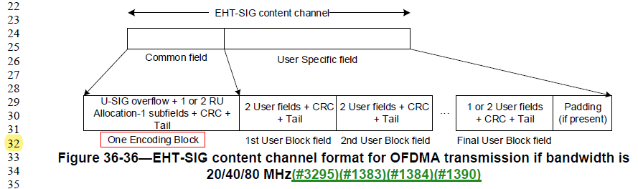
- In Page 478, Line 12, change ‘Encoding Block’ to ‘common encoding block’, which appears 2 times.

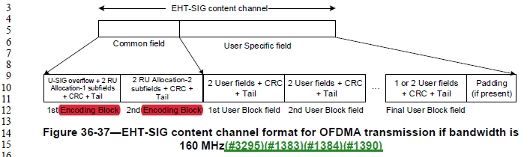
- In Page 478, Line 26, change ‘Encoding Block’ to ‘common encoding block’, which appears 2 times.

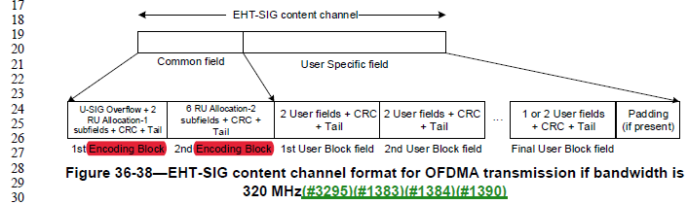

- In Page 479, Line 18, change ‘One Encoding Block’ to ‘The common encoding block’.

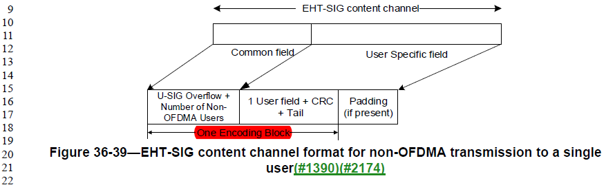

- In Page 479, Line 34, change ‘One Encoding Block’ to ‘The common encoding block’.
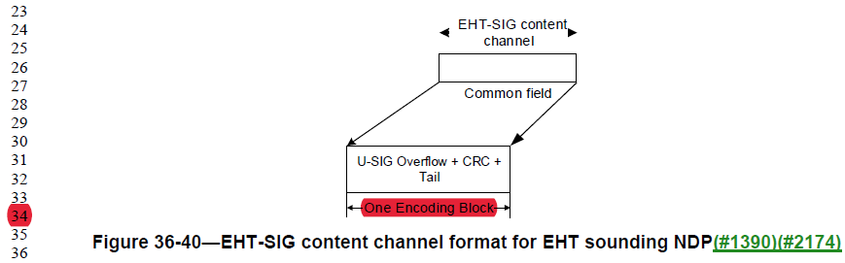
- In Page 479, Line 46, change ‘One Encoding Block’ to ‘The common encoding block’.

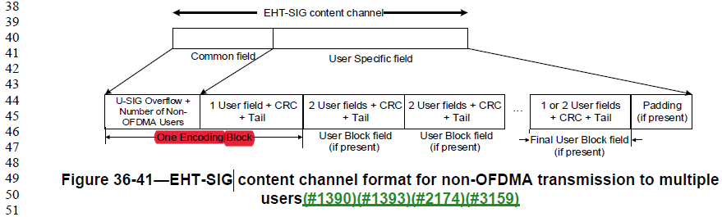

- In Page 483, Line 6, change ‘Encoding Block’ to ‘common encoding block’, which appears 2 times.

(#3295)B0–B26+9N of Table 36-33 (Common field for OFDMA transmission) composes the first common encoding block (#1390). B27+9N–B36+9N+9M composes the second common encoding block (#1390) if present.

- In Page 495, Line 39, make the following changes.

(#1407)(#8018)For a non-OFDMA transmission to a single user (in the U-SIG field, the UL/DL field is set to either 0 or 1, the PPDU Type And Compression Mode field is set to 1, and the EHT-SIG MCS field and the Number of EHT-SIG Symbols field are not set to 0 at the same time), and a DL non-OFDMA transmission to multiple users (in the U-SIG field, the UL/DL field is set to 0, and the PPDU Type And Compression Mode field is set to 2), the number of user fields is indicated by the Number Of Non-OFDMA Users subfield. The Common field of the EHT-SIG content channel is encoded together with the first user field. This common encoding block (#1390) contains a CRC and a Tail. The content of the common encoding block (#1390) in the EHT-SIG field for a non-OFDMA transmission to a single user and multiple users is defined in Table 36-38 (The common encoding block in an EHT-SIG field for non-OFDMA transmission to a single user and multiple users(#8018)(#1390)).

- In Page 496, Line 6, change ‘first Encoding Block’ to ‘common encoding block’.

Table 36-38—The common encoding block in an EHT-SIG field for non-OFDMA transmission to a single user and multiple users(#8018)(#1390)

- In Page 507 Line 42, make the following changes.

36.3.12.8.6 Encoding and modulation

(#3066)For OFDMA transmission, the Common field of each EHT-SIG content channel is included into one or two common encoding blocks. For EHT sounding NDP, the Common field of each EHT-SIG content channel is included in a single common encoding block. Each common encoding block shall be BCC encoded at rate R=1/2. For EHT-SIG for non-OFDMA transmission to a single user or non-OFDMA transmission to multiple users, the Common field of each EHT-SIG content channel, together with the only User field or the first User field of the User Specific field, is included into a single common encoding , which shall be BCC encoded at rate R=1/2.

- In Page 680 Line 47, change ‘First Encoding Block’ to ‘The common encoding block’.

Table Z-30—EHT-SIG content for example 5

 | EHT-SIG content channel 1 |  | EHT-SIG content channel 2
The common encoding block | 1111 11 010 1 10 0 1111 010 |  | 1111 11 010 1 10 0 1111 010
(U-SIG Overflow, Number Of | 10000101101 0101 1 100000 |  | 10100101101 1010 1 100000
Non-OFDMA Users, 1st User Field, CRC, Tail) | 1110 000000 |  | 0101 000000
User Specific field | STA 1443 | 11000101101 | Padding | 0000 0000 0000
except for the 1st User field |  | 1110 1 100000 |  | 0000 0000 0000
 |  |  |  | 000 0000
 | CRC and Tail | 0010 000000 |  | 000 0000
 | Padding | N/A

- In Page 682 Line 11, change ‘First Encoding Block’ to ‘The common encoding block’.

Table Z-33—EHT-SIG content for example 6

 | EHT-SIG content channel 1
The common encoding block  (U-SIG Overflow, Number Of Non-OFDMA Users, 1st User Field, CRC, Tail) | 1111 01 100 1 10 0 1111 000  10000101101 0101 1 1000 1 1  0001 000000
EHT-SIG field content in binary, organized as octets (LSB first) | 11110110 01100111 10001000  01011010 10111000 11000100 0000

- Please make the following changes in TGbe Draft D1.1(Unified as user encoding block).

- In Page 31, Line 49, change ‘User Block field’ as ‘The user encoding block’.

Table 36-39—The user encoding block .................................................... 497

- In Page 477, Line 32, change ‘User Block field’ as ‘user encoding block’, which appears 3 times.

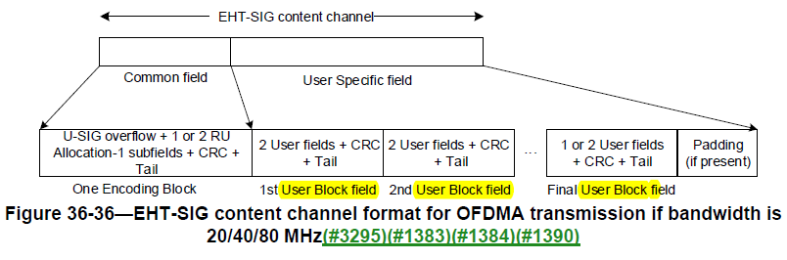

- In Page 478, Line 12, change ‘User Block field’ as ‘user encoding block’, which appears 3 times.

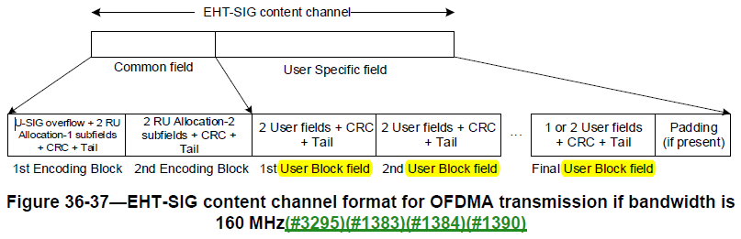

- In Page 478, Line 27, change ‘User Block field’ as ‘user encoding block’, which appears 3 times.

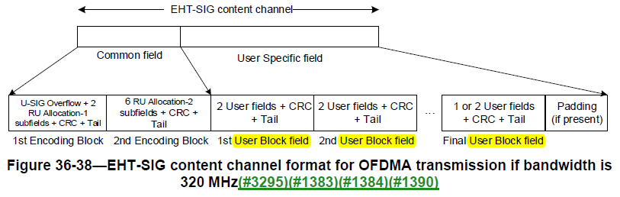

- In Page 478, Line 61, make the following changes.

The union of the User Specific fields in the EHT-SIG content channels contains information for all users in the PPDU on how to decode their payload. As shown in Figure 36-36 (EHT-SIG content channel format for OFDMA transmission if bandwidth is 20/40/80 MHz(#3295)(#1383)(#1384)(#1390)), Figure 36-37 (EHT-SIG content channel format for OFDMA transmission if bandwidth is 160 MHz (#3295)(#1383)(#1384)(#1390)), and Figure 36-38 (EHT-SIG content channel format for OFDMA transmission if bandwidth is 320 MHz(#3295)(#1383)(#1384)(#1390)), the User Specific field is organized into user encoding blocks that in turn contain User fields in OFDMA transmission. (#1393)(#1394)As shown in Figure 36-39 (EHT-SIG content channel format for non-OFDMA transmission to a single user(#1390)(#2174)), in the non-OFDMA transmission to single user, the User Specific field contains one User field but there exists no user encoding block . As shown in Figure 36-40 (EHT-SIG content channel format for EHT sounding NDP(#1390)(#2174)), EHT-SIG content channel for EHT sounding NDP does not contain the User Specific field. And, as shown in Figure 36-41 (EHT-SIG content channel format for non-OFDMA transmission to multiple users(#1390)(#1393)(#2174)(#3159)), in the non-OFDMA transmission to multiple users, the User Specific field is organized into user encoding blocks that in turn contain User fields except for the first User field. (#2734)The contents of the User Specific field are described in 36.3.12.8.5 (User Specific field).

- In Page 479, Line 46, change ‘User Block field’ as ‘user encoding block’, which appears 3 times.

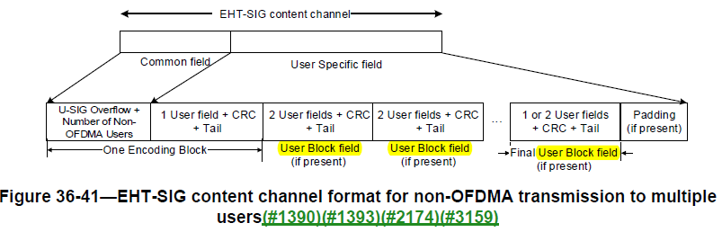

- In Page 495, Line 12, make the following changes.

(#1407)The User Specific field of an EHT-SIG content channel consists of zero or more user encoding blocks followed by padding (if present) as shown in Figure 36-36 (EHT-SIG content channel format for OFDMA transmission if bandwidth is 20/40/80 MHz(#3295)(#1383)(#1384)(#1390)), Figure 36-37 (EHT-SIG content channel format for OFDMA transmission if bandwidth is 160 MHz(#3295)(#1383)(#1384)(#1390)), Figure 36-38 (EHT-SIG content channel format for OFDMA transmission if bandwidth is 320 MHz(#3295)(#1383)(#1384)(#1390)), Figure 36-39 (EHT-SIG content channel format for non-OFDMA transmission to a single user(#1390)(#2174)), and Figure 36-41 (EHT-SIG content channel format for non-OFDMA transmission to multiple users(#1390)(#1393)(#2174)(#3159)). There is no User Specific field for EHT sounding NDP as shown in Figure 36-40 (EHT-SIG content channel format for EHT sounding NDP(#1390)(#2174)).

(#1407)(#8018)For a DL OFDMA transmission (in the U-SIG field, the UL/DL field is set to 0, and the PPDU Type And Compression Mode field is set to 0), the number of user fields is indicated by the RU Allocation subfields. Each nonfinal user encoding block is made up of two user fields that contain information for two STAs that are used to decode their payloads. The final user encoding block contains information for one or two users depending on the number of users in the EHT-SIG content channel.

- In Page 496, Line 1, change ‘user blocks’ as ‘user encoding blocks’.

In the case of a non-OFDMA transmission to multiple users, the remaining user fields are grouped into user encoding blocks using the same method as the OFDMA transmission.

- In Page 497, Line 1, make the following changes.

The user encoding block is defined in Table 36-39 (The user encoding block ).

Table 36-39—The user encoding block

Subfield | Number of subfields | Number of bits per subfield | Description
User field | N | 22 | N User fields are present, where:  N = 1 if it is the final user encoding block , and if there is only one user in the final user encoding block .  N = 2 otherwise.  The User field format for a non-MU-MIMO allocation is defined in Table 36-40 (User field format for a non-MU-MIMO allocation). The User field format for a MU- MIMO allocation is defined in Table 36-41 (User field format for a MU-MIMO allocation).
CRC | 1 | 4 | (#2670)(#2411)The CRC is calculated over bits 0 to 21 for a user encoding block that contains one User field, and bits 0 to 43 for a user encoding block that contains two User fields. See 36.3.12.7.3 (CRC computation).
Tail | 1 | 6 | Used to terminate the trellis of the convolutional decoder. Set to 0.

- In Page 507, Line 50, make the following changes.

For EHT-SIG for OFDMA transmission and non-OFDMA transmission to multiple users, each user encoding block in the User Specific field of each EHT-SIG content channel shall be BCC encoded at rate R=1/2. For OFDMA transmission, if the number of User fields in an EHT-SIG content channel is odd, there is a single User field in the final user encoding block . For non-OFDMA transmission, the first User field is encoded together with the Common field of the EHT-SIG. If the number of User fields in an EHT-SIG content channel is even, there is a single User field in the final user encoding block . CRC and tail bits are added immediately after the last User field in each user encoding block.

Padding bits are appended immediately after the tail bits corresponding to the final user encoding block in each EHT-SIG content channel to round up to the next multiple of number of data bits per EHT-SIG OFDM symbol.

- Please make the following changes in TGbe Draft D1.1(Correction of inaccurate usage of ‘Common field’).

- In P508L4.5, make the following changes.

The padding bits may be set to any value. Further padding bits are appended to each EHT-SIG content channel so that the number of OFDM symbols after encoding and modulation in different 20 MHz subchannels is the same and equal to the number of EHT-SIG symbols signaled in the Number Of EHT-SIG Symbol subfield in U-SIG. For the common encoding block and each user encoding block, the information bits, tail bits and padding bits (if present) are BCC encoded at rate R = 1 / 2 using the encoder described in 17.3.5.6 (Convolutional encoder). If the coding rate of the EHT-SIG-MCS is not equal to 1/2, the convolutional encoder output bits for each field are concatenated, then the concatenated bit streams are punctured as described in 17.3.5.6 (Convolutional encoder).

- In Page 599, Line 56, make the following changes.

If the received PPDU is EHT MU PPDU, the PHY entity shall begin receiving the EHT-SIG, EHT-STF, and EHT-LTF for EHT MU PPDU as shown in Figure 36-83 (PHY receive procedure for an EHT MU PPDU). The PHY entity shall check the CRC of the Common field of EHT-SIG.
- If the CRCs protecting the Common field of the EHT-SIG are valid, for all supported modes, unsupported modes and Validate indication, the PHY entity shall maintain PHY-CCA.indication(BUSY, channellist) primitive for the predicted duration of the transmitted PPDU, as defined by RXTIME in Equation (36-108)(#2624), unless it receives a PHY-CCARESET.request primitive before the end of the PPDU for instance during spatial reuse operation as described in 35.9 (Spatial reuse operation). A Validate EHT-SIG indication is defined as a Validate subfield in the User field (associated with a non-MU-MIMO allocation) equals to 0, or the Coding subfield in the User field (associated with a MU-MIMO allocation for RU/MRU size greater than 242 tone) equals to 0.

Editor’s Note: The subclause 35.9 (Spatial reuse operation) is missing in the draft amendment.
- If the CRCs protecting the Common field of the EHT-SIG arevalid, the PHY entity shall search for intended STA-ID in each User field. If an intended STA-ID is detected in a user encoding block or in the common encoding block(only if the PPDU type and compression mode and UL/DL indicate a DL non-OFDMA compressed mode) with valid CRC, and an unsupported mode or a Validate EHT-SIG indication is not indicated, the PHY entity shall continue receiving the EHT-STF right after the EHT-SIG.
- If the CRCs protecting the Common field of the EHT-SIG arevalid and no intended STA-ID is detected in all the User fields, the PHY entity shall issue a PHY-RXSTART.indication(RXVECTOR) then issue a PHY-RXEND.indication(Filtered).
- If the CRCs protecting the Common field of the EHT-SIG arevalid and an intended STA-ID is detected, but an unsupported mode or a Validate EHT-SIG indication is indicated in EHT-SIG field, the PHY shall issue a PHY-RXSTART.indication(RXVECTOR) then issue a PHY-RXEND.indication(UnsupportedRate) primitive.
- If the CRCs protecting the Common field of the EHT-SIG are not valid, the PHY shall issue the error condition PHY-RXEND.indication(FormatViolation) primitive and maintain PHY-CCA.indication(BUSY, channellist) primitive for the predicted duration of the transmitted PPDU derived from the LENGTH field in L-SIG as defined in Equation (36-108)(#2625) unless it receives a PHY-CCARESET.request primitive before the end of the PPDU for instance during spatial reuse operation as described in 35.9 (Spatial reuse operation).

