IEEE P802.11
Wireless LANs
EHT-SIG CR for CID5485 on P802.11be D1.0
Date: 2021.08.24
Author(s):
Name | Company | Address | Phone | email
Bo Gong | Huawei Technologies |  |  | gongbo8@huawei.com
Ross Jian Yu | Huawei Technologies |  |  | ross.yujian@huawei.com
Abstract

This submission shows
- resolution for a comment received from TGbe comment collection (TGbe Draft D1.0)
- the proposed changes based on 11be D1.1.

The submission provides resolutions to CID5485.

Revision Notes

R0 | Initial revision

CID 5485
Page.  Line | Clause Number | Comment | Proposed Change | Resolution
457.42 | 36.3.12.8.6 | Unify encoding block and coded block | as in comment | REVISED  Agreed in principle. Reflect the detailed explanation.  Instructions to the editor: Please make the changes as shown in 11/21-1387r1

Discussion:

- From the spec, we can see that the field and encoding block have a different meanings. The common field is labeled as yellow, the user field is labeled as blue, the Encoding block is labeled as red and the User Block field is labeled as green in the following figure.
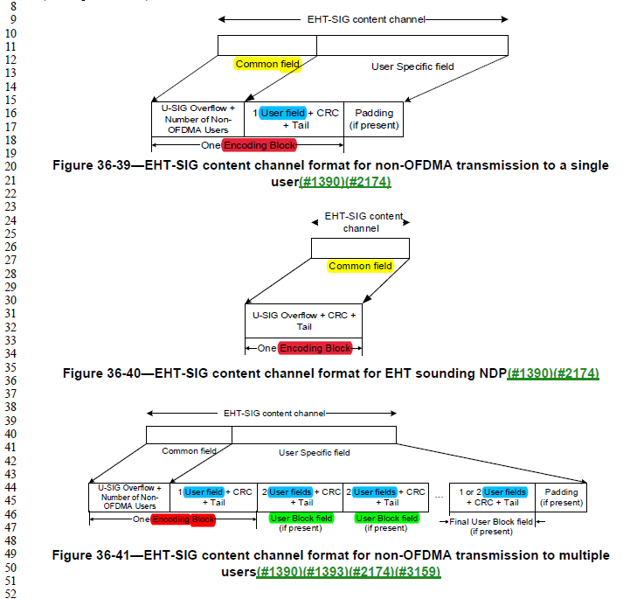
- The fields mean that it consists of regular information bits and an encoding block is a unit of the processing block. Thus, we want to change User Block field as user encoding block since User Block field is a unit of the processing block and consists of User fields, CRC and Tails bits. Correspondingly, we want to change the Encoding Block as common encoding block. Note that for non-OFDMA transmission to a single user or multiple users, the common encoding block includes the Common field of each content channel and the only User field or the first User field. The details of the common encoding block has been clarified in the spec:

(#3066)For OFDMA transmission, the Common field of each EHT-SIG content channel is included into one or two coded blocks. For EHT sounding NDP, the Common field of each EHT-SIG content channel is included in a single coded block. Each coded block shall be BCC encoded at rate R = 1/2. For EHT-SIG for non-OFDMA transmission to a single user or non-OFDMA transmission to multiple users, the Common field of each EHT-SIG content channel, together with the only User field or the first User field of the User Specific field, is included into a single coded block, which shall be BCC encoded at rate R = 1/2. (36.3.12.8.6 Encoding and modulation)

- Thus, the following revision should be conducted:
- Encoding Block/coded block should be unified;
- Similiarly, User Block field/User block should be unified either;
- For accurate description, the Encoding Block and coded block are renamed as common encoding block. The User Block field and User block are renamed as user encoding block.

Instructions to the editor:

- Four ‘coded blocks/coded block’ appear in the following positions in TGbe Draft D1.1 and should be revised as ‘common encoding block’.
- Page 507 Line 42
(2)-(3) Page 507 Line 44 (2 times)
(4) Page 507 Line 48

- Twenty ‘encoding block’ appear in the following positions in TGbe Draft D1.1 and should be revised as ‘common encoding block’.
- Page 31 Line 47
- Page 477 Line 32
(3)-(4) Page 478, Line 12 (2 times)
(5)-(6) Page 478, Line 26 (2 times)
(7) Page 478 Line 43
(8) Page 478 Line 46
(9) Page 479 Line 18
(10) Page 479 Line 34
(11) Page 479 Line 46
(12)-(13) Page 483 Line 6 (2 times)
(14)-(17) Page 495 Line 39 (4 times)
(18) Page 496 Line 6
(19) Page 680 Line 47
(20) Page 682 Line 11

- In addition, in P508L4.5 of TGbe Draft D1.1, ‘Common field’ should be ‘Encoding block’, and should be unified as ‘common encoding block’.

- Thirty-three ‘user block’ appear in the following positions in TGbe Draft D1.1 and should be revised as ‘user encoding block’.
- Page 31 Line 49
(2)-(4) Page 477 Line 32 (3 times)
(5) Page 478 Line 61
(6) Page 478 Line 65
(7)-(9) Page 478 Line 12 (3 times)
(10)-(12) Page 478 Line 27 (3 times)
(13) Page 479 Line 5
(14)-(16) Page 479 Line 46 (3 times)
(17) Page 495 Line 12
(18) Page 495 Line 27
(19) Page 495 Line 29
(20) Page 496 Line 1
(21)-(22) Page 497 Line 1
(23) Page 497 Line 5
(24)-(27) Page 497 Line 12 (4 times)
(28)-(31) Page 507 Line 50 (4 times)
(32) Page 507 Line 60
(33) Page 508 Line 5

- In addition, in Page 599 Line 56 of TGbe Draft D1.1, ‘in a user block’ or ‘in the common field’ should be revised as ‘in a user encoding block’ or ‘in the common encoding block’. Besides, for the 5 bullets in Page 599 Line 43, Page 599 Line 56, Page 599 Line 62, Page 600 Line 1, and Page 600 Line 6, it is not accurate for ‘If the CRC in the Common field of EHT-SIG is/is not valid’ since for non-OFDMA transmission to a single user or multiple users, the CRC is not in the common field, which should be revised as ‘If the CRCs protecting the Common field of the EHT-SIG are/are not valid’.

