IEEE P802.11
Wireless LANs
CR for Section 9.3.1.19 on P802.11be D1.01
Date: 2021.07.04
Author(s):
Name | Company | Address | Phone | email
Genadiy Tsodik | Huawei Technologies
Wook Bong Lee | Samsung
Edward Au | Huawei
Alfred Asterjadhi | Qualcomm Inc.
Abstract
This submission contains proposed comment resolutions to comments on P802.11be D1.01.

7 comments under subclause 9.3.1.19 are resolved.

Revision Notes

R0 | Initial revision
R1 | CIDs 4148 and 8262 are added. Editorial modifications on proposed text.
R2 | Added additional change on P80L59
R3 | Change to align to P802.11az™/D3.2
R4 | List of authors updated

CID 4146
Page.  Line | Clause Number | Comment | Proposed Change | Resolution
78.28 | 9.3.1.19 | I think there are 4 variants of NDPA (randing is missing). Please check and fix. | As in comment. | REVISED  Instructions to the editor:  Please make the changes to the spec as shown in 11/21-1105r4, under CID 5787

CID 8262
Page.  Line | Clause Number | Comment | Proposed Change | Resolution
78.28 | 9.3.1.19 | IEEE 802.11az define a type of ranging NDP Announcement frame. So there are four types. | as in the comment | REVISED  Instructions to the editor:  Please make the changes to the spec as shown in 11/21-1105r4.  Same resolution as for CID #4146

CID 4148
Page.  Line | Clause Number | Comment | Proposed Change | Resolution
78.62 | 9.3.1.19 | Maybe a good idea to rename these bits since it is odd that a settin of ranging and HE of 1 identify an EHT variant. Either that or add a table with the different combos. Also probably a good idea to have a different subclause for each of these variants? Getting very difficult to read. | As in comment. | REVISED  Instruction to the Editor: Please make the changes to the spec as shown in 11/21-1105r4, under CID 5787

CID 5083
Page.  Line | Clause Number | Comment | Proposed Change | Resolution
78.31 | 9.3.1.19 | No Reference to Sounding Dialog Token | Add reference to section/table where Sounding Dialog Token Field is defined | REVISED  Instructions to the editor:  Please make the changes to the spec as shown in 11/21-1105r4, under CID 5787

CID 5084
Page.  Line | Clause Number | Comment | Proposed Change | Resolution
78.61 | 9.3.1.19 | Fourth option of HE Subfield and Ranging Subfield is not specified | Add specification for the option when HE Subfield and Ranging Subfield are set to 0 and 1 respectively | REVISED  See discussion below  Instructions to the editor:  Please make the changes to the spec as shown in 11/21-1105r4, under CID 5787

CID 6005
Page.  Line | Clause Number | Comment | Proposed Change | Resolution
78.28 | 9.3.1.19 | Ranging NDP Announcement varient should be mentioed here | as in the comment | REVISED  See discussion below  Instructions to the editor:  Please make the changes to the spec as shown in 11/21-1105r4, under CID 5787

CID 5787
Page.  Line | Clause Number | Comment | Proposed Change | Resolution
78.23 | 9.3.1.19 | NDPA frame has four variants. For readability, it is better to divide this clause into five subclauses: 1) overview; 2) VHT variant; 3) HE Variant; 4) Ranging variant; 5) EHT variant | as in the comment | REVISED  Instructions to the editor:  Please make the changes to the spec as shown in 11/21-1105r4, under CID 5787

Discussion:

802.11ax defined two subfields of Sounding Dialog Token field as HE Subfield and Reserved.

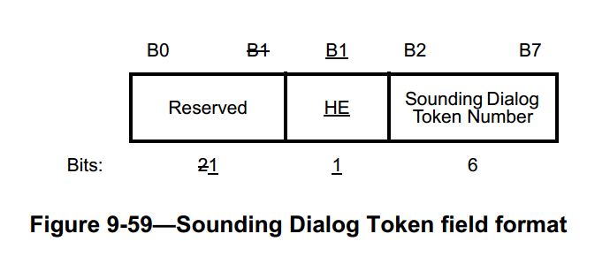

802.11az (P802.11az™/D3.2) replaced the HE and Reserved Subfields by single NDP Announcement Type subfield of two bits to indicate three variants of NDPA frame (HE/VHT/Ranging).

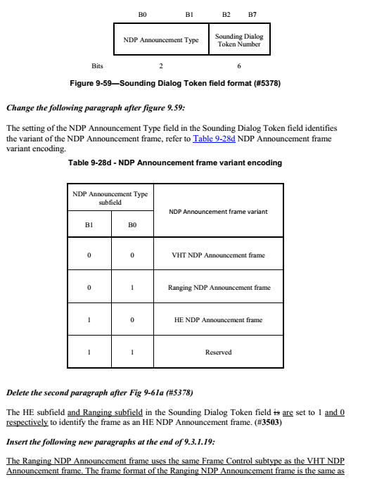
11be may accept the change of 11az and further modify it to add forth variant of EHT NDP Announcment frame.
Discussion Ends here.

Instructions to the editor: please make the following changes on page 80, L 59

The VHT/HE/Ranging NDP (#1732, #1767) Announcement frame has three four variants, the VHT NDP Announcement frame, the HE NDP Announcement frame, and the Ranging NDP Announcement frame and EHT NDP Announcement frame. The three four formats are distinguished by the setting of the NDP Announcement Type Variant subfield in the Sounding Dialog Token field.

The NDP Announcement frame contains at least one STA Info field. If the NDP Announcement frame contains only one STA Info field, then in the case of VHT or HE NDP Announcement frames the RA field is set to the address of the STA that can provide feedback (see 10.37.5.2 (Rules for VHT sounding protocol sequences)), while in the case of Ranging NDP Announcement frames, the RA address is set to the address of the RSTA or ISTA that is the intended recipient of the frame. If the NDP Announcement frame contains more than one STA Info field, then the RA field is set to the broadcast address.

The TA field is set to the address of the STA transmitting the NDP Announcement frame or the bandwidth signaling TA of the STA transmitting the NDP Announcement frame. In a VHT/HE/EHT NDP Announcement frame transmitted by an EHT STA that is a STA 6G with 320 MHz bandwidth support in a non-HT or non-HT duplicate format and where the scrambling sequence and SERVICE field carry the TXVECTOR parameter CH_BANDWIDTH_IN_NON_HT, the TA field is a set to a bandwidth signaling TA. Otherwise, in a NDP Announcement frame transmitted by a VHT,HE or EHT STA in a non-HT or non-HT duplicate format and where the scrambling sequence carries the TXVECTOR parameter CH_BANDWIDTH_IN_NON_HT, the TA field is set to a bandwidth signaling TA

Change Figure 9-59 (Sounding Dialog Token field format) as follows:

 | B0 B1 | B2 B7
 | NDP Announcement Variant | Sounding Dialog Token Number
Bits: | 2 | 6

Figure 9-59 — Sounding Dialog Token field format

Instructions to the editor: please make the following changes on page 81

The setting of the NDP Announcement Type Variant subfield in the Sounding Dialog Token field identifies the variant of the NDP Announcement frame, refer to Table 9-28d NDP Announcement frame variant encoding.

NDP Announcement Type Variant subfield |  | NDP Announcement frame Variant
B1 | B0
0 | 0 | VHT NDP Announcement frame
0 | 1 | Ranging NDP Announcement frame
1 | 0 | HE NDP Announcement frame
1 | 1 | EHT NDP Announcement frame

Table 9-28d — NDP Announcement frame variant encoding

Change the second paragraph after Fig 9-61a

Instructions to the editor: please make the following changes on page 81

The frame format of the EHT NDP Announcement frame is the same as the HE NDP Announcement frame shown in Figure 9-61a (HE NDP Announcement frame format).
The Duration, RA, and TA fields are set as in a VHT NDP Announcement frame.
The NDP Announcement Variant subfield isset to 3 to identify the frame as an EHT NDP Announcement frame.
The Sounding Dialog Token Number field in the Sounding Dialog Token field contains a value selected by the beamformer to identify the EHT NDP Announcement frame.

