IEEE P802.11
Wireless LANs
CR for Section 9.3.1.19 on P802.11be D1.01
Date: 2021.07.04
Author(s):
Name | Company | Address | Phone | email
Genadiy Tsodik | Huawei Technologies
Abstract
This submission contains proposed comment resolutions to comments on P802.11be D1.01.

7 comments under subclause 9.3.1.19 are resolved.

Revision Notes

R0 | Initial revision
R1 | CIDs 4148 and 8262 are added. Editorial modifications on proposed text.

CID 4146
Page.  Line | Clause Number | Comment | Proposed Change | Resolution
78.28 | 9.3.1.19 | I think there are 4 variants of NDPA (randing is missing). Please check and fix. | As in comment. | REVISED  Instruction to the Editor: change the text as following:  The VHT/HE/EHT/ Ranging NDP Announcement frame has four variants, the VHT NDP Announcement frame,  and the HE NDP Announcement frame, Ranging NDP Announcment frame and the EHT NDP Announcement frame

CID 8262
Page.  Line | Clause Number | Comment | Proposed Change | Resolution
78.28 | 9.3.1.19 | IEEE 802.11az define a type of ranging NDP Announcement frame. So there are four types. | as in the comment | REVISED  Instructions to the editor:  Please make the changes to the spec as shown in 11/21-1105r1.  Same resolution as for CID #4146

CID 4148
Page.  Line | Clause Number | Comment | Proposed Change | Resolution
78.62 | 9.3.1.19 | Maybe a good idea to rename these bits since it is odd that a settin of ranging and HE of 1 identify an EHT variant. Either that or add a table with the different combos. Also probably a good idea to have a different subclause for each of these variants? Getting very difficult to read. | As in comment. | REVISED  Instruction to the Editor: Please make the changes to the spec as shown in 11/21-1105r1, under CID 5787

CID 5083
Page.  Line | Clause Number | Comment | Proposed Change | Resolution
78.31 | 9.3.1.19 | No Reference to Sounding Dialog Token | Add reference to section/table where Sounding Dialog Token Field is defined | REVISED  Instructions to the editor:  Please make the changes to the spec as shown in 11/21-1105r1, under CID 5787

CID 5084
Page.  Line | Clause Number | Comment | Proposed Change | Resolution
78.61 | 9.3.1.19 | Fourth option of HE Subfield and Ranging Subfield is not specified | Add specification for the option when HE Subfield and Ranging Subfield are set to 0 and 1 respectively | REVISED  See discussion below  Instructions to the editor:  Please make the changes to the spec as shown in 11/21-1105r1, under CID 5787

CID 6005
Page.  Line | Clause Number | Comment | Proposed Change | Resolution
78.28 | 9.3.1.19 | Ranging NDP Announcement varient should be mentioed here | as in the comment | REVISED  See discussion below  Instructions to the editor:  Please make the changes to the spec as shown in 11/21-1105r1, under CID 5787

CID 5787
Page.  Line | Clause Number | Comment | Proposed Change | Resolution
78.23 | 9.3.1.19 | NDPA frame has four variants. For readability, it is better to divide this clause into five subclauses: 1) overview; 2) VHT variant; 3) HE Variant; 4) Ranging variant; 5) EHT variant | as in the comment | REVISED  No need for subclause per NDPA frame variant. This amendment specify only details of EHT NDPA frame variant. Only singnalling for all other variants should be provided.  See suggested definition in discussion below

Discussion:

802.11ax defined two subfields of Sounding Dialog Token field as HE Subfield and Reserved.

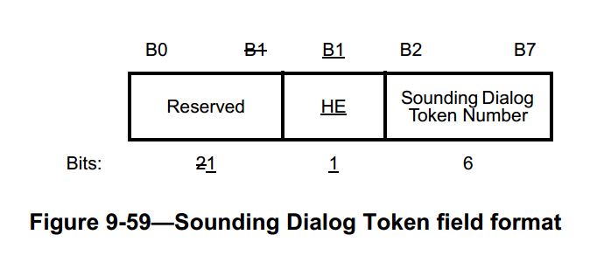

802.11az uses Reserved Subfield as Ranging Subfield to indicate Ranging variant of NDPA frame.
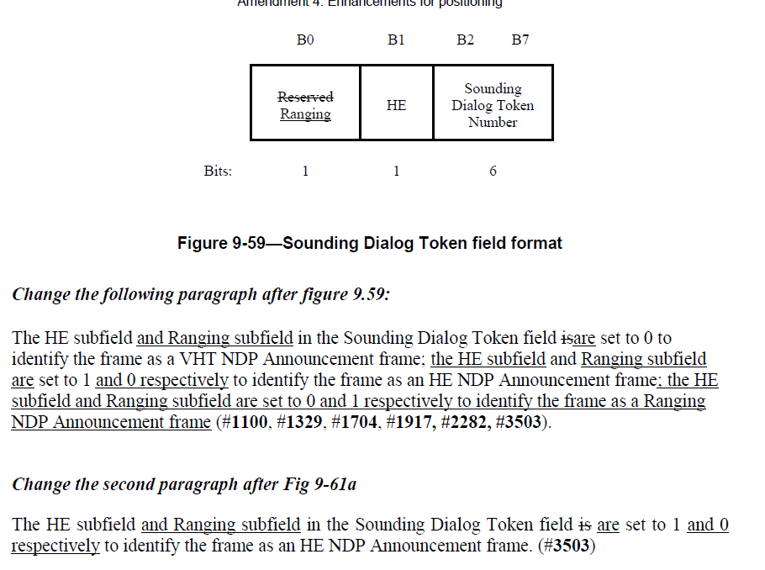

However, two subfields (HE subfield and Ranging Subfiled) of Sounding Dialog Token field can not be considered as idependent subfields as all four combinations are used.
Ranging subfield should be used for Ranging NDP Announcement frame indication in combination with HE Subfield.
Reciever can not ignore any of these two subfields and have to parse both. Thus better technical solution is to combine these two subfileds to single subfield and specify all four variants of the new subfield.
The conflict with current 802.11az amendment can be resolved by accepting the proposed change below in both amendments.

Discussion Ends here.

Instructions to the editor: please make the following changes on page 80, L 59

Change Figure 9-59 (Sounding Dialog Token field format) as follows:

 | B0 B1 | B2 B7
 | NDP Announcment Frame Variant | Sounding Dialog Token Number
Bits: | 2 | 6

Figure 9-59 — Sounding Dialog Token field format

Instructions to the editor: please make the following changes on page 81, L 23

The NDP Announcement Frame Variant value is set as defined in table XX

NDP Announcement Frame Variant Subfield value | NDP Announcement Frame Variant
0 | VHT NDP Announcement Frame
1 | HE NDP Announcement Frame
2 | Ranging NDP Announcement Frame
3 | EHT NDP Announcement Frame

Table XX — NDP Announcement Frame Variant Subfield

The frame format of the EHT NDP Announcement frame is the same as the HE NDP Announcement frame shown in Figure 9-61a (HE NDP Announcement frame format).
The Duration, RA, and TA fields are set as in a VHT NDP Announcement frame.
The NDP Announcement Frame Variant Subfiled is set to 3 to identify the frame as an EHT NDP Announcement frame.
The Sounding Dialog Token Number field in the Sounding Dialog Token field contains a value selected by the beamformer to identify the EHT NDP Announcement frame.

