IEEE P802.11
Wireless LANs
TGbf Evaluation Methodology and Simulation Scenarios
Date: 2021-9-28
Author(s):
Name | Company | Address | Phone | Email
Rui Du | Huawei Technologies Co.,Ltd. | F3, Huawei Base, Shenzhen, China |  | Ray.du@huawei.com
Meihong Zhang | Huawei Technologies Co.,Ltd. |  |  | zhangmeihong@huawei.com
Yi Lv | Huawei Technologies Co.,Ltd. |  |  | lvyi6@huawei.com
Mengshi Hu | Huawei Technologies Co.,Ltd. |  |  | humengshi@huawei.com
Kwok Shum Au | Huawei Technologies Co.,Ltd. |  |  | Edward.ks.au@huawei.com
Yan Xin | Huawei Technologies Co.,Ltd. |  |  | Yan.Xin@huawei.com
Junghoon Suh | Huawei Technologies Co.,Ltd. |  |  | Junghoon.Suh@huawei.com
Osama AboulMagd | Huawei Technologies Co.,Ltd. |  |  | Osama.AboulMagd@huawei.com
Haipeng Dai | Nanjing University | CS Building, Nanjing University Nanjing, China |  | haipengdai@nju.edu.cn
Shuyu Shi | Nanjing University | CS Building, Nanjing University Nanjing, China |  | ssy@nju.edu.cn
Wei Wang | Nanjing University | CS Building, Nanjing University Nanjing, China |  | ww@nju.edu.cn
Yuan Shen | Tsinghua University, Beijing | Department of Electronic Engineering, Tsinghua University, China |  | shenyuan_ee@tsinghua.edu.cn
Jie Xu | The Chinese University of Hong Kong, Shenzhen | School of Science and Engineering, The Chinese University of Hong Kong (Shenzhen), China |  | xujie@cuhk.edu.cn
Fan Liu | Southern University of Science and Technology | College of Engineering, Southern University of Science and Technology, Shenzhen, China |  | liuf6@sustech.edu.cn
Steve Blandino | NIST
Tanguy Ropitault | NIST
Jian Wang | NIST
Neeraj Varshney | NIST
Camillo Gentile | NIST
Nada Golmie | NIST

Abstract
The purpose of this document is to summarize simulation scenarios and parameters that might be used when evaluating the performance of 60 GHz WLAN sensing.

Revision History
Revision | Comments | Date
R0  R1 | initial contribution  inclusion of conference room as new scenario | 2 June 2021  17 September 2021

PHY Performance

The criteria for evaluation of PHY performance are
- Accuracy vs. SNR curves.
- Histogram of accuracy.
These criteria could be analyzed for different operation modes (monostatic sensing, bistatic sensing, et al) in different scenarios.

Usually, for parameter estimation, accuracy is described by Root Mean Square Error (RMSE) of the parameter to be estimated, which is defined as follows.

where, is the estimated parameter, is the ground truth. n is the number of observation.

Accuracy describes the closeness of the target estimated parameters (i.e. range, velocity, angle, et al) to the ground truth. With the WLAN sensing link level simulation, target’s parameters could be estimated (i.e. range, velocity, angle, et al) and accuracy could be calculated based on the estimated parameters and ground truth in the simulation.

Accuracy vs. SNR curves
The Accuracy vs. SNR curves indicate the WLAN sensing estimation accuracy with different SNRs. An example of accuracy vs. SNR about range estimation is shown as follows. In the following figure, the x-axis represents the SNR for simulation and the y-axis shows the accuracy of the range estimation. Usually, accuracy improves with SNR increases.
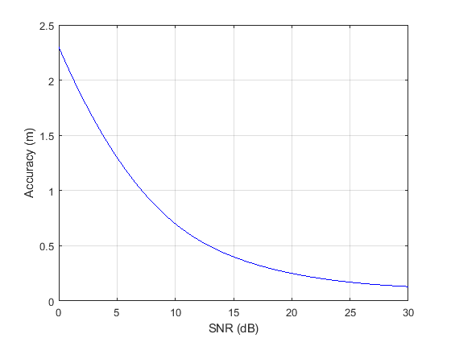
Figure 1. An example of range estimation accuracy vs. SNR

Histogram of accuracy
During the WLAN sensing simulation, a target is moving with certain trajectory. The SNR is different during target movement which leads to different estimation accuracies. Based on the information of estimation accuracy (i.e. range accuracy, velocity accuracy, angle accuracy), a histogram of accuracy during the simulation could be calculated. An example of range estimation accuracy histogram is shown as follows.
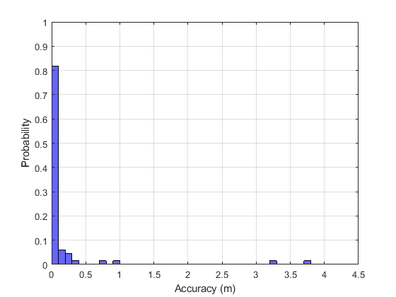
Figure 2. Histogram of the range estimation accuracy during the simulation

The x-axis represents the accuracy and the y-axis is the probability of the accuracy during the simulation. The histogram clearly shows the information of sensing performance (range estimation performance in this example) during entire simulation.

PHY Channel Impulse Response

In order to calculate accuracy vs. SNR curves, decoupling of the channel impulse response and path loss characteristics of the general channel model is required as follows:
- Channel impulse response (CIR) is to be normalized on an instantaneous basis (packet-by-packet). Instantaneous normalization of the CIRs is performed after application of beamforming.
- Different Antennas types (directional, isotropic) could be adopted in different scenarios.
Several models could be proposed, and one of the proposed models will be chosen depending on the simulation scenario. Also, it is proposed that the SISO model at 60GHz described below would be used for link level simulation.

SISO

Antenna configuration:
i. Directional antenna with 90 degree horizontal half-power beamwidth (HPBW) and 20 degree vertical HPBW, the antenna gain is 13dBi.
ii. Isotropic antenna with vertical polarization.
iii. Phased antenna array with rectangular geometry of M by N elements

Antenna combinations:
i. Directional TX to directional RX (this is a basic one applied for high rate SC/OFDM PHY transmission)
ii. Isotropic TX to isotropic RX
iii. Omni TX to directional RX, directional TX to isotropic RX (applied for TRN)

Polarization types:
i. Linear at both sides (V-V or H-H)

Hardware impairments

Phase noise of single path:
- model
- parameters
- PSD(0) = -90 dBc/Hz
- Pole frequency f_{p} = 1 MHz
- Zero frequency f_{z} = 100 MHz
- Corresponding PSD(infinity) = -130 dBc/Hz
- impairment is modeled at both transmitter and receiver

Phase noise of multiple paths:

A common oscillator and multiple (M>1) independent frequency multipliers for each path (RF structure is shown in the following figure).

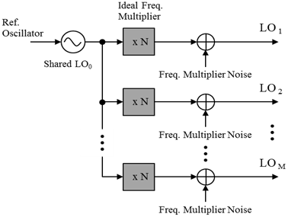
Figure 3. RF structure

  - phase noise
where
- PN^{(m)} is the output of phase noise in the m_{th} path LO, LO_{m} ;
- PN₀ is the output of LO signal after ideal frequency multiplier
- is the independent noise in the m_{th} path which is caused by frequency multiplier and is assumed to be white noise with PSD = -130 dBc/Hz

  - model
where PSD₀(f) equals the PSD(f) described in 1a above.

PA non-linearity model:
- Rapp AM-AM
- Modified Rapp AM-PM
in degrees
- CMOS PA model parameters
  - AM-AM
    - g = 4.65
    - Asat = 0.58
    - s = 0.81
  - AM-PM
    - α = 2560
    - β = 0.114
    - q1 = 2.4
    - q2 = 2.3
- Calculate backoff as the output power backoff from full saturation:
    - PA Backoff = 10 log10(Average TX Power/Psat)
    - Disclose: (a) EIRP and how it was calculated, (b) PA Backoff
    - Note: a PA Backoff equal to 8 dB for OFDM and 0.5 dB for single carrier is recommended.

Carrier frequency offset and symbol clock:
- Fixed carrier frequency offset of –13.675 ppm at the receiver, relative to the transmitter.
- The symbol clock shall have the same relative offset as the carrier frequency offset.
- Downlink multi-user simulations for all evaluations except offset compensation shall be run using a fixed carrier frequency offset selected from the array [N(1) ,N(2),……,N(8) ], relative to the transmitter, where N(j) corresponds to the frequency offset of the j-th client and is randomly chosen from [-20,20] ppm with a uniform distribution.

Transmitter and receiver I/Q imbalance:
- Imbalance model
- distortion coefficients

Evaluation Criteria

Accuracy vs. SNR curves
- channel impulse responses from channel model document
    - AWGN
- antenna combinations for each channel model:
    - Directional TX to directional RX; NLOS
    - Isotropic TX to isotropic RX.
    - Omni TX to directional RX, directional TX to isotropic RX

- simulations should include:
    - all impairments outlined in 2.2
    - timing acquisition on a per-packet basis
    - preamble detection on a per-packet basis
- performance metrics include:
    - range estimation accuracy
    - velocity estimation accuracy
    - angle estimation accuracy
    - recognition rate of presence or proximity
    - recognition rate of gesture

Histogram of accuracy (also could be accuracy vs. time index)
- channel impulse responses from channel model document
    - home living room
    - conference room
- antenna combinations for each channel model:
    - Directional TX to directional RX; NLOS
    - Isotropic TX to isotropic RX.
    - Omni TX to directional RX, directional TX to isotropic RX
- simulations should include:
    - all impairments outlined in 2.2
    - timing acquisition on a per-packet basis
    - preamble detection on a per-packet basis
- performance metrics include:
    - range estimation accuracy
    - velocity estimation accuracy
    - angle estimation accuracy
    - recognition rate of presence or proximity
    - recognition rate of gesture

Simulation Scenarios
The simulation scenarios are all defined as the link level simulations between one TX-RX pair and a moving target such as an object, an individual human, an animal, etc. The goal of the link level simulations is to evaluate the sensing performance of target parameter estimation including range, velocity, angular, or activity detection, such as motion, presence or proximity, gesture, etc.
Currently, two indoor scenarios are proposed:
- Indoor living room – the environment is filled with complicated multi-paths.
- Conference room – the environment is filled with complicated multi-paths.

General Parameters and Assumptions

For the link-level simulation, one AP is used as the transmitter, meanwhile, one STA is used as the receiver. AP and STA communicate with each other in SISO mode. Two types of antennas (directional and isotropic) could be adopted for the simulation. In this document, the antenna settings for AP and STA are same, and could be exchanged if needed. For the simulations with different antenna radiation patterns, the desired antenna pattern could be added on the isotropic type.

Transmitter Antenna Configurations

The following antenna settings are proposed for the AP:
- Living Room
- Directional.
- Antenna Number: Single Input
- Element radiation pattern: Horizontal/Vertical beamwidth = 90°/20°
- Gain: 13dBi
- Transmitter location: (3.5m, 6.75m, 0.85m)
- Transmitting power: 20dBm

- Isotropic.
- Polarization: Vertical
- Transmitter location: (3.5m, 6.75m, 0.85m)
- Transmitting power: 20dBm
- Phased array antenna:
  - Phased array antenna with 8x16 elements (8 rows by 16 columns of antenna elements) – baseline.
  - Phased array antenna with 8x32 elements (8 rows by 32 columns of antenna elements) – optional.
  - Phased array antenna with 8x64 elements (8 rows by 64 columns of antenna elements) – optional.

B: Conference Room
- Directional.
- Antenna Number: Single Input
- Element radiation pattern: Horizontal/Vertical beamwidth = 15.3°/15.7°
- Gain: 27.15dBi
- Transmitting power: 30dBm

Receiver Antenna Configurations

The following antenna settings are proposed for the STA:
- Living Room
- Directional.
- Antenna Number: Single Input
- Element radiation pattern: Horizontal/Vertical beamwidth = 90°/20°
- Gain: 13dBi
- Transmitter location: (3.5m, 6.75m, 0.85m)
- Transmitting power: 20dBm

- Isotropic.
- Polarization: Vertical
- Transmitter location: (3.5m, 6.75m, 0.85m)
- Transmitting power: 20dBm
- Phased antenna array with 2x8 elements

- Conference Room
- Directional.
- Antenna Number: Single Input
- Element radiation pattern: Horizontal/Vertical beamwidth = 15.3°/15.7°
- Gain: 27.15dBi
- Transmitting power: 30dBm

Waveform Generation
New sequences designed for WLAN sensing could be tested and evaluated with the information provided in this document.
The Pulse repetition frequency is changeable and should be consistent with the sampling frequency of channel model. Different bandwidth could be tested to evaluate the performance of the designed sequence.
An example is shown as follows:
Channel Estimation Field (CEF) sequences in DMG/EDMG single-carrier (SC) PHY could be used for sensing task (the waveform sequences are identical with that defined in 802.11ad and ay).
The following parameters are proposed for the waveform sequences:
--Pulse repetition frequency (PRF) = 2kHz
--Bandwidth (BW) = 1.76GHz

Training fields (TRN-R, TRN-T, TRN-TR) sequences in DMG/EDMG single-carrier (SC) PHY could be used for sensing task (the waveform sequences are identical with that defined in 802.11ad and ay).
The following parameters are proposed for the waveform sequences:
--Pulse repetition frequency (PRF) = 2kHz
--Bandwidth (BW) = 1.76GHz

Scenario 1: Indoor Living Room
The living room represents the typical indoor environments with dense clutters where the multipath effect is significant. In this scenario, we assume that there is one access link of an AP-STA pair and a target.
The deployment of the scenario is illustrated as Figure 4 and Table 1. The size of the living room is 7m*7m*3m, among which there exists one AP, one STA and a target. In this scenario, the AP and STA are placed at the same position while the initial position of the target in the xy-coordinate plane is (6m, 2m). The target is moving along a specific trajectory where it approaches the AP and STA at a speed of 1m/s.

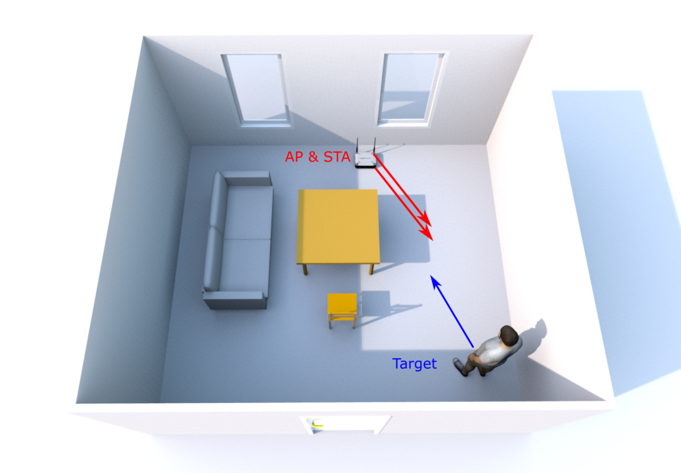

Figure 4. Deployment of living room

Table 1. Specific parameters of the indoor scenarios

Object | Size | Material
Chair | 2.8m x 1.05m x 1m (L x W x H) | wood
Chair with feet | 1.05m x 1.05m x 1m (L x W x H) | wood
Table1 | 1.5m x 0.7m x 0.8m (L x W x H) | wood
Table2 | 1m x 0.5m x 0.8m (L x W x H) | wood
Target | 0.3m x 1.5m (R x H) | wood
Door | 1m x 2.5m (W x H) | wood
Windows | 1.5m x 1.5m (W x H) | Glass
Wall |  | concrete
Floor |  | concrete
Ceiling |  | concrete

Scenario 2: Conference Room

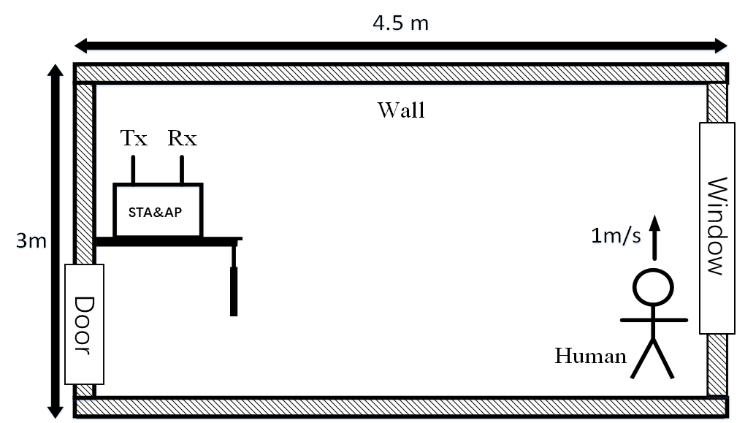

Figure 5. Deployment of conference room.

The model of conference room is shown in Figure 5. The size of the conference room is 4.5m*3m*3m (L×W×H), one STA, one AP and one target is considered. The AP and STA are placed at the same position which is 0.1m away from the table, and the target moves from its initial position (4.2,-1.5,0) with different postures in the same direction as the arrow at 0m/s for standing, 1m/s for walking and 0.5m/s for pacing. More detailed parameters are given in Table 2.

Table 2. Specific parameters of the indoor conference scenario
Object | Size | Material
Table1 | 0.28m x 0.39m x 1.5m (L x W x H) | wood
Target | 1.75m (H) | Human
Door | 1m x 2.5m (W x H) | wood
Windows | 1.5m x 1.5m (W x H) | Glass
Wall |  | concrete
Ceiling |  | concrete

Scenario 3: Bistatic indoor living room

The home living room represents a typical indoor environment with dense clutters where the multipath effect is significant. In this scenario, we assume that there is one access link of an AP-STA pair and a target.
The deployment of the scenario is illustrated in Figure 1 and Figure 2. The home living room has a table in the middle, a cabinet on the side, two sofas, and an armchair placed around the table. The size of the living room is 7m×7m×3m.
In this scenario, the AP (for instance, a set-top box transmitting uncompressed video) and STA (for instance, a TV receiving uncompressed video) with differently orientated mmWave antenna arrays, are placed at different positions and a human target is moving following a straight line with a speed of 0.86m/s.

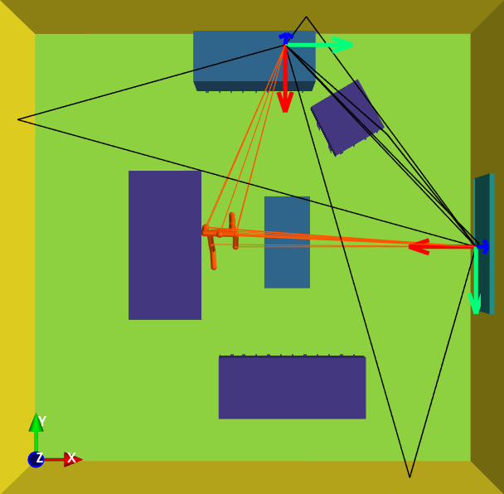
AP
STA
Figure 1: Bistatic Living Room Scenario, top view

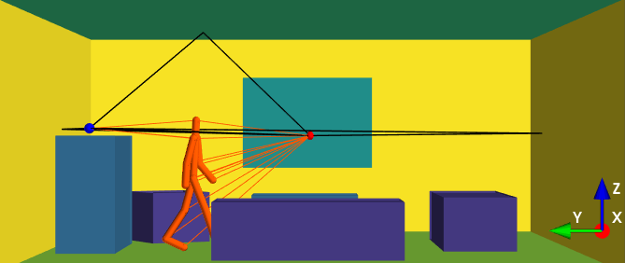
Figure 2: Bistatic Living Room, side view

Communication between the AP and STA may be done using the LOS link. The antenna array broadside directions of AP and STA are respectively 270° and 180°.

The human target model [1] uses a ray tracing methodology of the joints of a global human walking model based on an empirical mathematical model.

References
[1] 11-21-0782-03-00bf-channel-models-for-wlan-sensign-system.docx

SP
Do you agree to adopt the document (21/0876r3) as the Evaluation Methodology and Simulation Scenarios document for IEEE 802.11 bf ?
Note: Simulation is not mandatory for any contributions.

-Yes
-No
-Abstain

