IEEE P802.11
Wireless LANs
TGbf Evaluation Methodology and Simulation Scenarios
Date: 2021-6-2
Author(s):
Name | Company | Address | Phone | email
Rui Du | Huawei Technologies Co.,Ltd. | F3, Huawei Base, Shenzhen, China |  | Ray.du@huawei.com
Meihong Zhang | Huawei Technologies Co.,Ltd. |  |  | zhangmeihong@huawei.com
Mengshi Hu | Huawei Technologies Co.,Ltd. |  |  | humengshi@huawei.com
Kwok Shum Au | Huawei Technologies Co.,Ltd. |  |  | Edward.ks.au@huawei.com
Yan Xin | Huawei Technologies Co.,Ltd. |  |  | Yan.Xin@huawei.com
Junghoon Suh | Huawei Technologies Co.,Ltd. |  |  | Junghoon.Suh@huawei.com
Osama AboulMagd | Huawei Technologies Co.,Ltd. |  |  | Osama.AboulMagd@huawei.com
Haipeng Dai | Nanjing University | CS Building, Nanjing University Nanjing, China |  | haipengdai@nju.edu.cn
Shuyu Shi | Nanjing University | CS Building, Nanjing University Nanjing, China |  | ssy@nju.edu.cn
Wei Wang | Nanjing University | CS Building, Nanjing University Nanjing, China |  | ww@nju.edu.cn

Abstract

This document describes the evaluation methodology for TGbf. It defines the PHY performance, the comparison criteria and one indoor simulation scenario for the TGbf evaluation.

Revision History
Revision | Comments | Date
R0 | initial contribution | TBD

Introduction

The evaluation methodology defines PHY performance, one simulation scenario and comparison criteria for evaluating proposals.

PHY Performance

The criteria for comparison of PHY performance are
- Accuracy vs. SNR curves.
- Histogram of accuracy.
These criteria could be analyzed for different operation modes in different scenarios.

Usually, for parameter estimation, accuracy is described by Root Mean Square Error (RMSE) of the parameter to be estimated, which is defined as follows.

where, is the estimated parameter, is the ground truth. n is the number of observation.

Accuracy describes the closeness of the target estimated parameters (i.e. range, velocity, angle, et al) to the ground truth. Based on the WLAN sensing link level simulation, target’s parameters could be estimated (i.e. range, velocity, angle, et al). The accuracy could be calculated based on the estimated parameters and ground truth adopted for simulation.

Accuracy vs. SNR curves
The Accuracy vs. SNR curves indicate the WLAN sensing accuracy with different SNRs. An example of accuracy vs. SNR about range estimation is shown as follows. In the following figure, the x-axis represents the SNR for simulation and the y-axis shows the accuracy of the range estimation. Usually, accuracy improves with SNR increases.
An example of range estimation accuracy vs. SNR

Histogram of accuracy
During the WLAN sensing simulation, a target is moving with certain trajectory. The SNR is different during target movement which leads to different estimation accuracies. Based on the information of estimation accuracy (i.e. range accuracy, velocity accuracy, angle accuracy), a histogram of accuracy during the simulation could be calculated. An example of range estimation accuracy histogram is shown as follows.
Histogram of the range estimation accuracy during the simulation

The x-axis represents the accuracy and the y-axis is the probability of the accuracy during the simulation. The histogram clearly shows the information of sensing performance (range estimation performance in this example) during the whole simulation.

PHY Channel Impulse Response

In order to calculate accuracy vs. SNR curves, decoupling of the channel impulse response and path loss characteristics of the general channel model is required as follows:
- Channel impulse response (CIR) is to be normalized on an instantaneous basis (packet-by-packet). Instantaneous normalization of the CIRs is performed after application of beamforming.
- Antennas types (directional, isotropic)
Several models are proposed below, and one of the proposed models will be chosen depending on the simulation scenario. Also, it is proposed that the SISO model at 60GHz described below would be used for link level simulation.

SISO

Antenna configuration:
i. Directional antenna with 90 degree horizontal half-power beamwidth (HPBW) and 20 degree vertical HPBW, the antenna gain is 13dBi.
ii. Isotropic antenna with vertical polarization.

Antenna combinations:
i. Directional TX to directional RX (this is a basic one applied for high rate SC/OFDM PHY transmission)
ii. Isotropic TX to isotropic RX

Polarization types:
i. Linear at both sides (V-V or H-H)
ii. Circular for Access Point (AP) and single linear for user (V or H)

Hardware impairments

Phase noise of single path:
- model
- parameters
- PSD(0) = -90 dBc/Hz
- Pole frequency f_{p} = 1 MHz
- Zero frequency f_{z} = 100 MHz
- Corresponding PSD(infinity) = -130 dBc/Hz
- impairment is modeled at both transmitter and receiver

Phase noise of multiple paths:

A common oscillator and multiple (M>1) independent frequency multipliers for each path (RF structure is shown in the following figure).

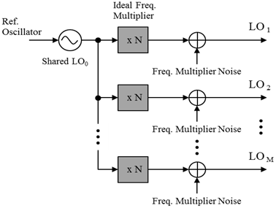

  - phase noise
where
- PN^{(m)} is the output of phase noise in the m_{th} path LO, LO_{m} ;
- PN₀ is the output of LO signal after ideal frequency multiplier
- is the independent noise in the m_{th} path which is caused by frequency multiplier and is assumed to be white noise with PSD = -130 dBc/Hz

  - model
where PSD₀(f) equals the PSD(f) described in 1a above.

PA non-linearity model:
- Rapp AM-AM
- Modified Rapp AM-PM
in degrees
- CMOS PA model parameters
  - AM-AM
    - g = 4.65
    - Asat = 0.58
    - s = 0.81
  - AM-PM
    - α = 2560
    - β = 0.114
    - q1 = 2.4
    - q2 = 2.3
- Calculate backoff as the output power backoff from full saturation:
    - PA Backoff = 10 log10(Average TX Power/Psat)
    - Disclose: (a) EIRP and how it was calculated, (b) PA Backoff
    - Note: a PA Backoff equal to 8 dB for OFDM and 0.5 dB for single carrier is recommended.

Carrier frequency offset and symbol clock:
- Fixed carrier frequency offset of –13.675 ppm at the receiver, relative to the transmitter.
- The symbol clock shall have the same relative offset as the carrier frequency offset.
- Downlink multi-user simulations for all comparisons except offset compensation shall be run using a fixed carrier frequency offset selected from the array [N(1) ,N(2),……,N(8) ], relative to the transmitter, where N(j) corresponds to the frequency offset of the j-th client and is randomly chosen from [-20,20] ppm with a uniform distribution.

Transmitter and receiver I/Q imbalance:
- Imbalance model
- distortion coefficients

Comparison Criteria

Accuracy vs. SNR curves
- all MCS’s
- channel impulse responses from channel model document
    - AWGN
- antenna combinations for each channel model:
    - Directional TX to directional RX; NLOS
    - Isotropic TX to isotropic RX.
- simulations must include:
    - all impairments outlined in 2.2
    - timing acquisition on a per-packet basis
    - preamble detection on a per-packet basis
- performance metrics include:
    - range detection accuracy
    - velocity detection accuracy
    - angle detection accuracy
    - recognition rate of presence or proximity
    - recognition rate of gesture

Histogram of accuracy
- all MCS’s
- channel impulse responses from channel model document
    - home living room
- antenna combinations for each channel model:
    - Directional TX to directional RX; NLOS
    - Isotropic TX to isotropic RX.
- simulations must include:
    - all impairments outlined in 2.2
    - timing acquisition on a per-packet basis
    - preamble detection on a per-packet basis
- performance metrics include:
    - range detection accuracy
    - velocity detection accuracy
    - angle detection accuracy
    - recognition rate of presence or proximity
    - recognition rate of gesture

Simulation Scenarios
The simulation scenarios are all defined as the link level simulations between one TX-RX pair and a moving target such as an object, an individual human, an animal, etc.. The goal of the link level simulations is to sense the context awareness of the target including range, velocity, angular, motion, presence or proximity, gesture, etc. Currently, one indoor scenario is proposed:
- Indoor living room——the environment is filled with complicated multi-paths.

General Parameters and Assumptions
For the link-level simulation, one AP is used as the transmitter, meanwhile, one STA is used as the receiver. AP and STA communicate with each other in SISO mode.

Transmitter Antenna Configurations

The following antenna settings are proposed for the AP:
- Directional.
- Antenna Number: Single Input
- Element radiation pattern: Horizontal/Vertical beamwidth = 90°/20°
- Gain: 13dBi
- Transmitter location: (3.5m, 6.75m, 0.85m)
- Transmitting power: 20dBm

- Isotropic.
- Polarization: Vertical
- Transmitter location: (3.5m, 6.75m, 0.85m)
- Transmitting power: 20dBm

Receiver Antenna Configurations

The following antenna settings are proposed for the STA:
- Directional.
- Antenna Number: Single Input
- Element radiation pattern: Horizontal/Vertical beamwidth = 90°/20°
- Gain: 13dBi
- Transmitter location: (3.5m, 6.75m, 0.85m)
- Transmitting power: 20dBm

- Isotropic.
- Polarization: Vertical
- Transmitter location: (3.5m, 6.75m, 0.85m)
- Transmitting power: 20dBm

Waveform Generation
Channel Estimation Field (CEF) sequences in DMG/EDMG single-carrier (SC) PHY is used for sensing task (the waveform sequences are identical with that defined in 802.11ad and ay).
The following parameters are proposed for the waveform sequences:
--Pulse repetition frequency (PRF) = 2kHz
--Bandwidth (BW) = 1.76GHz

Scenario 1: Indoor Living Room
The living room represents the typical indoor environments with dense clutters where the multipath effect is significant. In this scenario, we assume that there is one access link of an AP-STA pair and a target.
The deployment of the scenario is illustrated as Figure 1 and Table 1. The size of the living room is 7m*7m*3m, among which there exists one AP, one STA and a target. In this scenario, the AP and STA are placed at the same position while the initial position of the target in the xy-coordinate plane is (6m, 2m). The target is moving along a specific trajectory where it approaches the AP and STA at a speed of 1m/s.

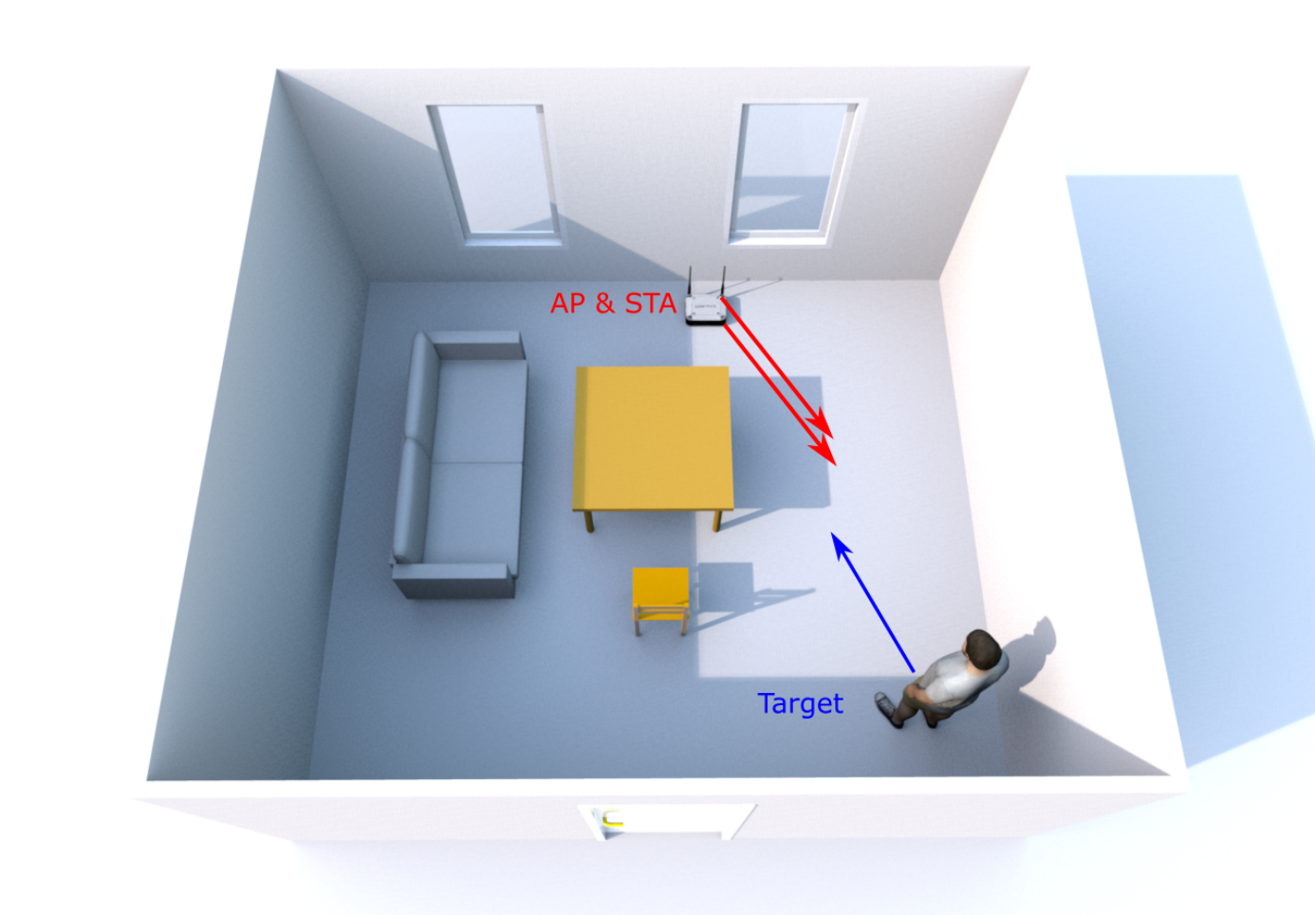

Figure 1. Deployment of living room

Table 1. Specific parameters of the indoor scenarios

Object | Size | Material
Chair | 2.8m x 1.05m x 1m (L x W x H) | wood
Chair with feet | 1.05m x 1.05m x 1m (L x W x H) | wood
Table1 | 1.5m x 0.7m x 0.8m (L x W x H) | wood
Table2 | 1m x 0.5m x 0.8m (L x W x H) | wood
Target | 0.3m x 1.5m (R x H) | wood
Door | 1m x 2.5m (W x H) | wood
Windows | 1.5m x 1.5m (W x H) | Glass
Wall |  | concrete
Floor |  | concrete
Ceiling |  | concrete

SP
Do you agree to adopt the document (21/0876r0) as the initial official Evaluation Methodology and Simulation Scenarios document for IEEE 802.11 bf ?
Note: Simulation is not mandatory for any contributions.

-Yes
-No
-Abstain

