IEEE 802.11
Wireless LANs
Channel Models for WLAN Sensing Systems
Date: 2021-05-10
Author(s):
Name | Affiliation | Address | Phone | email
Meihong Zhang | Huawei Technologies Co.,Ltd. | F3, Huawei Base, Shenzhen, China |  | zhangmeihong@  huawei.com
Rui Du | Huawei Technologies Co.,Ltd. |  |  | ray.du@huawei.com
Xiaohui Peng | Huawei Technologies Co.,Ltd. |  |  | pengxiaohui5@huawei.com
Kwok Shum Au | Huawei Technologies Co.,Ltd. |  |  | edward.ks.au@huawei.com
Yan Xin | Huawei Technologies Co.,Ltd. |  |  | Yan.Xin@huawei.com
Junghoon Suh | Huawei Technologies Co.,Ltd. |  |  | Junghoon.Suh@huawei.com
Mengshi Hu | Huawei Technologies Co.,Ltd. |  |  | humengshi@huawei.com
Jie Xu | The Chinese University of Hong Kong, Shenzhen |  |  | xujie@cuhk.edu.cn
Hailiang Xie | Guangdong University of Technology |  |  | hailiang.gdut@gmail.com
Claudio da Silva | Intel |  |  | claudio.da.silva@intel.com
Solomon Train | Qualcomm |  |  | strainin@qti.qualcomm.com
Assaf Kasher | Qualcomm |  |  | akasher@qti.qualcomm.com
Abstract
Description of channel models for Wireless Local Area Networks (WLANs) Sensing systems based on the results of ray tracing and other possible approaches (e.g., measurement campaigns).

Introduction
This document describes the channel models for Wireless Local Area Networks (WLANs) Sensing systems based on the results of ray tracing and other possible approaches (e.g., measurement campaigns). The goal of the channel modeling is to assist WLAN Sensing standardization process.
The document proposes a new channel model which takes into account non-stationarity characteristics of the propagation channel arising from non-device moving target(s) both in sub 7GHz and 60GHz. The channel model allows for generating a channel realization that includes spatial, temporal, and amplitude characteristics of all rays in this channel realization. The spatial characteristics of rays include azimuth and elevation angles for both a transmitter and a receiver.
Reference antenna models that may be potentially applied to the generated space-time channel realizations in the channel model are described. Directional and omni-directional antenna model are proposed to be used together with the channel model.

Scenarios for Channel Modeling
Living room scenario is considered in this document as a basic channel modeling scenario.

General Characteristics of Channel Model

Requirements for Channel Model
The following are the requirements of channel models for WLAN Sensing systems by taking into account propagation properties of non-device moving target(s) and applications of WLAN Sensing technology:
- Provide accurate space-time characteristics of the propagation channel (basic requirement) for the main usage models of interest;
- Support non-stationarity characteristics of the propagation channel arising from target motion around the area causing time-dependent channel variations.

Usage of Channel Model in Simulations
This subsection provides a brief description of the channel realization generation process that is implemented in the channel model. The whole process of the channel realization generation is schematically shown in Figure 1.

Figure 1. Process of channel realization generation
The generation of the channel impulse response begins with selecting model input parameters, which are related to the scenario, target (s), and antenna configurations.
The next step is to generate possible channel rays between the transmitter and the receiver, which takes into account non-stationarity characteristics of the propagation channel arising from non-device moving target(s). Amplitude, time, and angular characteristics for all rays are generated.
After this step, the channel impulse response is generated and can be used for simulations.

Living Room Channel Model

Modeling Scenario
Set up of the living room scenario is shown in Figure 2. The dimensions of a living room are 7 m x 7 m x 3 m (L x W x H). The living room has a table (table1) in the middle, a chair and a small chair with feet placed around the table. One outer wall has two windows and the opposite outer wall has a door placed in its middle. The target is a cubic object which is made of wood, as shown in Fig 3.
Figure 2. Set up of the living rom scenario.
Fig 3. Target illustration and parameters
The dimensions and materials of all furnitures are given in Table 1.

Table 1. Parameters of the furniture dimensions and materials
Object | Size | Material
Chair | 2.8m x 1.05m x 1m (L x W x H) | wood
Chair with feet | 1.05m x 1.05m x 1m (L x W x H) | wood
Table1 | 1.5m x 0.7m x 0.8m (L x W x H) | wood
Table2 | 1m x 0.5m x 0.8m (L x W x H) | wood
Target | 0.3m x 1.5m (R x H) | wood
Door | 1m x 2.5m (W x H) | wood
Windows | 1.5m x 1.5m (W x H) | Glass
Wall |  | concrete
Floor |  | concrete
Ceiling |  | concrete

Note: In this whole section, all the ray tracing simulation are excuted by the Volcano software [1], materials like wood, metal, concrete, plastered board, and glass can be supported in this software, but it is difficult to model the target as human body directly, or to consider materials with a permittivity similar to that of a human body due to the limitation of the software. Therefore, in this document the target is considered as an object mode of wood.
Even though the electrical characteristic of our tatget is different from that of human beings, it can still be used for some use cases listed in [2], like room sensing (presence detection) and home security (detection of presence of intruders in a home).

4.1.1 Case 1: MonoStatic-Directional sub-scenario (60GHz)
In this scenario, the left corner of the room is set as the coordinate origin. The AP (TX) and the STA (RX) are co-located in the same place, both on one of the walls at a height of 0.85 m, and the position in the horizontal plane is 3.5m at X-axis, 6.75m at Y-axis.
The type of antenna model proposed to be used together with the channel model at both the AP and the STA sides is directional antenna with 90 degree horizontal half-power beamwidth (HPBW) and 20 degree vertical HPBW, and antenna gain 13dBi.
The target moves towards AP at a speed of 1 m/s with the direction inside the static living room, as illustrated in Figure 4.

Figure 4. Living room scenario (Monostatic)

Ray tracing simulation results
Ray Tracing is adopted in the channel model simulation. During the simulation, 0.5 ms is adopted as the channel generation interval. The LOS ray and the first reflection rays from walls, ceiling, floor and target, are considered. The propagation paths due to diffraction are not taken into account in the model.
As the target moves, parameters such as power, delay, and angles (AOA, AOD) change.The corresponding snapshot results are shown in Figure 5 and Figure 6.
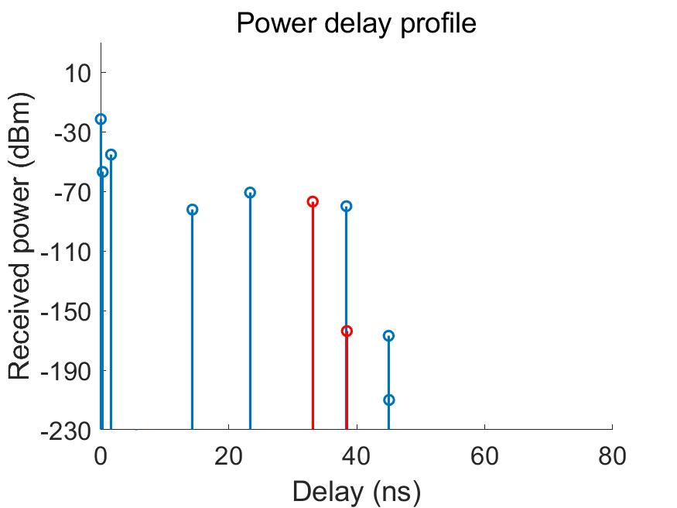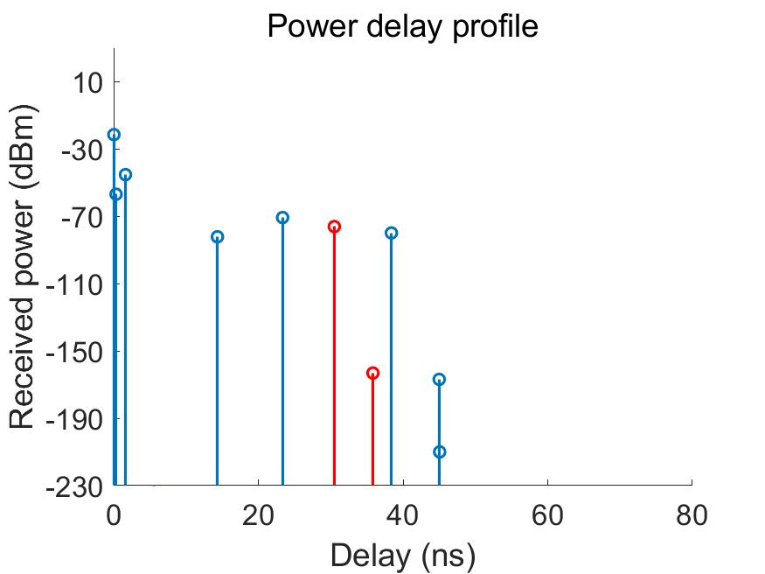
(a) (b)
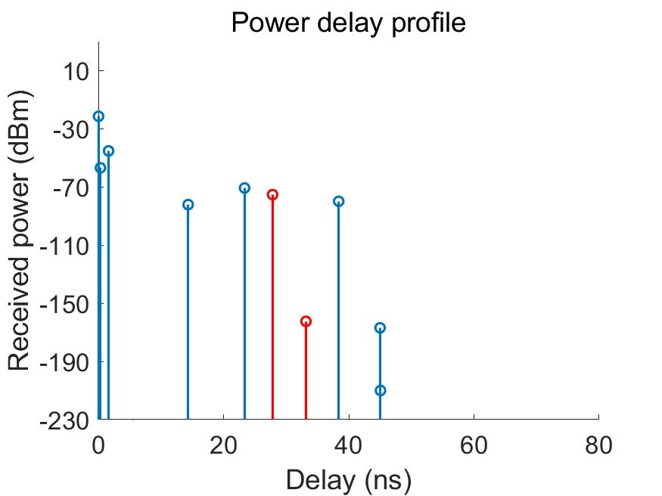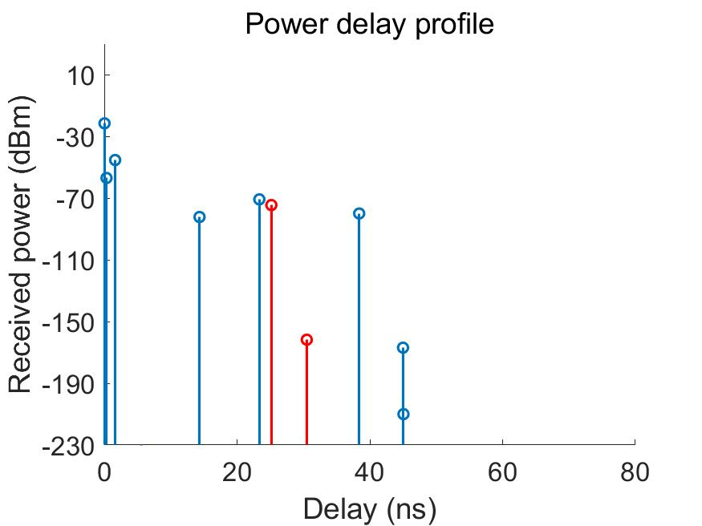
(c) (d)
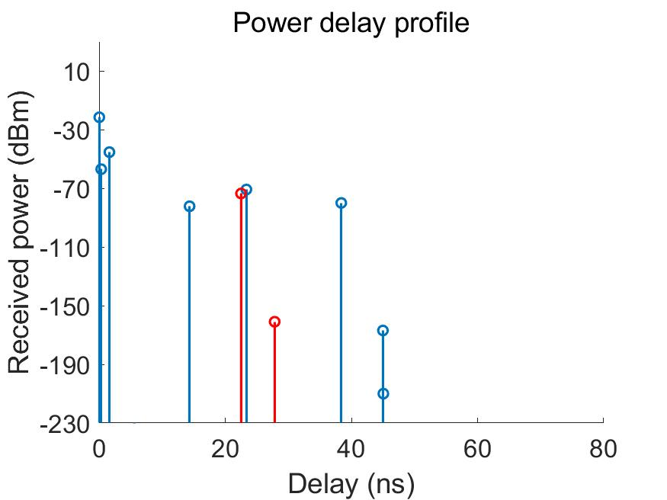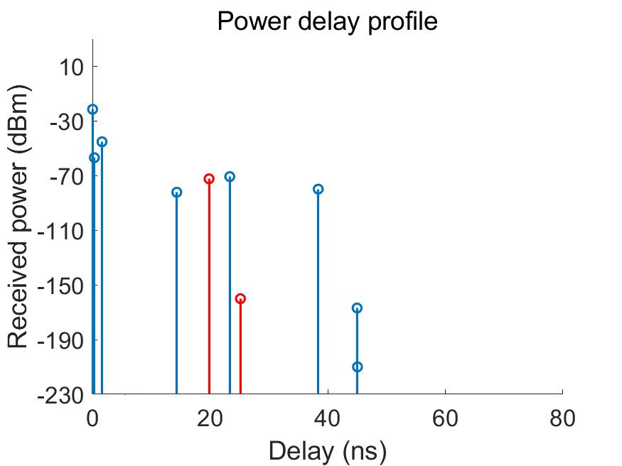
(e) (f)
Figure 5. Power Delay Profile. (a) 1st snapshot (b) 800th snapshot (c) 1600th snapshot
(d) 2400th snapshot (e) 3200th snapshot (f) 4000th snapshot

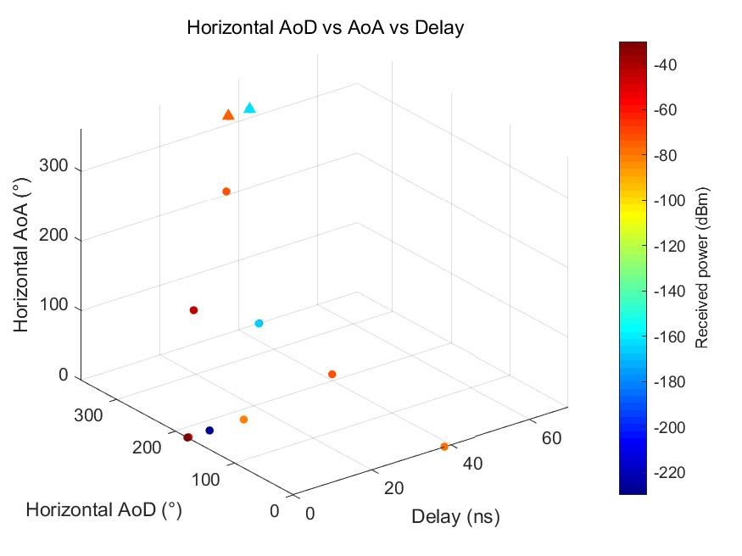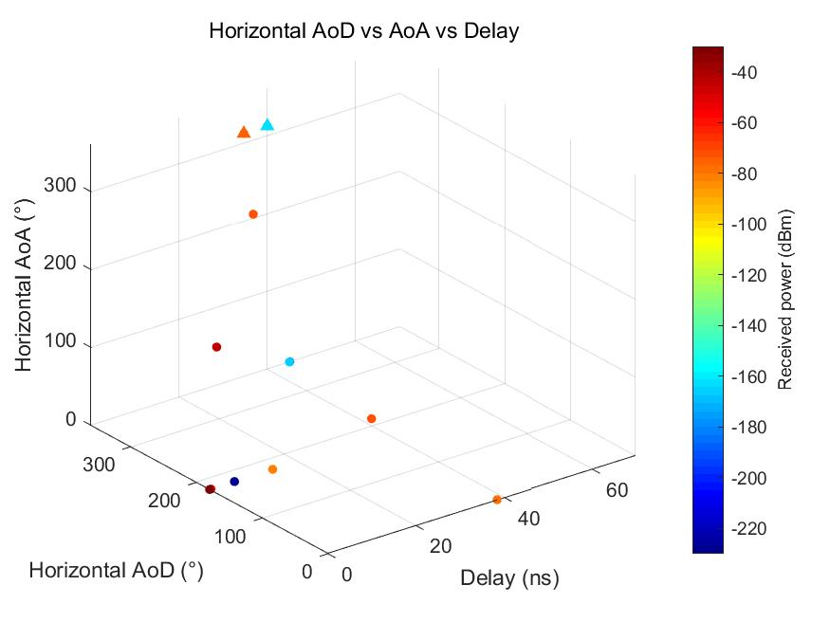
(a) (b)
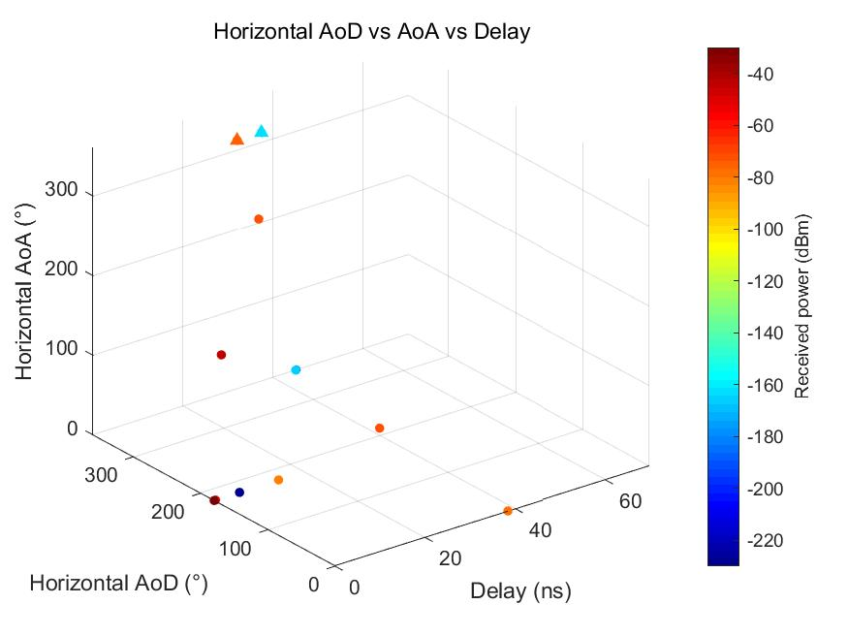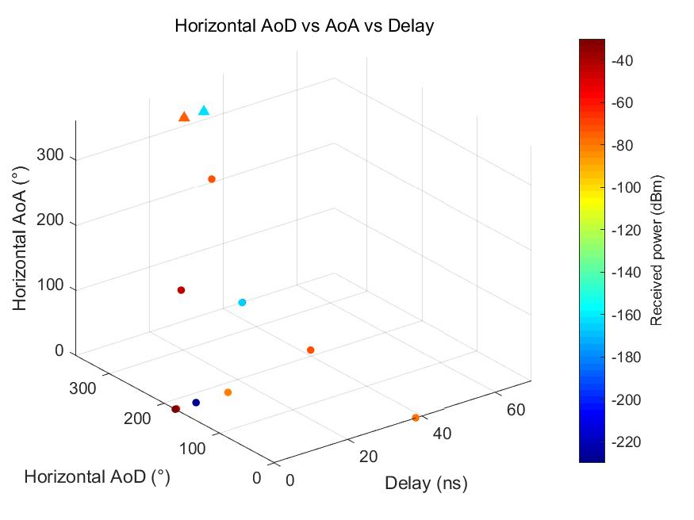
(c) (d)
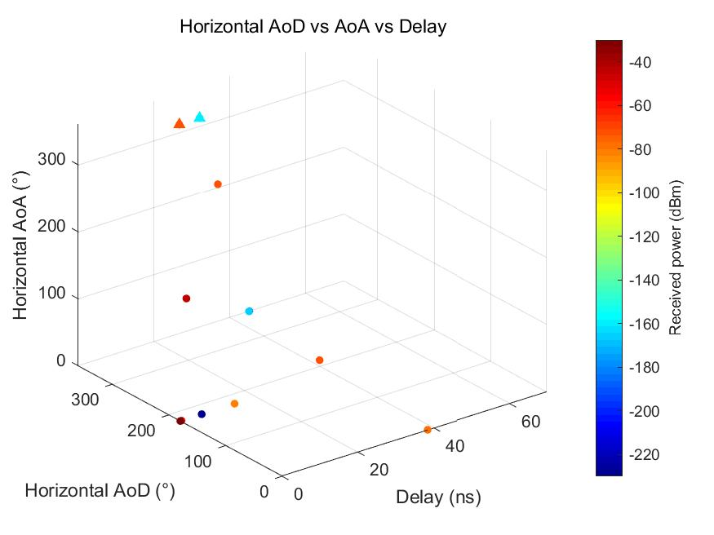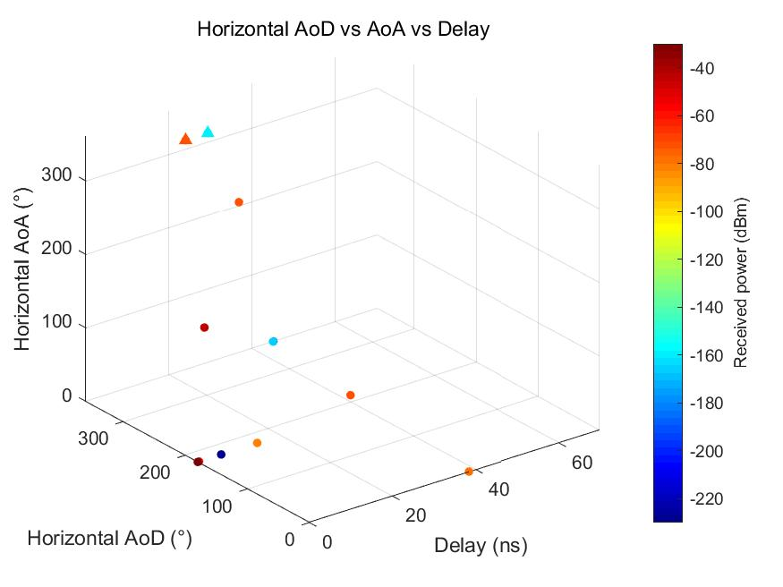
(e) (f)
Figure 6. Horizontal AoD vs AoA vs Delay. (a) 1st snapshot (b) 800th snapshot (c) 1600th snapshot
(d) 2400th snapshot (e) 3200th snapshot (f) 4000th snapshot
Note: Since the gif image format is not supported in the document, only simulation results of some snapshots are shown.

Case 2: Monostatic-Isotropic sub-scenario (60GHz)
In this scenario, the coordinates of an AP and a STA are the same as that in case 1.
The type of antenna model is proposed to be used together with the channel model at both the AP and the STA sides is isotropic antenna with vertical polarization.
The target moves towards the AP at a speed of 1 m/s with the direction inside the static living room, as illustrated in Figure 4.

Ray tracing simulation results
Ray Tracing is adopted in the channel model simulation. During the simulation, 0.5 ms is adopted as the channel generation interval. The LOS ray and the first reflection rays from walls, ceiling, floor, and target are considered. The propagation paths due to diffraction are not taken into account in the model.
As the target moves, parameters including power, delay, and angles (AOA, AOD) are changing, for which the corresponding results are shown in Figure 7 and Figure 8.
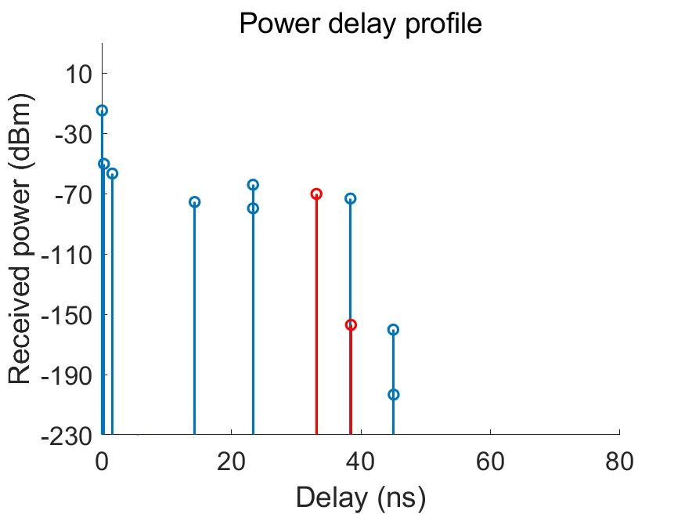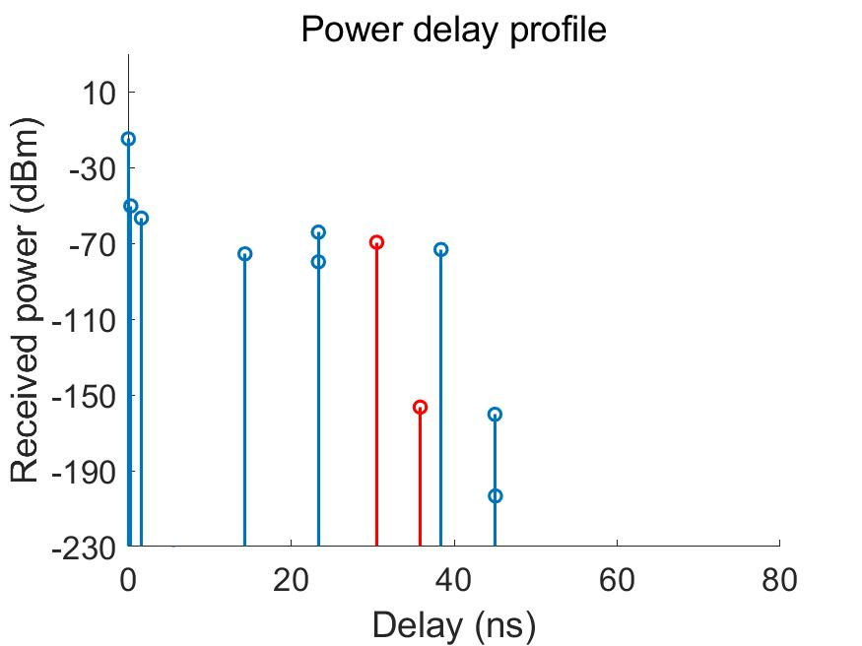
(a) (b)
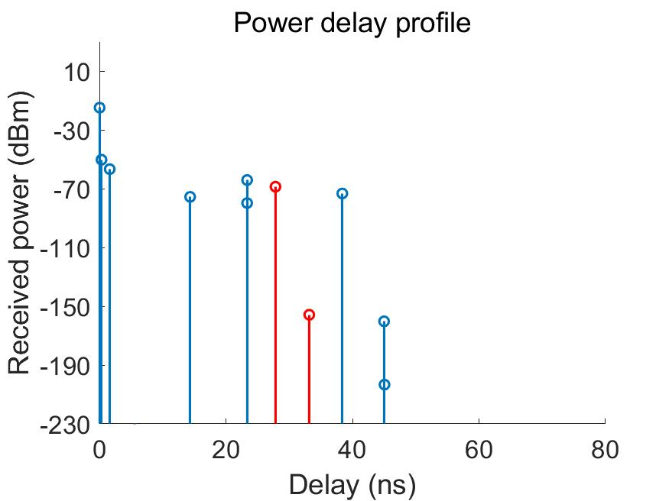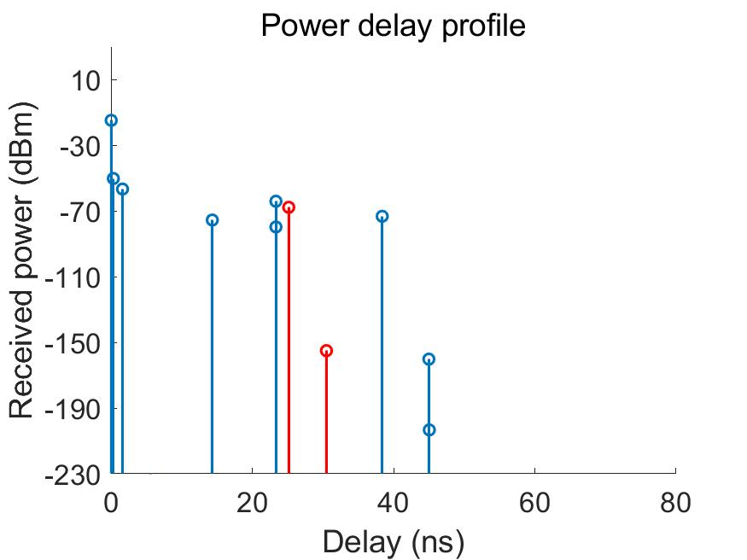
(c) (d)
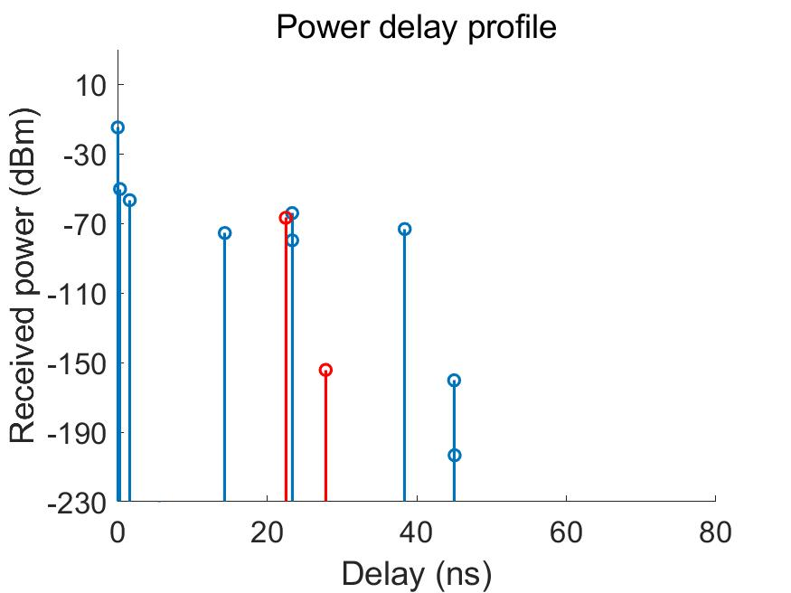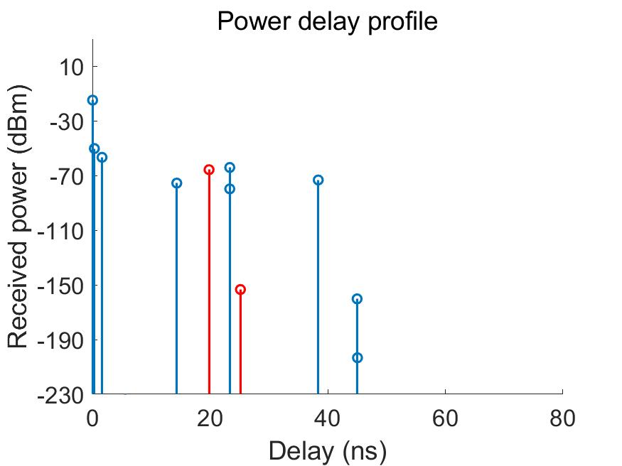
(e) (f)
Figure 7. Power Delay Profile. (a) 1st snapshot (b) 800th snapshot (c) 1600th snapshot
(d) 2400th snapshot (e) 3200th snapshot (f) 4000th snapshot
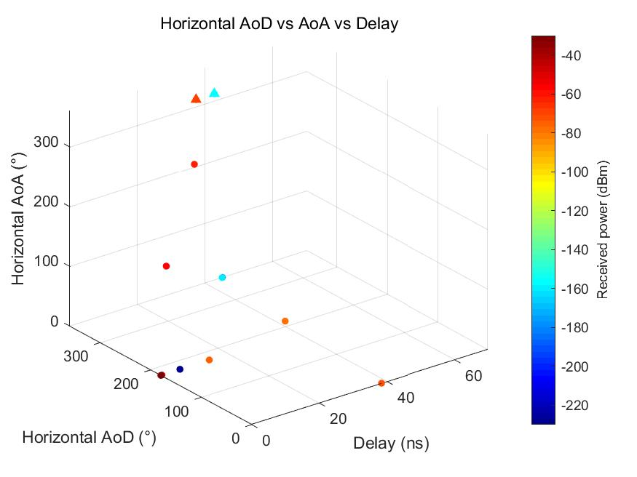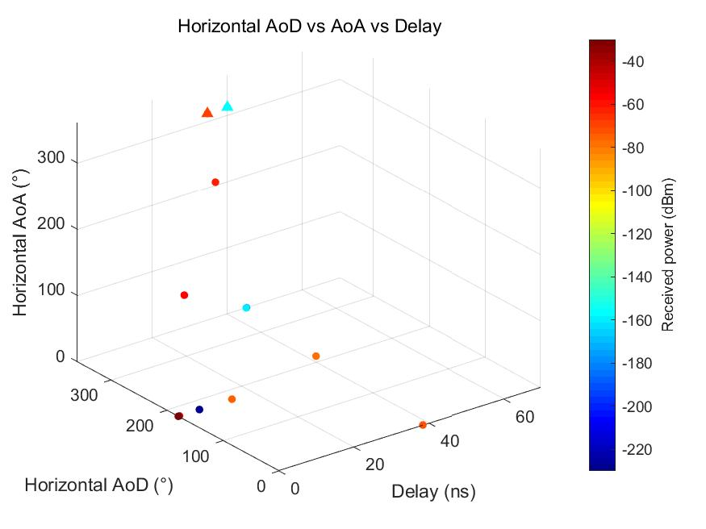
(a) (b)
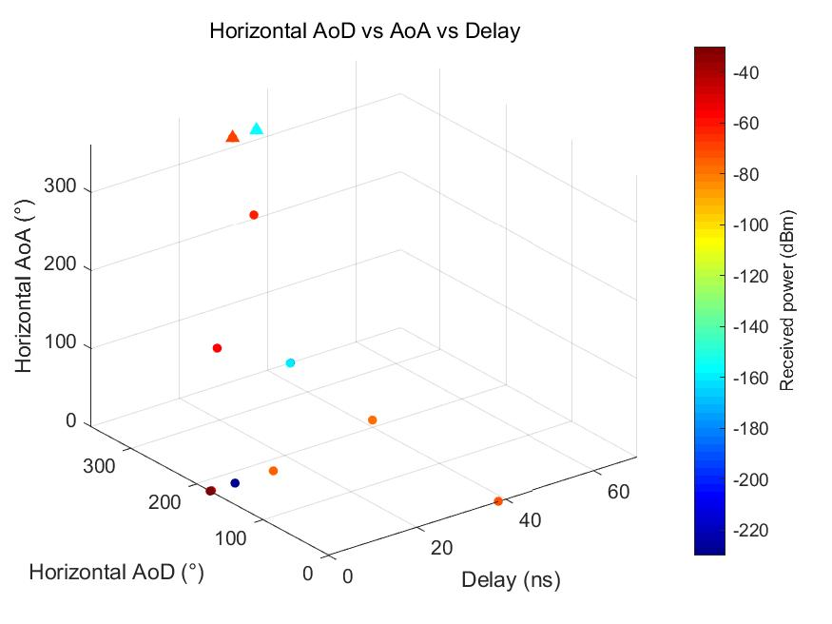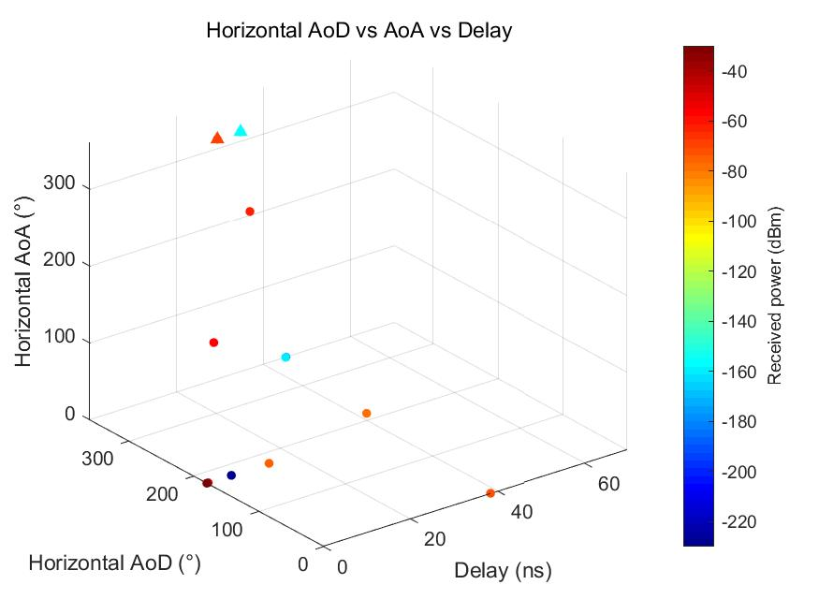
(c) (d)
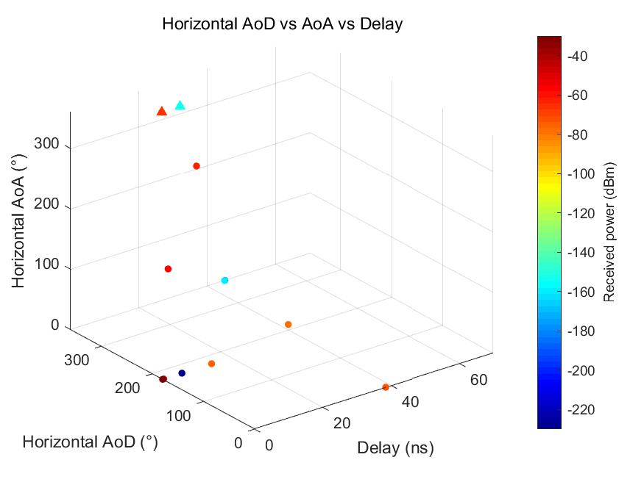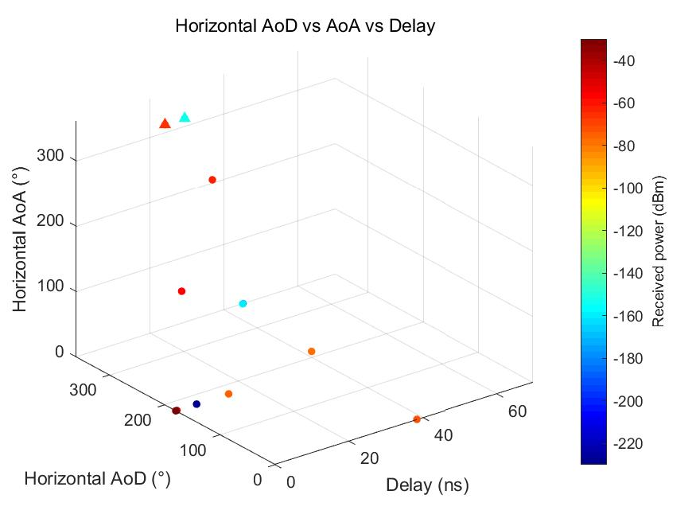
(e) (f)
Figure 8. Horizontal AoD vs AoA vs Delay. (a) 1st snapshot (b) 800th snapshot (c) 1600th snapshot
(d) 2400th snapshot (e) 3200th snapshot (f) 4000th snapshot
Note: Since the gif image format is not supported in the document, only simulation results of some snapshots are shown.
References:

- https://www.siradel.com/
- 11-20-1712-02-00bf-wifi-sensing-use-cases.xlsx

SP
Do you agree to adopt the document (21-0782r2) as the initial official Channel Models for IEEE 802.11bf ?
- Yes
- No
- Abstain

