IEEE P802.11
Wireless LANs
CR for CID 1652, 1954 and 2765
Date: 2021.04.09
Author(s):
Name | Company | Address | Phone | email
Mengshi Hu | Huawei Technologies | F3-6-A118, Huawei Base, Bantian, Longgang, Shenzhen, Guangdong, China, 518129 |  | humengshi@huawei.com
Ross Yu | Huawei Technologies
Abstract
This submission contains proposed comment resolutions to comments on P802.11be D0.3.

3 comments under 36.3.13 Packet extension:
CID 1652, 1954 and 2765

Revision Notes

R0 | Initial revision
R1 | Typo

CID 1652
Page.  Line | Clause Number | Comment | Proposed Change | Resolution
313.58 | 36.3.13 | The maximum PE duration is 20 us for EHT TB PPDU as well as EHT MU PPDU, but the current default PE duration signaling does not support 20 us. | Define the method to signal 20 us as the default PE duration, or define a restriction regarding the default PE duration of 20 us | REVISED  Define the method to signal 20 us for the Default PE Duration subfield.  Instructions to the editor:  Please make the changes as shown in 11/21-0xxxr0

Instructions to the editor
Please make the changes to P114, L1 in D0.4 as shown below:
The format of the EHT Operation element is shown in Figure 9-788ee (EHT Operation element format).

 | Element ID | Length | Element ID  Extension | EHT Operation Parameters | EHT Operation  Information
Octets: | 1 | 1 | 1 | TBD | TBD
Figure 9-788ee – EHT Operation element format

Please make the changes to P114, L38 in D0.4 as shown below:
The format of the EHT Operation Parameters field is defined in Figure 9-xxx (EHT Operation Parameters field format).

 | EHT Default PE Duration | .,..
Bits: | 1 | TBD
Figure 9-xxx – EHT Operation Parameters field format

The EHT Default PE Duration subfield is set to 1 to indicate that the PE field duration for an EHT TB PPDU solicited by a TRS Control subfield is 20 µs and set to 0 to indicate that the PE field duration is the same as that indicated in the HE Operation Parameters field in the HE Operation element. The use of the PE field duration indicated in the EHT Default PE Duration subfield is defined in 35.4.2.3 (Non-AP STA behavior for UL MU operation).

Discussion:
(The following shows another design of the EHT Default PE Duration subfield)
The format of the EHT Operation Parameters field is defined in Figure 9-xxx (EHT Operation Parameters field format).

 | EHT Default PE Duration | .,..
Bits: | 3 | TBD
Figure 9-xxx – EHT Operation Parameters field

The EHT Default PE Duration subfield indicates the PE field duration in units of 4 µs for an EHT TB PPDU that is solicited by a TRS Control subfield and its use is defined in 35.4.2.3 (Non-AP STA behavior for UL MU operation). Values 0-5 of the EHT Default PE Duration subfield indicates 0, 4, 8, 12, 16, 20 µs, respectively, and values 6-7 of the Default PE Duration subfield are reserved.

Appendix:
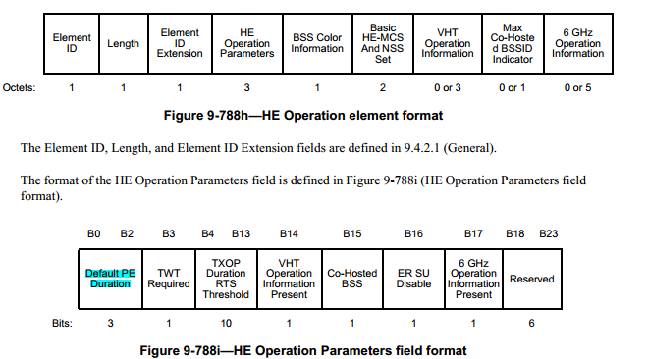

CID 1954
Page.  Line | Clause Number | Comment | Proposed Change | Resolution
310.26 | 36.3.13 | Define PPET values for different NSS, RU, constellation, similar as 11axg | As in comment | REVISED  Instructions to the editor:  Please make the changes as shown in 11/21-0xxxr0

Instructions to the editor
Please make the changes to P415, L3 in D0.4 as shown below:
The duration of the PE field for an EHT MU PPDU is determined by both the pre-FEC padding factor value in the last OFDM symbol of the Data field, and the TXVECTOR parameter NOMINAL_PACKET_PADDING as described in 35.11 (Nominal packet padding values selection rules).

CID 2765
Page.  Line | Clause Number | Comment | Proposed Change | Resolution
310.28 | 36.3.6.10 | PPE Threshold need to be updated to reflect 4K-QAM, 16SS and 320MHz | Need to define the PPE Threshold fields such that they accommodate 4K-QAM, 16SS and 320MHz | REVISED  Note to the Editor:  The resolutions for CIDs 1954 and 2765 are the same.  No further changes are needed.

