IEEE P802.11
Wireless LANs
EHT CR 2661 and 2671
Date: 2021.03.23
Author(s):
Name | Company | Address | Phone | email
Ross Jian Yu | Huawei Technologies | F3-6-A120, Huawei Base, Bantian, Longgang, Shenzhen, Guangdong, China, 518129 |  | ross.yujian@huawei.com
Edward Au | Huawei Technologies
Mengshi Hu | Huawei Technologies
Ming Gan | Huawei Technologies
Abstract
This submission contains proposed comment resolutions to comments on P802.11be D0.3. The instruction to the editor are based on P802.11be D0.4 for Editor’s convenience.

2 comments:
CID 2661 and 2671
are resolved in this document.

Revision Notes

R0 | Initial revision

CID 2661
Page.  Line | Clause Number | Comment | Proposed Change | Resolution
197.60 | 36.3.4 | Incorrect name | Change "triggering frame" to "Trigger frame" | Rejected  triggering frame is a correct name:  “triggering frame: A Trigger frame or a frame carrying a TRS Control subfield.”

Discussion
In Line 60 page 197, it is
“The format of the EHT TB PPDU is defined as Figure 36-23 (EHT TB PPDU format). This format is used for a transmission that is a response to a triggering frame from an AP.”

Triggering frame is a correct name. In P802.11ax D8.0, page 47, L48, it shows:
“triggering frame: A Trigger frame or a frame carrying a TRS Control subfield.”

End of discussion

CID 2671
Page.  Line | Clause Number | Comment | Proposed Change | Resolution
313.(36-78),(36-79) | 36.3.13 | Equations (36-78) and (36-79) should be TBD since the value of parameter LENGTH is TBD in the description | Mark (36-78) and (36-79) as TBD. | Revised  The LENGTH is defined in 11/21-0259r4 now. Instead of adding more TBDs, we can remove the TBD now.  Instructions to the editor  Please make the changes as shown in 11/21-0527r0.

Discussion
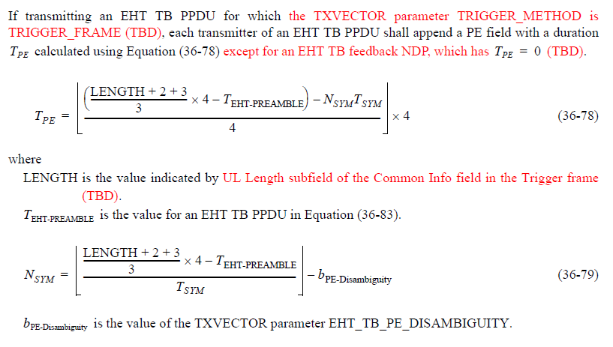

In 11/21-0259r4, the passed PDT of trigger frame, the meaning of LENGTH is already clear.
An EHT non-AP STA that responds to a Trigger frame that solicits an EHT TB PPDU shall set the TXVECTOR parameters below as follows:
- The FORMAT parameter is set to EHT_TB
- The L_LENGTH parameter is set to the value indicated by the UL Length subfield in the Common Info field of the Trigger frame.(#M7)
Hence we can remove the TBD now and simply follows 11ax:
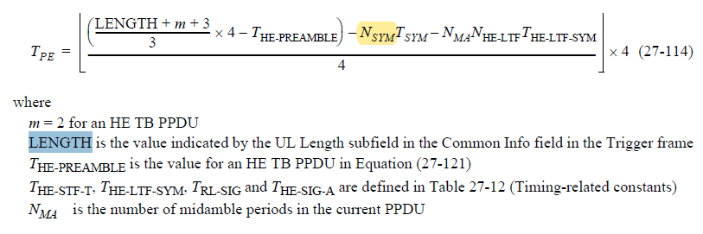

End of discussion

Instructions to the editor
Please make the changes to L41, P417 of P802.11 D0.4 as shown below:
LENGTH is the value indicated by UL Length subfield in the Common Info field of the Trigger frame.

