IEEE P802.11
Wireless LANs
D0.3 Remaining CRs on EHT-LTF of TB PPDU
Date: 2021.03.23
Author(s):
Name | Company | Address | Phone | email
Chenchen Liu | Huawei Technologies | Huawei Base, Bantian, Longgang, Shenzhen, Guangdong, China, 518129 |  | liuchenchen1@huawei.com
Abstract
This submission contains proposed comment resolutions to comments on P802.11be D0.3.

19 comments under 36.3.11.10:
CID 2939
CID 2675
CID 1570

are resolved in this document.

Revision Notes

R0 | Initial revision

Background
In D0.3：
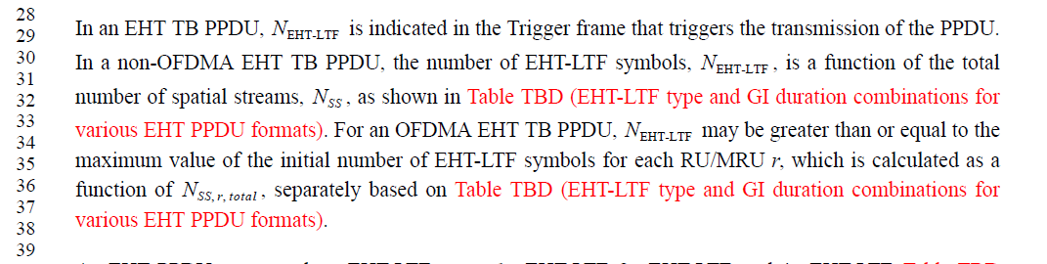
In D0.4：
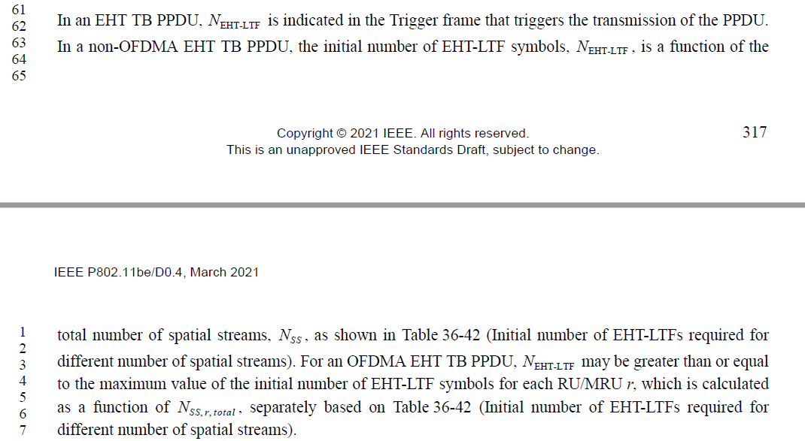

The related motions：
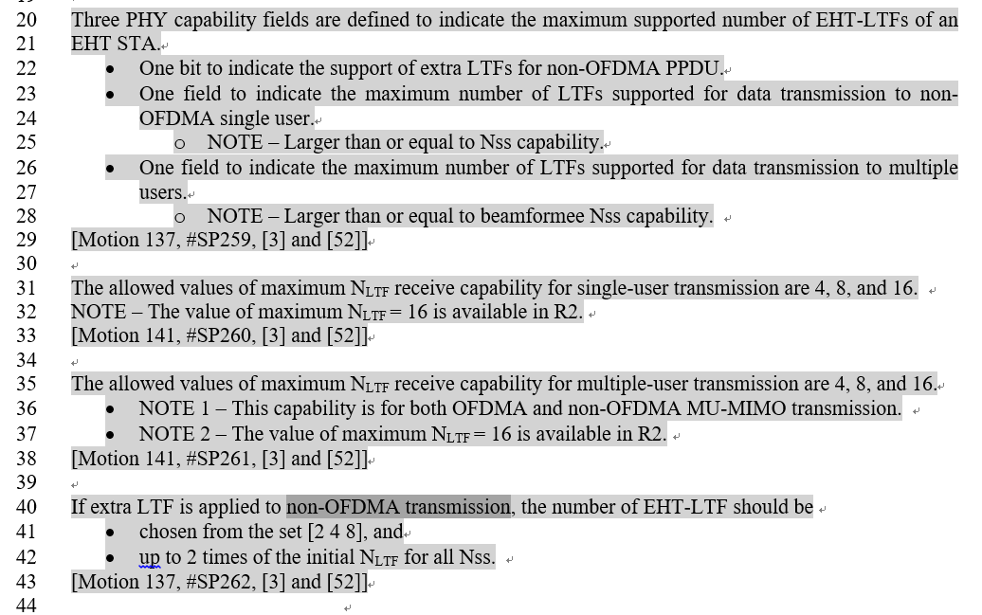

CID 2939 TBD
Page.  Line | Clause Number | Comment | Proposed Change | Resolution
282.29 | 36.3.11.10 | "In an EHT TB PPDU, N_EHT-LTF is indicated in the Trigger frame that triggers the transmission of the PPDU. In a non-OFDMA EHT TB PPDU, the number of EHT-LTF symbols, N_EHT-LTF, is a function of the total number of spatial streams, N_ss, as shown in Table TBD (EHT-LTF type and GI duration combinations for various EHT PPDU formats). For an OFDMA EHT TB PPDU, N_EHT-LTF may be greater than or equal to the maximum value of the initial number of EHT-LTF symbols for each RU/MRU r, which is calculated as a function of N_ss,r,total, separately based on Table TBD""  With EHT MU PPDU, the use of more LTFs than the ones defined here is allowed. To harmonize and to reduce options, more LTFs than number of spatial streams should be considered for non-OFDMA EHT TB PPDU too." | remove references to non-OFDMA and OFDMA cases. That is to change "non-OFDMA EHT TB PPDU" to "EHT TB PPDU", and "OFDMA EHT TB PPDU" to "EHT TB PPDU" | REVISED  The non-OFDMA transmission has more constrains on the number of extra LTF based on Motion 137. So they non-OFDMA transmission and OFDMA transmission are described separately. Please refer to the latest PDT 11/21-114r4.  Instructions to the editor  Please add the following sentence to Page 282, L33  If additional EHT-LTFs is supported which is indicated by extra LTFs for non-OFDMA PPDU capability fields, N_{EHT-LTF} may be greater than or equal to the initial number of EHT-LTF symbols, with the limit that N_{EHT-LTF} shall be no more than twice the initial number of EHT-LTFs and chosen from the set [2 4 8].
Disscussion:
1. 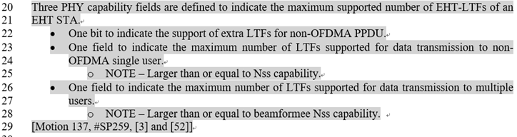
2.
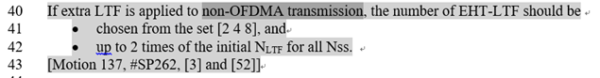

CID 2675 TBD
Page.  Line | Clause Number | Comment | Proposed Change | Resolution
282.28 | 36.3.11.10 | This paragraph conflicts with passed motions namely motions 137 and 141: | "In an EHT TB PPDU, is indicated in the Trigger frame that triggers the transmission of the PPDU. In a non-OFDMA EHT TB PPDU, the number of EHT-LTF symbols, , is a function of the total number of spatial streams, , as shown in Table TBD (EHT-LTF type and GI duration combinations for various EHT PPDU formats)."  Motion 137:  The number of EHT-LTF in non-OFDMA transmissions is larger than or equal to the initial number of EHT-LTFs determined by the number of total spatial streams.  · The maximum number of EHT-LTFs supported by the receiving STA(s) can be claimed by capability.  · The number of EHT-LTFs is signaled separately from Nss or Nss_total.  · This feature is optional for receiver.  · The allowed number of extra LTFs is TBD.  · The support for NDP is TBD.  [Motion 137, #SP258, [3] and [52]]  Motion 141:  The allowed values of maximum NLTF receive capability for multiple-user transmission are 4, 8, and 16.  · NOTE 1 - This capability is for both OFDMA and non-OFDMA MU-MIMO transmission.  · NOTE 2 - The value of maximum NLTF = 16 is available in R2.  [Motion 141, #SP261, [3] and [52]] | REVISED  Agree in principle.  Note to the editor: This problem is similar as CID2939. No further changes are needed.

CID 1570 TBD
Page.  Line | Clause Number | Comment | Proposed Change | Resolution
282.31 | 36.3.11.10 | the extra LTF symbol has been defined for OFDMA and non-OFDAMA transmission. and if the extra LTF is used, the number of LTF symbol is not a function of the total number of Nss | correct the sentence for the number of LTF symbol by referring to the MU-PPDU case | REVISED  Agree in principle.  Note to the editor: This problem is similar as CID2939. No further changes are needed.

