IEEE P802.11
Wireless LANs
Construction of EHT Data field CR on P802.11be D0.3
Date: 2021.02.22
Author(s):
Name | Company | Address | Phone | email
Mengshi Hu | Huawei Technologies | F3-6-A118, Huawei Base, Bantian, Longgang, Shenzhen, Guangdong, China, 518129 |  | humengshi@huawei.com
Ross Yu | Huawei Technologies
Abstract
This submission contains proposed comment resolutions to comments on P802.11be D0.3.

10 comments under 36.3.6.10 Construction of Data field in an EHT PPDU:
CID 1610, 1644, 1947, 2994, 2995, 2996, 2997, 2998, 2999 and 3284 are resolved in this document.

Revision Notes

R0 | Initial revision

CID 1610
Page.  Line | Clause Number | Comment | Proposed Change | Resolution
209.21 | 36.3.6.10 | There is no description of the encoding procedure for EHT Dup mode. | Describe how to construct Data field for EHT Dup mode. | REVISED  Note to the Editor: The proposed changes have been reflected in Draft 0.4.  No further changes are needed.

Discussion: (Draft 0.4)
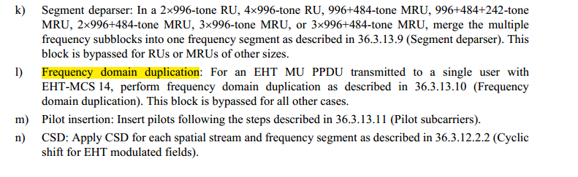

CID 1644
Page.  Line | Clause Number | Comment | Proposed Change | Resolution
209.55-209.56 | 36.3.6.10 | Segment Deparser section is missing | Add Section 36.3.12.XX - Segment Deparser with the following proposed text:  After BCC Interleaver, LDPC Tone Mapper and Constellation Mapper merge the multiple frequency subblocks into one frequency segment as described in 27.3.12.11 (Segment Deparser) | REVISED  Note to the Editor: The proposed changes have been reflected in Draft 0.4.  No further changes are needed.

Discussion: (Draft 0.4)
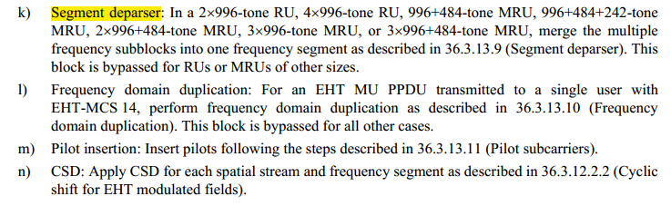


CID 1947
Page.  Line | Clause Number | Comment | Proposed Change | Resolution
209.21 | 36.3.6.10 | Describe the procedure is for non-EHT duplicate case obviously instead of a note. | As in comment | REVISED  Note to the Editor: the resolutions for CIDs 1610 and 1947 are the same.  No further changes are needed.

CID 2994
Page.  Line | Clause Number | Comment | Proposed Change | Resolution
209.27 | 36.3.6.10 | There is no description how to append the pre-FEC pad bits in 36.3.12. | Please add "Pre-FEC padding process" subsection and refer that subsection. | REVISED  11ax uses the following sentence:  Pre-FEC padding: “Append the pre-FEC pad bits and tail bits as described in 27.3.12 (Data field).”  In 11be Draft 0.4, the similar sentence is used: “Pre-FEC padding: Append the pre-FEC pad bits as described in 36.3.13 (Data field). If the user is using BCC, then add tail bits.”  The process of Pre-FEC padding is reflected in 36.3.13.3.4 EHT PPDU padding process, 36.3.13.3.5 Encoding process for an EHT MU PPDU, and  36.3.13.3.6 Encoding process for an EHT TB PPDU.  Thus it is fine to use the subclause 36.3.13 to be the reference.  Note to the Editor:  To be consistent, use “pre-FEC padding bits” to replace “pre-FEC pad bits”  please make the changes as follows to Page 209, L27 of P802.11be D0.3 or Page 306, L26 of P802.11be D0.4:  Pre-FEC padding: Append the pre-FEC padding bits as described in 36.3.13 (Data field). If the user is using BCC, then add tail bits.

CID 2995
Page.  Line | Clause Number | Comment | Proposed Change | Resolution
209.30 | 36.3.6.10 | Add reference for scrambler. | Modify "Scrambler: Scramble the pre-FEC padded data." as follows "Scrambler: Scramble the pre-FEC padded data as described in 36.3.12.2 (EHT PHY DATA scrambler and descrambler)." | REVISED  The subclause number is changed in Draft 0.4.  Note to the Editor:  please make the changes as follows to Page 209, L30 of P802.11be D0.3 or Page 306, L29 of P802.11be D0.4:  "Scrambler: Scramble the pre-FEC padded data as described in 36.3.13.2 (EHT PHY DATA scrambler and descrambler)."

CID 2996
Page.  Line | Clause Number | Comment | Proposed Change | Resolution
209.34 | 36.3.6.10 | Change reference to subsection for post FEC padding and PE. | Modify "Post-FEC padding: Append the post-FEC pad bits and PE field as described in 36.3.12 (Data field)." as follows "Post-FEC padding: Append the post-FEC pad bits and PE field as described in 36.3.13 (Packet extension)." | REVISED  Post-FEC padding is described in  36.3.13 Data field and PE field is described in 36.3.14 Packet extension.  Note to the Editor:  please make the changes as follows to Page 209, L34 of P802.11be D0.3 or Page 306, L33 of P802.11be D0.4:  "Post-FEC padding: Append the post-FEC padding bits as described in 36.3.13 (Data field) and the PE field as described in 36.3.14 (Packet extension)."

CID 2997
Page.  Line | Clause Number | Comment | Proposed Change | Resolution
209.53 | 36.3.6.10 | Change reference to subsection for segment deparser, and create segment deparser subsection. | Add segment deparser subsection and modify text "Segment deparser: In a 2x996-tone RU, 4x996-tone RU, 996+484-tone MRU, 996+484+242-tone MRU, 2x996+484-tone MRU, 3x996-tone MRU, or 3x996+484-tone MRU, merge the multiple frequency subblocks into one frequency segment as described in 36.3.12.4 (Stream parser). This block is bypassed for RUs or MRUs of other sizes." as follows "Segment deparser: In a 2x996-tone RU, 4x996-tone RU, 996+484-tone MRU, 996+484+242-tone MRU, 2x996+484-tone MRU, 3x996-tone MRU, or 3x996+484-tone MRU, merge the multiple frequency subblocks into one frequency segment as described in 36.3.12.X (Segment deparser). This block is bypassed for RUs or MRUs of other sizes." | REVISED  Note to the Editor: the resolutions for CIDs 1644 and 2997 are the same.  No further changes are needed.

CID 2998
Page.  Line | Clause Number | Comment | Proposed Change | Resolution
210.8 | 36.3.6.10 | Why data construction part refering preamble subsection? | Modify "Analog and RF: Upconvert the resulting complex baseband waveform with each transmit chain to an RF signal according to the center frequency of the desired channel and transmit. Refer to 36.3.10 (Mathematical description of signals) and 36.3.11 (EHT preamble) for details." as follows "Analog and RF: Upconvert the resulting complex baseband waveform with each transmit chain to an RF signal according to the center frequency of the desired channel and transmit. Refer to 36.3.10 (Mathematical description of signals) for details." | REVISED  Note to the Editor:  please make the changes as follows to Page 210, L8 of P802.11be D0.3 or Page 307, L10 of P802.11be D0.4:  "Analog and RF: Upconvert the resulting complex baseband waveform with each transmit chain to an RF signal according to the center frequency of the desired channel and transmit. Refer to 36.3.11 (Mathematical description of signals) for details."

CID 2999
Page.  Line | Clause Number | Comment | Proposed Change | Resolution
212.27 | 36.3.6.10 | Add subcarrier allocation related constants for the EHT-DUP and modify the title of full bandwidth non-OFDMA EHT PPDU to full bandwidth non-OFDMA EHT PPDU except for the EHT-MCS 15. | See comment. | REVISED  Note to the Editor: The proposed changes have been reflected in Draft 0.4.  No further changes are needed.
Discussion:
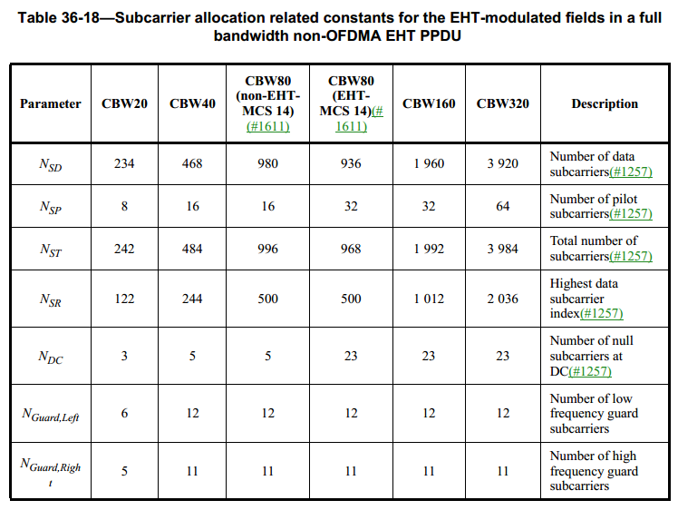

CID 3284
Page.  Line | Clause Number | Comment | Proposed Change | Resolution
209.46 | 36.3.6.10 | BPSK DCM should be BPSK_DCM to be consistent | See comment | REVISED  BPSK-DCM, instead of BPSK_DCM, is used in many places in D0.3 and D0.4.  Note to the Editor:  please make the changes as follows to Page 209, L46 of P802.11be D0.3 or Page 306, L45 of P802.11be D0.4:  “BPSK DCM” should be “BPSK-DCM”

