IEEE P802.11
Wireless LANs
EHT-SIG CR on P802.11be D0.3 – part 6
Date: 2021.03.15
Author(s):
Name | Company | Address | Phone | email
Ross Jian Yu | Huawei Technologies | F3-6-A120, Huawei Base, Bantian, Longgang, Shenzhen, Guangdong, China, 518129 |  | ross.yujian@huawei.com
Ming Gan | Huawei Technologies
Abstract
This submission contains proposed comment resolutions to comments on P802.11be D0.3.

5 comments:
CID 1410, 3189, 3190, 3191, 2643
are resolved in this document.

Revision Notes

R0 | Initial revision
R1 | Add CID2643, forwarded by Editor
R2 | Changes during the presentation

CID 1410
Page.  Line | Clause Number | Comment | Proposed Change | Resolution
256.40 | 36.3.11 | allowed 2*996+484 tone MRUs at ru allocation subfield at OFDMA, Table 36-26 | Figure 36-19 proposes 12 possible MRUs for 2*996+484 tones, meanwhile only 6 of them are defined in RU allocation subfields, Table 36-26 | REVISED  Note to the Editor: The comment has been resolved in the CR document 11/21-338r0 by adding the corresponding physical MRU index and no further changes are needed.
Discussion:
Changes in 11/21-338r0 for reference:
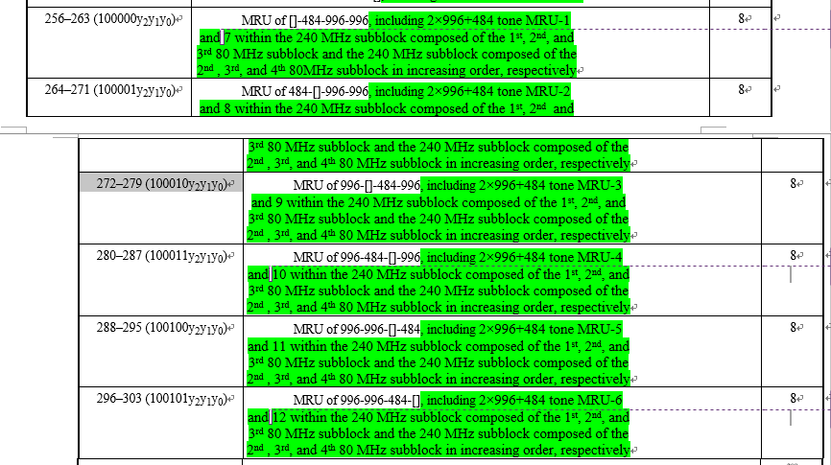

CID 3189
Page.  Line | Clause Number | Comment | Proposed Change | Resolution
248.14 | 36.11.8.3 | Both BW value 4 and 5 are 320 MHz PPDUs | Change  "2, 3, 4, or 5 (indicating an 80 MHz, 160 MHz, 320 MHz-1, or 320 MHz-2 EHT MU PPDU)"  to  "2, 3, 4 or 5 (indicating an 80, 160 or 320 MHz EHT MU PPDU)"  Or, simply delete what is in the (). | REVISED  Instructions to the Editor:  please make the following changes to Page 248, L14 of P802.11be D0.3:  Change  "2, 3, 4, or 5 (indicating an 80 MHz, 160 MHz, 320 MHz-1, or 320 MHz-2 EHT MU PPDU)"  to  "2, 3, 4 or 5  please make the following changes to Page 249, L17 of P802.11be D0.3:  Change:  “M = 6 if the Bandwidth field in the U-SIG field is 4 or 5 (indicating a 320 MHz-1 or 320 MHz-2 EHT MU PPDU).”  to  “M = 6 if the Bandwidth field in the U-SIG field is 4 or 5

CID 3190
Page.  Line | Clause Number | Comment | Proposed Change | Resolution
249.55 | 36.3.8.3 | Can we use the OFDMA mode to transmit RU996 in 80 MHz EHT MU PPDU? | Change "A 4x996 tone RU cannot be indicated by the RU Allocation subfield."  to  "An RU Allocation subfield shall not indicate an RU which spans the entire PPDU bandwidth.  NOTE - For example, a 4x996 tone RU cannot be indicated by the RU Allocation subfield. A 996 tone RU cannot be indicated by the RU Allocation subfield in an 80 MHz EHT MU PPDU. A 3x996+484 tone RU cannot be indicated in a 320 MHz EHT MU PPDU with 40 MHz puncturing indicated in the U-SIG." | ACCEPTED  Note to the editor: this change will overwrite the proposed change of CID 3301 where “4x996 tone RU” is changed to “4x996-tone RU” in 11-21/0236r1.
Discussion:
In 11ax, the spec allows to transmit 996-tone RU in non-compressed mode of an 80 MHz HE MU PPDU, also for 484-tone RU of 40 MHz, 242-tone RU of 20 MHz. The only exception is 2*996-tone RU, which was in the RU allocation table and later removed.

For 11be, it is debatable. Since the mode with RU allocation subfield is already called OFDMA transmission, so it will make the description consistent by not allowing non-OFDMA transmission (RU which spans the entire PPDU bandwidth). And is also beneficial to reduce the number of duplicated modes.
End of discussion

CID 3191
Page.  Line | Clause Number | Comment | Proposed Change | Resolution
250.40 | 38.3.11.8.3 | "For an RU that is referred to by a first or only RU Allocation subfield in an EHT-SIG content channel, the  RU Allocation subfield encodes the number of User fields per RU contributed to the User Specific field in  the same EHT-SIG content channel as the RU Allocation subfield."  This is very hard to understand. | I don't have a specific suggestion, but the sentence requires better wording. | REJECTED  This sentence is basically borrowed from P802.11ax D8.0 page 599, L50, and has been shown understoodable by implementers:  “For an RU that is referred to by a first or only RU Allocation subfield in an HE-SIG-B content channel, the RU Allocation subfield encodes the number of User fields per RU contributed to the User Specific field in the same HE-SIG-B content channel as the RU Allocation subfield. This number is labeled Nuser(r, c) for RU r and HE-SIG-B content channel c as described in Table 27-26 (RU Allocation subfield).”

CID 2643
Page.  Line | Clause Number | Comment | Proposed Change | Resolution
243.54 | 36.3.11.8 | Definition of u-sig overflow | EHT-SIG section does not contain a clear definition of U-SIG overflow. | Revised  U-SIG overflow bits have been defined after Table 36-32, 36-35, 36-36 in 11-21/0220r1 and also reflected in D0.4.  Note to the editor: the comment has been resolved in EHT-SIG PDT 11-21/0220r1 and reflected in D0.4 and no further changes are needed.

