IEEE P802.11
Wireless LANs
EHT scrambler CR on P802.11be D0.3
Date: 2021.02.25
Author(s):
Name | Company | Address | Phone | email
Chenchen Liu | Huawei Technologies | Huawei Base, Bantian, Longgang, Shenzhen, Guangdong, China, 518129 |  | liuchenchen1@huawei.com
Abstract
This submission contains proposed comment resolutions to comments on P802.11be D0.3.

9 comments under 36.3.12.2:
CID 1571
CID 1572
CID 1588
CID 1971
CID 2026
CID 2412
CID 2664
CID 2665
CID 3069
CID 3070
CID 3071
are resolved in this document.

Revision Notes

R0 | Initial revision

CID 1571
Page.  Line | Clause Number | Comment | Proposed Change | Resolution
287.24 | 36.3.12.2 | following text " The octets of the PSDU are placed in the transmit serial bit stream, bit 0 first and bit 7 last" is not needed. | delete the this sentence. | REJECTED  It is needed following from the previous standard

Discussion:
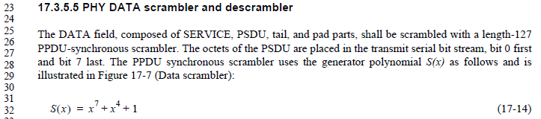

CID 1572
Page.  Line | Clause Number | Comment | Proposed Change | Resolution
288.15 | 36.3.12.2 | The 11bit of service field is used for scramble seed in EHT PPDU. Why the 7bit of service field is considered when MU-RTS is transmitted by using the EHT-PPDU? Clarify it. | as in comment. | REVISED  This is based on the Motion 124, to guarantee all the CTS from different STAs are identical.  Instructions to the editor:  Please add the sentence” The SERVICE field of a CTS frame in response to an MU-RTS after scrambling shall have the identical first 7 bits to the SERVICE field of corresponding MU-RTS frame ” to the end of P288 L18

Discussion:
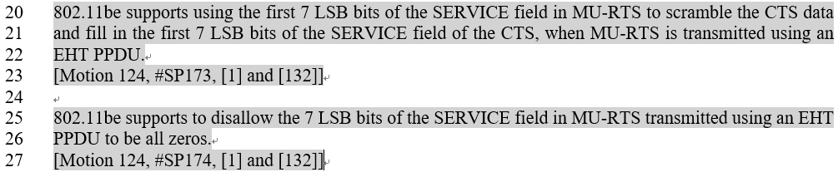
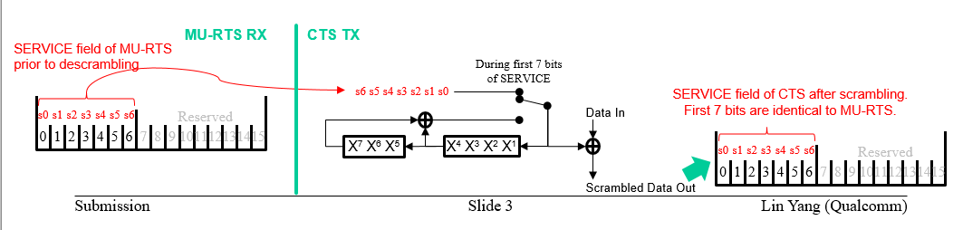

CID 1588
Page.  Line |  | Clause Number | Comment | Proposed Change | Resolution
287.01 |  | 36.3.12 | Segment deparser block is defined in the transmitter block diagram. A new subsection which adresses this block is also needed in the Data field section. | Add a new subsection for segment deparser into the Data field section and describe its detail. | REJECTED  Not related to the scrambler subclause. Already exists in 36.3.12.5.

Discussion:
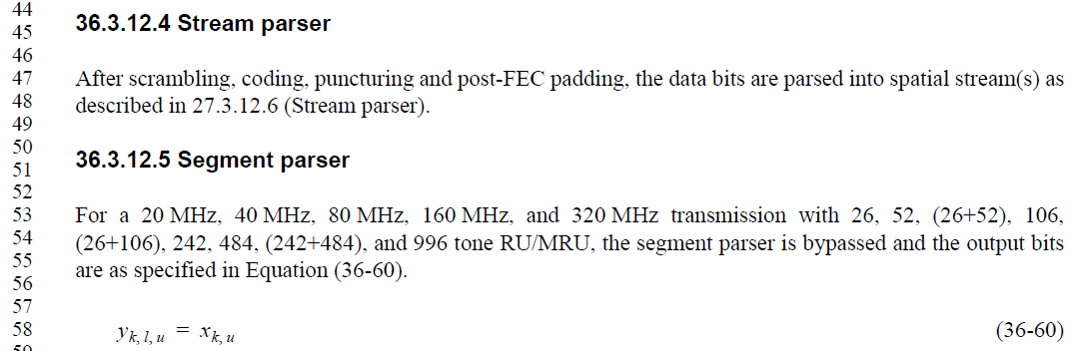

CID 3070
Page.  Line | Clause Number | Comment | Proposed Change | Resolution
287.42 | 36.3.12.2 | The text in the figure are not readable | suggest editor to re-import the figure | REVISED  Instructions to the editor  Please replace figure 36-51 of Page 287 with the following figure

CID 1971
Page.  Line | Clause Number | Comment | Proposed Change | Resolution
287.21 | 36.3.12.2 | Clear TBDs in 36.3.12.2 EHT PHY DATA scrambler and descrambler | As comment. There are quite a few TBDs and red colored paragarphs. | ACCEPTED  The TBDs and red colored paragarphs are unnessary.  Instructions to the editor:  Please remove all the TBDs in 36.3.12.2 and recover the red colored paragarphs to normal.
Discussion:
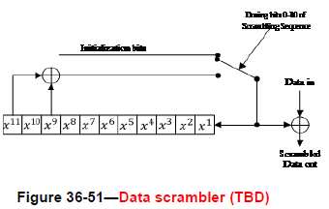
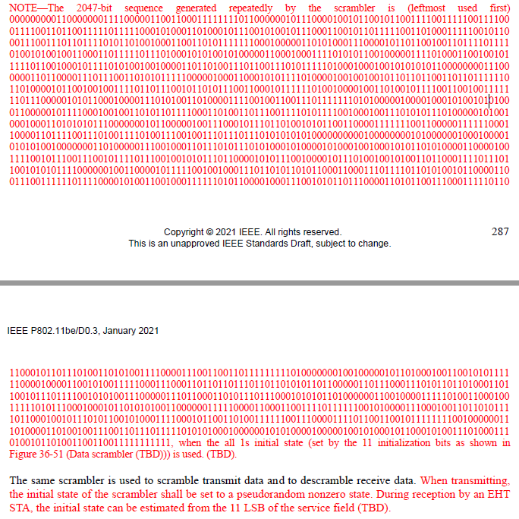

CID 2026
Page.  Line | Clause Number | Comment | Proposed Change | Resolution
287.46 | 36.3.12.2 | We already decided to use 11bit Scrambler Initialization in Service field. So the Data scrambler is fine. | as in comment.  Delete TBDs in Figure 36-51 and the following texts | ACCEPTED  Same as CID1971.

CID 2412
Page.  Line | Clause Number | Comment | Proposed Change | Resolution
287.23 | 36.3.12.2 | The sentence of "The DATA field, composed of SERVICE, PSDU, tail (if BCC is used), and pad parts, shall be scrambled with a length-2047 PPDU-synchronous scrambler" can make it possible to misunderstand that tail bits are scrambled. | Modify the sentence as follows: "The SERVICE field, PSDU, and pre-FEC PHY padding of the Data field shall be scrambled by the length-2047 PPDU-synchronous scrambler." | REJECTED  The tail bits shall be scrambled and set to zeros after scrambling.
Discussion:
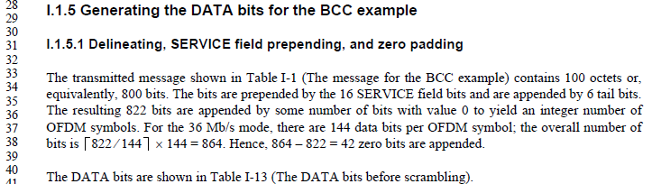
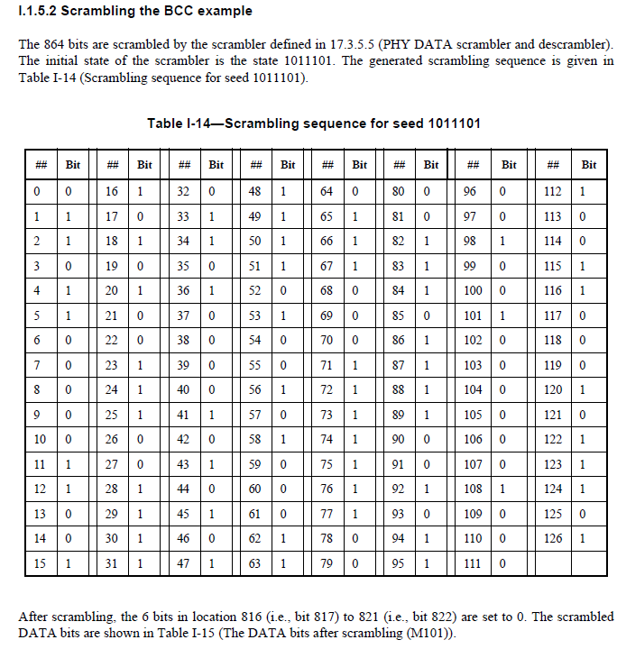

CID 2664
Page.  Line | Clause Number | Comment | Proposed Change | Resolution
287.23 | 36.3.12.2 | Incorrect description | Scrambler is mandated to scramble pre-FEC padding and post-FEC padding sequence is designer's choice, so "and pad parts" is incorrect and should be replaced with pre-FEC padding (pad parts is copied from original description for 11a/g and not 11ax) | ACCEPTED  Instructions to the editor  Please replace “pad parts” in Page 287 L23 with “pre-FEC pad parts”

CID 2665
Page.  Line | Clause Number | Comment | Proposed Change | Resolution
288.12 | 36.3.12.2 | Incomplete description | Recommended to change paragraph as following similar to original description of 7-bit scrambler:  "The same scrambler is used to scramble transmit data and to descramble receive data. When transmitting, the first 11 bits of scrambling sequence, which is also used to set the initial state of the scrambler, shall be set to a pseudorandom nonzero state. During reception by an EHT STA, the initial state can be estimated from the 11 LSB of the service field (TBD)." | REJECTED  The initial state is not determined by the first 11 bits of scrambling sequence

CID 3069
Page.  Line | Clause Number | Comment | Proposed Change | Resolution
288.15 | 36.3.12.2 | change "pad parts" to pre-FEC padding | as commented | REVISED  Same as CID2664, where  “pad parts” in Page 287 L23 replaced with “pre-FEC pad parts”

CID 3071
Page.  Line | Clause Number | Comment | Proposed Change | Resolution
288.12 | 36.3.12.2 | The text here doesn't match figure 36-51. with the current figure the initial state of the scrambler, which is the value in the shift register, can be arbitrary value. | Remove "When transmitting,  the initial state of the scrambler shall be set to a pseudorandom nonzero state" | REJECTED  Follows from the previous standard

