IEEE P802.11
Wireless LANs
EHT-LTF CR on P802.11be D0.3
Date: 2021.03.11
Author(s):
Name | Company | Address | Phone | email
Chenchen Liu | Huawei Technologies | Huawei Base, Bantian, Longgang, Shenzhen, Guangdong, China, 518129 |  | liuchenchen1@huawei.com
Abstract
This submission contains proposed comment resolutions to comments on P802.11be D0.3.

19 comments under 36.3.11.10:
CID 1413
CID 1568
CID 1569
CID 1570
CID 1584
CID 1630
CID 1979
CID 1998
CID 1999
CID 2000
CID 2001
CID 2230
CID 2663
CID 2675
CID 2816
CID 2938
CID 2939
CID 3068
CID 3075
are resolved in this document.

Revision Notes

R0 | Initial revision

CID 1413
Page.  Line | Clause Number | Comment | Proposed Change | Resolution
282.20 | 36.3.11.10 | P282L15-18 is language specific to EHT MU with a single RU/MRU, then a sentence general to EHT MU is provided at P282L20 but the para continues at P282L21-26 with language specific to EHT MU with > 1 RU/MRU. This orderig is unnatural. | Move sentence at P282L20 to its own para above P282L15 | ACCEPTED  Note to the editor: This problem is already revised in the PDT 11/21-114r4 for Draft 0.4 No further changes are needed.

Draft0.4 FYI
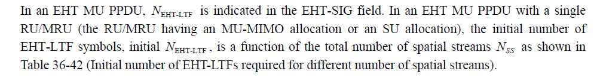

CID 1568
Page.  Line | Clause Number | Comment | Proposed Change | Resolution
282 | 36.3.11.10 | the extra LTF symbol has been defined for OFDMA and non-OFDAMA transmission. to indicate using of extra LTF, it should be indciated by using the U-SIG or EHT-SIG | define the extra LTF indication in U-SIG or EHT-SIG field | REVISED  Agreed in principle.  Note to the editor: This problem is already revised in the PDT 11/21-114r4 for Draft 0.4. No further changes are needed.

Draft0.4 FYI

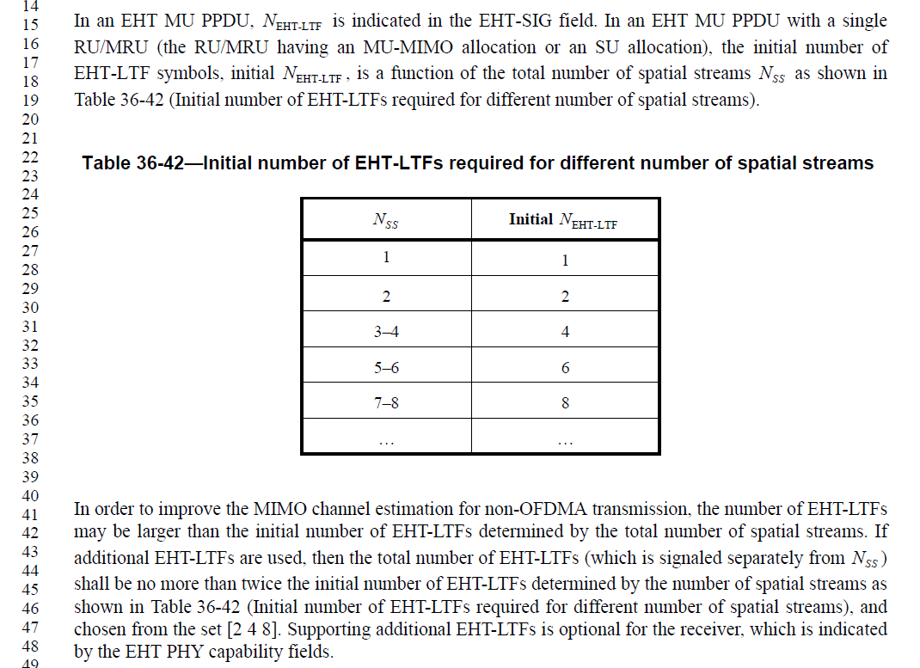

CID 1569
Page.  Line | Clause Number | Comment | Proposed Change | Resolution
282.16 | 36.3.11.10 | the extra LTF symbol has been defined for OFDMA and non-OFDAMA transmission. and if the extra LTF is used, the number of LTF symbol is not a function of the total number of Nss | correct the sentence for the number of LTF symbol by referring to the MU-PPDU case | REVISED  Agree in principle.  Note to the editor: This problem is already revised in the PDT 11/21-114r4 for Draft 4.0. No further changes are needed.

CID 1570
Page.  Line | Clause Number | Comment | Proposed Change | Resolution
282.31 | 36.3.11.10 | the extra LTF symbol has been defined for OFDMA and non-OFDAMA transmission. and if the extra LTF is used, the number of LTF symbol is not a function of the total number of Nss | correct the sentence for the number of LTF symbol by referring to the MU-PPDU case | REVISED  Agree in principle.  Note to the editor: This problem is already revised in the PDT 11/21-114r4 for Draft 4.0. No further changes are needed.

CID 1584
Page.  Line | Clause Number | Comment | Proposed Change | Resolution
285.65 | 36.3.11.10 | Clarify EHT-LTF coefficients for the tones corresponding to punctured channels for non-OFDMA or for the tones which are not assigned to STAs for OFDMA. | See the comment. | REVISED  Agree in principle.  Note to the editor: This  Please add the following text to  Page285 L65  “For a non-OFDMA transmission when preamble puncturing is applied, a single large size MRU spans the non-punctured portions of the PPDU bandwidth. In the puncturing case, the values of the EHT-LTF sequence (defined in Equation (27-41) to Equation (27-52) and Equation (36-35) to Equation (36-37)) are replaced by zero for subcarriers that fall outside the aforementioned single large size MRU. This is also applicable to an EHT Sounding NDP with preamble puncturing. The mapping of the non-OFDMA puncturing pattern signaled in the U-SIG to the corresponding large size MRU is defined in Table 36-21.  For an OFDMA transmission, the values of EHT-LTF sequence (defined in Equation (27-41) to Equation (27-52) and Equation (36-43) to Equation (36-45)) are replaced by zero, for subcarriers that belong to unassigned RUs as well as for DC tones or null sub-carriers.  ”  For OFDMA, This problem is already partialy revised in the PDT 11/21-114r4 for Draft 4.0, only the underlined need to be updated.

Draft0.4 FYI
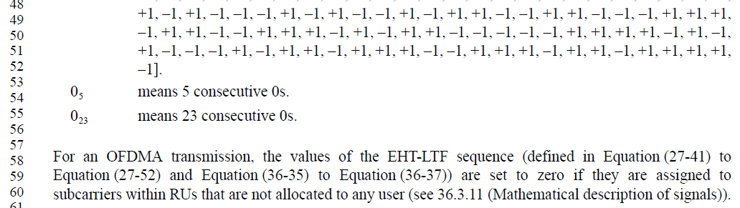

CID 1630
Page.  Line | Clause Number | Comment | Proposed Change | Resolution
282.12 | 36.3.11.10 | MAP is a Rel2 topic. Delete the sentence "This is applicable to multi-AP transmission modes as well". | See the comment. | ACCEPTED

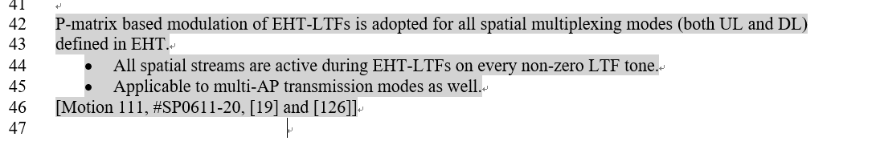

CID 1979
Page.  Line | Clause Number | Comment | Proposed Change | Resolution
282.11 | 36.3.11.10 | Multi-AP transmission is under the scope of Rel.2 features. | Suggest to delete the sentence "This is applicable to multi-AP transmission modes as well." at this stage of draft. (We can still tract the concept passed in SFD and bring it back in the proper stage of the draft for Rel.2) | ACCEPTED  Note to the Editor: The resolution is the same as that of the CID1630.

CID 1998
Page.  Line | Clause Number | Comment | Proposed Change | Resolution
283.53 | 36.3.11.10 | EHTLTF_{-2036:2036} is better to be modified as EHTLTF_{-2036, 2036} as like EHTLTF_{-1012, 1012} in 160 MHz transmission, since {-2036:2036} is not specifying what's the granularity of used LTF tones within given range(e.g. see the notation of EHTS_{-2032:16:2032} in 36.3.11.9). Otherwise, it may be better to express with the granularity(e.g. 4) according to 1x LTF tones. | As in comment. | REVISED  Instructions to the editor  Please replace  EHTLTF_{-2036:2036} with EHTLTF_{-2036, 2036}  in Page 283 L53 e.q.36-34,  Page 284 L8 e.q.36-35  and Page 285 L5 e.q.36-36

CID 1999
Page.  Line | Clause Number | Comment | Proposed Change | Resolution
284.08 | 36.3.11.10 | EHTLTF_{-2036:2036} is better to be modified as EHTLTF_{-2036, 2036}, otherwise, it may be better to express by the granularity(e.g. 2) within the given range according to 2x LTF tones. | As in comment. | ACCEPTED  Note to the Editor: The resolution is the same as that of the CID1998.

CID 2000
Page.  Line | Clause Number | Comment | Proposed Change | Resolution
285.05 | 36.3.11.10 | EHTLTF_{-2036:2036} is better to be modified as EHTLTF_{-2036, 2036}, otherwise, it may be better to express by the granularity(e.g. 1) within the given range according to 4x LTF tones. | As in comment. | ACCEPTED  Note to the Editor: The resolution is the same as that of the CID1998.

CID 2001
Page.  Line | Clause Number | Comment | Proposed Change | Resolution
285.65 | 36.3.11.10 | The time domain representation of the signal for EHT MU PPDU and EHT TB PPDU are missing. | Add the description for time domain representation of the signal of EHT LTF for both EHT MU PPDU and EHT TB PPDU. | REVISED  Agree in principle.  Note to the editor: This problem is already revised in the PDT 11/21-114r4 for Draft 0.4. No further changes are needed.

Draft 4.0 FYI
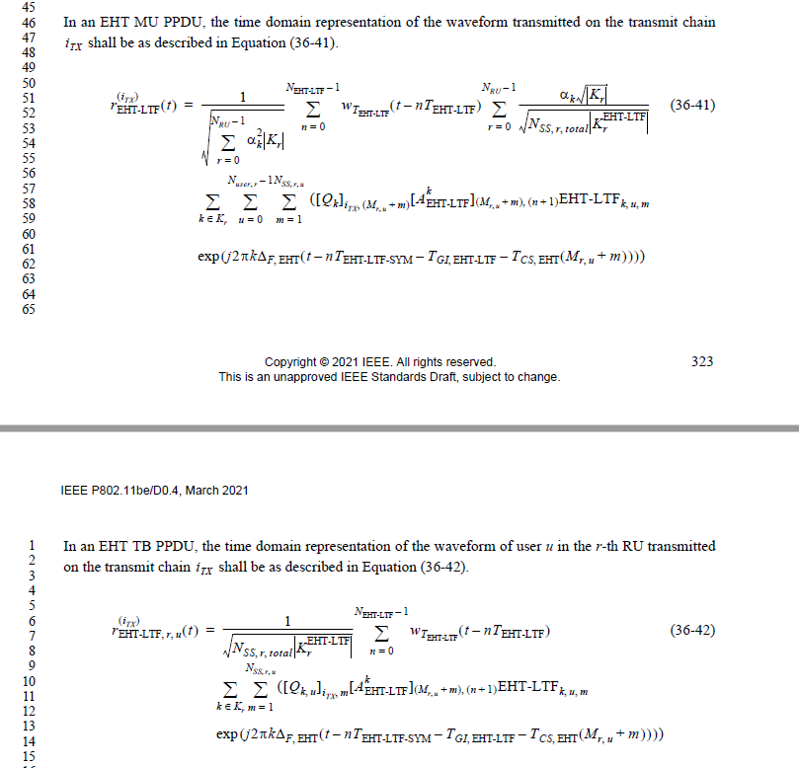

CID 2230
Page.  Line | Clause Number | Comment | Proposed Change | Resolution
282.11 | 36.3.11.10 | R2 feature is mentioned in R1 draft | Remove this sentence "This is applicable to multi-AP transmission modes as well." | ACCEPTED  Note to the Editor: The resolution is the same as that of the CID1630

CID 2663
Page.  Line | Clause Number | Comment | Proposed Change | Resolution
285.65 | 36.3.11.10 | Missing description | Matematical description of EHT-LTF is missing, 11ax not only included that, it also included block diagrams on how to generate 1x and 2x LTF. Same diagrams can be referenced here, but mathematical description specifying various parameters that are present in EHT-LTF generation is a must | REVISED  Agree in principle.  Note to the editor: This problem is already revised in the PDT 11/21-114r4 for Draft 0.4. No further changes are needed.

CID 2675
Page.  Line | Clause Number | Comment | Proposed Change | Resolution
282.28 | 36.3.11.10 | This paragraph conflicts with passed motions namely motions 137 and 141: | "In an EHT TB PPDU, is indicated in the Trigger frame that triggers the transmission of the PPDU. In a non-OFDMA EHT TB PPDU, the number of EHT-LTF symbols, , is a function of the total number of spatial streams, , as shown in Table TBD (EHT-LTF type and GI duration combinations for various EHT PPDU formats)."  Motion 137:  The number of EHT-LTF in non-OFDMA transmissions is larger than or equal to the initial number of EHT-LTFs determined by the number of total spatial streams.  · The maximum number of EHT-LTFs supported by the receiving STA(s) can be claimed by capability.  · The number of EHT-LTFs is signaled separately from Nss or Nss_total.  · This feature is optional for receiver.  · The allowed number of extra LTFs is TBD.  · The support for NDP is TBD.  [Motion 137, #SP258, [3] and [52]]  Motion 141:  The allowed values of maximum NLTF receive capability for multiple-user transmission are 4, 8, and 16.  · NOTE 1 - This capability is for both OFDMA and non-OFDMA MU-MIMO transmission.  · NOTE 2 - The value of maximum NLTF = 16 is available in R2.  [Motion 141, #SP261, [3] and [52]] | REVISED  Agree in principle.  Note to the editor: This problem is already revised in the PDT 11/21-114r4 for Draft 0.4. No further changes are needed.

CID 2816
Page.  Line |  | Clause Number | Comment | Proposed Change | Resolution
285.65 |  | 36.3.11.10 | There is no mathematical expression for the time-domain representation of EHT-LTF | Add | REVISED  Same as the CID2663  Agree in principle.  Note to the editor: This problem is already revised in the PDT 11/21-114r4 for Draft 0.4. No further changes are needed. The proposed resolution is also the same as that of CID 2663.

CID 2938
Page.  Line |  | Clause Number | Comment | Proposed Change | Resolution
282.20 |  | 36.3.11.10 | "In an EHT MU PPDU, N_EHT-LTF is indicated in the U-SIG field. In an EHT MU PPDU with more than one RU/MRU, N_EHT-LTF may take a value that is greater than or equal to the maximum value of the initial number of EHT-LTF symbols for each RU/MRU"  The use of more LTFs is beneficial for channel estimation in all PPDUs regardless how may RU/MRUs are present. The case of one RU/MRU should therefore not be excluded. | remove "with more than one RU/MRU" and change related text in line number 15 to 18 | REJECTED  The non-OFDMA transmission has more constrains on the number of extra LTF based on Motion 137. so the non-OFDMA transmission and OFDMA transmission are described separately. Please refer to the latest PDT 11/21-114r4.
Discussion:
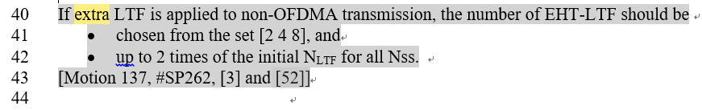

CID 2939
Page.  Line |  |  | Clause Number | Comment | Proposed Change | Resolution
282.29 |  |  | 36.3.11.10 | "In an EHT TB PPDU, N_EHT-LTF is indicated in the Trigger frame that triggers the transmission of the PPDU. In a non-OFDMA EHT TB PPDU, the number of EHT-LTF symbols, N_EHT-LTF, is a function of the total number of spatial streams, N_ss, as shown in Table TBD (EHT-LTF type and GI duration combinations for various EHT PPDU formats). For an OFDMA EHT TB PPDU, N_EHT-LTF may be greater than or equal to the maximum value of the initial number of EHT-LTF symbols for each RU/MRU r, which is calculated as a function of N_ss,r,total, separately based on Table TBD""  With EHT MU PPDU, the use of more LTFs than the ones defined here is allowed. To harmonize and to reduce options, more LTFs than number of spatial streams should be considered for non-OFDMA EHT TB PPDU too." | remove references to non-OFDMA and OFDMA cases. That is to change "non-OFDMA EHT TB PPDU" to "EHT TB PPDU", and "OFDMA EHT TB PPDU" to "EHT TB PPDU" | REVISED  The non-OFDMA transmission has more constrains on the number of extra LTF based on Motion 137. So they non-OFDMA transmission and OFDMA transmission are described separately. Please refer to the latest PDT 11/21-114r4.  Instructions to the editor  Please add the following sentence to Page 282, L33  If additional EHT-LTFs is supported which is indicated by extra LTFs for non-OFDMA PPDU capability fields, N_{EHT-LTF} may be greater than or equal to the initial number of EHT-LTF symbols, with the limit that N_{EHT-LTF} shall be no more than twice the initial number of EHT-LTFs and chosen from the set [2 4 8].
Disscussion:
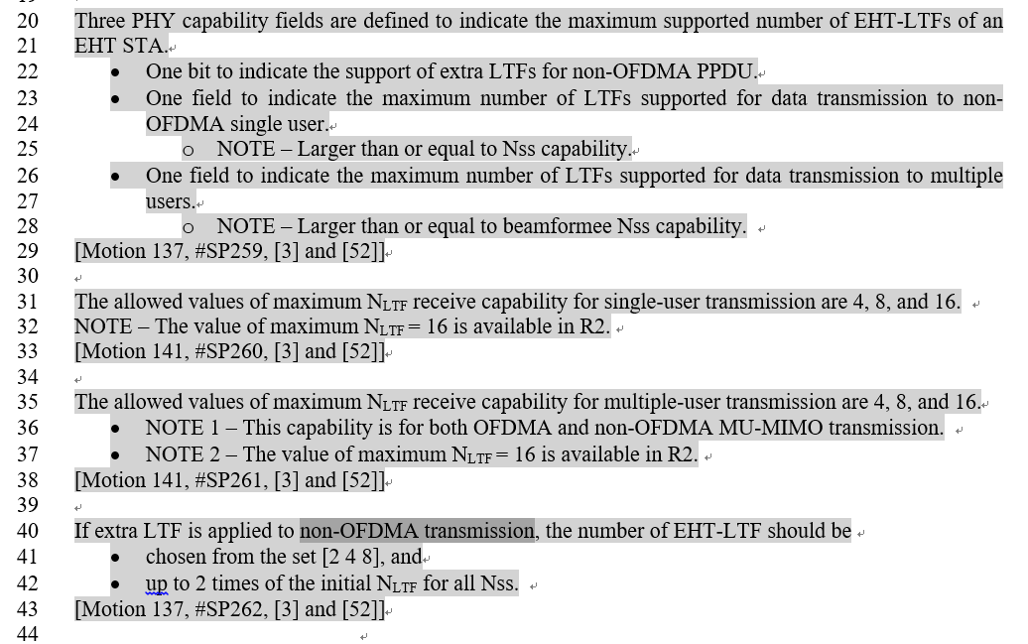

CID 3068
Page.  Line |  |  | Clause Number | Comment | Proposed Change | Resolution
281.56 |  |  | 36.3.11.10 | add a table to list the M/O for EHT-LTF similar as in HE-LTF | as commented | REVISED  Agree in principle.  Note to the editor: This problem is already revised in the PDT 11/21-114r4 for Draft 0.4. No further changes are needed.
Dsicussion:
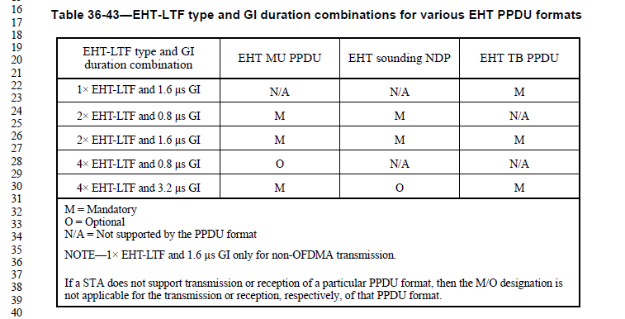

CID 3075
Page.  Line |  |  | Clause Number | Comment | Proposed Change | Resolution
281.56 |  |  | 36.3.11.10 | missed NDP feedback tone set definition that already exsit in 11ax | add it back | REJECTED  No EHT TB feedback NDP is defined yet.

