IEEE P802.11
Wireless LANs
EHT-SIG CR on P802.11be D0.3 – CID 2410
Date: 2021.02.27
Author(s):
Name | Company | Address | Phone | email
Ross Jian Yu | Huawei Technologies |  |  | ross.yujian@huawei.com
Ming Gan | Huawei
Abstract
This submission contains proposed comment resolutions to comments on P802.11be D0.3.

1 Comment: CID2410 is resolved in this document.

Revision Notes

R0 | Initial revision

CID 2410
Page.  Line | Clause Number | Comment | Proposed Change | Resolution
251.29 | 36.3.11.8.3 | The sentence of "For a 996-tone RU, the second 9-bit RU Allocation subfield referring to the RU shall be set to 30 (000011110 in binary representation), which encodes zero additional User fields in the corresponding content channel." and "The RU Allocation subfield corresponding to 996-tone RU in large-size MRU combinations of 996+484-tone MRU, 2x996+484-tone MRU, 3x996+484-tone MRU, 3x996-tone-MRU, and&#65440;2x996-tone RU is set to 30 (000011110 in binary representation) to indicate the zero users, which encodes zero additional User fields in the corresponding content channel." can be merged. | Delete the sentence of "For a 996-tone RU, the second 9-bit RU Allocation subfield referring to the RU shall be set to 30 (000011110 in binary representation), which encodes zero additional User fields in the corresponding content channel." and modify the sentence of " The RU Allocation subfield corresponding to 996-tone RU in large-size MRU combinations of 996+484-tone MRU, 2x996+484-tone MRU, 3x996+484-tone MRU, 3x996-tone-MRU, and 2x996-tone RU is set to 30 (000011110 in binary representation) to indicate the zero users, which encodes zero additional User fields in the corresponding content channel" as follows:  The RU Allocation subfield corresponding to 996-tone RU in large-size MRU combinations of 996+484 tone MRU, 2x996+484 tone MRU, 3x996+484 tone MRU, and 3x996-tone MRU and in RUs of 996-tone RU and 2x996-tone RU is set to 30 (000011110 in binary representation) to indicate the zero users, which encodes zero additional User fields in the corresponding content channel. | REVISED  Agreed in principal.  “indicate the zero users” is not correct, should be removed.  Instructions to the editor  Please make the changes as shown in 11/21-0337r0

Discussion
The commenter tries to merge the first and fourth subbullet
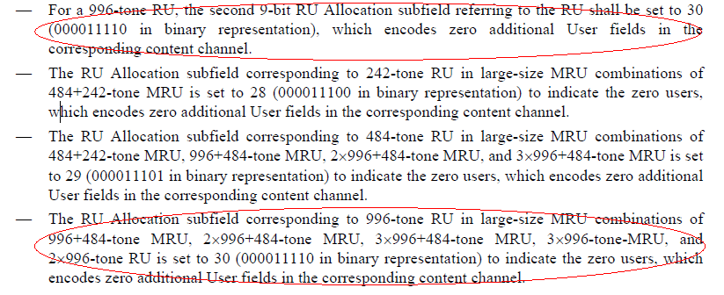

Instructions to the editor
Please make the changes to L29, P251 as shown below:
For the EHT-SIG content channel that includes one or more User fields associated with a RU/MRU larger than 484-tone, the first 9-bit RU Allocation subfield referring to the RU/MRU may use values in the range 80–303 (001010y2y1y0–100101y2y1y0 in binary representation) as in Table 36-26 (RU Allocation subfield) with y2y1y0 indicating the number of User fields signaled in the corresponding content channel, while the remaining 9-bit RU Allocation subfields referring to the RU/MRU shall be set as follows:

- The RU Allocation subfield corresponding to 242-tone RU in large-size MRU combinations of 484+242 tone MRU is set to 28 (000011100 in binary representation), which encodes zero additional User fields in the corresponding content channel.
- The RU Allocation subfield corresponding to 484-tone RU in large-size MRU combinations of 484+242 tone MRU, 996+484 tone MRU, 2×996+484 tone MRU, and 3×996+484 tone MRU is set to 29 (000011101 in binary representation), which encodes zero additional User fields in the corresponding content channel.
- The RU Allocation subfield corresponding to 996-tone RU in large-size MRU combinations of 996+484 tone MRU, 2×996+484 tone MRU, 3×996+484 tone MRU, 3×996-tone MRU, and in RUs of 996-tone RU and 2×996-tone RU is set to 30 (000011110 in binary representation), which encodes zero additional User fields in the corresponding content channel.

